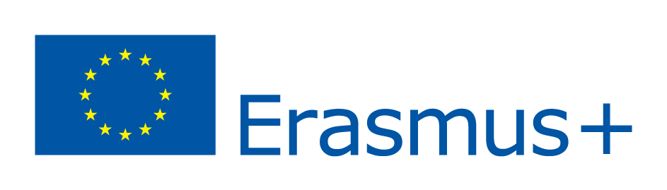

Volunteering as an opportunity bridge

KA1 - Learning Mobility of Individuals, Youth mobility

28th February- 8th of March 2015

Zagreb, Croatia
VoVo Association is planning to apply for the 1st of October 2014 Erasmus+ dead-line with a KA1 project to introduce youth how can volunteering help young people to choose a career and gain some experience and competences that will improve their employability.
- Place: Zagreb, Croatia
- Participating countries: Croatia (host), Italy, Spain, Greece, Lithuania
- Project duration: 9 days (28. February- 4. March 2014.)
- Participants per country: 5 + 1 team leader (aged 18-30)

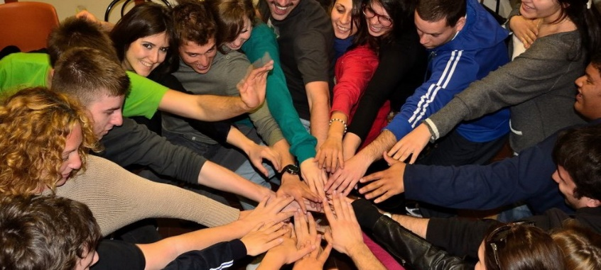
Project includes introduction of young people with advantages which volunteering provides in choosing a career and finding a job. Project will show to young people how volunteering can help them to choose and find a job. Furthermore, we want to show them that through volunteering they can gain some skills and knowledge which will make them more desirable to potential employers and more concurrent on a work market. It is desirable that young people are introduced with a fact how they can use competences gained through education before its ending. Through volunteering they will be introduced with possibilities which their education puts before them, simultaneously expanding that possibilities with new skills and knowledge.
One of the goals of the project is to show how volunteering is not the waste of time, but investing in a future. Project goals, which are in accordance with a statute of our organization are laid down in accordance with recent trends of growing unemployment of people younger than 25 years of age. We want to show how volunteering is not a waste of time which has no advantages and contribute to perception of volunteering as an instrument for gaining new knowledge and competences and investment in future. Inspired by that our organization came up with idea of a project which would as much as is possible contribute to more positive perception of volunteering.
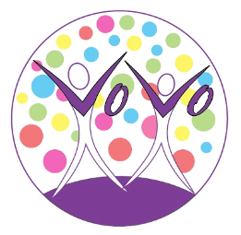
Accommodation, living and other project / exchange related expenses: 100% funded by the EU. This includes everything except for travel costs.
Travel (flights, other means of transport) expenses are compensated (up to 100%), based on the distance from your location of residence to the location of the project. These distances must be calculated using the distance calculator supported by the European Commission.
Partner Profile:
- non-profit organizations from the Program Countries (Member states of the EU
- works with young people
- able to send 5 participants one team leader (6 participants total) that fit the profile bellow
- gendered balanced group
Participants:
- in decision making positions, project manager, director of organizations, EVS
coordinator, youth worker, trainer or other position in an NGO that requires good
communication skills
- open-minded
- open to new challenges
- able and willing to actively participated in all the planned activities
- medium - high level of English
Working language: English
Procedure to apply:
- fill the PARTNER ORGANISATION FORM with the PIC number and all the fields required than we will send you Mandate letter
- fill the MANDATE of the project if you are interested in being a partner, sign, stamp, scan and send it to us by e-mail. It MUST BE SIGNED by the LEGAL REPRESENTATIVE

- Send your application and documents to udruga.vovo@gmail.com with the Subject of the
email: Volunteering as an opportunity bridge - Application
Contact person:
Luka Mardešić, General Secretary at VoVo; udruga.vovo@gmail.com;
Tel: +385958456699 (Whatsapp, Viber);
web: www.vovo.hr
fb: www.fb.com/NGO.vovo

