Services

Mission and Objectives of Activity
1) National Centre for Community Services is an independent institution, non-political, that has as its basic mission to help in addressing the needs of different communities in Albania through:
a) The development of researches and scientific analyzes and stimulation of information exchange and technical-professional points of view for thematic, issues, problems and politics that affect communities;
b) Offering of community services and promotion of conditions and standards for social welfare increase and living and health culture of communities in need.;
c) Civil community education and increase of communities organizational-political culture and awareness, promoting their active participation in public politic compilation, program implementation and addressing of issues with community interests;
d) Support of projects and community self-help initiatives and insurance of financial sources for helping communities in poverty relief and emergency situations.
2) The activities areas of the Centre are mainly as below, but are not limited within them:
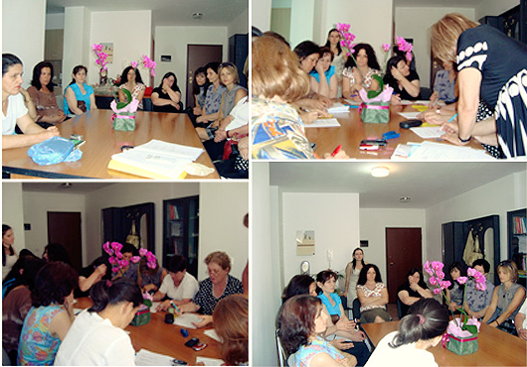
a) Public Health
b) Scientific and social-political researches
c) Civil and Community Education
d) Social and Technical Services
e) Organizational -Institutional Capacity Building
f) Environment Protection and Alternative Energy Utilization
g) Humanitarian Aids
The Incomes
The incomes for Centre activity in order to fulfill the aim and object of activity will be providing from:
* Funds provided by the Centre;
* Different Grants;
* Gifts or donations offered by private or public subjects, national or foreign;
* Incomes from the economical activity of Centre;
* In any other legal way.

