We are looking forward to working with you to promote tourism and the engagement of young women and men in sports and culture for peaceful world
AIMS
To share different historic experiences among different countries how did they overcome their ethnic conflict and how did the developed sustainable peace.
To promote tourism, sports, modern cultural and social values among participating countries.
To exchange culture, idea, thoughts and experiences between various countries.
To socialize participating students and to create collaborative bridges on the future.
for Learning to Live Together
for Health Education
for Building Peace Programmes
The Organization promotes good policies and practice in the education sector, helps partners create safe learning environments, and promotes life skills-based instruction through modern, interactive teaching methods our tools is using social media for change for creating video , e books, photo for promote our program for change the world for peaceful world
1- the first program is
We want to organize diving sports courses for youth from the EUROPE in Egypt sharm elshiekh from 25 TO 30 SEPTEMBER
AGE FROM : 18 TO 45 YEARS OLD-
COUNTRIES : EURO MED -
- NUMBERS FROM : 50 TO 100 PERSONS

FOR FULL BORD WITH MEALS AND TRIPE FOR RED SEA-
- TYPE OF CAMERA : DOUBLE CAMERA FOR ALL AND SINGLE CAMERA FOR ORGANIZER
6 NIGHT – 7 DAYS-
DATE FROM : 25 TO 30 SEPTEMBER
THIS EVENT WILL ORGANIZE WITH SUPPORT OF ORGANIZATION FROM EUROPE UNION

COORDINATOR FOR THIS EVENT
AHMED ABD EL MEGID
00201285781385
editorelibri@yahoo.com

6 Reasons makes Diving is Good for our Health

Diving is a very enjoyable and relaxing sport, but did you know that it is truly good for your health…mind, body and soul? Here are 6 key factors that show why this is true:
Diving and Physical Fitness

1. Physical Fitness
There are many reasons why Scuba Diving increases our overall Physical Fitness. Scuba diving on a regular basis steadily improves and maintains your general fitness and stamina levels. Exercising in water is very effective due to the natural resistance water has against our bodies especially when we kick our legs to fin and propel ourselves in the water. It has been shown that scuba diving for an hour can burn as many as 500 calories, making it just as beneficial in terms of calorie burn as working out for an hour on a cardiovascular machine in the gym.
Because divers have to be able to support the weight of their scuba gear when moving on land, they are constantly building muscle tone in their legs and back. Increased muscle tone helps in relieving tension and improves ailments such as backache because, by strengthening the back muscles, pressure is reduced in the spine.

2. Meditative Breathing
Slow, deep breathing is important in scuba diving to optimize air consumption and bottom time. An added bonus is that deep, steady breathing promotes a calm attitude and reduces the risk of a lung-expansion injury.
Similar to breathing during meditation, breathing slowly and deeply while diving induces a calm, relaxed state while the diver focuses on the underwater environment rather than thinking about problems they may be experiencing in daily life. This helps to reduce stress and balance the nervous system. A relaxed, calm state of mind has been proven to promote a positive attitude and prevent depression.
Deep breathing also means increased oxygen intake and this has numerous benefits too. Increased oxygen levels in the body raises energy levels, stimulates circulation, benefits heart and lung function and improves mental capacities. When there is sufficient oxygen in the body the need for intoxicants and stimulants diminishes.
Tropical Island Destination

3. Warm Water Adventures
Taking a vacation and getting away from daily stresses will improve one’s mental health. In addition, the majority of divers when planning a diving vacation choose warm, tropical climates where they are exposed to more sunlight than usual. One of the most important benefits of sunlight is that it supplies the body with Vitamin D which has many health benefits including increased absorption of calcium which strengthens bones. It also increases endorphin production in the brain which makes us “feel good.”

Diving in another country brings other benefits too. They say that travel is the best form of education and most people relish in the experience of visiting new places, experiencing a different culture, and all the new sights and smells and tastes that go with it. Dive travel abroad also means you are likely to meet fun people from all over the world with whom you have a common interest. Have you ever noticed how people tend to be happier and friendlier in a warm climate?

4. Healing Effects of Water
Often times people are submersed in water to calm down or to be healed. Water has a way of making us feel healed and restored. For example, watching fish in an aquarium has a relaxing affect on the mind. Compare that to actually being in that underwater environment and those calming effects are intensified. This is one of the reasons divers keep going back for more. They find it a great way to unwind, relax and forget about all the stresses of daily modern life.

When divers are underwater, they are at the mercy of the ocean currents and surges. The very act of surrendering to this force instantly calms the body and allows it to flow just as the marine life does so naturally. Rather than fighting against the natural flow, this act of surrender induces a calmness and feeling of being at home in the underwater environment.

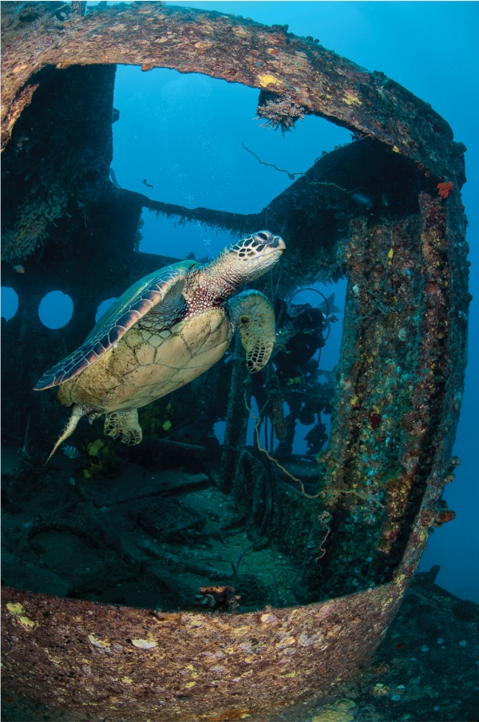
Marine Life Encounters

5. Marine Life Encounters
Connecting with marine life takes the health benefits of diving to a whole new level. Just as pet owners feel good when they interact with their household pets, interacting with marine life creates a connection that most divers will never forget. The pure pleasure, wonder and awe of interacting with and being up close to amazing marine creatures produces a feeling of increased well-being. This feeling is heightened when we have an encounter with a species we feel a certain attraction to, or particular respect for, such as sharks or sea turtles.

Marine life encounters increase one’s awareness of the environment and how critical the health of the ocean is. Millions of life forms depend on clean, healthy oceans, and marine life interaction deepens the conviction for divers to make a difference in their daily lives to benefit the oceans.

6. Social Health Benefits – The Buddy System
Scuba diving means you need to learn to be responsible for both yourself and your buddy and to look after your own safety. You will learn to stay calm at all times and that can help you during stressful situations in your every day life.

When you dive, you meet other like-minded people who often become good friends as you all share that common interest. It’s easy to make friends among divers as you will find a sense of community among them. It’s an exhilarating feeling to surface from a dive full of wonderful memories of your experience and then to be able to talk about and share them with good companions who are just as excited as you are!

Notes

Selected participants are requested to pay a participation fee up …………………..
This fee it’s all inclusive, covering the accommodation, food & refreshment, seminars and workshops, necessary material, trips around the country and some entertaining activities.
As for travel cost, each attendant is in charge of his/her own travel expenses Notes

نريد تنظيم كورسات لتعليم الشباب من الاتحاد الاوروبى الغوص
اعمار الشباب : من 18 وحتى 45 عام
البلاد القادمون منها : بلاد الاتحاد الاوروبى والمتوسط
نريد عمل بيان اسعار لاقامة كاملة شاملة اسعار 3 وجبات والمأكولات بالاضافه الى رحلة بحرية
نوع الغرفة : غرف مزدوجة
غرفة سنجل للمنظم بالاضافة الى :
ميعاد الوصول من 25 وحتى 30 سبتمبر
و6 ايام 7 ليالى
هذا الحدث سوف يتم تنظيمة بالتعاون احدى منظمات الشباب الاوربية المدعومة من الاتحاد الاوروبى
منسق الحدث
احمد السيد ابراهيم عبد المجيد الشهير باحمد الشرقاوى
00201285781385
editorelibri@yahoo.com
Notes

Selected participants are requested to pay a participation fee up …………………..
This fee it’s all inclusive, covering the accommodation, food & refreshment, seminars and workshops, necessary material, trips around the country and some entertaining activities.
As for travel cost, each attendant is in charge of his/her own travel expenses

