**Call for Partners**

**Applicant: Hazissa – Institute for the Prevention of Sexualized Violence**

**Karmeliterplatz 2, 8010 Graz, AUSTRIA**

[office@hazissa.at](mailto:office@hazissa.at)

**Tel.: 0043 316 90370 160**

**Funding framework:** Youth in Action, Key Action 2, Cooperation for Innovation and the Exchange of Good Practices

**Deadline: 1st of October 2014, please reply by the 10th of September**

**Duration: 01.02.2015 – 31.01.2017**

**Project:** “European Flirt Experts”

**Number of partners:** 3

**Countries:** Program Countries

**Issue:** Prevention of sexualized infringements among adolescents, Sexual Health, Non-Violent and equal communication, Contact, Friendship, Relationship and Sexuality; “Flirting Strategies” of adolescents, Reflection of role models, Promotion of gender equality, Development of preventative projects in each participating country

**Target groups:** Adolescents from the minimum age of criminal responsibility to the age of majority (Austria: 14 to 18 years) and their peer-groups.

Multipliers of the partner-organizations

**Primary Objectives:** Prevention of sexualized assaults among adolescents, awareness raising

**European Flirt-Experts**

**Description**

Sensitization, imparting of knowledge & development of sex educative, preventive projects for adolescents:

Partner-organizations support adolescents to deal with their own sexual needs and the needs of their partners in a self-determined and socially accepted way.

Adolescents are sensitized to perceive boarders, tolerate differences and are informed about relevant legal regulations and contact points for help and support.

Sexuality is a human’s right: adolescents should learn to deal with their sexuality responsibly and self-determined and to respect the needs and borders of others.

European Flirt-Experts know about flirting, love and sexuality!

European Flirt-Experts show respect and don’t violate borders!

European Flirt-Experts know their own borders, demand respect and know where to get help and support if someone violates their borders.

European Flirt-Experts are also respectful in other countries, know about the legal regulations and accept individual differences!

**I am a European Flirt-Expert!**

* I know about the usual possibilities and ways how teenagers in other countries get to know each other.
* I know about the laws concerning sexuality and sexualized violence in my own country and in other countries.
* I don’t need to violate boarders!
* I don’t have to tolerate everything!
* I know where to get help and support if someone violates my borders!

**Groundwork**

Based on studies of Krahé (2011) and Fegert (2011) the project focuses on the issue of sexualized infringements among adolescent peers while dating each other or rather in relationships.

Strategies to get to know each other and interact consensually concerning relationships and sexuality should be developed together with adolescents.

According to Fegert (2011) an increasing sexualized brutalization and waywardness is focused in public but not sufficiently analyzed. Aggressive sexual behavior was seen as part of juvenile violence but not explored as sexualized violence among adolescents.

Through correct knowledge and sensitization for the issue adolescents are able to change their sexual behavior and implement new positive elements.

The sexual behavior of a person has a strong cultural foundation and shows the accepted gender stereotypes and behavioral expectations of the respective culture.

Because of this fact the project wants to generate good results and findings concerning the partner-countries to show differences and create a better understanding.

1. The right to sexual freedom.

2. The right to sexual autonomy, sexual integrity, and safety of the sexual body.

3. The right to sexual privacy.

4. The right to sexual equity.

5. The right to sexual pleasure.

6. The right to emotional sexual expression.

7. The right to sexually associate freely.

8. The right to make free and responsible reproductive choices.

9. The right to sexual information based upon scientific inquiry.

10. The right to comprehensive sexuality education.

11. The right to sexual health care.[1]

**Aims**

**Aim 1:** Collection of flirting-strategies and ways of adolescents to get to know each other. Sensitization for feelings and sexual needs. Sex education.

Survey on sexual health, physical self-determination and concernment of sexualized violence - as victim or offender.

**Aim 2:** Collection and modifying of relevant legal regulations and contact points which provide help and support concerning sexualized violence.

Sensitization for respect, personal and legal boundaries. Strategies and opportunities in case of sexualized infringements.

**Aim 3:** Development of projects concerning aim 1 and 2 in every participating country.

e.g. concerning aim 1: Films or cartoons about getting to know each other, flirting-tricks, what does respect and self-determination means in the respective country?

e.g. concerning aim 2: Creating a folder containing the most important legal regulations concerning sexualized violence / sexuality in the most important national languages and a list of regional contact points which offer help and support. Posters, folders, films, comics, etc. of the most important legal regulations.

**Aim 4: Homepage**

Modification and Presentation of the results:

* Flirt-Strategies of the different countries
* Legal regulations of the different countries
* Projects of the different countries
* Materials like films, cartoons, folders, posters etc.

**Aim 5:** **Conference and Presentation**

Public conference: international exchange and presentation of the projects and results.

**We look forward to your response and cooperation!**

**The Hazissa-Team**

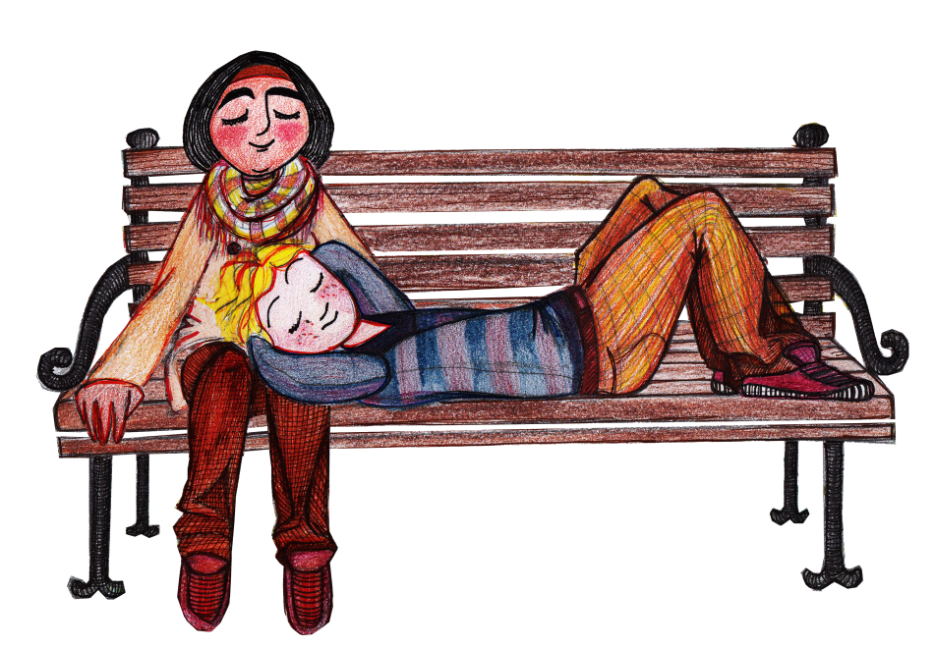

1. Declaration of sexual rights, Adopted in Hong Kong at the 14th World Congress of Sexology, August 26, 1999