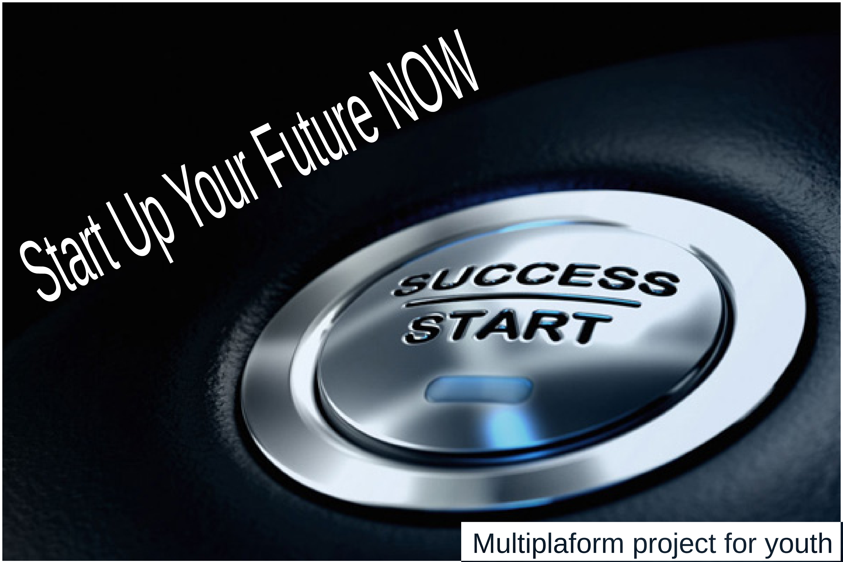
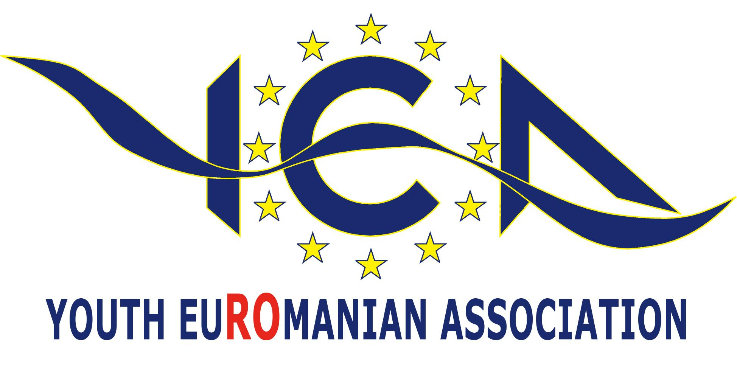

Start Up Your Future
- a multiplatform project for helping young people start their own business -

”You don't build a business - you build people - and then people build the business.” - Zig Ziglar

What's this?
Multiplatform = using both internet training portal and Erasmus + projects (seminars, mobilities and EVS) for creating trained & informed young business people.

Do I need this?
Imagine: what & how it will change in your life if you can learn how to start your own business, what to do start up in the right way and how to develop it to a stable & profitable business who can get you money every month for the rest of your life? Instead of working for others' dreams you'll learn to work for yours! Do you want this?

Who are the participants?
In first phase, this project is designed especially for 18-30 yo people from: Poland, Ukraine, Czech, Slovak, Hungary, Romania, Turkey, Bulgaria, Slovenia, Croatia.
In second phase older people from rest of EU may join.
Third phase, sky is the limit!

Where it will be?
In first phase, a series of youth projects (seminars & mobilities) will take place in some countries: Poland, Ukraine, Czech, Slovak, Hungary, Romania, Turkey, Bulgaria, Slovenia, Croatia. Selected participants and NGOs will be invited to join and to get basic info. Also, the multilingual platform will asist all start-ups to launch and develop in early stages.

How to join?
An application file will be provided for all interested people and NGOs from: Poland, Ukraine, Czech, Slovak, Hungary, Romania, Turkey, Bulgaria, Slovenia, Croatia. Selected participants will be invited to join.
All applications must be send to: startupyourfuture@mail.com ONLY!

When?
First mobilities projects are schedule to take part in July-August 2015.

How much it will cost?
Your investment will be up to 30% of international travel cost. Food, activities, local transport & accommodation will be provided free of charge.
A EUR 20-30 fee might occur in special cases only.
A certain amount of time for preparing for the activities in the projects will be needed.
Also, small amounts of traditional food & beverages and other promo materials might be needed for cultural nights.

StartUpYourFuture Team
- Ionel Florea -
Project coordinator

