

**WE ARE YOUTH IDEAS PROJECT GROUP. WE ARE UNIVERSITY STUDENT AT ESKISEHIR. WE HAVE GOT A LOT OF PROJECT IDEAS. WE PRODUCE YOUNG IDEAS.**

**WE TALK TO PEOPLE FROM AROUND THE WORLD.BECAUSE IDEAS ARE IMPORTANT TO MY GROUP. WE DO VOLUNTEER TO PROJECT.**

**WE ARE WORKIG THAT ISSUES.**

**\*YOUTH ** ENTREPRENEURSHİP * VOLUNTEER * TIE * FREEDOM * EUROPEAN UNION * AND MANY MORE TOPICS.**

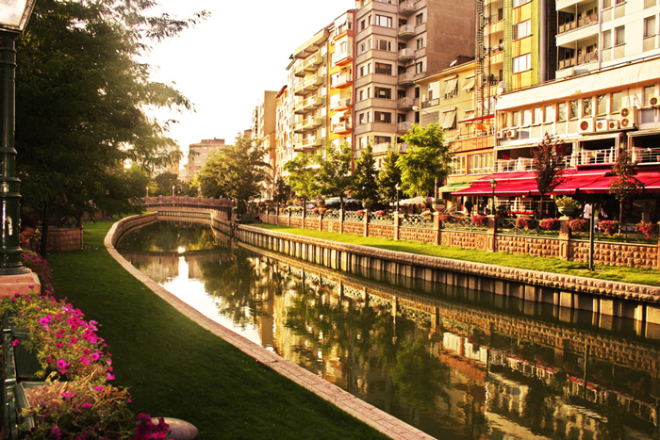

**This photos my country “ESKİŞEHİR” . Maybe one day you will come this city.**

**If you want work together you can send me message. I will write for you.**

**If you have got a questıon you can write.**

**I think you must fast . Because this day is finishing. We have got a slogan. “RUN OF TODAY”**

**YOUTH IDEAS PROJECT COORDINATOR**

**AHMET MUHAMMED UZAR**

[**ahmetuzar.ogu@gmail.com**](mailto:ahmetuzar.ogu@gmail.com)

**+905443004939**