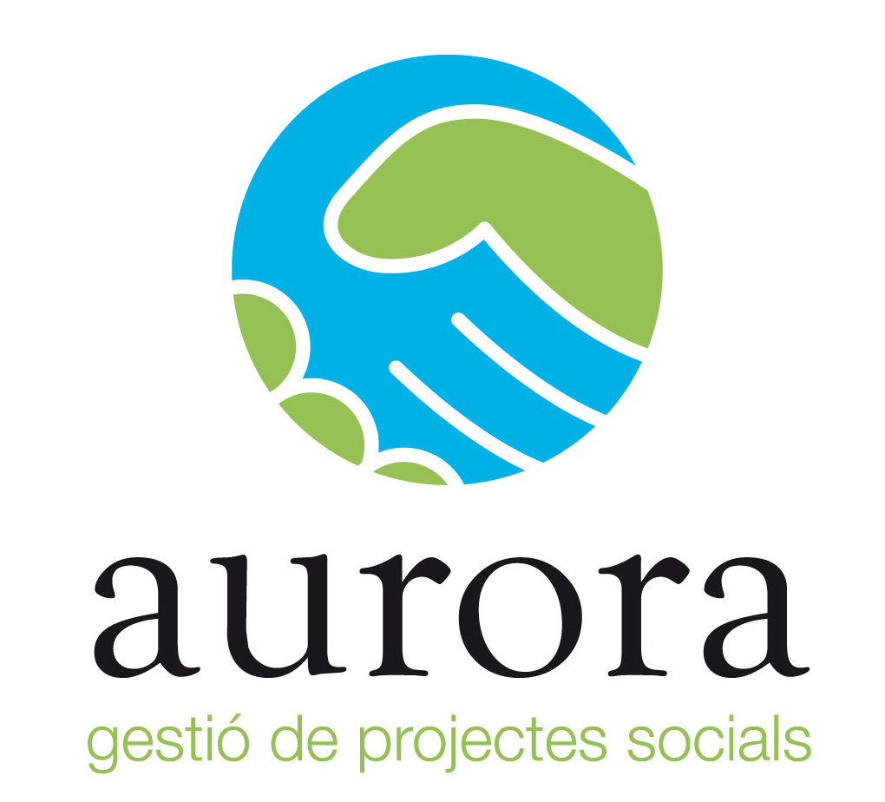


2theINCLUSION

Type of the Project: European Voluntary Service
Coordinating organisation: AURORA - creation and management of innovative social projects www.projecteaurora.com
Hosting organisation: Asociation Sant Tomàs
Where? Vic - CATALUNYA
Language of the region: CATALAN
Date starting: September 2014

2theINCLUSION: introduction
St. TOMÀS and AURORA Association - Social Project Management have joined forces to develop the 2theINCLUSION project, with the main objective of improving the quality of life of people with intellectual disabilities and their families in the Osona, while we provide European youth the opportunity to enjoy professional experiences abroad .
2theINCLUSION! wants to be an innovative project that will enable the Association to incorporate St.Tomás its workforce young people from different European countries within their services and projects , with the following objectives :
1 - . Improve the quality of life of people with intellectual disabilities and their families in the Osona
2 - Fight against school failure and youth unemployment through innovative volunteer projects.
3 - . Promote European public awareness of the issue of intellectual disability and community solidarity, and promote prevention and research in this area.
4 - Support to affected families and provide parents, relatives and guardians with information, training and appropriate advice.
5 - Promote the exchange of best practices among Technicians Association and volunteers, improving teamwork skills in a multicultural environment .
6. - Networking between member organizations and openness to the implementation of European projects in the new ERASMUS Programme +
2theINCLUSION: activities
A) Riudeperes CENTER (1 vacancy)
Service residential care and day-care service, both for people with intellectual disabilities who require widespread support and that can present health problems and / or mental health added.
- Features: Comprehensive care (personal hygiene, dressing, feeding , medication administration , transfers of units , ...) and support to improve their functioning and quality of life.

B) OCCUPATIONAL CENTER (1 vacancy)
It is an establishment in the field of social services intended for the care of people with intellectual disabilities in working age Osona. It is the alternative to the employment of adults with intellectual disabilities who do not have a sufficient level of habits and access to employment skills.
- Functions: Assist and support the needs of therapeutic occupation and personal and social adjustment, to improve the performance of the wearer.
C) TAC OSONA GARDENING SERVICE AND HORTICULTURE (1 vacancy)
The Special Tac Osona Job Center is a social enterprise where most of its workers are people with intellectual disabilities, but also with other types of disabilities.
- Functions: gardening tasks, plus support staff with disabilities to their adaptability.

2theINCLUSION: methodology
1.- Introducing volunteer in the basic day-to- day operation of the methodology and of the particularities of the St.Tomás Association. Conferences were held in order to achieve the necessary skills to get started in the year of volunteering in the sector of persons with intellectual disabilities in addition to knowing and knowing what is volunteering within the sector of persons with DID , reflect on the meaning of voluntary action and create networking among volunteers Sant Tomás .
2.- Monitoring and gradual knowledge and technical services of the Association.
3.- Progressive involvement of volunteers in other activities and actions of the Association in accordance with their specific motivations and training (includes creating and managing their own individual or group projects).
Moreover, we also facilitate positive professional experiences to young Europeans to a reference entity within the social economy and combating exclusion. The project also aims to improve personal skills of young volunteers and increase the chances of entering the labor market ended on volunteering.

2theINCLUSION: volunteering
We will need very motivated volunteers, open, flexible and with lots of ideas to improve and develop new projects mind. We want our volunteers are willing to work efficiently and put effort into their occupation. His primary motivation should be to contribute to the welfare of society and serve the community. Moreover, taking into account the characteristics of the project, should be especially sensitive to people with intellectual disabilities.

2theINCLUSION, you are interested?
If you are interested to take part in the project please send partner Info and mandate till
20th April 2014
AURORA
Gestió de Projectes Socials
+34 630098592
CIF: G65862260
evsaurora@gmail.com
C/ Narcís de Monturiol, 31 Pol. Ind. Mas Galí
Gurb 08503 (Barcelona)
(SPAIN)
http://projecteaurora.wordpress.com

