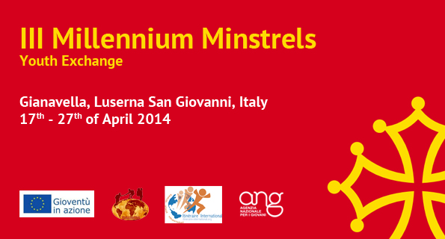
Application Form

*before you fill in the application form
make sure you have fully read the infoletter
Country
First name
Last name
Name you want to be called in the exchange
Date of Birth
Your age at the start of the exchange
Sex
Address
City
Zip code
Your mobile number:
E-mail:
Contact person in case of emergency:
- Full Name
- Address
- Phone numbers
- Relationship to you
Level of English: (bad, medium, good, excellent)
What are your hobbies, passions and skills?
What is your formal education until now?
Do you have any previous international experience?
If yes, please describe.
What is your current occupation? Work/ study/ internship/ unemployed or anything else:
What is your knowledge of Occitan culture?
What is your motivation to participate in this exchange?
What can you contribute in the program of the exchange?
Are you taking any medicine? Do you have any kind of physical limitation?
Allergies and special diet:
Other remarks, questions or something that you want to share
If you want to participate in the exchange, send the filled in application form to the contact person of your country:
France – Marta: sc-mp3@itineraire-international.org
Italy – Beppe: infoyouthprojects@gmail.com
Make the email subject: Application Form “III Millennium Minstrels”
You will receive a confirmation letter with further information if your participation to this exchange is approved.

