" Learn, act, grow - developing competencies of youth workers”
The TC is designed for those participants who are focused on developing their competences to strengthen effectiveness of their work with youth. We will use a variety of working methods based on:
- non-formal learning, coaching,
- dynamic exercises, role plays,
- games, brainstorming, simulations,
- case studies based on a creativity.
Our aim is - inspire participants to enhance skills related to:
- intercultural dialogue,
- creative entrepreneurship,
- social project for youth,
- situation on modern labor market,
- empowering of active civic life.
As host organization Stowarzyszenie Edukacji Nieformalnej Kulturatka will provide this opportunity for 8 days TC for 40 youth workers, youth leaders, teachers, educators, project managers, social workers, actively involved in youth work.
Stowarzyszenie Edukacji Nieformalnej Kulturatka – The Association was founded in 2006 by young people interested in integration and culture. The association was established to facilitate access to culture for young people and those for whom access to culture can be difficult for financial reasons. Group consists of young, open-minded people who are very happy to contribute to this discussion on the similarities and differences among young people in modern Europe. Our usual activities is: promotion of cultural events, writing and publishing articles on the website, organizing competitions for young people at risk of social exclusion, participation in cultural events, working with young people, teaching young people how to promote culture, how to work with cultural institutions, meetings with youngsters and discussing various matters associated with young people.
The main topics of the TC:
•The development of partnerships by initiating cooperation between organizations.
•The development of intercultural dialogue, tolerance and understanding of cultural diversity.
•The exchange of good practices and experiences in the implementation of development projects aimed at tackling social exclusion.
•Competence development of youth workers in project management, with particular emphasis on projects for people at risk of social exclusion.
•Tools and methods for effective work with young people at risk of social exclusion
•Increase knowledge of the situation on the European labor market.
•Methods for the development of entrepreneurship and creativity of young people in an international environment.
- Partners – 8 partners - We're looking for 1 more partner from Germany who will send 3 participants (1 W, 3 M)
- Deadline for this partner request: 18.01.2015
- Period of TC: 18-25.03.2015 (8 days of TC)
- Place Kraków, Poland
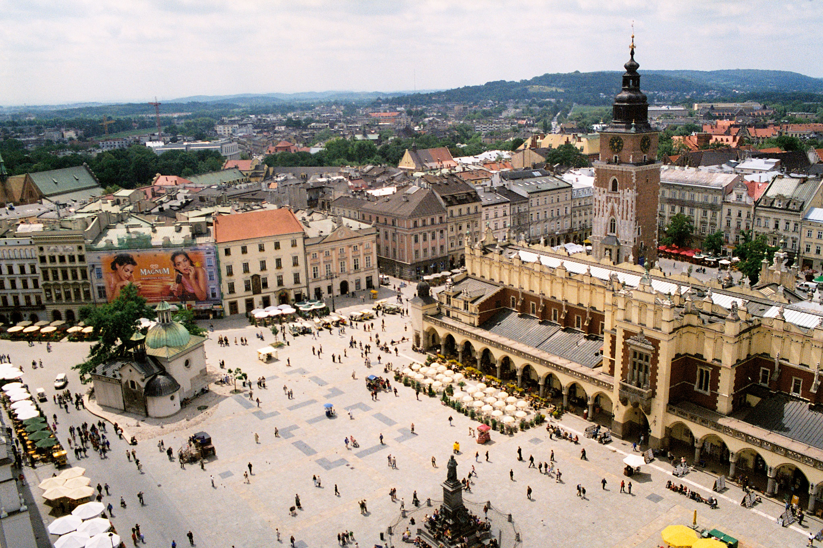
Invitation to KRAKÓW – POLAND

