“Scola Nostra” Association

Săcueni- Bihor- Romania

”Petőfi Sándor” High school

Săcueni is a small town located in
BihorCounty, Western Transilvania, Romania, in the proximity of the Hungarian border. The first written
record of the town's name dates back to
year 1217.

According to the census from 2011, there were 10,940 people
living within the city. Of this population, 77.23% are Hungarians,
14.97% are Roma(Gypsy), 7.63% are Romanians and 0.17% others.
The Association was founded in 2004, having in mind and heart
the desire to do something more for the community, to be involved in local, national and international events, activities and programs. We know that big changes start with a first step, so this is what we are trying to do through all the activities that we are organizing or taking part in.
Nowadays we count on the involvement and work of volunteers,
pupils and teachers from “Petőfi Sándor” High school. The financial
support comes from donations, dues, and 2% of the entire salary amount of
the teaching staff.

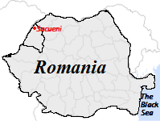


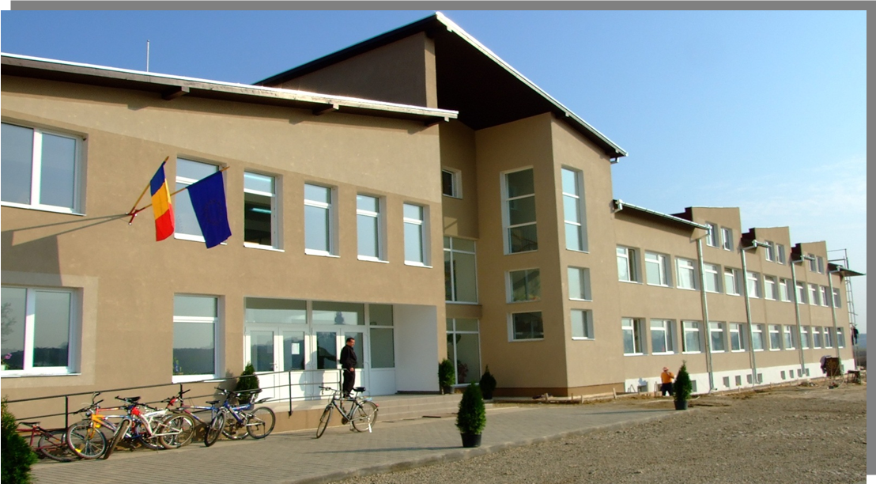

”Scola Nostra” Association

Postal address: Dunării Street, no. 57,
Săcueni, 417435
Bihor- Romania
Contact Information:
Contact person:
Mr. Pap József – President of the Association
Phone: +40 741 083038

Fax: +40 259 35 25 39

Ms. Egeresi Ingrid – Project manager
Phone: +40 741 139129
E-mail: kovingand@yahoo.com

The objectives of our association are:
- Organizing and supporting cultural, scientific, art and sport events
- Organizing ecological and environmental protection activities
- Material and moral support for youngsters and teachers of Săcueni
- Social inclusion of disadvantage children
- Ensuring the continuous training of the teachers
- - Stimulating the gifted youngsters of Săcueni

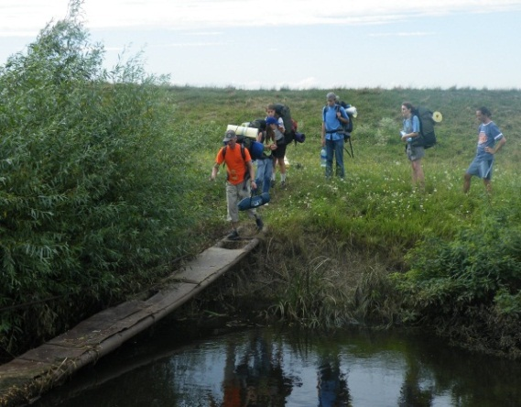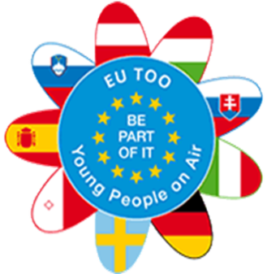
GEOCACHING Summer Camp
-every summer, pupils and teachers spend one week having trips for developing orientation skills and team work.

PHARE Projects
. the project regarding the Access to education of poor people, mainly gypsies, had a great impact in our area. We focused on basic functional literacy courses and general adult education courses.
- The PHARE Project gave us the chance of establishing tolerance, cultural pluralism and a multi-cultural social approach towards the Roma people.

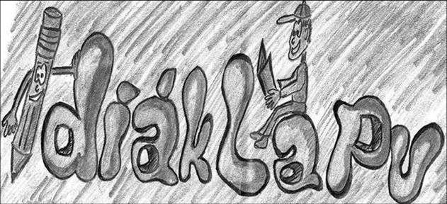
Diaklapu- a school paper, through which young people are weekly informed about interesting topics, current projects and the way they could get involved in different following activities.

“Petofi Sandor” School days, when there are programs designed especially for young people and different activities are organized to stir up people’s interest on different issues, such as sport, environment problems, community and so on.

Be part of it!
February 2008-December 2009, Vienna and Venice,
Youth in action project 100% financed by the E.U.
The project aims were to create a network of young people, youth organizations and public actors working with youngsters which should debate and make concrete proposals tackling social issues at local and European level.
Young people from 10 different EU countries shared their ideas and suggestions about their own future, future perspectives on the main social and cultural topics. They have made researches,
interviews and questionnaires on three social topics:
addiction, migration and environmental risks.

Activities and events
in which the members of the organization participate

“Protecting our environment project”
PRO NATURA VĂII IERULUI
One year project sponsored by The Romanian Ministry of Environment and Forests. We had people involved in this project by organizing contests, cleaning public areas or organizing trips. The aim of this project was to get involved more and more pupils, to teach them about the importance of taking care of the nature and of the surrounding area.

School Marathon- a program for an entire day, when there are interesting lessons, when pupils ask questions from teachers, we have outdoor activities, cooking and sport competitions.

Sport Inclusion June – October 2010, Toscana, Adult training.
Knowing Identities September 2010, Kayseri, Turkey, seminar and conference.
Creative Methods March 2010, Vienna, Training workshop for adults.

Other international collaborations:

Summer camps
-every summer there are camps in foreign countries (Germany and Belgium ) supported by the guest families and by the organization. Usually, the most talented pupils may visit one of these countries and may stay for a whole week at a family.

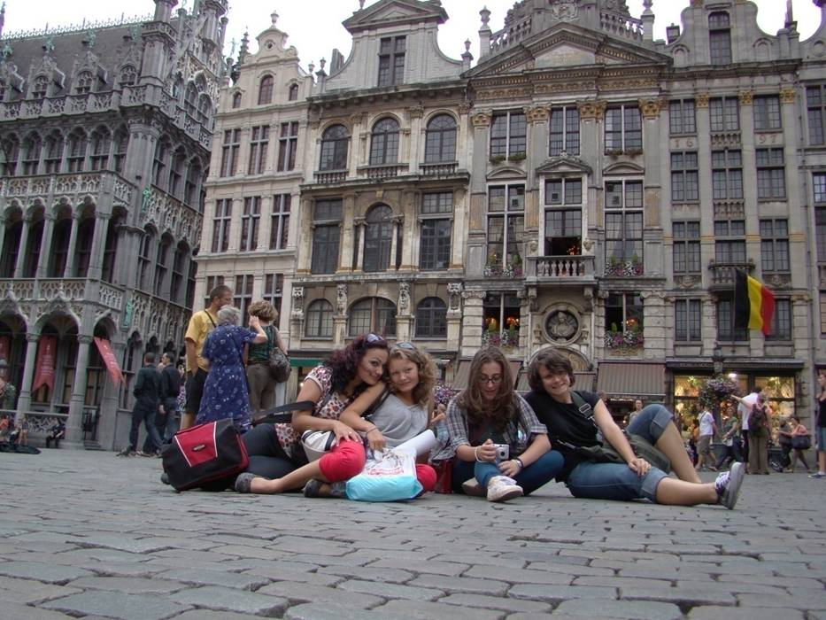
Borderless Bihar
-our school is in collaboration with a school in Hungary, so there are activities and programs organized for pupils in order for the pupils to get to know each other’s tradition, culture, history and language.
EU-TOO “Young People On Air”
26 February 2009- 30 June 2010, Berlin and Venice,
Youth in Action, 100% financed by the E.U. 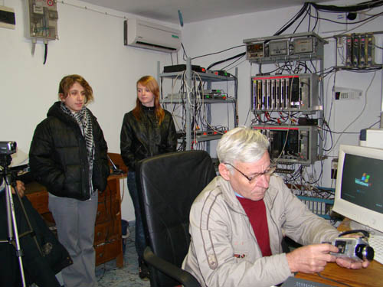

VESI-Volunteering in Europe and Social Inclusion
February-March 2011, Cremona and Genova
The project was organized by Courage Foundation, Bulgaria and UISP Linguria, Italy. The 6 partner volunteer organizations from 4 EU countries: Bulgaria, Romania, Estonia and Italy gather together to exchange best practices in social inclusion and open a debate on possible partnerships with stakeholders to expand the existing networks and foster wider participation through volunteering.
The aim of the project was to promote volunteering in social integration of vulnerable groups: children without families, handicapped people, people discriminated for their origin, religion or other reasons. 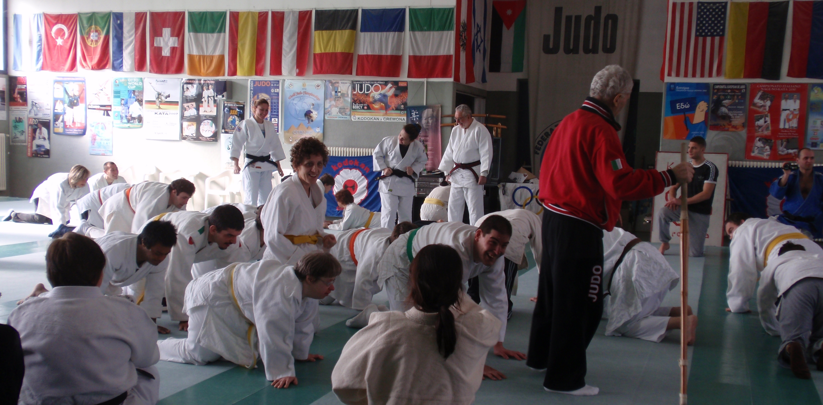

During this initiative, hundreds of young people from 10 different countries had the opportunity of discussing and sharing their ideas and proposals on relevant social topics like emigration, addiction, environment risks and human rights.
It involved press conferences and DVD shooting, which were later analyzed and discussed during a conference in Venice, Italy.

International projects along the years, with the help of the European Union

