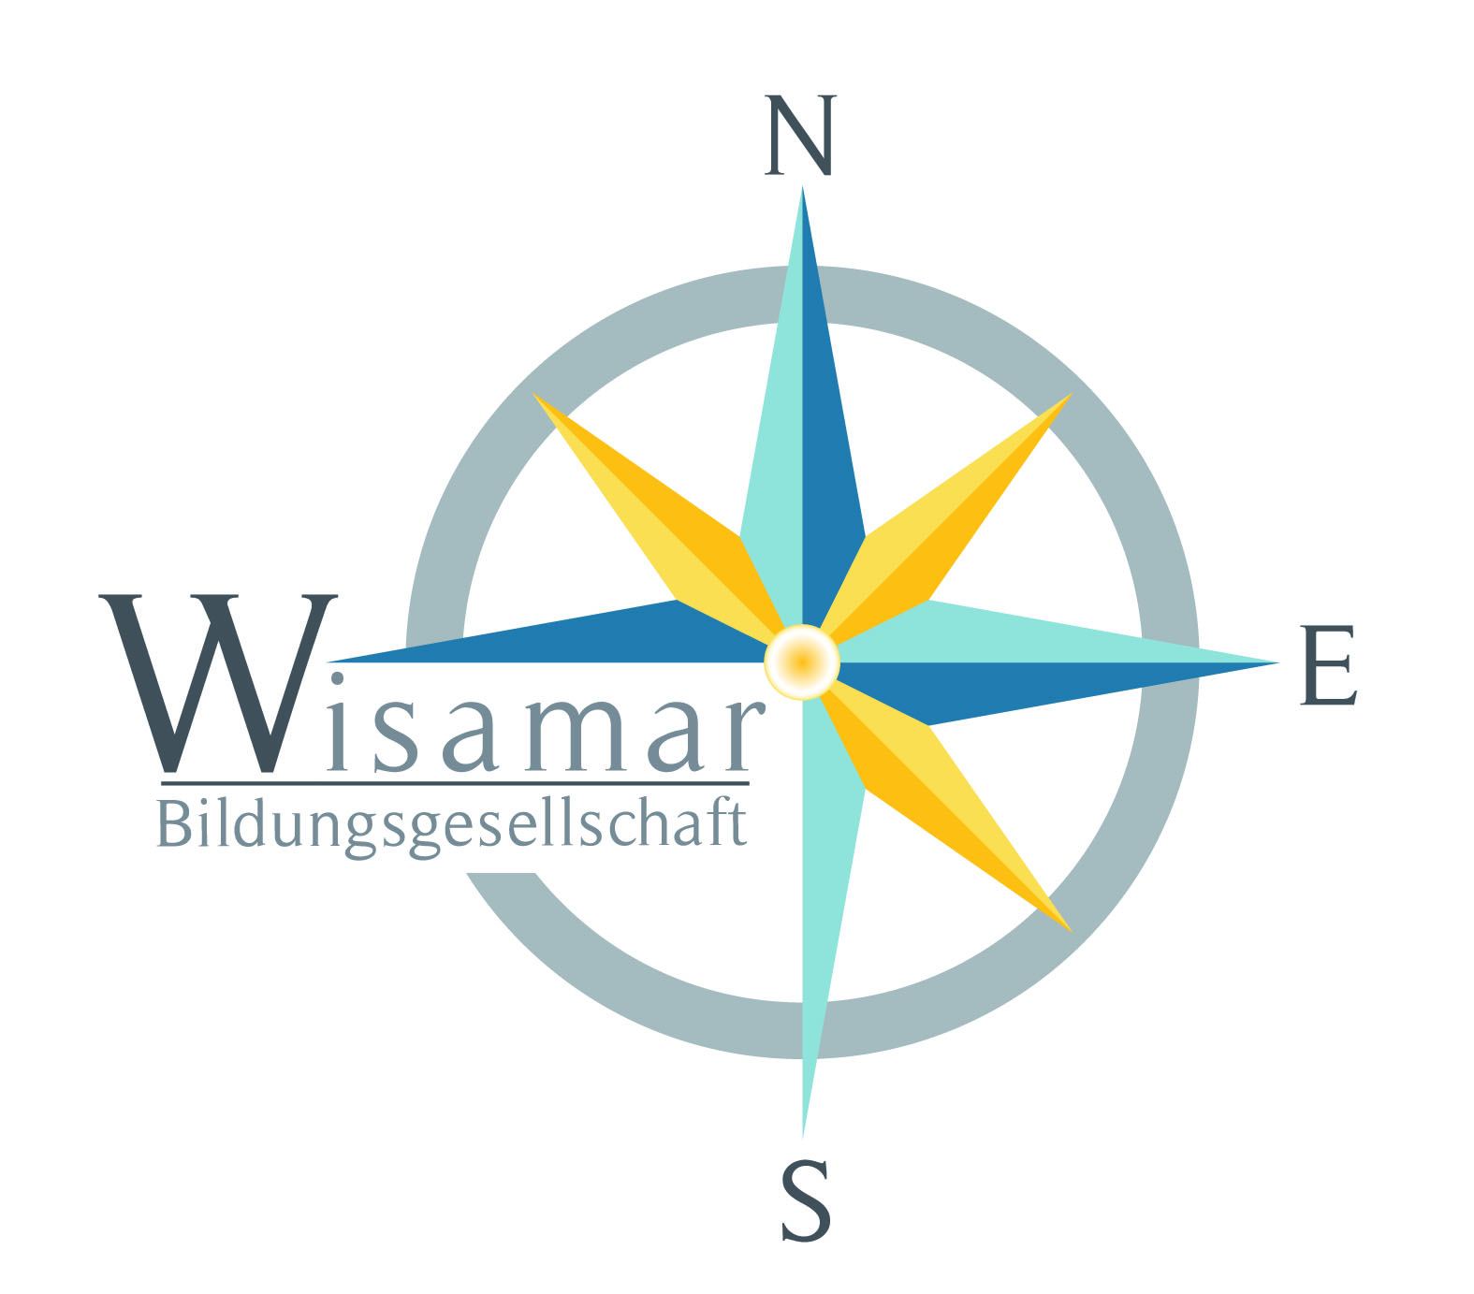

A European story

*A Youth-in-Action-Project that encourages young people with learning difficulties from different countries to write their own story.*

You might easily feel powerless and left alone in Europe if you are a teenager struggling with learning difficulties. So what could be more farfetched than being a successful writer? This project wants to empower these young people by giving them the opportunity to prove themselves and create something big together. By using the latest technics in trans-medial storytelling, taught by professional storytellers and media-pedagogues, these youths will communicate their own ideas of Europe and write their own “European” story.

By focusing on trans-media storytelling we bypass the classic way of story-writing and the literal competences involved. Instead we focus more on oral and visual communication via pictures, video and audio, distributed via social media channels such as YouTube, Instagram and Facebook. The result will be a highly adaptive story, disseminated over many channels. The most important aspect though is its open structure, which allows readers to contribute and thus keep the story alive and viral.

However, the process of writing and creating the story is highly structured. Writing stories is a craft like any other – a craft that can be learned and thought. In other words: Writing follows clear rules and procedures like the *journey of the hero* – a template that is implemented in almost all Hollywood films. Provided with excellent moderation and storytelling-competences it is thus possible to include youths struggling from learning difficulties in the creative process and teach them the skills they need to write their own story.

The Project is written for partners in Germany, France, Spain, U.K, Greece and Romania. The reason for this selection is that we want to address a cross-section of European challenges in our story. The goal is for the youths to contemplate about the current problems in their country and then include their findings into the story. In correspondence with the motto: *write about what you know*. Thus the selection of the partners has direct influence onto the content of the story. Our goal is to reflect on some of the current problems in Europe. Those could be:

* youth-unemployment in Greece and Spain (European Financial Crisis)
* migration in Romania
* refugee-debate in Germany, France and Greece
* the widening gap between rich and poor in the U.K.

We want to emphasize that these are mere guidelines. We want to influence the creative writing process as *little as possible* and provide the youths with maximum freedom, so that they can voice their views, fears and doubts. *The youths should write their own story!*

In practice this means, that each partner has to acquire a certain number of participants (around 10 to 15) that fit the profile of “youths struggling from learning difficulties”. Cooperations with youth-clubs and/or schools for special needs seem to fit. In addition each group of participants has to be accompanied by a tutor, who will act as a mediator and mentor. The tasks of the tutor are:

* to accompany the group on mobilities
* to moderate between group and teacher and other groups
* to help with translation and speech-barriers
* to supervise the work aside from the workshops

The tutor is an important element in this equation. He or she needs to have a good relationship with their students to be able to communicate the goals and tasks. Knowledge in new media would be most welcome but is not essentially part of the requirements. All needed skills will be taught.

To realize the project we need partners who have the following competences:

* Coordination, evaluation, finance (Wisamar)
* Storytelling
* Moderation
* Media-technic (Video, Audio, Tools)
* Dissemination in social media
* Graphic/design

Our project supports the following KeyActions of the ERASMUS + guidelines:

* Key Action 1: Mobility of Individuals
* Key Action 2: Strategic Partnership and Knowledge Alliances

*“Strategic partnership aimed to develop initiatives addressing one or more fields of education training and youth and promote innovation, exchange and experience and know-how…”*

* Multilingualism

“*Multilingualism is one of the cornerstones of the European project and a powerful symbol of the EU’s aspiration to be united in diversity”*

* Equity and Inclusion

*“The Erasmus+ Program aims at promoting equity and inclusion by facilitation the access to learners with disadvantaged backgrounds and fewer opportunities compared with their peers”*

We would love to have you with us on this project and welcome your contribution to this draft.

Please contact us if you’re interested.

Best regards,

Your Wisamar Team