A training for teachers on how to promote gender equality
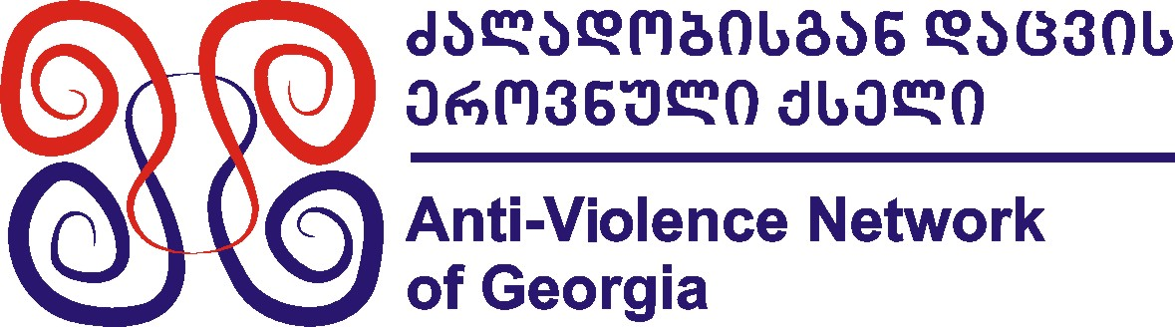
“Gender awareness through non-formal learning”
Georgia, July/August 2014

General idea:
The general idea of this training course is to bring together teachers from different European and Eastern European and Caucasian countries in order in to share realities on what is the situation regarding gender equality in different countries, develop common understanding on how the relationship among genders could be made more respectful among young people and what non-formal methodology could be applied to promote it.

Contents of this non-formal training:
- Developing awareness and understanding about various concepts related to gender issues, especially gender-based discrimination and violence
- Discovering realities when it comes to gender inequalities in different countries (especially in school environment)
- Discussing the “power” of teachers in the non-formal settings to promote gender equality
- Sharing and creation of tools to fight against gender-based discrimination and violence
- Empowering participants to become active promoters of gender equality

Participants:
24 teachers and education specialists from Eastern Partnership countries (Armenia, Azerbaijan, Georgia, Moldova, Ukraine and Belarus) and Programme Countries (27 EU countries, Latvia, Turkey, Norway, Lichtenstein, Croatia and Swissland) – 2-3 representatives from each country. Teachers should be working with students aged 13 to 20 years old.

Partner organizations for this training course could be schools or organizations that work with schools that are working with youth outside bigger towns and cities. There is no age limit of participants, but it is highly crucial that each teacher/education specialist participating in the seminar knows English at the level of being able to participate in discussions actively.

Financial conditions:
The training course will be implemented in the framework of EU “Youth in Action” Programme. The accommodation and food will be covered fully. Travel expenses will be reimbursed at 70% of the real cost (with cheapest mean of transportation) in return of original tickets/invoices. Insurance should be arranged and covered by each participant.

Application procedure:
If you are interested participate in this project, please send to us by e-mail salome090@yahoo.com the following documents LATEST by Tuesday, 20-th of August:

- Application form (below – in this document).
- “Preliminary agreement” (at the end of this document) – it should be signed, stamped and scanned.

Should you have any questions, please do not hesitate to contact us:
salome090@yahoo.com
+995 593 250202
Part A: IDENTIFICATION OF THE PROMOTER
Promoter
Role in the application
Promoter’s legal name (national language)
Promoter’s legal name (latin characters)
Acronym, if applicable
National ID number, if applicable
Department, if applicable
Legal address
Postal code
City
Country
Region
Web site
Email
Telephone
Fax
Person authorised to legally commit the promoter (legal respresentative)
Title
Family name
First name
Position
Email
Same address as the organisation
Telephone
Fax
Person responsible for the implementation of the action (contact person)
Title
Family name
First name
Position
Email
Same address as the organisation
Telephone
Fax
PART B. PROFILE OF THE PROMOTER
Status | Private (PR) |  |  |  | Public (PB)
Type | Non profit/non governmental organisation (NFP-NGO) |  |  |  | Informal group of young people (NFP- IGYP)
 | Body active at European level in the youth field (NFP-ENGYO)
Activity level | Local (L) Regional (R) National (N) European (E)  International (I)
Objectives and activities of the promoter
Please provide a short presentation of your organisation/group (usual activities, affiliations, etc.) in relation to the field covered by the project – what experience your organization has with working with schools/teachers and/or gender issues.
Please describe the role of your organisation/group in the project – how could you contribute
Motivation
Why is it important for your organization to participate in this project?
As participants of this training course will be teachers, please describe how do you plan to recruit them. them?
Travel cost
Please provide us with the travel cost from the place your organization is registered until Tbilisi and back (if you would be buying a ticket 10 days in advance the travel date...).
Please mention also the means of transportation (bus, train, plane...).
Other community funding
Please give information about any type of EU grant your organsiation/group has received/applied for in the last financial year.
Programme or initiative |  | Identification/contract number |  | Contracting promoter |  | Title of the project

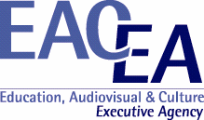 | 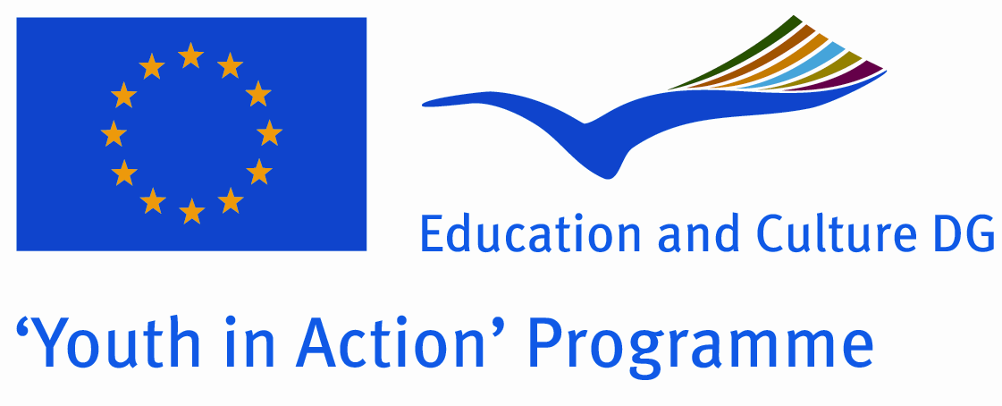

Preliminary agreement of the partner

- To be signed by the person authorised to enter into legally binding commitments on behalf of the partner

I, the undersigned confirm the participation of the organisation:

(Full name of the organisation as stated in Part A.1 of the application form)
for which I am acting as legal representative in each stage of the project entitled:
Gender awareness through non-formal learning
I declare having reached an agreement with all the promoters involved in the project with regard to the share of EU grant my organisation/group is entitled to receive in order to implement the project.
I confirm that my organisation/group has not applied for funding for this project to another National Agency or to the Executive Agency.
Furthermore, I confirm my undertaking to ensure visibility of the European Union support for the project and to ensure dissemination and exploitation of its results.
Partner organisation: |  |  | Stamp  (if available)
Legal representative:  (Mr/Ms Surname, First name) |  |  | Stamp  (if available)
Position/function in the organisation: |  | Signature
Date and place:

