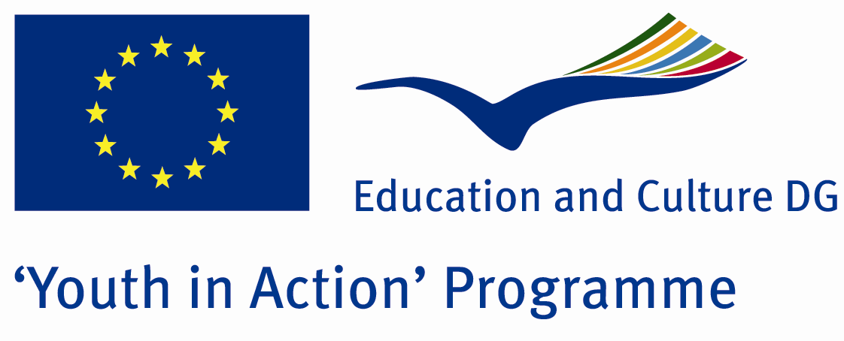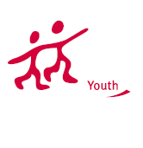

Music Colour
Bridges of Tradition

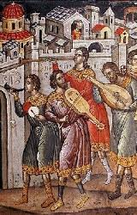

ACTION 1.1 – Youth Exchange

8-14th November , 2011

Thessaloniki, GREECE

ACTION 1.1 Youth Exchange

8-14th November , 2011

Thessaloniki, GREECE

Please contact directly to:
brailletheo@gmail.com

Project Summary:

Music can be considered as an international language. There are a lot of similarities between the traditional music of each country. In this Project, Μusic Colors Bridges of Tradition, which will take place in Thessaloniki from 8-11-2011 untill 13-11-2011 under the support in the frame of Youth in Action 1.1, 3 Organisatιons from 3 countries will collaborate: Greeve(Host), Cyprus and Spain. Each partner will present traditional music, hymns and traditional instruments from each country. There will be a discussion about the use of the traditional music scales, suck as Byzantine music chant, traditional songs, chords, music therapy and religious music.Additionaly, a variety of visits anf training activities of music schools and culural organisations will be included in the programme.
Εach group partner will choose, prepare, present and teach traditional music from its own music culture. Finally, we will present of our work in public and we will record a cd inclunding traditional carols and songs. This action will take place and is supported by St Panteleimon Parish of Kalamaria and the Music School of Thessaloniki.

Project Title: Music Colour Bridges of Tradition

Date and Venue: 8-14th November 2011 Thessaloniki, Greece.

Target Group: Municipalities, City Councils and Non-Governmental organizations,
youth groups,culture and art groups that have to do with traditional music

Participants: 5 people from each country (over 13 -25 ) and one leader for each group. Totally 4 countries.

Conditions: Accommodation, board and programme costs will be financed through European Commission Youth in Action Programme (Action 1.1). Travel costs will be reimbursed in 70%. Organizations from all 27 EU member countries plus Liechtenstein , Norway and Iceland are eligible to take part.

Working language: English

Organizer: Volunteer singers of St Panteleimon Kalamaria/ Youth Choir of St Panteleimon Church Kalamaria
How to apply

Step 1: If you are interested, please complete, and send your Part III form
to +30 2310330488 by FAX please.
In this address you can download the form:
https://sites.google.com/site/choragpant/volunteer-singers-of-st-panteleimon-kalamaria/PartIIIform.doc?attredirects=0&d=1

Note1: Don’t forget to sign and stamp the form
Note2: jpeg is not allowed, please send by fax and then by post

Step 2
Original send your form via regular post to this address please:

Fr Theodor Tsampatzidis
Drakopulu 40
Gr-55132 Kalamaria Thessaloniki
Greece

Step 3
Please send 1-2 music videos of your group to this email address:
brailletheo@gmail.com

Deadline for application: until 2 May 2011.

For Further information:
Contact Person
Fr Theodor Tsampatzidis
Drakopulu 40
Gr-55132 Kalamaria Thessaloniki
Greece

e-mail : brailletheo@gmail.com
Mobile : 0030 6940737564
Fax : 0030 2310330488
Choir Site :
https://sites.google.com/site/choragpant/volunteer-singers-of-st-panteleimon-kalamaria

