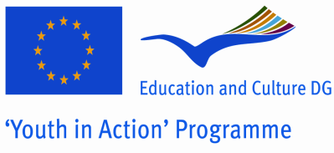

Preliminary agreement of the partner

- To be signed by the person authorised to enter into legally binding commitments on behalf of the partner

I, the undersigned confirm the participation of the organisation:

(Full name of the organisation as stated in Part A.1 of the application form)
for which I am acting as legal representative in each stage of the project entitled:
Youth Taking Role
(Project title as stated in the application form)
I declare having reached an agreement with all the promoters involved in the project with regard to the share of EU grant my organisation/group is entitled to receive in order to implement the project.
I confirm that my organisation/group has not applied for funding for this project to another National Agency or to the Executive Agency.
Furthermore, I confirm my undertaking to ensure visibility of the European Union support for the project and to ensure dissemination and exploitation of its results.
Partner organisation: |  |  | Stamp  (if available)
Legal representative:
(Mr/Ms Surname, First name)
Position/function in the organisation: |  | Signature
Date: (dd/mm/yyyy)

