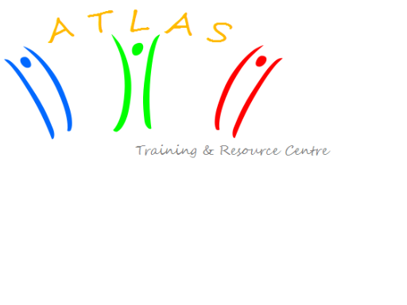


Call of partners

Youth in Action as a tool for supporting early school leavers. An international training course organised by the Junior Chamber – Jeune Chambre Economique Oltenia and Training &Resource Centre ATLAS

TC “Stick with the school!”

DATES AND VENUE
From 21 October (arrival day) to 27 October (departure day) 2013 - participants are requested to organise their travel, 70% of their tickets’ price will be reimbursed. The TC will be held in Romania, Sinaia.

BACKGROUND
Many countries are being confronted with young people who loose motivation for school and as a result are in risk of dropping out of education prematurely¹. This results often in prolonged difficulties well into adulthood and possible to social-economic challenges in later life. Schools often don´t have the time, staff, recourses or knowledge to deal with these youngsters. This training course would like to explore how youth work can support formal education on how to deal with young people in risk of leaving education early through a Non-formal education approach

AIM
The “Stick with the school!” course goal is to raise the potential of youth work to improve the chances of young people in their professional life.

The aim of this training course is to train youth workers, youth leaders, trainers and teachers in how to support young people at risk of leaving school early as well as young people who have already dropped out through nonformal education in their self-development

OBJECTIVES
- To reflect on the needs, challenges of early school leavers;
- to develop strategies that support early school leavers;
- Develop competences to train young people to acquire necessary life skills like communication, self-confidence, creativity, project management;
- to work on the recognition of the Non-formal;
- Sharing good practices;
- to use the youth in action programme as a tool in dealing with early school leavers;
- to reflect on how to motivate young people.

PROGRAMME ELEMENTS
- Managing self-development, coaching, mentoring
- Youth work approach on early school leavers: non-formal education, Youth in Action, Youthpass and their effect on youth employment
- Learning reflections on project practices from different European countries
- Youth in Action programme and project planning

The course is intended for young people (18+), youth workers and youth leaders who:
- Have experience of at least one year in youth field (as volunteers or professionals) and in developing projects with and for young people;
- Are committed to work directly with youth on the issues related to the training (youth employment);
- Have basic knowledge of the Youth in Action programme and interests in developing international projects;
- Are motivated to take active part in the training and are able to attend the course for its full duration;
- are residents in a member state of the EU, EFTA countries or EU candidate countries
- Are able to work in English.

APPROACH & METHODS
The learning process will be based on intrinsic motivation of the learner. The methods used will be learner-cantered and based on the experience of the participants. Participants have a big personal responsibility for learning, supported by a strong group dimension and collective approach.
The youth@work course should enable participants to apply and transfer what they have learned to their youth work, practice and social life. The course will take into account the needs and motivation of participants and be open to regular feedback and evaluations.
In the setting, the group process, the content and the methodology of the training activities, the focus is put on participation, active involvement, sharing of thoughts and feelings, learning by doing, group work and the intercultural dimension. Creativity & variety of the methods are important in our approach.
Main methodologies were learning by experiencing, intercultural communication, reflective approach and the educational approach. The intercultural setting is an overall educational approach during the training as working/living/leisure experience

TRAINERS TEAM
The trainers’ team is composed of 3 trainers (plus support staff).
Margus –T. Pihlakas, Finland
Tomasz Lubotzki Poland
Cora Sanda , Romania

POSSIBLE PARTNER COUNTRIES

Country | Nº Pax | Fee
UK | 3 | €50
Bulgaria | 3 | €30
Spain | 3 | €25
Romania | 3 | €25
Germany | 3 | €50
Sweden | 3 | €50
Estonia | 4 | €25
Finland | 3 | €50

WHAT DO YOU GET?
This project will apply for funding under the Youth in Action Programme. Thanks to this support participants will only pay the participation fee + 30% of the travel cost. All other expenses (70% of the travel, lodging, food and activities) are covered by the hosting organisation.
Participants

HOW TO APPLY?
Deadline for applications online is 15 April 2013.
*Note: The deadline for the part III agreement to be sent is 15 of April. Each NGO interested in being a partner of this project will fill the application that you find in the attachment of this e-mail and send it to coragabriela_fariseu@yahoo.com.

