Partner Search for EU Youth in Action
Youth Exchange or Youth Democracy Project
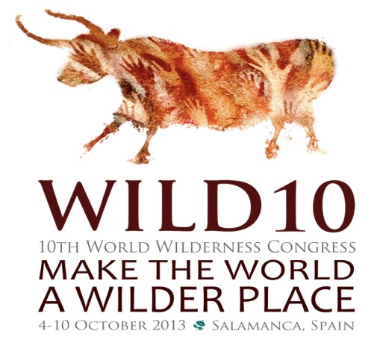
Project (working) title: Walking-2-Wild10
Background:
Every four years, a world wilderness congress is organized by the Wild Foundation. In October 2013, WILD10 will take place in Salamanca, Spain. At this event, there will be special components specifically for young professionals/adults (19-30 years old) called CoaltionWILD.
WE want to be there! - but to get there - we want to walk!
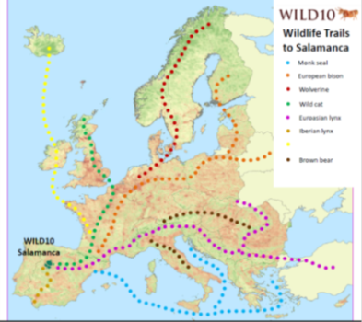
Project Concept:
This project would start one week before the conference begins (4.10), and the group would meet at a designated location in Spain, that is approximately a 7 day hike to Salamanca, and from there we will walk to the conference.
The walk will be designed as a “Mobile Training” – a mixture of hiking/walking each day mixed with personal development, deep nature connection, and team building activities as well as interactive workshops to prepare the participants for the WILD10 conference. Depending on the funding line (Youth Exchange or Democracy) we will need to focus the program based on the guidelines.
Interested? Deadline for submission of interest: March 22, 2013 (see last page)
Partners: We are looking for 5-8 partners from different member states of the European Union, but could also include program countries: Iceland, Liechtenstein, Norway, Switzerland, Croatia, and Turkey to apply with us on 1.05.2013.
Partner profiles: Partners who are interested in applying should be able to fulfill the majority of the following descriptors:
- Passion for adventure, outdoors, experiential learning, wilderness/nature protection, sustainability (i.e. creating a more fair and sustainable world).
- Experience working with non-formal, outdoor, nature, experiential, and/or environmental education methodology.
- Experience using deep ecology, nature-connection, and other related approaches.
- Can provide a “group leader” who is capable of facilitation, group dynamic activities and is first-aid certified during the walk and conference (ca. 2 weeks).
- Able to participate in planning calls, face-to-face planning meeting, and preparation tasks leading up to event.
- Able to recruit the designated number of young adults ages 19-30 (ca. 4-6 PAX) to participate in project.
- Spanish partner: Will need to be able to be our “on the ground” organizer – identifying route, camping/accommodations, food, etc. It may be advantageous that they serve as the applicant (TBD).
DRAFT! CONCEPT
NOTE: This will change based on the development of the proposal, the group, and the realities of being “in the field” (i.e. weather, trail conditions, etc.)
Walking-2-WILD10
Day 1 (27.09) | Day 2 (28.09) | Day 3 (29.09) | Day 4 (30.09) | Day 5 (1.10) | Day 6 (2.10) | Day 7 (3.10)
Arrive at starting point location* (in Spain) | - Pack up and begin walking | - Pack up and begin walking | - Pack up and begin walking  - (short day – relax) | - Pack up and begin walking | - Pack up and begin walking | - Pack up and begin walking
- Getting to know the group  - Program overview  - Safety talk/group norms | - My personal connection with wilderness/ nature | - Workshops/activities: Themes TBD | - Workshops/activities: Themes TBD | - Workshops/activities: Themes TBD | - Workshops/activities: Themes TBD | Arrive in Salamanca  Check-in  Relax
- Preparing for the walk: distributing group gear  - Route planning  - Stay at a hostel | Camping out, cooking, etc. | Camping out, cooking, etc. | Camping out, cooking, etc. | Camping out, cooking, etc. | Camping out, cooking, etc.  Final evening “on the trail” – preparing for reentry / arrival at conference

*Starting point: We may want to start at a location within this priority area: www.rewildingeurope.com/areas/western-iberia/conservation-setting

@ WILD10 - CoalitionWILD: 4.-10.10.2013
According to the WILD10 website (http://wild10.org/en/intergenerational/coalitionwild), the young professionals “Track” will consist of:
- Leadership and Professional Skills Training – Contribute to the professional and capacity development for young adult delegates. Provide training, tools, and information for each to become better leaders in their communities, in the conservation movement, and in WWC in the future.
- Mentor program: The mentor program will be designed to advance their knowledge of, and effectiveness in, their specific sectors of interest.
Walking-2-WILD10
APPLICATION for Interested Partners
In order to be considered as a partner (promoter) for this project application, we ask that you please answer the following questions, so that we can assemble the most capable and dynamic team! Applications/questions should be sent to nathan.spees@wwf.at by March 22, 2013.
Please feel free to use bullet points (K.I.S.S.!) in your answers.
Note: Applicable partners/promoters must fit within the guidelines of the Youth in Action programme (see page 16): http://ec.europa.eu/youth/youth-in-action-programme/programme-guide_en.htm

- Partner information

- Organization’s name:
- Address/country:
- Contact person (including contact information):
- Description of organization (short):
- Management capabilities:

- Partner background and motivation

- Your motivation to participate in this project:

- What you bring to the partnership:

- Experience in this field/with this topic:

- Access to/experience working with target group:

- Your creative vision for the project

- In a short text/bullets, please briefly describe how you could envision a component(s) of the Walking-2-WILD10 project (eg. a workshop, activity, daily ritual, reflection, etc.). Let your creativity run wild!

- Knowledge of area (specifically for Spanish partners)
- Please describe any special connections you have to the area around Salamanca (knowledge of trail system/natural areas, accommodations/camping areas, existing partners, etc.) that could be advantageous for the planning and organization process.

