Food Detectives – What Is Really Behind Your Meal?
Project idea
Food is part of our everyday lives, yet we rarely think about what happens before it reaches our plates. Where was it produced? Who was involved in making it? How far did it travel? How much water, energy and packaging were needed? Were the workers and animals treated fairly? And what happens to food that is never eaten?
Food Detectives would be a youth exchange focused on discovering the hidden environmental, social, economic and ethical impacts of our food choices. Participants would become “detectives” investigating the stories behind everyday products and exploring the wider food system—from farming and production to transportation, marketing, consumption and waste.
The project would not promote one “correct” diet or try to convince participants to become vegan, stop buying imported products or radically change their lifestyles. Food choices are influenced by many factors, including culture, family habits, health, availability and financial circumstances. Therefore, the project would create a non-judgmental environment where participants can explore different perspectives, question their assumptions and decide which changes are realistic for them.
The main idea is to help young people move from passive consumption towards more conscious decision-making. Instead of simply being told which products are “good” or “bad,” they would learn how to ask the right questions, find reliable information, understand labels and certifications, recognise greenwashing and evaluate the consequences of different choices.
Through non-formal education, international teamwork, discussions, simulations, research activities and practical challenges, participants would examine how their individual decisions are connected to wider global issues. These include climate change, food waste, animal welfare, unfair working conditions, child labour, the position of small farmers and the influence of large food companies.
At the same time, the project would avoid placing all responsibility on consumers. Participants would also explore the roles of producers, supermarkets, corporations, governments and the European Union in shaping the food system. This would help them understand that meaningful change requires both individual action and wider systemic solutions.
Venue: Viveiro, Spain
The youth exchange is proposed to take place in Viveiro, a coastal town in Galicia (northern Spain), with beaches, a historic old town and the surrounding Atlantic countryside as a backdrop for the project's activities.

Viveiro, Galicia (Spain) – coastline, harbour and old town
Topics
The programme will cover:
- the journey of food from farm to fork;
- food waste and practical ways to prevent it;
- sustainable agriculture and food production;
- animal welfare;
- the carbon and water footprints of food;
- local, seasonal and imported products;
- reading food labels and understanding certifications;
- greenwashing and misleading food marketing;
- conscious and responsible shopping;
- supporting local farmers and small producers;
- the influence of the EU on agriculture and food systems;
- GMOs and common misconceptions surrounding them;
- child labour and working conditions in global supply chains;
- the practices and influence of large food companies.
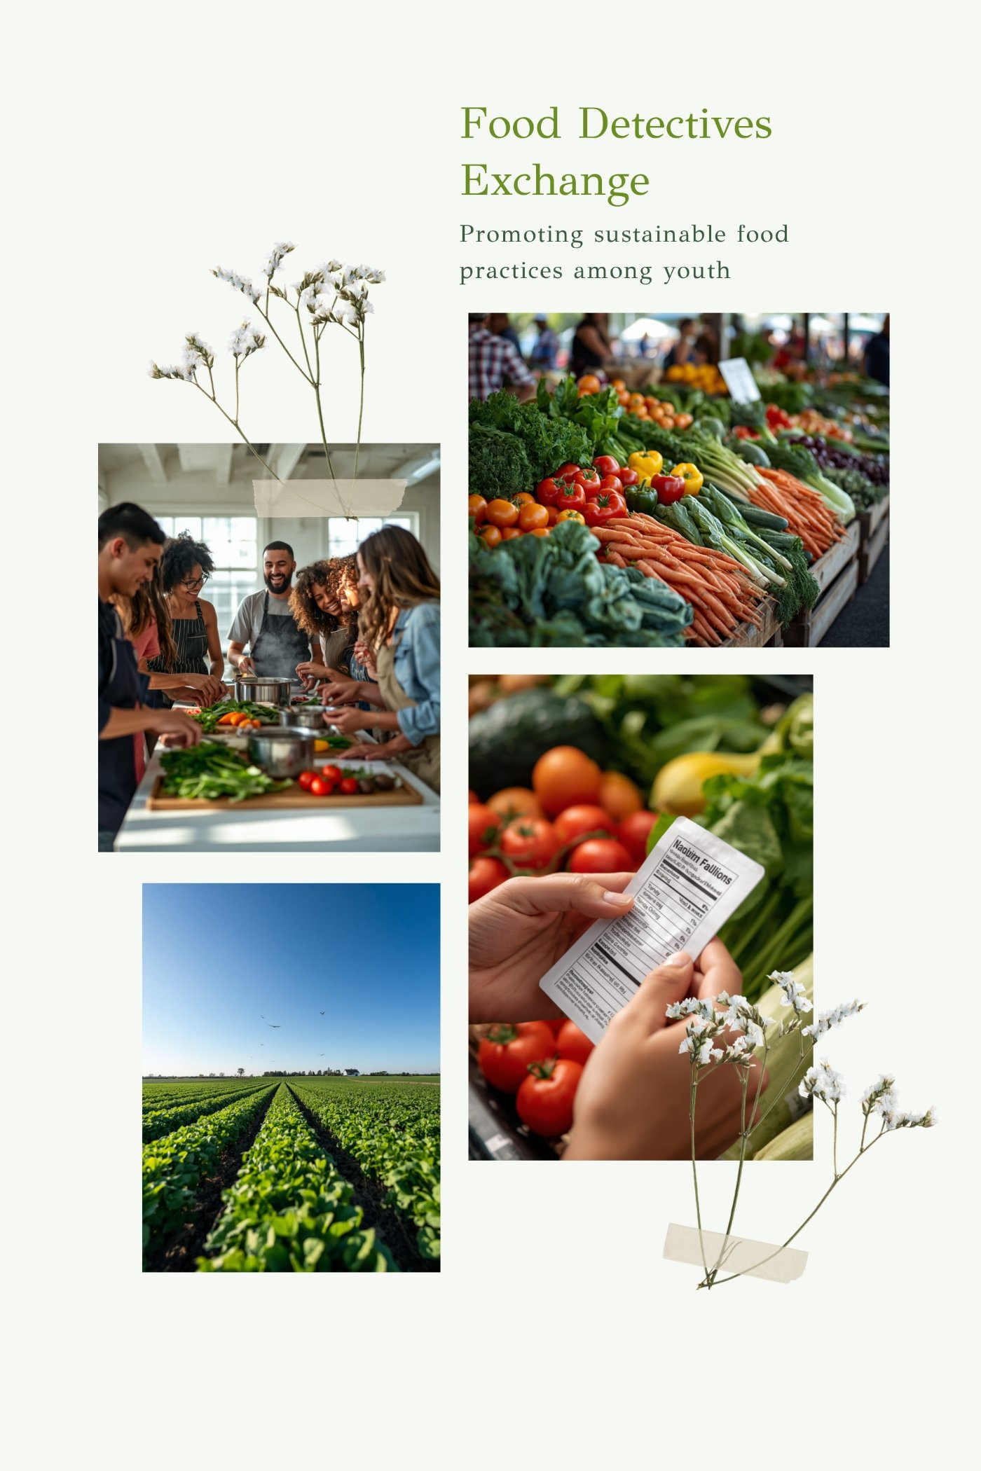
Food Detectives – local markets, cooking together, farming and reading labels

Practical element
An important part of the project would be connecting the discussions with real-life practice. Ideally, participants would visit a local farm, sustainable producer, food cooperative, community garden, food bank or zero-waste initiative.

Expected impact
After the exchange, participants should be better able to understand the story behind the food they buy and consume. They should know how to check information, interpret labels, recognise misleading claims and reflect on the wider consequences of their choices.
The expected result is not a complete lifestyle transformation. Instead, each participant would identify several small, realistic actions they are willing and able to introduce—for example, planning meals more carefully, reducing food waste, buying seasonal products, checking the origin of certain foods or supporting local producers when possible.

