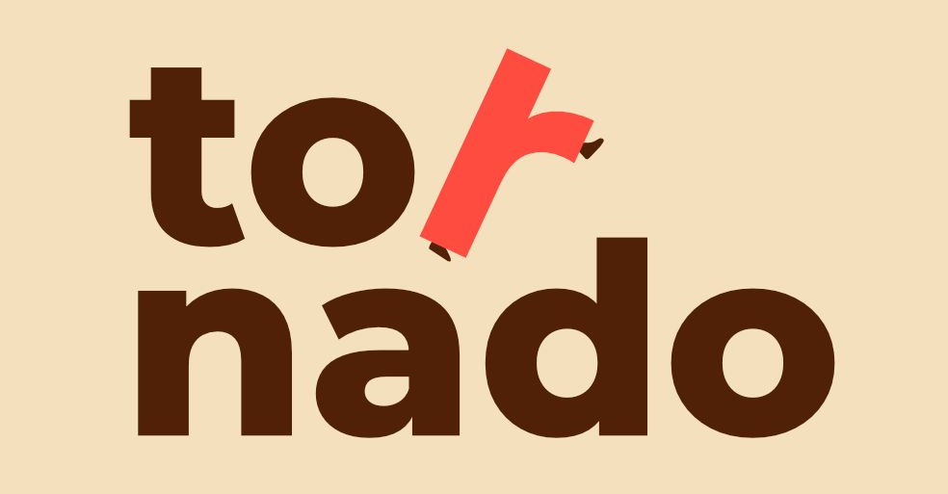

Organisation ID : E10438968
Address: C/ Dionisio Aldama Nº7
City: Amurrio, Spain
Email: tornadoasociacion@gmail.com
Profile
Type of organisation: NGO
Is the partner organisation a public body? No
Is the partner organisation a non-profit? Yes
Contact Person
Title: Vicepresident
Gender: Male
First Name: Xabier
Family Name: Bordagaray Aldama
Email: tornadoasociacion@gmail.com
Telephone: +34619768053
Legal Representative
Title: President
Gender: Female
First Name: Ana
Family Name: Fernández Hernández
Email: anaafernandez221@gmail.com
Telephone: +34683362070

Please briefly present the partner organisation
“Asociación TORNADO por la Inclusión Social y la Diversidad Cultural” is an intercultural youth organization based in Amurrio (Álava), Spain. As a non-governmental, politically independent, and non-profit entity, TORNADO is open to any young person eager to volunteer, drive local initiatives, or engage in international mobility.
While our activities welcome all youth interested in making a difference, we place a strong, dedicated focus on supporting young migrants. We work directly on the ground to facilitate their inclusion by providing administrative guidance, accommodation support, cultural mediation, and language literacy programs.
What makes our methodology unique is the deliberate and natural mix of participants: we bring together local youth from highly diverse backgrounds with newly arrived young migrants. TORNADO is not just an organization for migrants, but a shared community space designed to welcome them and foster real, reciprocal integration through daily interaction with local peers. This rich blend of perspectives ensures that our projects are a true, living example of social inclusion.
We provide a robust platform for young people to propose their own ideas, launch social projects, and cultivate their professional and civic spirit. By bridging the gap between local integration and international contexts, we empower youth to overcome social barriers and become proactive, engaged global citizens.
The foundation of Asociación TORNADO is built upon three core pillar values that guide every project we undertake:
-Solidarity & Social Integration
-Intercultural Dialogue & Respect
-Active Civic Participation
Diversity and inclusion are not just goals; they are at the center of all our work. We are deeply committed to ensuring that our activities are accessible to people with fewer opportunities, including young migrants, individuals facing administrative or legal hurdles, and those experiencing economic, social, or geographical barriers.

What are the activities and experience of the organisation in the areas relevant for this application?
Since our founding in June 2026, Asociación TORNADO has been dynamically building its foundation and launching targeted local initiatives. While our trajectory is recent, our team and volunteer network have been intensely active, achieving significant milestone impacts from day one.
At this stage, we are developing our operational capacity through two main pillars:
MIGRANT POPULATION INCLUSION & EMPOWERMENT
We work directly on the ground to provide immediate, high-impact inclusion pathways for young migrants. Despite our short history, we have already achieved tangible results in our core intervention areas:
-Legal & Administrative Guidance: We have successfully managed and resolved complex documentation procedures, enabling 5 young migrants to obtain their legal residency in Spain.
-Accommodation & Residential Support: Our team provides direct housing mediation, having already assisted 2 young people in finding safe, stable, and sustainable housing solutions.
-Pathways to Employment (Camino al empleo): Leveraging our grassroots network and local corporate contacts, we have successfully facilitated labor market integration for 3 young people, bridging the gap between vulnerable youth and local employers.
YOUTH PARTICIPATION & EUROPEAN NETWORKS
We believe in learning-by-doing, engaging our youth in local and international projects to foster their civic and entrepreneurial spirit:
-International Mobility via Partner Networks: While we are preparing to host our own initiatives, we actively empower our local youth by sending them to international Youth Exchanges organized by our Spanish partner network. This allows our members to gain valuable intercultural skills across different regions.
-Sustainable Action (The Clothing SWAP): To promote sustainable consumption and raise awareness about the environmental impact of fast fashion, our youth successfully designed and implemented a local clothing exchange event. This initiative directly promoted circular economy principles among local citizens.
-Co-Creation of European Projects: Our youth network is actively involved in the drafting and design of future Erasmus+ and European Solidarity Corps (ESC) grant applications, ensuring that all our proposals directly reflect the genuine needs and voices of young people.
What are the skills and expertise of key staff/persons involved in this application?

Ana Fernández Hernández:
Graduated in Social Education from the University of Burgos, she brings extensive professional and field experience to her role as the founder and president of Asociación TORNADO. Her background includes extensive volunteering with prominent social organizations such as Nuevo Futuro, Fundación Salud y Comunidad, and Brisa Intercultural, alongside hands-on professional expertise in migrant integration. Her deep understanding of European mobility stems from her own 11-month participation in a European Voluntary Service (EVS) project.
Between 2017 and 2021, she was a highly active member of the AEGEE-Burgos network, serving as Head of International Relations for three years and successfully organizing multiple international youth events. Currently, she works as a professional Social Educator, splitting her career between child protection services in Vitoria and supporting migrant youth in Vizcaya. This background provides her with the ideal competencies to lead, manage, and guarantee the quality of complex Erasmus+ inclusion initiatives.
Xabier Bordagaray Aldama:
Graduated in Industrial Engineering, he is responsible for the legal documentation, administrative compliance, and financial management of Asociación TORNADO. His engineering background provides the organization with high-level skills in project logistics, budget optimization, and data control.
He possesses extensive experience within the non-profit and youth sectors. Between 2017 and 2023, he was a highly active member of AEGEE-Bilbao, where he successfully organized local events and served as an advisor for young people participating in international Summer University programs abroad. Additionally, he was an active board member of Scouts Amurrio, where he designed and executed camps, outdoor activities, and non-formal learning programs tailored for youth, including those facing fewer opportunities.

