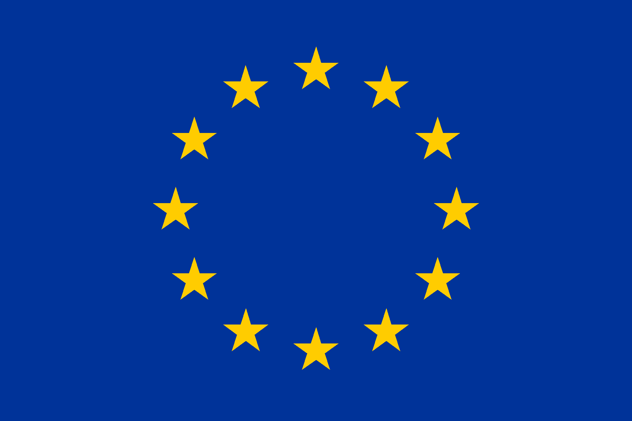
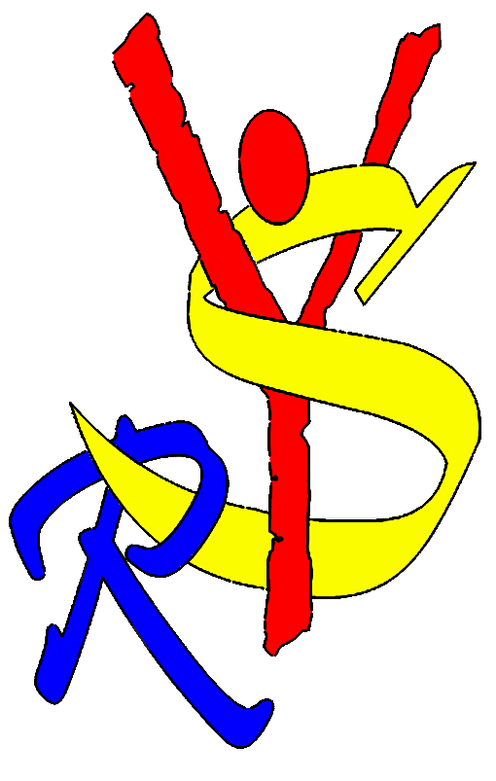
ERASMUS+ PARTNER · EUROPEAN SOLIDARITY CORPS PARTNER
YELLOW SHIRTS ROMANIA
PARTNER INFORMATION FILE
Youth organisation based in Baia Mare, Romania — non-formal education, youth mobility and European partnerships since 2010.
BAIA MARE · MARAMUREȘ COUNTY · ROMANIA
OID E10099033

CONTENTS
What's in this file

01 Organisation Identification 3
02 About Yellow Shirts Romania 4
03 What We Do, and Who For 5
04 Areas of Expertise 6
05 Meet the Team 7
06 Current & Upcoming Projects 8
07 What We Look for in a Partnership 9
08 How We Can Help Your Projects 10
09 Please briefly present your organization 11
10 What are the activities and experience of the organisation in youth work? Please provide information on your organisation’s regular youth work activities. 12
11 Please give information on the key staff/persons involved in this application and on the competences and previous experience that they will bring to the project 13

01 — ORGANISATION IDENTIFICATION

Organisation Identification
Core identifiers and registration details, as recorded in the Organisation Registration System (ORS).
OID | E10099033
PIC | 949526890
FULL NAME | Yellow Shirts Romania
ACRONYM | YSR
NATIONAL ID | 1922042010
LEGAL FORM | Non-profit association (NGO) · Founded 2010
ADDRESS | Iza Street, No. 3/3, 430073 Baia Mare, Maramureș, Romania
WEBSITE / SOCIAL | facebook.com/YellowShirtsRomania
EMAIL | yellow_shirts_ro@hotmail.com
TELEPHONE | +40 774 602 557
PUBLIC BODY | No
NON-PROFIT | Yes

Legal Representative
NAME | ANDREEA CAPLESCU
POSITION | President & Legal Representative
DEPARTMENT | International Projects
EMAIL | yellow_shirts_ro@hotmail.com
TELEPHONE | +40 774 602 557

Contact Person for this Partnership
NAME | OCTAVIA FIRESCU
POSITION | Project Coordinator
DEPARTMENT | International Projects
EMAIL | projects.yellowshirts@gmail.com
TELEPHONE | +40 723 976 455

02 — WHO WE ARE

About Yellow Shirts Romania
Yellow Shirts Romania is a non-profit youth organisation based in Baia Mare, in Maramureș County, northern Romania. What began in 2007 as an informal group of young people taking their first steps in Youth in Action projects became, in 2010, a formally registered NGO — and has been growing steadily ever since.
Our mission is to create educational contexts — formal, non-formal and informal — for the personal and professional development of young people, helping them integrate into their communities, discover new cultures, and build the competences they need for active, engaged lives.
We work in a distinctive social context. Baia Mare is a town shaped by the collapse of its mining industry in the early 2000s, which triggered labour migration and left many children and young people growing up with relatives while their parents work abroad. At the same time, it is a genuinely multicultural town — home to Romanian, Hungarian, Ukrainian, Roma, Jewish and other communities — which makes it a meaningful, lived-in setting for youth work on inclusion, diversity and intercultural learning, rather than a theoretical one.

LOCAL CONTEXT
Baia Mare & Maramureș
Baia Mare, the capital of Maramureș County, is a regional hub of around 110,000 inhabitants in northwestern Romania, close to the border with Ukraine. Once known as Romania's mining capital, the city has spent the past three decades transforming its post-industrial landscape — through environmental remediation, soil rehabilitation and a growing focus on sustainable urban development — while unemployment and poverty remain real challenges for parts of the population.
Around 12% of the city's population is ethnically Hungarian, one of Transylvania's significant Hungarian communities, and the wider region carries a long history of Jewish, Ruthenian/Ukrainian, German and Roma presence. The historic centre, anchored by a 14th-century Gothic clock tower, sits alongside this living multicultural fabric — making Baia Mare a genuinely relevant setting for youth projects on inclusion, cross-border cooperation and intercultural dialogue.

03 — MISSION & REACH

What We Do, and Who For
Key objectives
- Support formal, non-formal and informal education for our beneficiaries and members
- Provide educational programmes and open access to partnerships
- Deliver training in our areas of expertise
- Promote multi-directional communication and cooperation — locally, regionally, nationally and internationally
- Exchange information, tools and good practice with organisations working toward similar goals

Who we work with
- Children (5–13) — early development
- Young people (14–35) — our core group
- Adults & seniors (18+) — especially those who directly influence young people: parents, teachers, relatives, youth workers

Track record at a glance
170+  ERASMUS+ & ESC PROJECTS | 4,200+  YOUNG PEOPLE REACHED | 2014  EVS / ESC ACCREDITED | 2007  ACTIVE IN YOUTH WORK
Delivered by a core team of 8, supported by 8–10 local volunteers for specific activities.

04 — EXPERTISE

Areas of Expertise
- Entrepreneurship & Employability — counselling on jobs, internships, CVs, cover letters and interview preparation
- Social Inclusion — working with young people facing social, economic, cultural or geographic disadvantage
- Arts & Intercultural Dialogue — using creative expression to promote multiculturalism and mutual understanding
- Non-formal Education — designing and delivering training courses, workshops and seminars, from local to international level
- Volunteering — local volunteering plus international volunteers through EVS / European Solidarity Corps since 2014
- Sport — local sport activities, amateur championships, and volunteering at sporting events
- Holistic Youth Work — methods and tools that support young people's mental health, wellbeing and self-development

Core activities
- Training courses, seminars, conferences, study visits, networking events, youth exchanges, workshops, summer schools
- Publishing educational materials and promotional content
- Information campaigns and knowledge-transfer initiatives
- Consultation, mentoring and counselling services
- Organising local sport activities and volunteering at sport events

European programme experience
- Youth in Action, since 2007
- Erasmus+ youth exchanges and training courses
- European Voluntary Service / European Solidarity Corps — sending and hosting individual and group volunteers, 150+ young people to date
- Erasmus+ Sport actions with EACEA
- Erasmus+ KA2 partnerships at National Agency level

05 — THE PEOPLE

Meet the Team
A core team of eight has worked together since the organisation's founding, joined for specific activities by 8–10 local volunteers.
Andreea Căplescu  PRESIDENT & LEGAL REPRESENTATIVE  Project manager with hands-on experience accessing and managing EU funds; youth worker and trainer. Responsible for the partnership's official documentation. | Alexandru Gyongy  PROJECT COORDINATOR  Leads day-to-day relations with partners and the administrative and logistical implementation of projects.
Octavia Firescu  FINANCIAL COORDINATOR  Accredited accountant, responsible for budget management and timely, correct payments. | Beata Daubner  MONITORING & EVALUATION  EU project consultant overseeing monitoring and evaluation on our side.
Ramona Vecean  EXTERNAL COMMUNICATION  Leads dissemination — social media, web presence and visibility materials. | Vlad Horotan  VISUAL COMMUNICATION  Develops the visual identity and design of dissemination and promotional materials.
Georgiana Ștefănescu  LOCAL ACTIVITIES COORDINATOR  Supports the organisation of locally implemented activities and dissemination events. | Gabriel Balan  LOGISTICS  Coordinates the practical side of hosting mobilities — venues, accommodation and transport.

06 — 2027 PORTFOLIO

Current & Upcoming Projects
Erasmus+ Key Action 1 mobility projects Yellow Shirts Romania is preparing for 2027, alongside our accreditation application:
PROJECT | ACTION | FOCUS | TIMING
GameCraft AI | KA153 · TC | AI-assisted design of educational board games | 17–26 May 2027
Connect & Reflect | KA153 · TC | AI-supported, human-supervised reflection & debriefing | 2–10 Jun 2027
Learn to Escape | KA152 · YE | Escape rooms mapped to the 8 Youthpass competences | 3–13 May 2027
Equality Through Diversity | KA152 · YE | Recognising & challenging discrimination through intercultural learning | 17–28 Jun 2027
Beyond Borders | KA155 | DiscoverEU Inclusion — 4 thematic trips for 20 young people with fewer opportunities | 2027 · TBC
Steps Outside | KA122-ADU | Short-term adult-education mobility & job-shadowing in Ireland | 2027 · TBC
Next Level Learning | KA220-YOU | AI-adapted escape-room toolkit — cooperation partnership (in development) | 2027 - TBC
We are also completing our Erasmus+ Accreditation (KA150) application, due September 2026, to secure longer-term structural funding for youth mobility.

07 — PARTNERING WITH US

What We Look for in a Partnership
We look for partners who share a genuine commitment to non-formal education and youth work quality — organisations with real, hands-on experience of the young people or youth workers they bring into a project, who see a mobility as a two-way exchange rather than a one-off trip, and who take Youthpass recognition seriously as part of the learning process, not as paperwork.
We look for partner organisations that treat a mobility as a shared responsibility, not a logistics exercise. The quality of a project depends as much on what each partner does before and after the activity as on what happens during it, and that is exactly where we hope our partners will invest real effort.
The single biggest factor in a strong project is participant selection. We look for partners who choose participants that genuinely match the profile requested for each specific mobility — the right age range, the right motivation, and, where a project calls for it, real representation of young people with fewer opportunities — rather than filling seats to meet a quota. A well-selected group of four brings more to a project than a mismatched group of six.
We also look for partners who contribute, not just attend. That means preparing participants properly before departure, sending a group leader who can genuinely support daily reflection, bringing local knowledge and material into the sessions, and treating the project's objectives as their own rather than something the host organisation alone is responsible for delivering.
Dissemination matters to us as much as delivery. A project's impact should not end when participants fly home, so we look for partners who actively share the results back in their own communities — through their own channels, with their own networks, in their own language, reaching people who were never in the room. A partner who disseminates well multiplies the value of the whole project, for everyone involved, not only their own participants.
If that sounds like you, we would love to hear from you.

Get in touch
CONTACT | Andreea Căplescu, President
EMAIL | projects.yellowshirts@gmail.com
TELEPHONE | +40 741 249 264
ADDRESS | Iza Street, No. 3/3, 430073 Baia Mare, Maramureș, Romania
SOCIAL | facebook.com/YellowShirtsRomania

08 — HOW WE CAN HELP YOUR PROJECTS

How We Can Help Your Projects
Yellow Shirts Romania brings a working, tested set of resources to any partnership — not just a signature on an application form.

Human resources — Our core team of eight covers the full range of roles a project needs: project management and EU-funds administration, training and facilitation, financial management, monitoring and evaluation, and communication and visual design. We are joined by 8–10 local volunteers for specific activities, so we can scale up capacity when a project needs it.

Training delivery — Our team includes active youth workers and trainers who can design and deliver full non-formal sessions, not only accompany participants. We are comfortable running workshops on entrepreneurship and employability, social inclusion, intercultural dialogue, digital and AI literacy applied to non-formal education, and holistic approaches to youth wellbeing.

Participant selection and preparation — We have an established process for recruiting and selecting participants who genuinely match a project's target profile, including young people with fewer opportunities, and for preparing them properly before a mobility, so they arrive ready to contribute rather than just observe.

Content and resource development — We design original non-formal education tools rather than only using existing ones: competence-based educational board games, escape-room formats mapped to Youthpass competences, and reflection and debriefing protocols, increasingly supported by AI tools used thoughtfully and under human supervision.

Hosting and logistics — When we host, we manage the practical side end-to-end — venues, accommodation, transport and daily programme delivery — so visiting partners can focus on their participants rather than logistics.

Recognition and follow-up — We treat Youthpass as a daily process built into the programme, not paperwork completed at the end, and we build in structured reflection so learning outcomes are visible and documented throughout.

Dissemination and reach — We maintain an active local presence and existing relationships with other NGOs and public authorities in Baia Mare, which we use to extend a project's visibility well beyond the partnership itself.

Financial and administrative reliability — With an accredited accountant managing budgets and a project manager experienced in EU-funded projects handling official documentation, partners can rely on our side of a project being run correctly and on time — a track record built across more than 170 international and national projects since 2010.
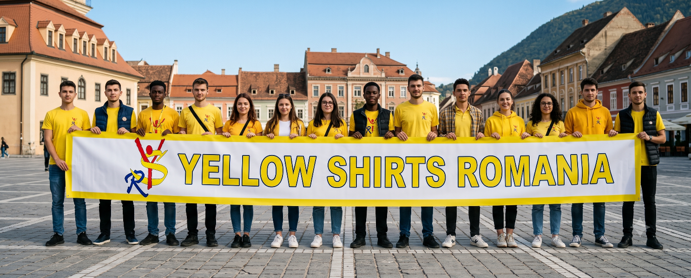
09 — PLEASE BRIEFLY PRESENT YOUR ORGANISATION

Please briefly present your organisation
(TO BE INSERTED IN THE APPLICATION FORM)

Yellow Shirts Romania is a non-profit youth organisation based in Baia Mare, in Maramureș County, northern Romania. Our roots go back to 2007, when a group of young people came together informally and took their first steps in Youth in Action projects. Through repeated participation in youth projects over the following years, the group built up real, hands-on experience in organising groups — selecting and preparing participants, developing leadership — and in managing projects more broadly, largely by learning from the good practice of more established organisations we worked alongside. In 2010, this informal group formally registered as an NGO, and has continued to grow steadily ever since.

Our mission is to create educational contexts — formal, non-formal and informal — for the personal and professional development of young people, helping them integrate into their communities and discover new cultures while building the competences they need for active, engaged lives. We work primarily with young people aged 14 to 35, our core target group, alongside children aged 5 to 13 for early development work, and adults and seniors aged 18 and above, particularly those who directly influence young people's lives: parents, teachers, relatives and fellow youth workers.

We work in a distinctive social context. Baia Mare, the capital of Maramureș County, is a regional hub of around 110,000 inhabitants in northwestern Romania, close to the border with Ukraine. Once known as Romania's mining capital, the town was reshaped by the collapse of that industry in the early 2000s, which triggered labour migration abroad and left many children and young people growing up with relatives rather than parents. At the same time, Baia Mare is genuinely multicultural: around 12% of its population is ethnically Hungarian, one of Transylvania's significant Hungarian communities, and the wider region carries a long history of Jewish, Ruthenian/Ukrainian, German and Roma presence alongside the Romanian majority. Its historic centre, anchored by a 14th-century Gothic clock tower, sits alongside an active programme of post-industrial urban regeneration, environmental remediation and soil rehabilitation. This lived-in, multicultural, post-industrial setting is what grounds our work on inclusion, diversity and intercultural learning in real experience rather than theory.

Our work is organised around seven core areas of expertise: entrepreneurship and employability, where we counsel young people on jobs, internships, CVs, cover letters and interview preparation; social inclusion, working with young people who face social, economic, cultural or geographic disadvantage; arts and intercultural dialogue, using creative expression to promote multiculturalism and mutual understanding; non-formal education, designing and delivering training courses, workshops and seminars from local to international level; volunteering, both locally and, since 2014, through the European Voluntary Service and European Solidarity Corps; sport, through local activities, amateur championships and volunteering at sporting events; and holistic youth work, applying methods and tools that support young people's mental health, wellbeing and self-development alongside their more formal learning.

Since 2010, we have delivered more than 170 international and national projects, engaging over 4,200 young people, on themes including sport, wellbeing and healthy lifestyle, entrepreneurship, volunteering, youth work, institutional management, environmental protection and sustainable development, cultural identity, team building, project management, leadership, gender equality and active citizenship. Our European programme experience runs from Youth in Action, since 2007, through Erasmus+ youth exchanges, training courses and KA2 partnerships at National Agency level, to Erasmus+ Sport actions with EACEA. A core team of eight — covering project management, training, financial administration, monitoring and evaluation, and communication — is joined by 8 to 10 local volunteers for specific activities, and we maintain regular working relationships with other local NGOs and public authorities active in youth and sport, extending our support network well beyond our own organisation.

Looking ahead, we are completing our application for Erasmus+ Accreditation (KA150) in the Youth field, due in September 2026, as a way of securing more stable, longer-term structural funding for our youth mobility work rather than relying solely on standard, call-by-call project applications.
10 — WHAT ARE THE ACTIVITIES AND EXPERIENCE OF THE ORGANISATION IN YOUTH WORK

What are the activities and experience of the organisation in youth work? Please provide information on your organisation’s / group’s regular youth work activities
(TO BE INSERTED IN THE APPLICATION FORM)

Yellow Shirts Romania's core activity is non-formal education for young people. On a regular basis, we organise and take part in training courses, seminars, conferences, study visits, networking events, youth exchanges, workshops and summer schools, at local, national and international level. These activities sit within seven areas of expertise we return to consistently: entrepreneurship and employability, social inclusion, arts and intercultural dialogue, non-formal education itself, volunteering, sport, and holistic youth work supporting young people's mental health and wellbeing.

Since 2014, we have been accredited to send and host volunteers through the European Voluntary Service and, subsequently, the European Solidarity Corps. This is not a one-off activity: volunteer hosting is a continuous part of our work, with hosted volunteers joining our team on an ongoing basis to work alongside us, contribute to our local activities in Baia Mare, and help make the town more multicultural and youth-friendly. More than 150 young people have taken part as EVS or ESC volunteers with us to date, sent and hosted both individually and in groups.

At local level, our regular activities span several areas: education and training delivered through non-formal methods; volunteering and civic action, both for local volunteers and international ones hosted through EVS/ESC; personal and professional development support; entrepreneurship and employability counselling, including CV and cover-letter preparation and interview practice; social inclusion work with young people facing social, economic, cultural or geographic disadvantage; sport and physical activity, including hosting regional and national amateur championships and volunteering at community sporting events; and holistic approaches to youth wellbeing. We also run regular consultation, mentoring and counselling services, and publish our own educational materials and promotional content as part of ongoing information campaigns and knowledge-transfer work.

Designing our own non-formal education resources, rather than only using existing ones, is itself a regular activity for us. Recent and ongoing examples include competence-based educational board games developed with youth workers as a co-creation tool, and escape-room formats built around the eight Youthpass key competences for use in youth exchanges — both intended as reusable resources for our own future activities and for our partners, not one-off products for a single project.

Hosting youth exchanges and training courses in Baia Mare is also a recurring part of our regular work rather than an occasional one: we have organised this type of activity repeatedly since our Youth in Action years, and continue to do so, which means our team, our local partners and our venues are all practised in receiving international groups rather than encountering the process for the first time.

Our regular approach centres on bringing together young people from different backgrounds — Romanian, Hungarian, Ukrainian, Roma, Jewish and others reflecting our own town's make-up — to stimulate mutual understanding through direct contact rather than abstract discussion. Much of our day-to-day work happens through direct meetings and workshops between beneficiaries and our volunteers or staff, focused on individual development, in the belief that positive change at the individual level gradually reaches the wider community. We use Youthpass as a continuous, day-to-day recognition process built into our regular activities, not only as a certificate issued at the end of a mobility.

Our regular youth work also includes maintaining an active network: we collaborate consistently with other local NGOs and with public authorities responsible for youth and sport in Baia Mare, creating a support network our beneficiaries can draw on beyond our own activities. This regular local work sits alongside our European programme activity, which began with Youth in Action in 2007 and has continued through Erasmus+ youth exchanges and training courses as our main mobility formats, Erasmus+ Sport actions with EACEA, and KA2 partnerships at National Agency level — giving our day-to-day youth work a consistent international dimension as well as a local one.

11 — PLEASE GIVE INFORMATION ON THE KEY STAFF/PERSONS INVOLVED IN THIS APPLICATION AND ON THE COMPETENCES AND PREVIOUS EXPERIENCE THAT THEY WILL BRING TO THE PROJECT

Please give information on the key staff/persons involved in this application and on the competences and previous experience that they will bring to the project
(TO BE INSERTED IN THE APPLICATION FORM)

Yellow Shirts Romania's core team of eight has worked together since the organisation's founding, and brings complementary competences to every project we apply for or join as a partner. The team meets and coordinates regularly regardless of the specific project underway, which means new mobilities are absorbed into an already-functioning structure rather than requiring one to be built from scratch each time.

Andreea Caplescu, President and legal representative, is a project manager with hands-on, practical experience accessing and managing EU-funded projects, and is also an active youth worker and trainer in her own right. She takes overall responsibility for a project's official documentation and coordination on our side, and, in most projects, for direct facilitation and training delivery as well. Alexandru Gyongy, project coordinator, leads day-to-day relations with partner organisations and oversees the administrative and logistical implementation of activities — from early planning and communication with partners through to on-the-ground delivery.

Octavia Firescu is an accredited accountant who acts as financial coordinator on our projects, responsible for budget management and for ensuring payments to participants, partners and suppliers are made correctly and on time — a role that carries particular weight under the lump-sum funding model, where financial discipline is tied directly to the achievement of agreed activities and results. Beata Daubner, an EU project consultant, is responsible for monitoring and evaluation, tracking whether a project's activities and results are on track against its objectives and indicators, and feeding that back into how the project is run.

Ramona Vecean leads external communication, managing our social media presence, web content and the visibility materials a project needs to meet its dissemination commitments. Vlad Horotan develops the visual identity and design behind that communication — from dissemination materials and promotional content to the visual side of the resources a project produces — so that what we publish is professional and consistent.

Georgiana Ștefănescu coordinates locally implemented activities and dissemination events, supporting the organisation of whatever happens on the ground in Baia Mare, including where local volunteers are involved. Gabriel Balan handles the logistics of hosting mobilities — venues, accommodation and transport — so that visiting partners and participants can focus on the programme itself rather than on the practicalities of getting there and being looked after.

Beyond this core team, we draw on 8 to 10 local volunteers for specific activities, typically supporting logistics, local cultural programming and interpretation where needed. These volunteers are themselves usually alumni of our previous projects or EVS/ESC placements, which means they already understand how we work before they join a given activity.

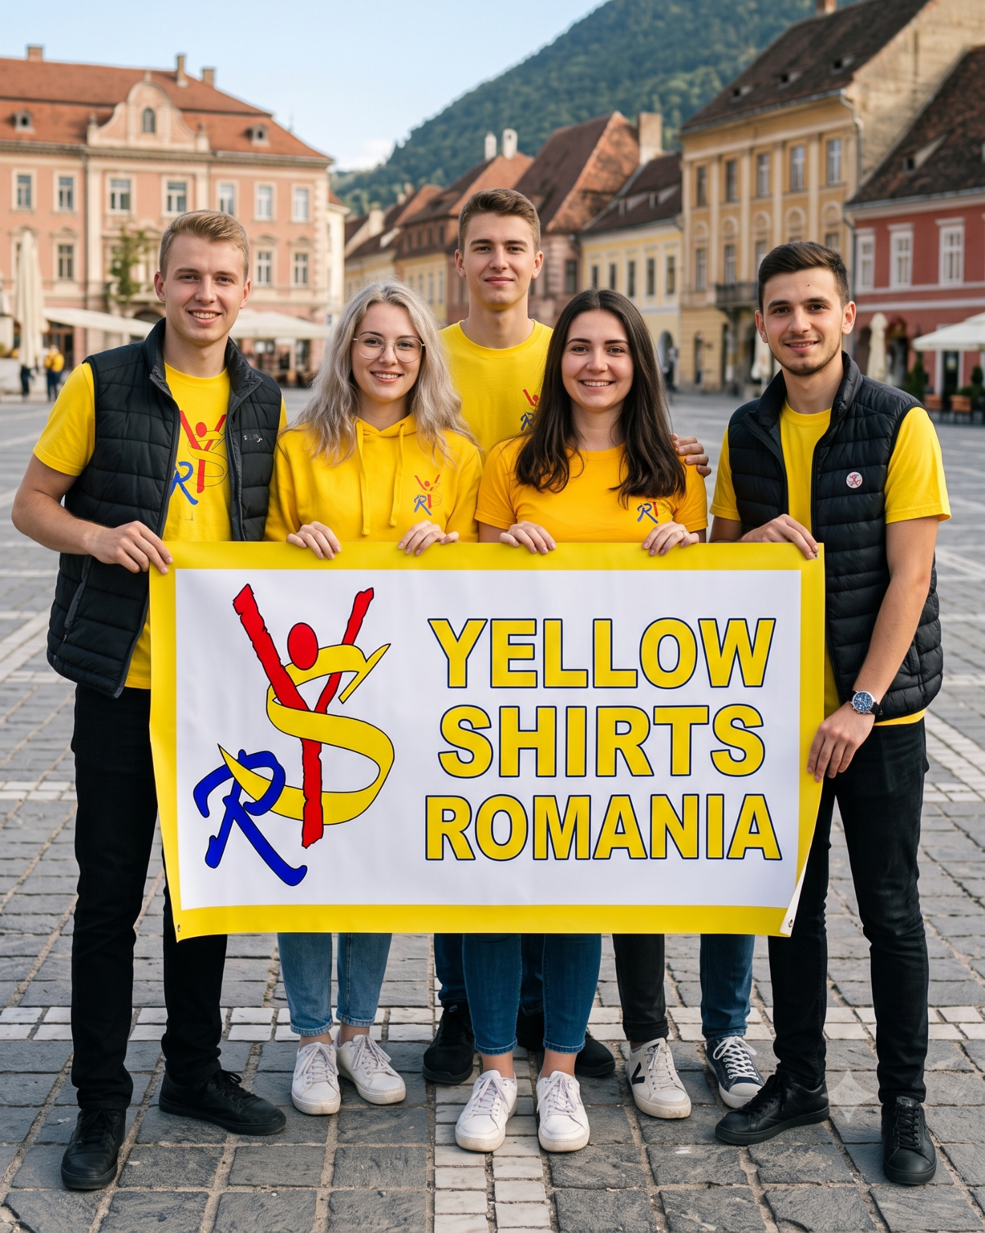
Exactly how these competences are deployed depends on the type of Key Action 1 mobility involved. In a youth exchange (KA152), Andreea and Alexandru typically lead facilitation and group-leader coordination, working closely with Georgiana and Gabriel on the local and logistical side, while Beata builds Youthpass-based reflection into the daily programme. In a training course for youth workers (KA153), Andreea generally takes a more central training and facilitation role, with Alexandru managing the partnership and Ramona and Vlad handling participant-facing communication before and during the activity. In youth participation activities (KA154) or DiscoverEU Inclusion (KA155), Georgiana's experience coordinating local activities and inclusion-oriented work comes to the fore. In adult-education, school-education or staff mobility formats (such as KA121/KA122-ADU or KA131/KA121-SCH types), Alexandru and Octavia's coordination and financial management experience carry proportionally more weight, given the heavier administrative and reporting demands typical of those formats. Across all of these, the team's combined experience spans more than 170 international and national projects since 2010, giving us a consistent base of practical competence regardless of the specific Key Action or target group involved. This same team, and the same division of competences, applies whether Yellow Shirts Romania is the applicant and coordinator of a project or a partner organisation within someone else's application — the roles above describe what we bring to the partnership either way.

