KAB STRUGAs CV
About KAB Struga
KAB Struga is a non-governmental, non-political and non-profit organization which aims to contribute to the development and promotion of mountain sports, aims to educate, mobilize and raise awareness among citizens by addressing key environmental issues and various public activities. At the core of our activities is working with people and institutions to promote tangible social transformation and bring about positive change on the society.
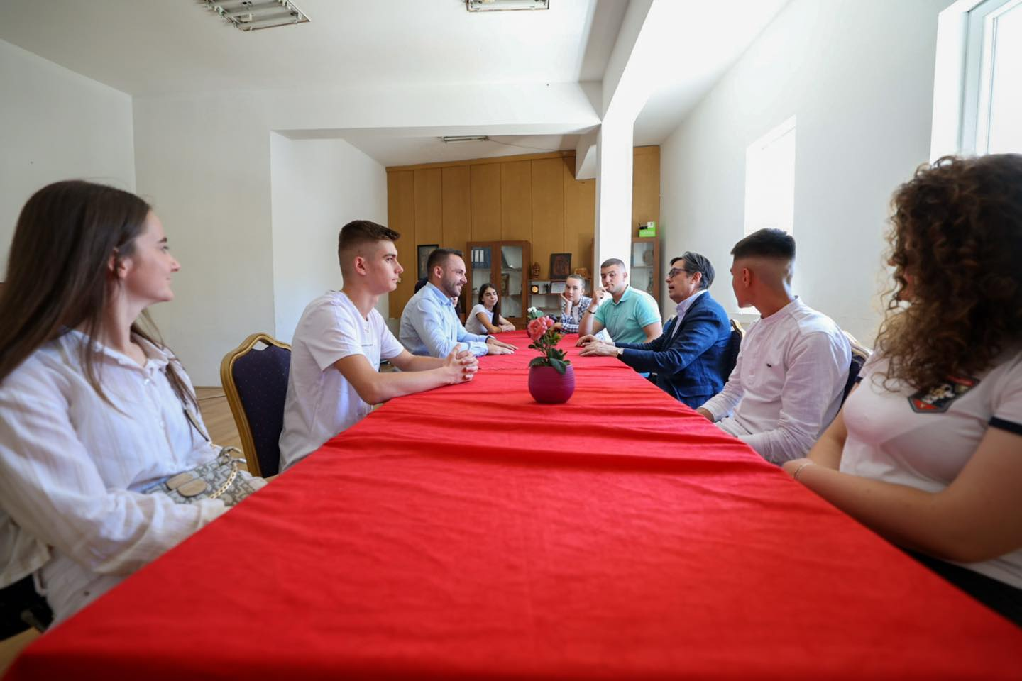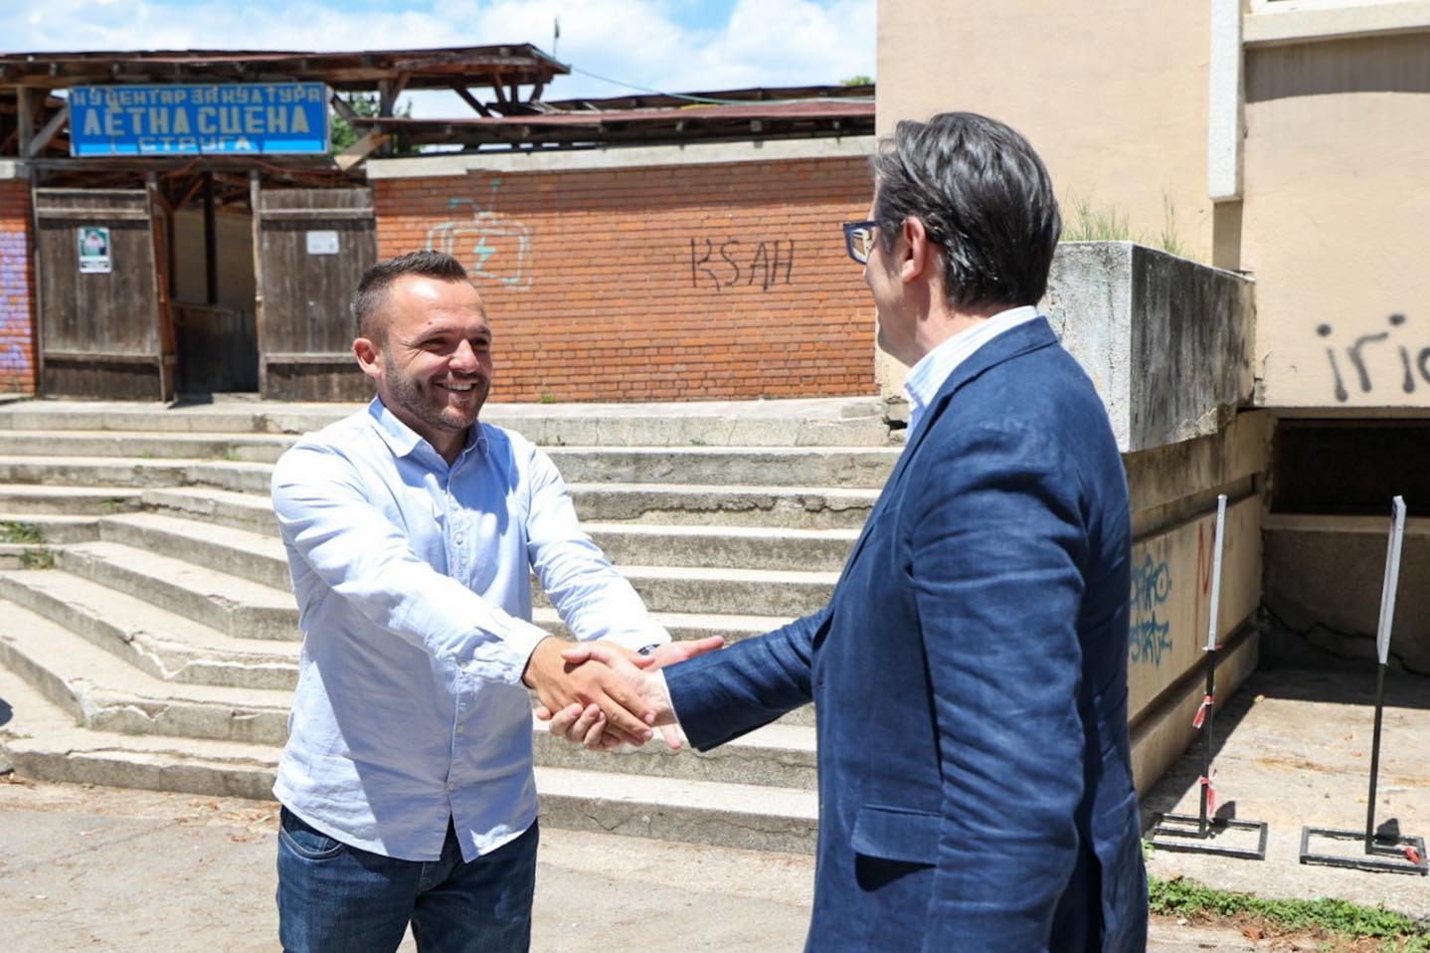
The President of the Republic of North Macedonia Mr. Stevo Pendarovski honored our organization and activists for our activism
Mission: KAB Struga works to strengthen the friendly coexistence between man and nature in Struga and beyond. Through our activities, we aim to promote the Ohrid Lake region as an Alternative Tourism destination, protect the natural and cultural heritage of the region, to have a sustainable development and a healthy environment.
Vision: KAB Struga is built on the belief in the future of the Lake Ohrid region, as a World Natural Cultural Heritage that guarantees sustainable development and a healthy environment, as a highly reputable tourist destination, a model for heritage tourist destinations and alternative tourism, branding and promotion, which is made possible through policies that guarantee inclusiveness in every decision-making for the region!
The organization consists of:
- Trainers and experts for capacity building for the community, local government and civil society organizations;
- Nature Guide composed of young people prepared to provide environmental education and nature guides;
- Young volunteers motivated and engaged in various awareness projects with the community;

The basic goals and tasks of the Association are:

- Activating the youth by organizing mountain marches and other mountain and environmental activities in the Republic of North Macedonia and in neighboring countries.
- Helping the development and promotion of mountaineering in the city of Struga and in the Republic of North Macedonia
- Preservation of the natural beauty and other natural treasures of the mountain from damage
- Taking care of mountain architecture
- Creating conditions for staying in nature, especially in the mountains
- Promoting ecology as a science
- Protection and promotion of the environment and nature
- Initiation and management of scientific or application projects in the field of ecology and the environment
- Drafting or participating in the drafting of strategies for the sustainable use of natural resources
- Spreading environmental knowledge and promoting environmental education
- Promoting the principle of sustainable development

To fulfill its mission and objectives, KAB STRUGA focuses its work on several main strategic directions:
• Supporting volunteering as an important contribution to society and the natural environment;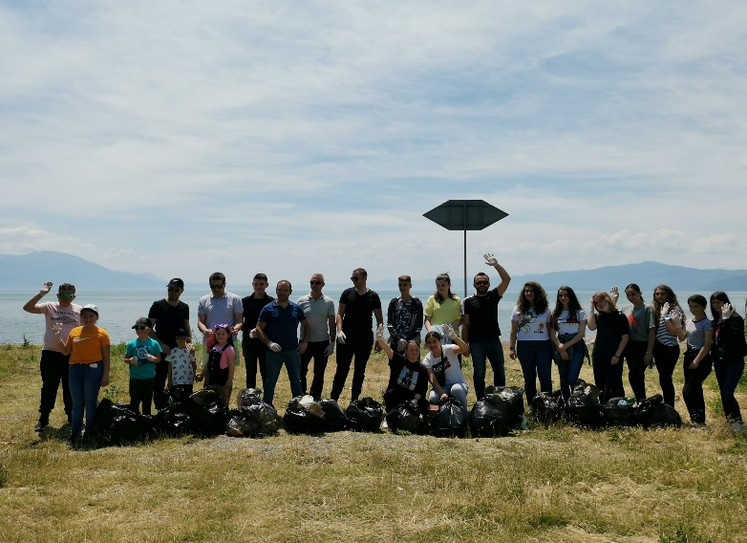 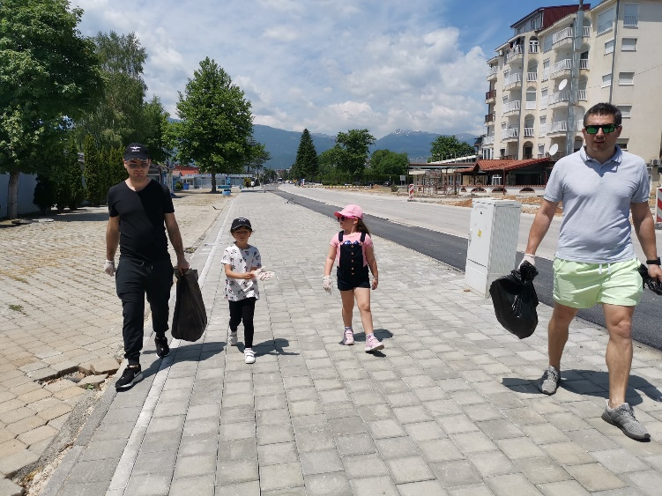

• Organization of climbing and Mountain adventures
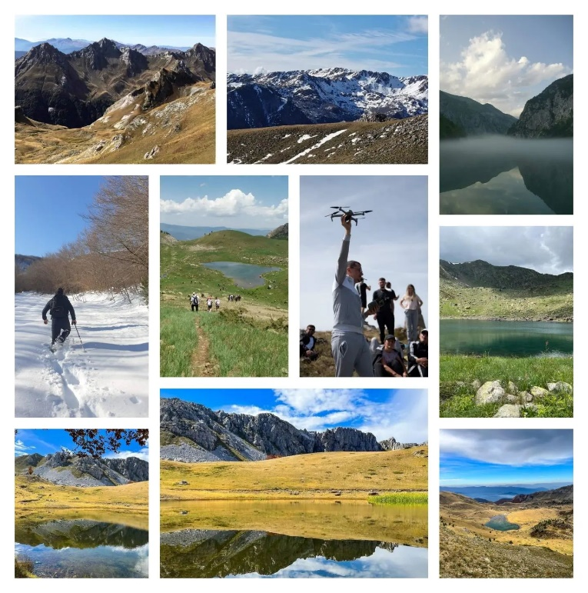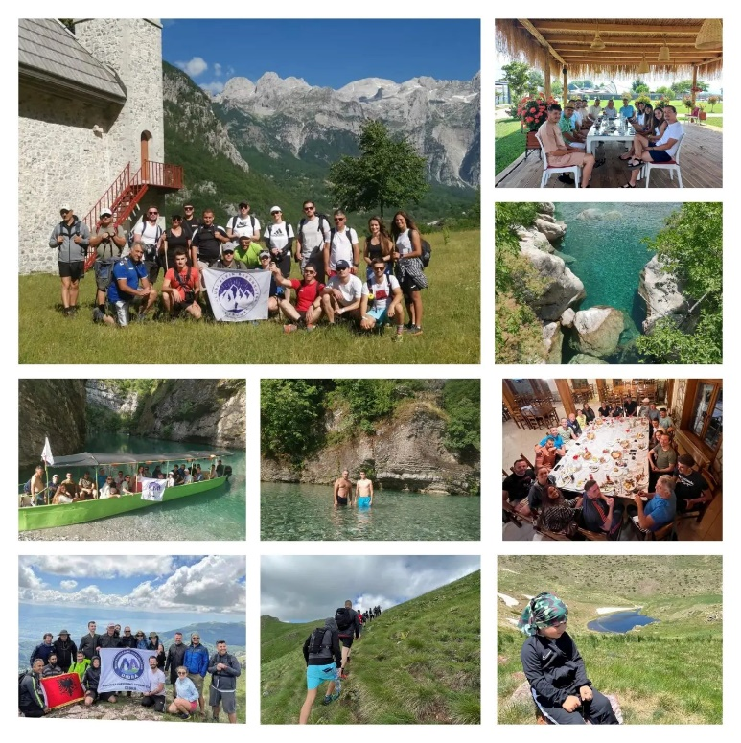
- • Undertaking campaigns to limit negative human interventions in natural ecosystems;
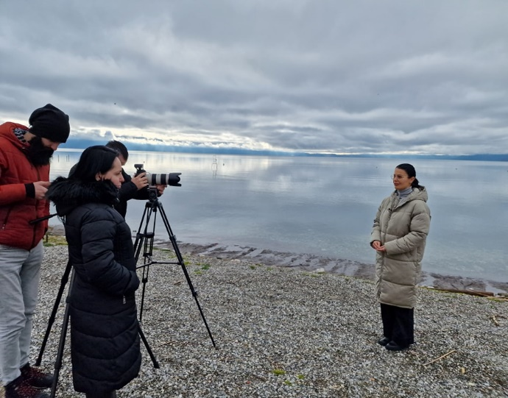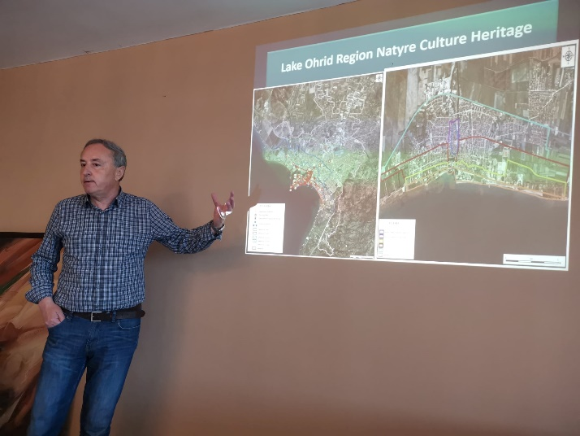

• Innovative approach (friendly to the environment) in defense of the status of the region as a UNESCO Site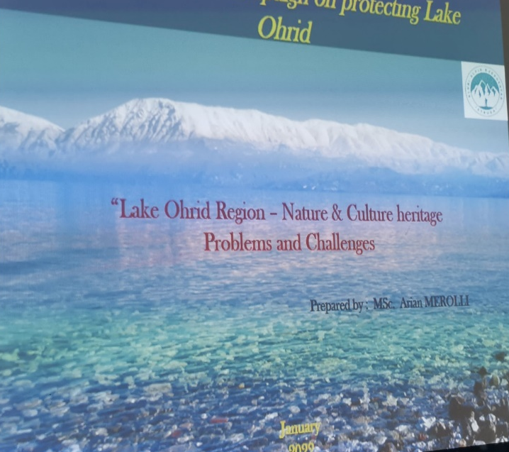 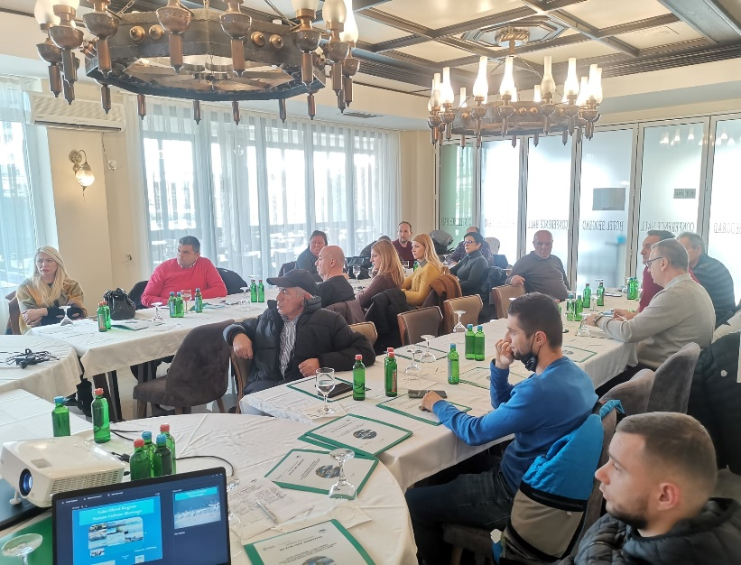
• Effective networking and partnership to influence decision-making, policy-making and public attention.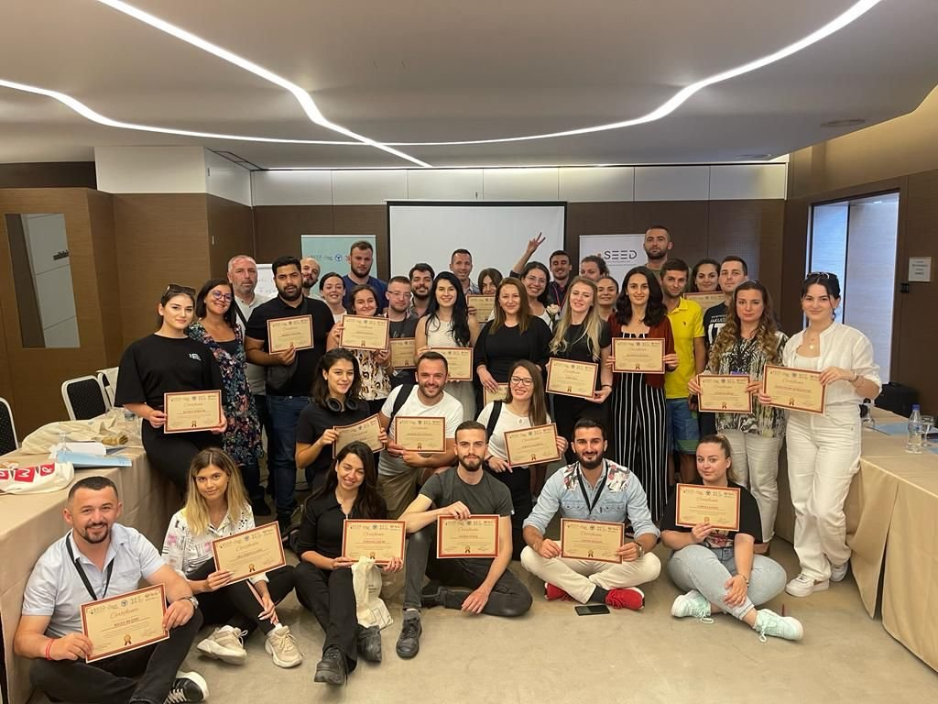 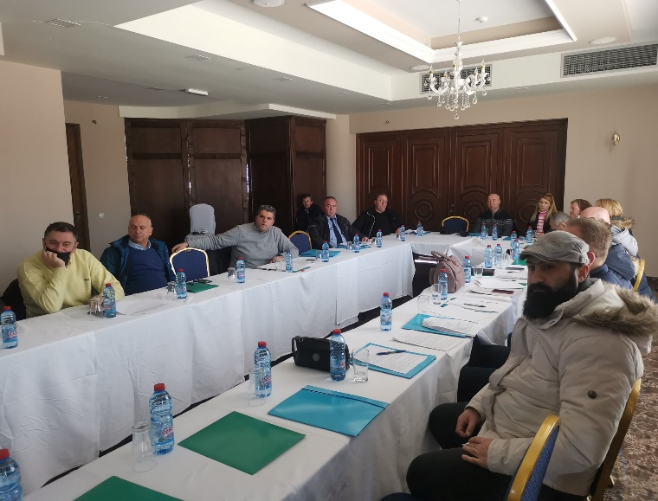

• KAB Struga is an important actor in the Lake Ohrid region through environmental vigilance, advocacy and lobbying.

KAB Struga Staff
The staff of KAB Struga consists of the best experts in the fields they represent, who add value to the organization with their expertise. They are young, energetic and come from different backgrounds, best representing the work philosophy of KAB Struga. The staff is qualified in several thematic areas: urban and regional management, municipal finance management, urban environment management as well as the research field.
Transparency

Transparency, accountability and equality are closely related to the achievements and strengthening of KAB Struga. Publishing the organization's Annual Report makes it possible to document and share information with all our partners and collaborators.

PROJECTS:
KAB Struga has short experience and a diversified portfolio of projects in the field of local government, environment, youth and public policies. Some of our projects financed by international donors: USAID, European Union, Open Society Foun
dation, Swiss Development Agency, etc.

Project title: | Cleaner city together with youth
Implementation period | 2020-2021
Objective and main results | Monitoring of the local government in relation to the budget intended for illegal landfills in the municipality of Struga, encouraging local communities to be active, as well as volunteer activities for cleaning public areas. Our main results were: Ready Financial Report, More Active Citizens and Institutions, setting up regular activities for cleaning public areas that are active today.
Main target groups | Young, local communities, volunteers, local government ETC.
Donor(s) | Institute for Communication Studies / EU FOR YOU
Project cost | 6000 Euro
Project duration | 01 December 2020 – 31 May 2021

Project title: | Save our pearl, lake ohrid
Implementation period | 2021-2022
Objective and main results | All institutions to get acquainted with the Rulebook and the current situation of UNESCO, to establish communication between institutions, to create a strategy of communication by experts. Created Strategy for Communication by Experts, our results of this project will be part of the RSM Government's report towards UNESCO.
Main target groups | Local and national institutions, the citizens of three municipalities, fishermen and other small business people who are connected to Ohrid Lake.
Donor(s) | Civica Mobilitas
Project cost | 5500 Euro
Project duration | 01.11.2021 – 28.04.2022

Project title: | How realistic are the election promises?
Implementation period | 2022
Objective and main results | Mobilizing the community to raise awareness among citizens for monitoring and evaluating election programs and establishing democratic tools for communication with representatives, taking responsibility and accountability from their country for their assumed responsibility according to public office.
Main target groups | Youth, Representatives of the civil sector, Representatives of local communities, Representatives of the business community.
Project cost | 5000 Euro
Donor(s) | Support to electoral reforms, IFES
Project duration | 01.11.2022 - 30.04.2023

Project title: | Take the future into your own hands
Objective and main results | The main goal of the project is to support North Macedonia in advancing its climate action, sustainable development, and environmental protection efforts, particularly in waste management, nature protection, civil protection, and climate change. The aim is to significantly enhance the country's green transition and ensure compliance with EU standards and regulations for a healthier environment and improved quality of life.
Main target groups | The main target groups of the project are the North Macedonian government, local communities, private sector entities, and NGOs.
Donor(s) | EU Civil Resilience Mechanism
Project cost | 14500 Euro
Project duration | 01.06.2023 – 21.12.2023

Project title: | Eco-Adventures in Jabllanica – Empowering Rural Tourism in North Macedonia
Objective and main results | To revitalize sustainable rural tourism in the Jabllanica mountain region by empowering local stakeholders through digitalization, green energy efficiency, organic food promotion, and social integration. A functional digital platform (www.ruraltourmk.com) was created to showcase eco-tourism packages including camping, hiking, off-road jeep and horse-riding tours. Over 50 locals and tourists participated in the final May event, and several businesses adopted green practices and digital tools.
Main target groups | Local entrepreneurs, eco-activists, rural tourism operators, small family farms, and tourists interested in authentic and sustainable experiences.
Donor(s) | EuroCluster Rural Tourism, funded by the European Union
Project cost | 5000 Euro
Project duration | 15.03.2024 - 15.9.2024

Project title:
  UNESCO – Shared Stories by Youth
Objective and main results | Raise awareness and build resilience in communities through environmental and social education aligned with the European Green Deal and Balkan Green Agenda. Promote sustainable tourism by conducting field surveys, SWOT analyses, and developing ecotourism models.  Main Results: Strengthened regional youth cooperation and reconciliation; increased awareness of environmental and socio-economic values; empowerment of youth as local leaders; creation of draft action plans and youth-led initiatives; stronger cross-border collaboration and local institutional support.
Main target groups | Youth from rural and protected areas in North Macedonia, Albania, Kosovo, Montenegro, and Serbia; local communities; regional tourism stakeholders; local authorities and CSOs.
Donor(s) | Regional Youth Cooperation Office (RYCO) – through EU-supported mechanisms
Project cost | 26535 Euro
Project duration | 20.12.2023 – 20.07.2024

Project title: | Nature-Based Solutions (IUCN) for Climate Change Adaptation and Flood Prevention in the Municipality of Struga
Objective and main results | Introduce Nature-Based Solutions (NbS) to address climate change and flood risks in Struga. Key results include:  - Biodiversity and ecosystem assessment  - Installation of wildlife monitoring cameras  - Restoration of 2.3 ha of degraded forest  - Erosion and flood risk reduction  - Awareness campaigns and training  - Inclusion of NbS in local policies  - Protection of UNESCO heritage
Main target groups | - Local communities (Struga, Misleshevo, Moroishta, Lozhani)  - Municipal institutions  - Environmental stakeholders  - Youth and researchers
Donor(s) | CNVP & PONT
Project duration | 15.11.2024 - 15. 08.2025
Project cost | 18600 Euro

EXPERTISE:
Territorial Governance and Spatial Planning
Local Government and Territorial Development is one of the key units of KAB Struga. Since 2017, KAB Struga has been working with communities and public institutions to address issues of urban development, focusing on community issues, as well as creating bridges of cooperation between interest groups and at the same time generating knowledge and ideas of new to respond to the pressure of urban and regional development. A new thematic area in the program of KAB Struga that has supported local government units is related to issues of urban and territorial development, urban regulatory plans, detailed local plans and other guiding documents. The progress of the decentralization process and the increase in the number of responsibilities delegated to local government, emphasized the need for clear policies for the financing and implementation of economic development strategies at the local level, so it has supported the improvement of financial performance through community participation and better administration. good local income, etc.
Environmental education and management
Working for the habitat, KAB Struga has constantly taken into consideration all aspects of the development and sustainability of the ecosystem and has considered urban and natural environmental management as a cross-cutting dimension for all its projects and initiatives. Improvement of service standards for a better environmental performance, capacity building and local institutional empowerment to address the environment are the initial contributions of KAB Struge in relation to environmental protection. During the last years, these topics were expanded in the direction of the deepening of strategic environmental planning, the assessment of environmental impacts, the assessment of ecosystem services, the governance of natural resources, including energy, etc.
Impact of Local and Regional Policies
In cooperation with relevant actors and with the aim of generating knowledge and good governance practices, KAB Struga has developed or adopted a number of good governance instruments. The creation of these instruments has been continuously supported by processes of knowing the local context, and then by adapting contemporary methodologies to the Albanian reality. In addition to participation processes and community-based approaches, research activities are generally framed within the framework of a project in order to assess needs and support the design of planning instruments with local perceptions, with the aim of supporting political decision-making. KAB Struga has contributed and intends to expand its role in relation to the shaping of territorial governance, public policy, advocacy, communication and networking and cooperation with key actors at the local and regional level.

GALLERY:
