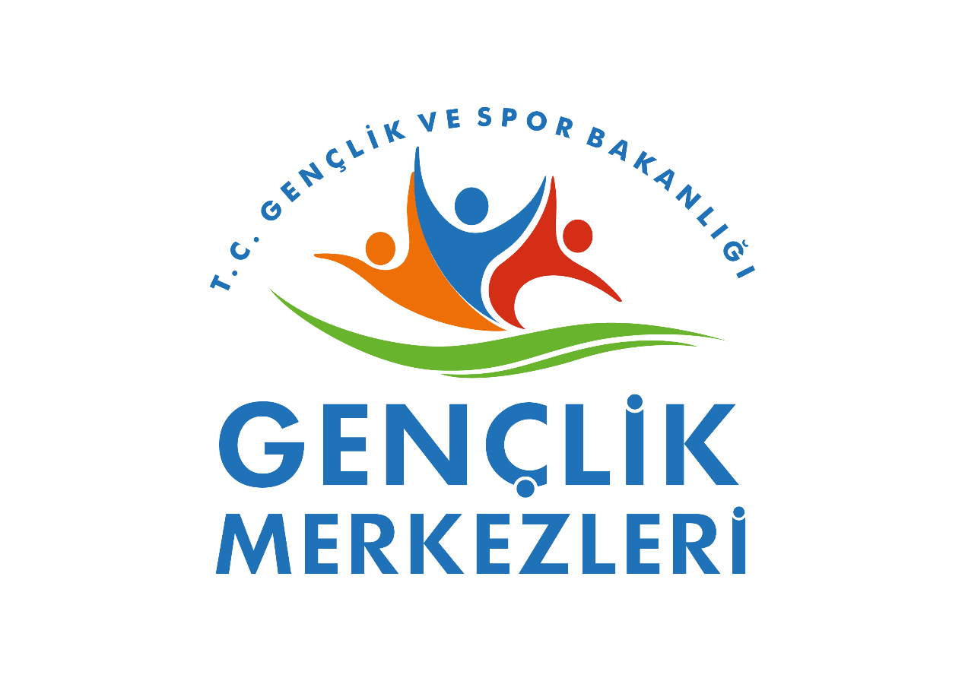
Partner Information Form
OID | E10406163
Legal name of the organization in Latin characters (if applicable) | Kırklareli Dr. Sadık Ahmet Youth Center
Acronym/Short name of the organization | DSAYC
Address | Karakaş Mahallesi Ihlamur Sokak No:3/1 Kırklareli/Türkiye
Region | Turkiye
Postal code | 39000
City | Kırklareli
Email 1 | semihozturk189@gmail.com
Phone 1 | +905512095191

Profile
Organization type | Common
Is the partner organization a public body? | Yes
Is the partner organization a non-profit organization? | Yes
Main sector of activity | Youth Centres are centres that carry out various activities, organise historical and cultural trips, camps and sports activities in order to protect the physical and mental health of young people, support their socio-cultural development, contribute to their education in related fields, and ensure that young people receive education in their own fields.

Background and experience
Please briefly introduce the organization (e.g. type, scope of work, areas of activity and ifapplicable, approximate number of paid/unpaid staff, learners | Our Mission:  To contribute multi-dimensionally to the cognitive, social, cultural, artistic, and physical development of young people; to raise them as responsible, active citizens who uphold national and spiritual values, and to guide them in discovering their potential.  Our Vision:  To be a leading, innovative, and inclusive center in youth work within the province of Kırklareli; to ensure the adaptation of youth to global developments through national and international collaborations.  Target Audience and Activity Areas:  This section summarizes whom the center serves and its areas of expertise.  Target Audience:  * Primary Target Group: Youth between the ages of 14-29 (the age range may vary according to the center's specific programs).  * Secondary Target Group: Volunteer youth, youth workers, university students, and the local community.  Opportunities We Offer to Potential Partners:  * Physical Space: Suitable physical venues for your activities, such as multi-purpose halls, training classrooms, a library, and workshops.  * Human Resources: Our staff of trainers, specialists, and youth leaders, along with our pool of volunteer youth.  * Local Network: Access to the extensive youth network in Kırklareli and established relations with local administrations.  * Institutional Capacity: The institutional experience of the Ministry of Youth and Sports in project management, dissemination, and reporting.
What are the organization's activities and experience in the areas relevant to this  project? | Key Activity Areas:  * Education and Development: Academic support, language courses, personal development seminars, technology and software training.  * Social and Cultural: Trips, camps, theatre, music, folk dances, Youth Clubs (Book, Debate, Cinema, etc.).  * Volunteering: Social responsibility projects, environmental awareness, support programs for the elderly and individuals with disabilities.  * Sports and Physical Activity: Sports activities and tournaments such as basketball, volleyball, and table tennis.  * International Studies: EU projects (Erasmus+), youth exchanges, and international volunteering programs.
What are the skills and competences of the staff/key people involved in this application? | Our full-time paid staff, part-time paid staff, volunteers and students have been trained in many areas, and our training staff has the capacity to quickly organize a training program and provide training on the skills required for your project.
Platforms for the dissemination and sharing of information and project results? | website social media platforms conventional media

C. ACCREDITATION
Has the organisation received any type of accreditation before submitting this application? |  |  | - no
Has the partner organisation participated in a European Union granted project in the 3 years preceding this application? |  |  | - yes
EU Programme | Year | Project Identification or Contract Number |  | Applicant/Beneficiary Name
Erasmus+ Ka-152 | 2024 | 2024-1-TR01-KA152-YOU-000234090 |  | Game Journey From Past to Present

Contact Person

Title | Mr.
Genre | Man
First name | Semih
Last name | Öztürk
Department
Position | Contact Person
E-mail | semihozturk189@gmail.com
Phone 1 | + 905512095191
Address | Karakaş Mahallesi Ihlamur Sokak No:3/1 Kırklareli/Türkiye
Country | Türkiye
City | Kirklareli
Postal code | 39000

Legal Representative

Title | Mr
Genre | Man
First name | Kenan
Last name | Mete
Department
Position | Legal Representative
E-mail | kenan.mete@gsb.gov.tr
Phone 1 | +905359373819
Address | Karakaş Mahallesi Ihlamur Sokak No:3/1 Kırklareli/Türkiye
Village | Türkiye
City | Kirklareli
Postal code | 39000

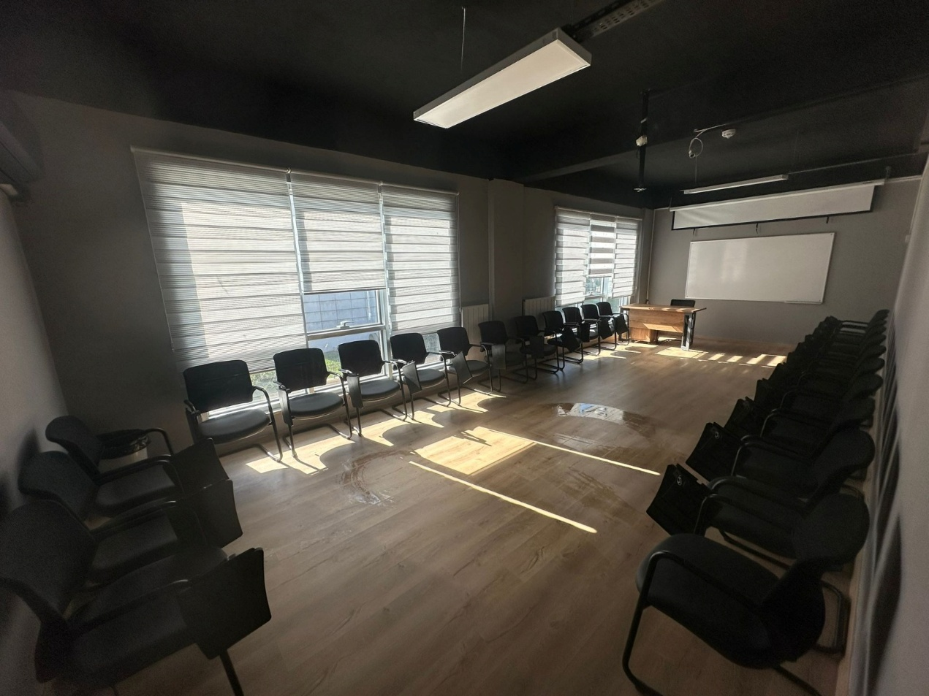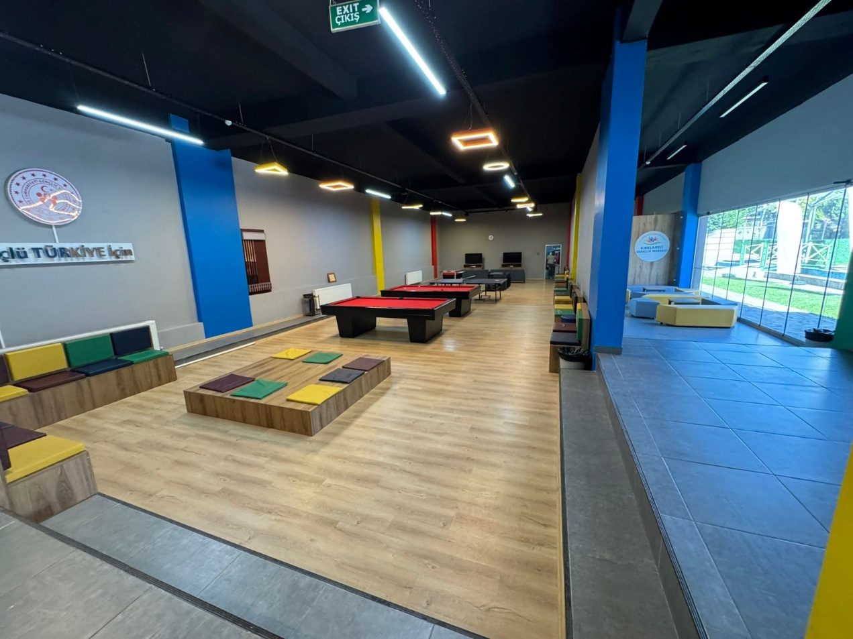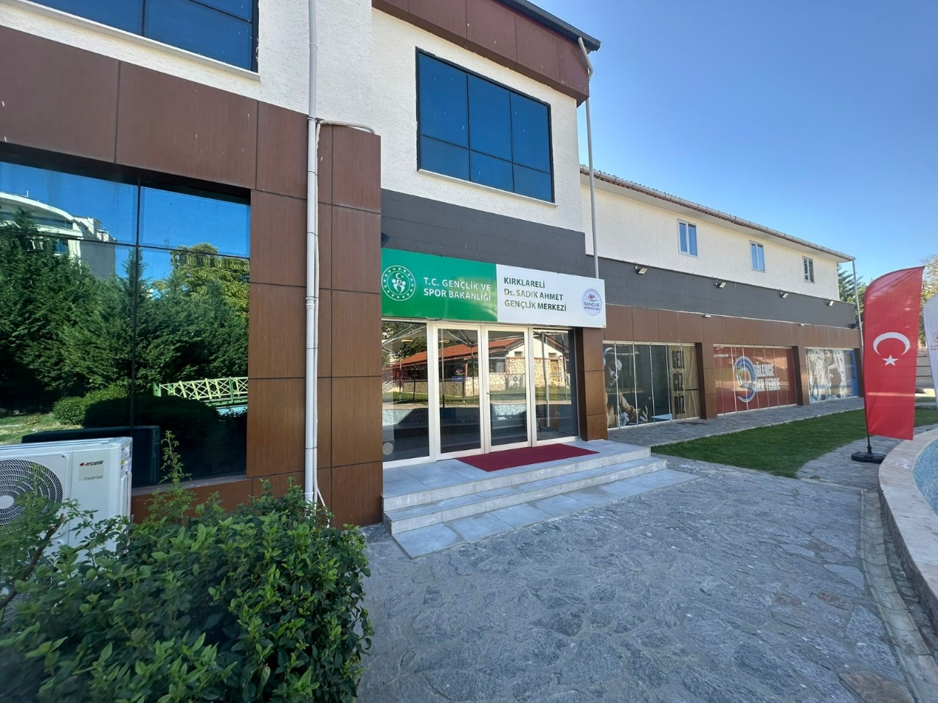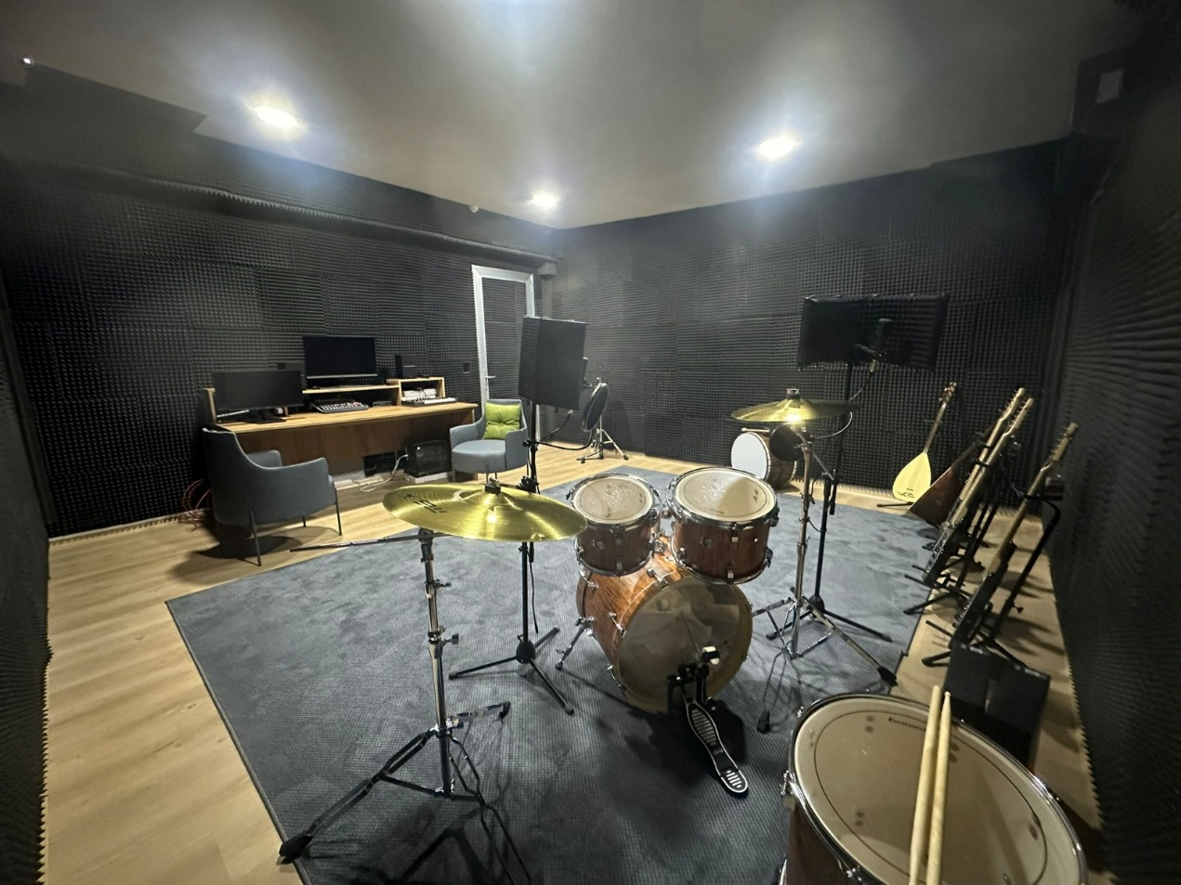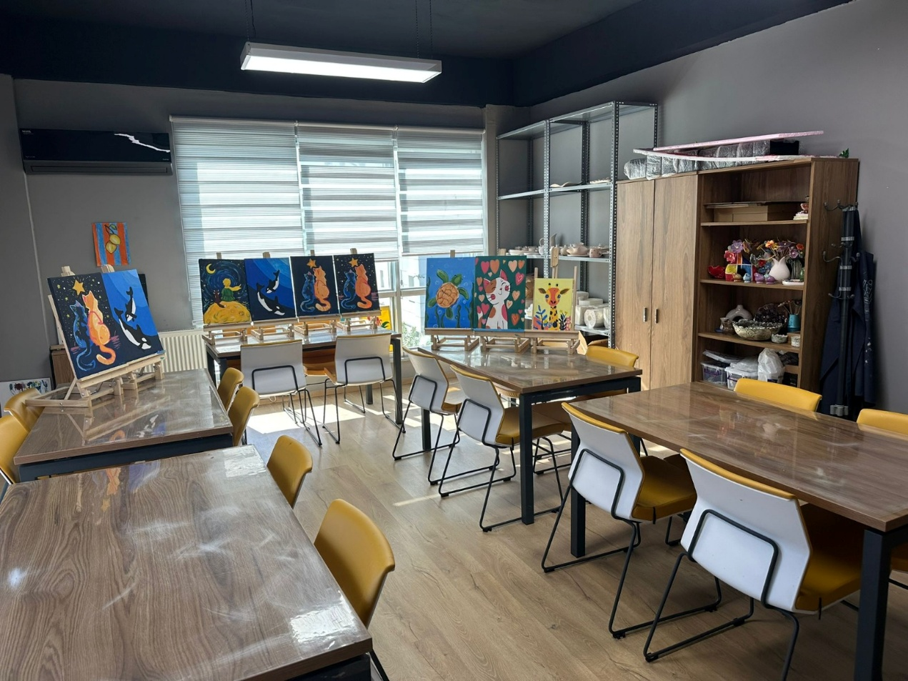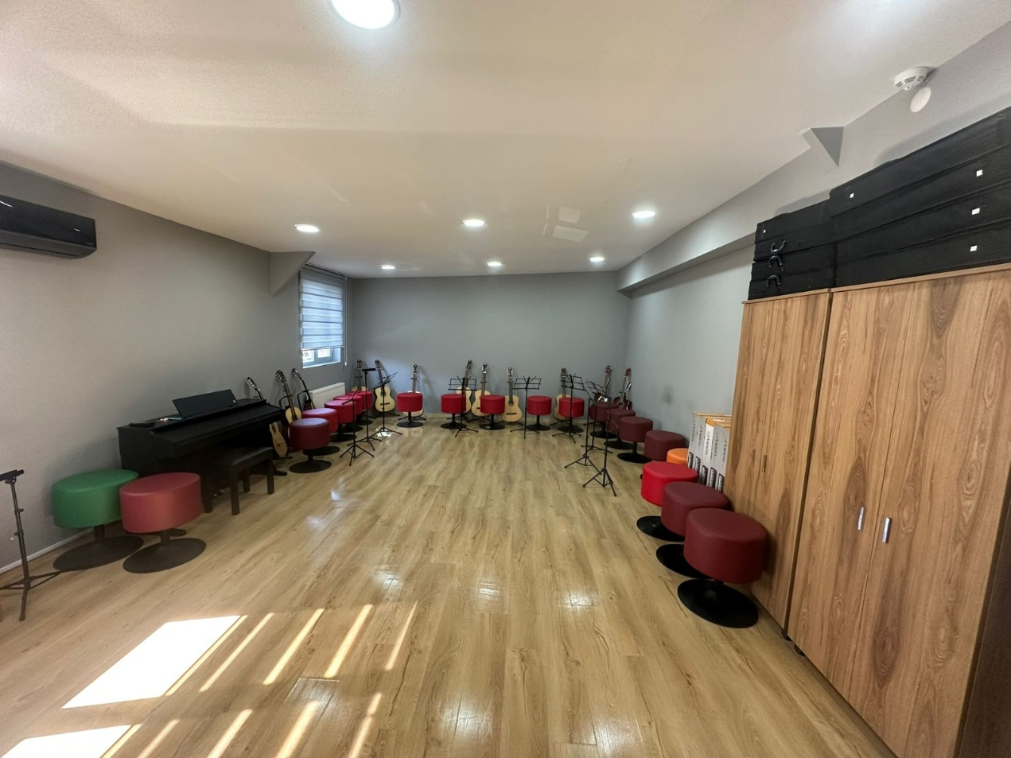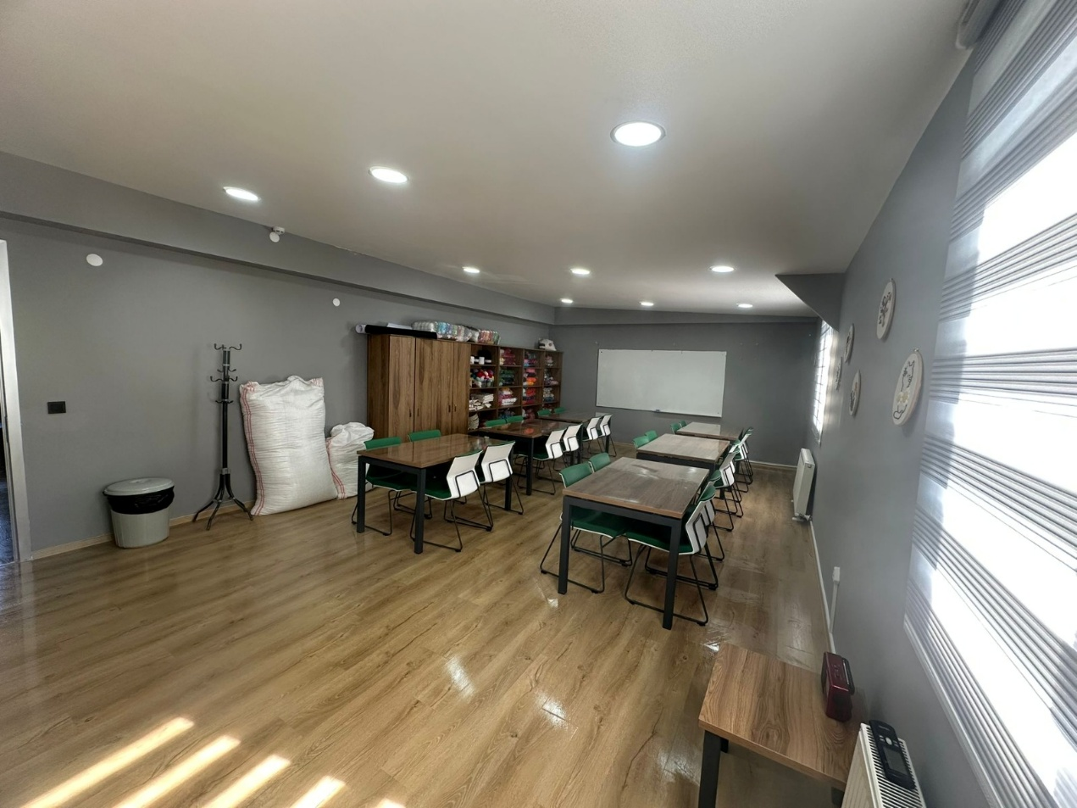

Back and Experience

Game Journey From Past To Present

Erasmus+ KA152 2024 2024-1-TR01-KA152-YOU-000234090

Project Location and Date: February 1-February 10, 2025/ Kırklareli-Center
Project activity area: Hotel, Kırklareli Youth Center
Countries: Lithuania, Ukraine and Poland
This project aims to revive forgotten cultural heritage by adapting traditional children's games to the modern age and introducing them to young people. By hosting participants from Kırklareli, Lithuania, Ukraine and Poland, intercultural interaction was ensured and a game atlas reflecting cultural diversity was created. In addition, different types of games were experienced by emphasizing that games are not limited to technological devices.
A total of 8 people aged 18 and over from each country participated in the project and a team of 35 people took part in total. There were 9 participants from Turkey and 24 participants from abroad. During the event, 2 Turkish trainers were in charge and all accommodation, travel and food expenses were covered by the Turkish National Agency.
Within the scope of this project, traditional games played in the streets and schools in the past were reminded and awareness was raised against the inactivity brought by the technological age. Participants were selected among individuals who are familiar with their own culture and open to exploring different cultures. At the same time, this project was the first Erasmus+ project of Kırklareli Youth Center and promoted Kırklareli. Finally, a successful project process was realized and the participants were gladly sent off to their countries.

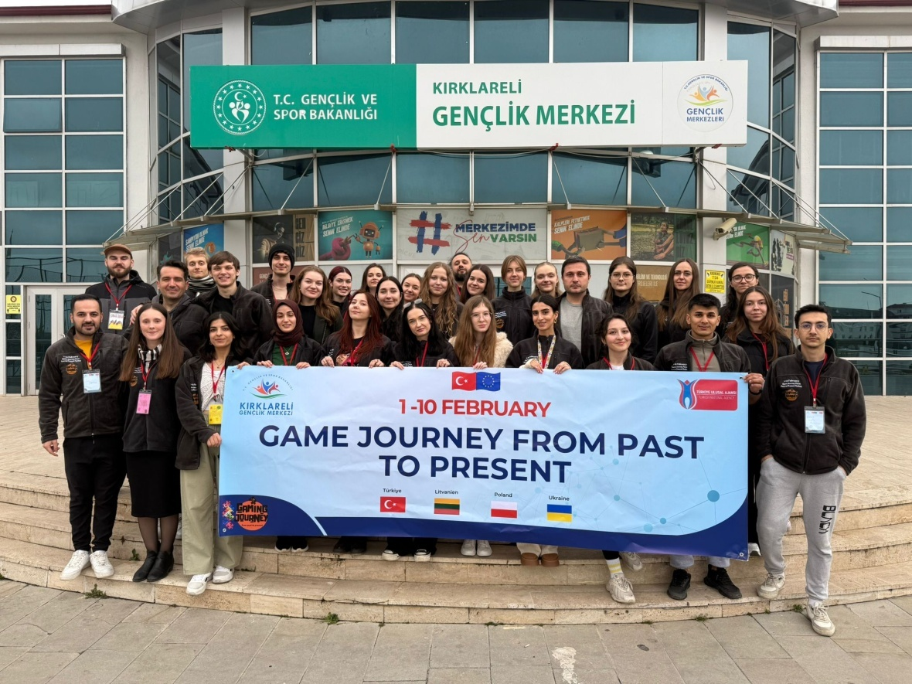02.02.2025