
Training course for youth leaders on how to fight against gender-based discrimination and violence “Gender equality creators”
Georgia, 7 days in August 2013 (tbc)

General idea:
Although equality between men and women should be an obvious thing in the 21-st century, this is unfortunately not yet the reality and many forms of gender-based discrimination and violence still exist.

We are organizing this project to help active young people (youth leaders) to become more gender-aware and sensitive to be able to detect situations and contexts where there are gender discrimination and violence and to take action to promote gender equality both locally, nationally as well as in international contexts.

Contents of this non-formal training:
- Developing awareness and understanding about various concepts related to gender issues, especially gender-based discrimination and violence
- Discovering realities when it comes to gender inequalities in different countries
- Discussing the “power” of youth work to promote gender equality at various contexts
- Sharing and creation of tools to fight against gender-based discrimination and violence
- Empowering participants to become active promoters of gender equality (“gender equality creators”)
- Partnership building and common project ideas (“Youth in Action” programme, etc.)

Participants:
24 participants from Programme Countries (EU, Turkey, Norway, Lichtenstein, Croatia and Swissland) and Eastern Europe and Caucasus (Armenia, Azerbaijan, Georgia, Moldova, Ukraine and Belarus) – 3 representatives from each country.

The course is designed for active young people that would like to share their knowledge with the others through peer-to-peer approach, youth leaders, educators and youth workers, who work represent some institution or organization and work with youth, who are willing later on to act as multipliers by sharing their knowledge and implementing activities that promote gender equality. As the training course will be carried out in English, participants must have a good command of English.

Financial conditions:
The training course will be implemented in the framework of EU “Youth in Action” Programme – Eastern Partnership Youth Window. The accommodation, food and visa fees will be covered fully. Travel expenses will be reimbursed at 70% of the real cost (with cheapest mean of transportation) in return of original tickets/invoices. Insurance should be arranged and covered by each participant.

Application procedure
If you are interested participate in this project, please (1) fill in the application form and (2) fill in, sign and put a stamp on “Preliminary agreement” (both of them you can find below) and send them to: guri.koiava@gmail.com

Deadline: 18-th January, nevertheless, should we have good candidates before this time, we would be closing the application deadline earlier.

Should you have any questions, please do not hesitate to contact us:
Gurieli Koiava (guri.koiava@gmail.com;+371221151159) or Salome Chagelishvili (salome090@yahoo.com)

Part A: IDENTIFICATION OF THE PROMOTER
Promoter
Role in the application
Promoter’s legal name (national language)
Promoter’s legal name (latin characters)
Acronym, if applicable
National ID number, if applicable
Department, if applicable
Legal address
Postal code
City
Country
Region
Web site
Email
Telephone
Fax
Person authorised to legally commit the promoter (legal respresentative)
Title
Family name
First name
Position
Email
Same address as the organisation
Telephone
Fax
Person responsible for the implementation of the action (contact person)
Title
Family name
First name
Position
Email
Same address as the organisation
Telephone
Fax
PART B. PROFILE OF THE PROMOTER
Status | Private (PR) |  |  |  | Public (PB)
Type | Non profit/non governmental organisation (NFP-NGO) |  |  |  | Informal group of young people (NFP- IGYP)
 | Body active at European level in the youth field (NFP-ENGYO)
Activity level | Local (L) Regional (R) National (N) European (E)  International (I)
Objectives and activities of the promoter
Please provide a short presentation of your organisation/group (usual activities, affiliations, etc.) in relation to the field covered by the project – gender issues, gender-based discrimination and violence.
Please describe the role of your organisation/group in the project – how could you contribute
Do you have some good practice examples working on promotion of gender equality?
Motivation
Why is it important for your organization to participate in this project?
What kind of participants do you plan to delegate to participate in this seminar? How you will find them and select them?
Travel cost
Please provide us with the travel cost from the place your organization is registered until Tbilisi and back (if you would be buying a ticket 10 days in advance the travel date...).
Please mention also the means of transportation (bus, train, plane...).
Other community funding
Please give information about any type of EU grant your organsiation/group has received/applied for in the last financial year.
Programme or initiative |  | Identification/contract number |  | Contracting promoter |  | Title of the project

 | 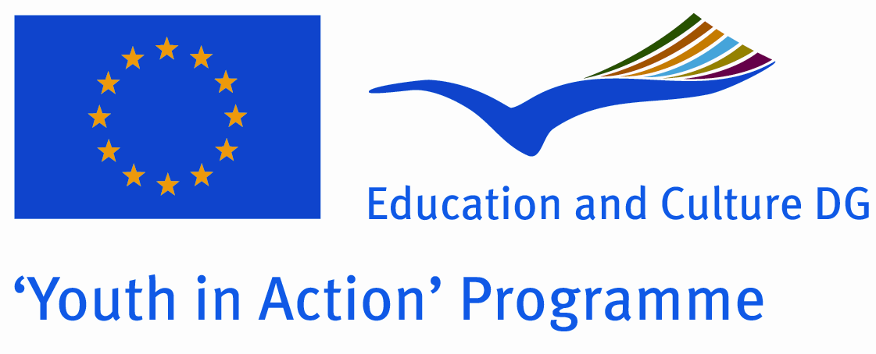

Preliminary agreement of the partner

- To be signed by the person authorised to enter into legally binding commitments on behalf of the partner

I, the undersigned confirm the participation of the organisation:

(Full name of the organisation as stated in Part A.1 of the application form)
for which I am acting as legal representative in each stage of the project entitled:
“Gender equality creators”
I declare having reached an agreement with all the promoters involved in the project with regard to the share of EU grant my organisation/group is entitled to receive in order to implement the project.
I confirm that my organisation/group has not applied for funding for this project to another National Agency or to the Executive Agency.
Furthermore, I confirm my undertaking to ensure visibility of the European Union support for the project and to ensure dissemination and exploitation of its results.
Partner organisation: |  |  | Stamp  (if available)
Legal representative:  (Mr/Ms Surname, First name) |  |  | Stamp  (if available)
Position/function in the organisation: |  | Signature

