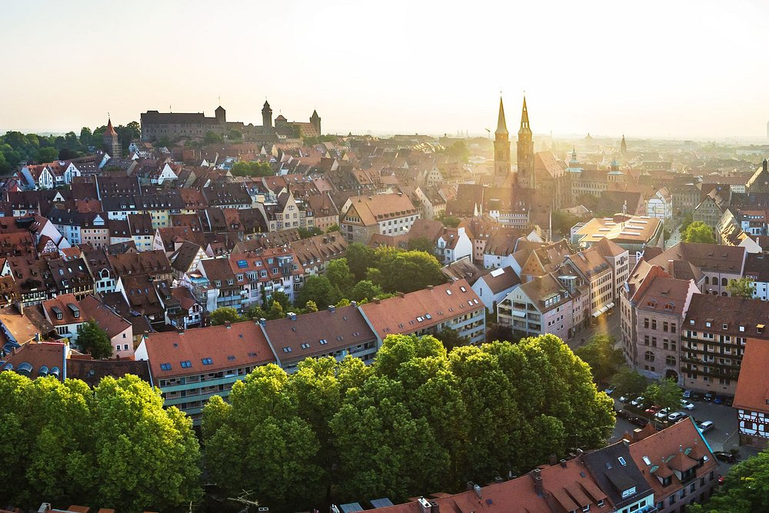

**EVENT**

**“Embrace Technology, Engage as an Active Citizen”**

CALL FOR PARTICIPANTS FROM GERMANY AT OUR EVENT in NUREMBERG! Please register today.

https://docs.google.com/forms/d/e/1FAIpQLSfI8U_a_gz37LxyV0PJZ11pBDo2_yFdcNu3lGOFeNRyHkSaQA/viewform

The main event will take place on **25.05.2025**

NUREMBERG/ GERMANY

**INFORMATION ABOUT THE PROJECT**

Our general goal is to ensure that young people are proficient in digital tools in today's technology age, participate in policy-making processes, influence decision-makers, and are knowledgeable about their rights and responsibilities in the digital world. Implementing a youth participation program in this context will be one of the most effective ways to achieve this goal.

Specific Objectives:

● To raise awareness among young people about media literacy, access to accurate information and data verification.

● To inform young people about human rights and motivate them to defend their rights using digital tools, both at the local and European level.

● To educate young people about participation in democratic life and policymaking processes using digital tools, teaching them about their responsibilities and best practices.

The project will enhance media literacy among youths, equipping them with skills to discern accurate information and combat misinformation. It will raise awareness about human rights, empowering young people to defend their rights using digital tools at local and European levels. Additionally, it will educate them about participating in democratic processes and policymaking, fostering responsible civic engagement and understanding of their roles in democracy.

They will exhibit enhanced media literacy, enabling them to critically evaluate information and media sources. Their heightened awareness of human rights will empower them to actively defend and promote these rights using digital tools.

Additionally, their engagement in democratic processes and policymaking will be more informed and responsible, leading to more active and effective participation in civic life. This will foster a generation of well-informed, proactive citizens ready to contribute positively to society

***Adress***

**Bahnhofstr. 13-15  
Mitte  
90402 Nürnberg  
Germany**

**Conference room and event day**

The main event will take place on 25.05.2025

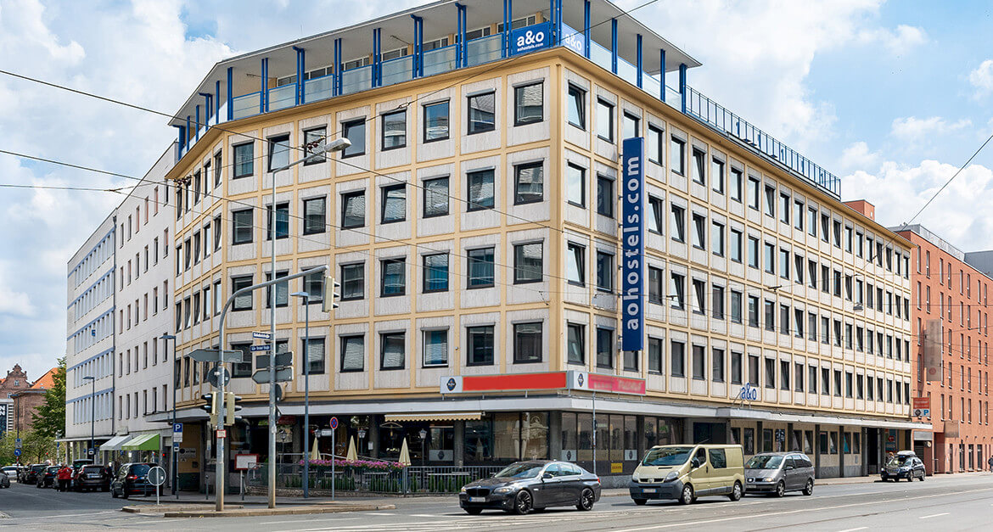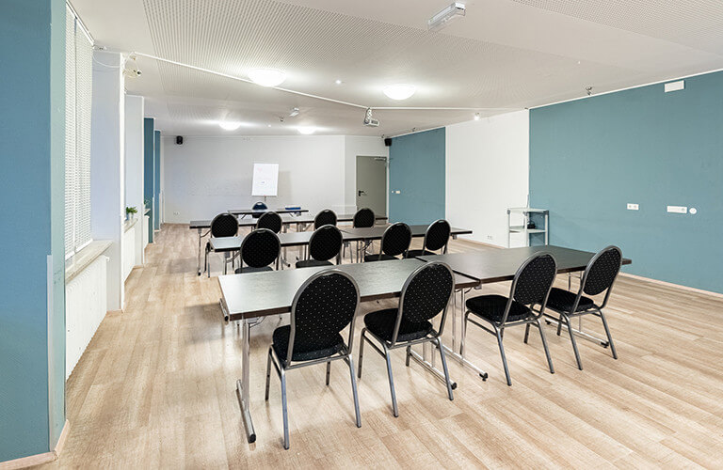

There wil be participants from Germany, Hungary, Romania and Turkey with 50 participants from Germany.

**About the event**

At the meeting, which will be attended by local policymakers and various NGOs, a presentation of the project and its results will be made first. Then, the detailed digital active citizenship guide prepared by the participants will be shared.

Storytellings: During the project activities, participants will create a storytelling project using the methods and knowledge they learn, which they will share through the internet. This application will not only enhance their digital skills but also serve as a dissemination tool.

Discussion, research, brainstorm: participants, activities, group work and brainstorming constantly in discussions, presentations and research for practice and will gain confidence in expressing their minds.

Energisers and Ice breakers: participants will play different games during the first days of the project, every morning and every afternoon before the activities, so that they will get to know each other better and group dynamics can be achieved more easily.

CONTACT

**E-mail:** Sanda-Daniela Alexeiciuc: [danielaalexeiciuc@gmail.com](mailto:danielaalexeiciuc@gmail.com)