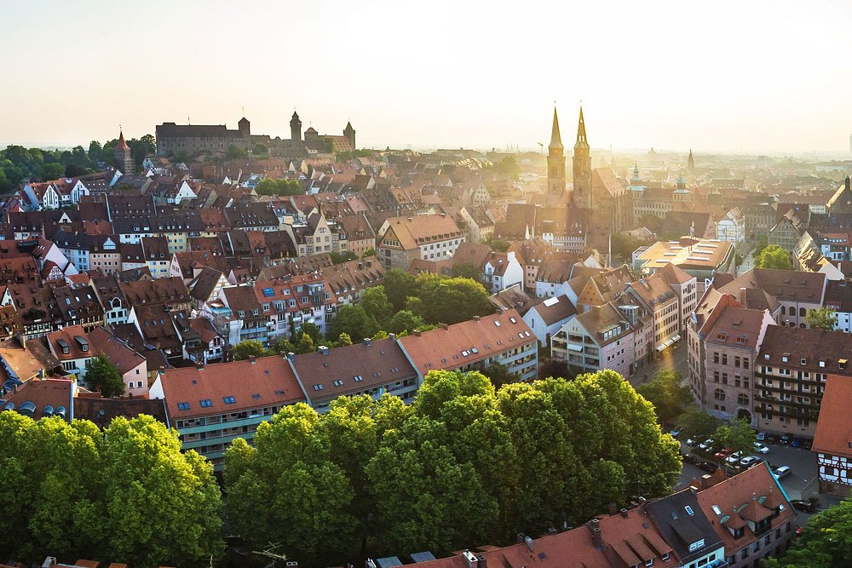
Info PACK
Please read the given information carefully and do not hesitate to ask questions
KA1 154 titled
“Embrace Technology, Engage as an Active Citizen”
CALL FOR GERMANY PARTICIPANTS
NUREMBERG/ GERMANY
INFORMATION ABOUT THE PROJECT
Our general goal is to ensure that young people are proficient in digital tools in today's technology age, participate in policy-making processes, influence decision-makers, and are knowledgeable about their rights and responsibilities in the digital world. Implementing a youth participation program in this context will be one of the most effective ways to achieve this goal.
Specific Objectives:
● To raise awareness among young people about media literacy, access to accurate information and data verification.
● To inform young people about human rights and motivate them to defend their rights using digital tools, both at the local and European level.
● To educate young people about participation in democratic life and policymaking processes using digital tools, teaching them about their responsibilities and best practices.
The project will enhance media literacy among youths, equipping them with skills to discern accurate information and combat misinformation. It will raise awareness about human rights, empowering young people to defend their rights using digital tools at local and European levels. Additionally, it will educate them about participating in democratic processes and policymaking, fostering responsible civic engagement and understanding of their roles in democracy.
They will exhibit enhanced media literacy, enabling them to critically evaluate information and media sources. Their heightened awareness of human rights will empower them to actively defend and promote these rights using digital tools.
Additionally, their engagement in democratic processes and policymaking will be more informed and responsible, leading to more active and effective participation in civic life. This will foster a generation of well-informed, proactive citizens ready to contribute positively to society


FIRST MOBILITY
Day of arrival in Germany: 11.05.2025
Day of departure from Germany: 17.05.2025

PROJECT VENUE
Jugendschulungshaus Karlstein
Address:
https://jugendschulungshaus.org/karlstein-journal/
Birkenzanter Straße 7
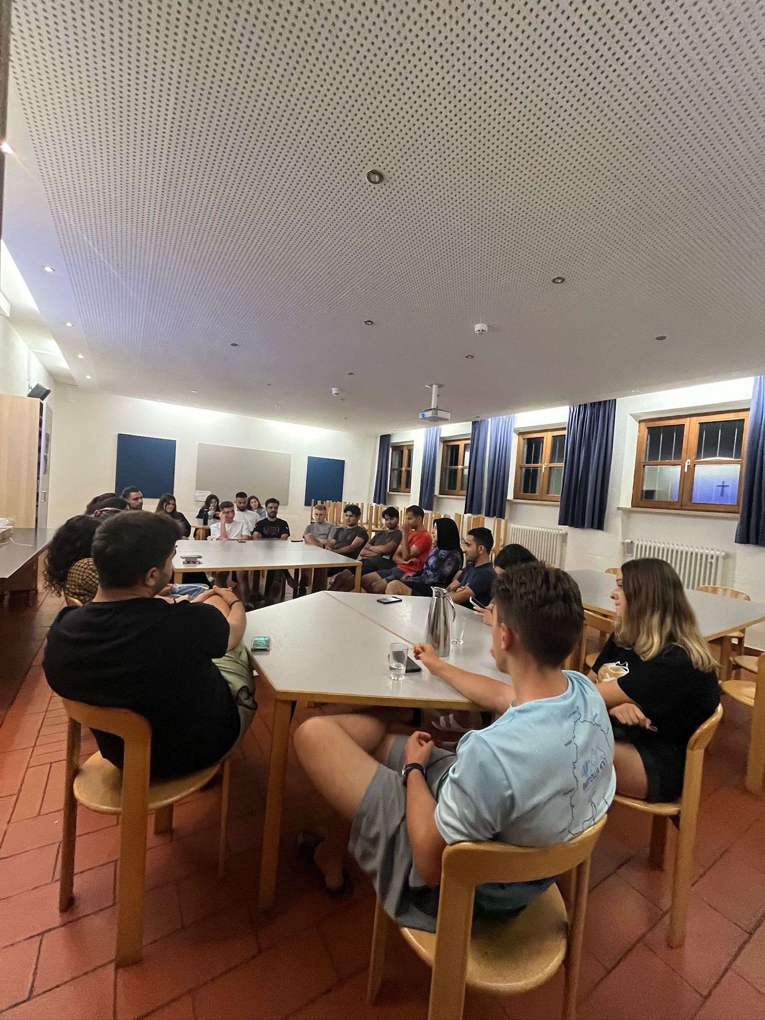
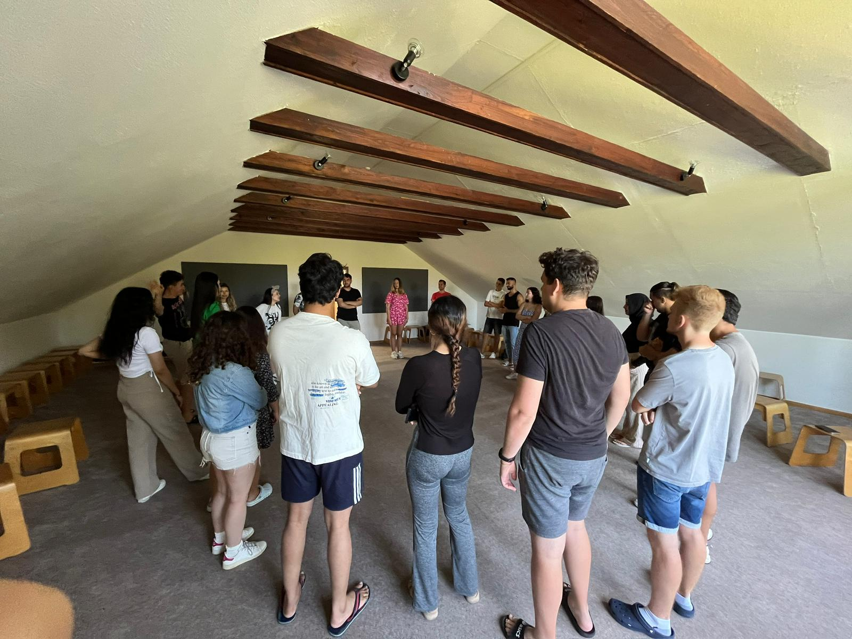
93128 Karlstein bei Regenstauf, Germany

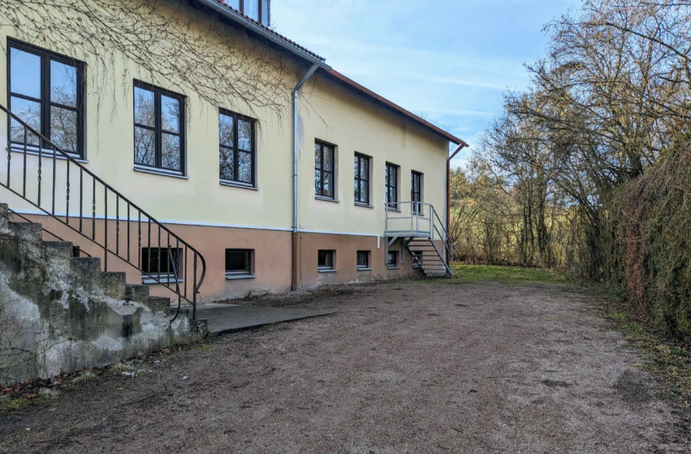

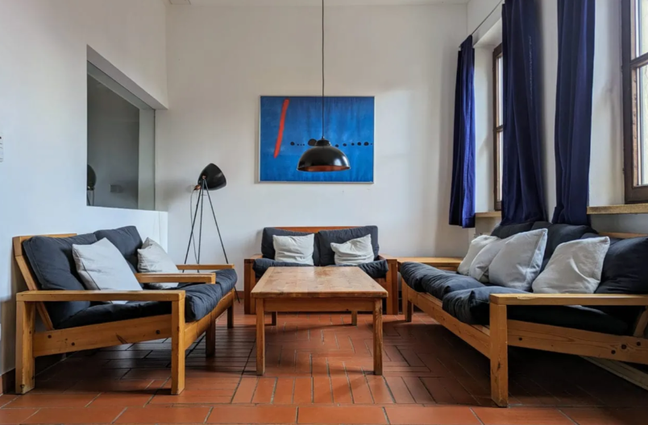

- We will stay in mixed rooms according to gender. We will have 3 meals a day at the hotel. There will be shared bathrooms and toilets according to gender.
- Slipper, shampoo, towels, bed linens etc. (personal belongings)
- hoodies, jackets (Weather can be a bit colder at night in Germany

We will have INTERCULTURAL NIGHTS.

Please bring something representing your country (food, drinks, sweets, etc.). During the Intercultural night, you can represent your country using presentations, videos songs, or dances. Please discuss everything with your national teams to coordinate it in advance.
LANGUAGE OF THE PROJECTS
English is the general language of the projects, but during our activities group leaders will arrange and organize the translation in order to facilitate full understanding and the effective communication between participants.

BACKGROUND OF THE PARTICIPANTS

- Youth workers, leaders, trainers, multipliers
- High motivation
- From 18-28 years old
- Gender balance among national groups preferably
- English proficiency is required
- People who are open to learning about the topic,
- High motivation on interculturality and the importance of cultural value.
NUMBER OF PARTICIPANTS
There will be participants from Germany, Hungary, Romania and Turkey.
The age limit for participants is 18-28 years old
Country | Number | Travel
Germany  (GREEN TRAVEL) | 10 participants | Grant per participant 50 EUR for travel cost


TRAVEL AND RULES
Booking Tickets
- Choose the most optimal tickets for your travel.
- Do not purchase tickets without prior confirmation from the project coordinator. Tickets bought without confirmation will not be reimbursed.
Documentation
- Keep all boarding cards, e-tickets, invoices, and bus/train tickets. These documents are necessary for reimbursement. Tickets should always be accompanied with the boarding passes, when requesting the travel reimbursement.
- Lost documents will result in reimbursement issues.
Reimbursement rules
- Reimbursements will be processed at the event once we have all tickets or bank transfers if we miss something.
- Attendance of at least 80% of activities is mandatory for reimbursement eligibility.
- The participants are invited to use the cheapest means of transportation.
TO KEEP IN MIND
- On the project, please make sure to take with you a standard set of medication, including specific medications, if there's anything you need to take regularly.
- After the selection of participants, a Google form will be sent to know about participants' allergies, diets, etc. But please, think about your personal diet needs and if there's anything you doubt to find in Germany, bring it with you, as we cannot guarantee the providence of very specific dietetics.
- Please at least one person from each team bring digital devices like laptop, phone, camera, iPad. We will use them during the workshops
- Participants needs to be responsible of attending all the activities and being respectful and positive.
- The participants will have the following tasks: 1. To complete the Participant’s mobility report sent by EU. 2. Implement at least one activity for publicity sharing the result of the project (blog interview, article, FB post, etc.), and make at least one follow up activity using the experience from the training (individually or together with another person from the same country). 3. Everything else that they could do or organize as a dissemination of the project will be warmly welcomed and appreciated from us.

TRANSPORTATION TO THE VENUE
Hotel address: Birkenzanter Str. 7, 93128 Regenstauf, Germany
- Everyone will come to the closest train station (REGENSTAUF TRAIN STATION) from airports. From this station there are buses or if there is no bus at that time, organization members will pick you guys up in a car in small groups.
- Pick-up shots can only start around 4.30 pm on the 11th of May 2025.
TICKETS
1st option: 1st option is to book your tickets at the airports (from the ticket machines) according to your routes for going and coming back. It will cost around 30 € one way as we checked on the internet. (From Nuremberg and Munich Airports)
2nd option: there is a monthly ticket in DB application (Unlimited travel for just 58€ per month)
It is Valid throughout Germany on all local public transport (not valid in ICE, IC/EC high speed trains)
https://www.bahn.com/en/offers/regional/deutschlandticket
YOU CAN BOOK THIS TICKET AND YOU CAN TRAVEL FREE DURING THE PROJECT. But please note that the Deutschland Ticket is only available by subscription. So, you need to cancel your subscription until 10th of May (YES IT WILL BE STILL VALID TILL END OF THE MONTH)
*BE SURE THAT YOU SUBSCRIBED YOUR TICKET ONLY FOR MAY 2025. Otherwise, it will charge you in June as well!

You can only buy this ticket on website or on the application, so you can not buy on the spot/train stations.
2 website to book this monthly ticket:
* DB navigator app and DB websites https://int.bahn.de/en/offers/regional/deutschland-ticket
* VVS MOBİL APP: https://apps.apple.com/it/app/vvs-mobil/id408372353?l=en-GB
*In both apps you will get a ticket with QR code, and you will use this QR code every time.
EXAMPLE ROUTE: you can check routes from DB navigator app or on Rom2rio website. Platforms and train number may change everyday
- From Munich Airport:

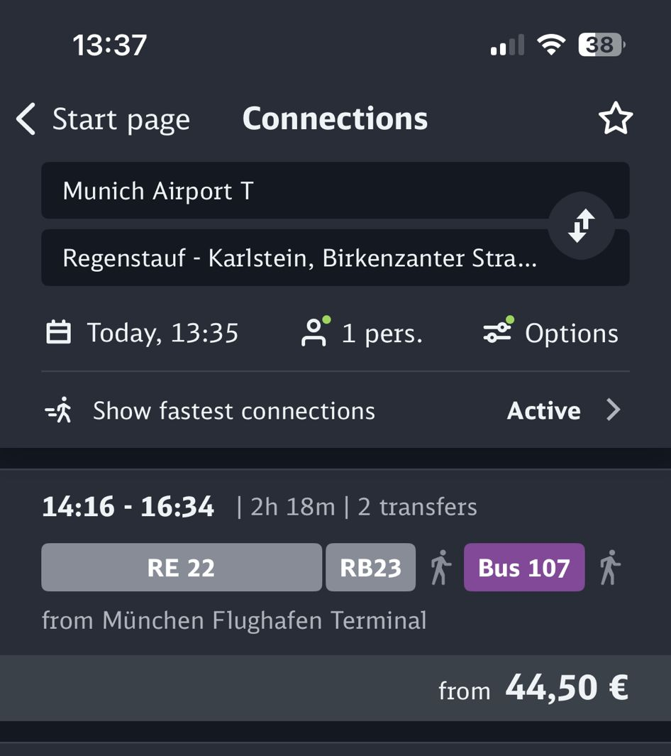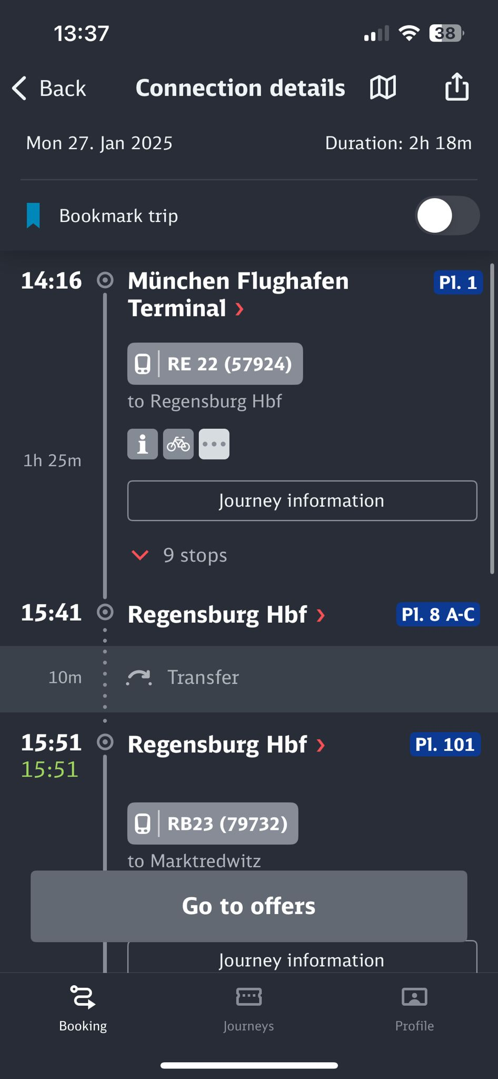
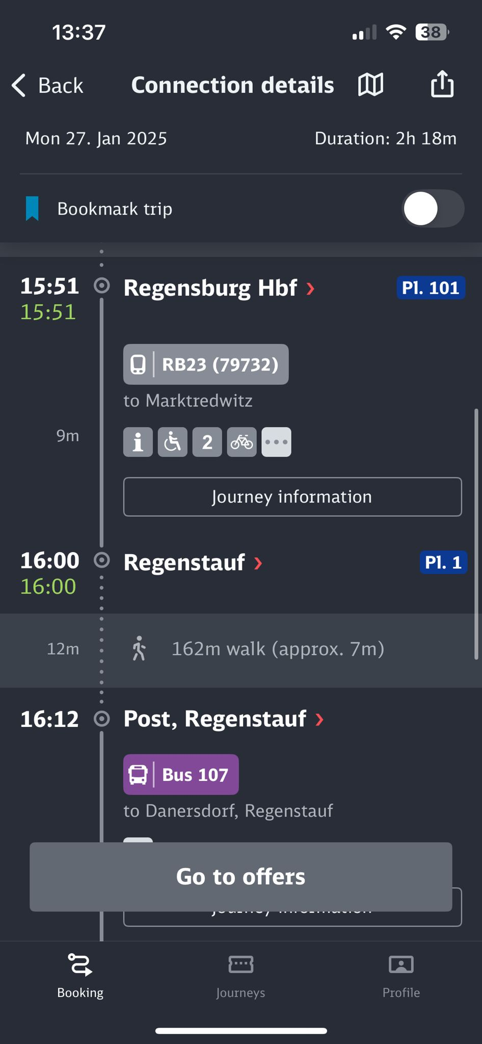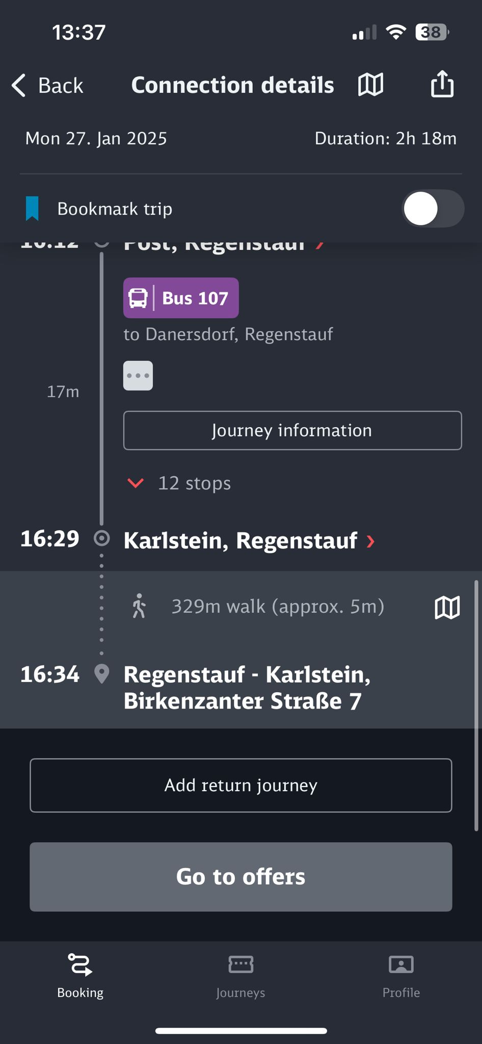

- From Nuremberg Airport
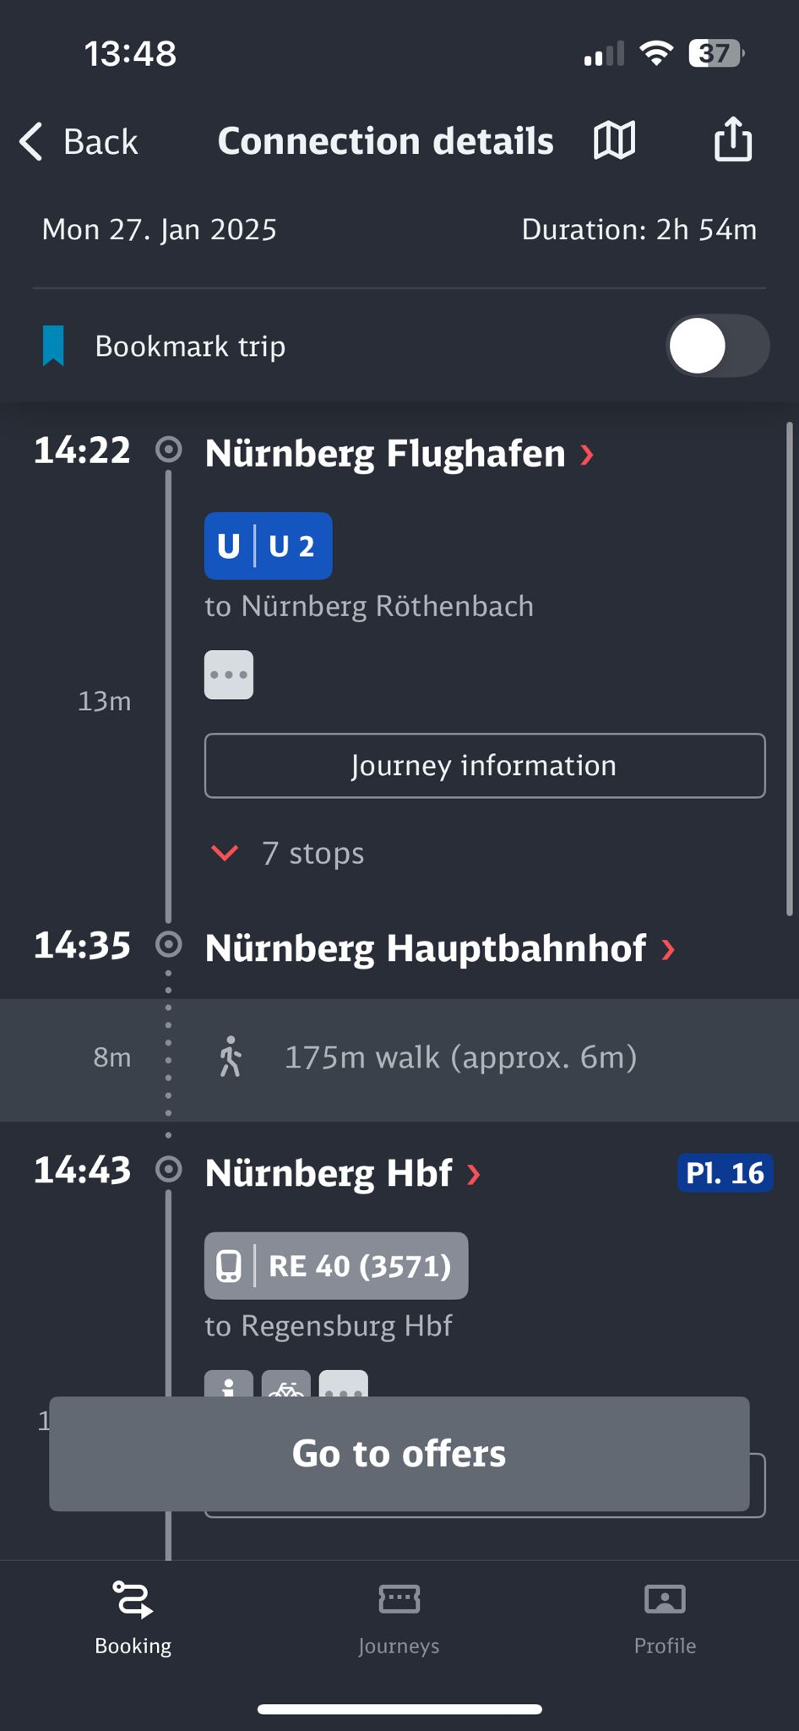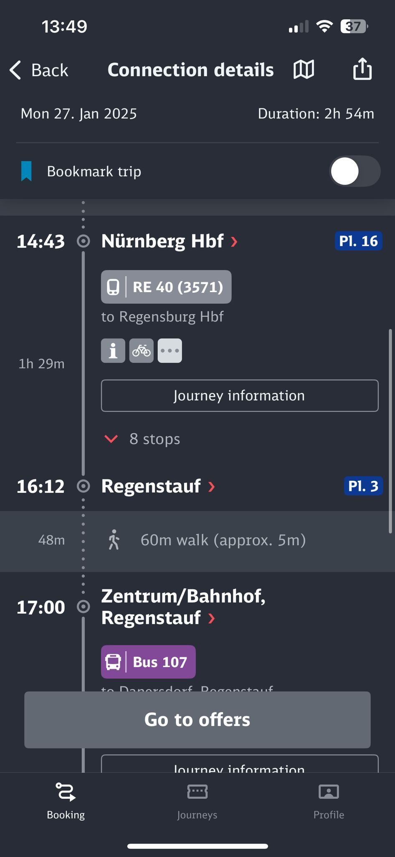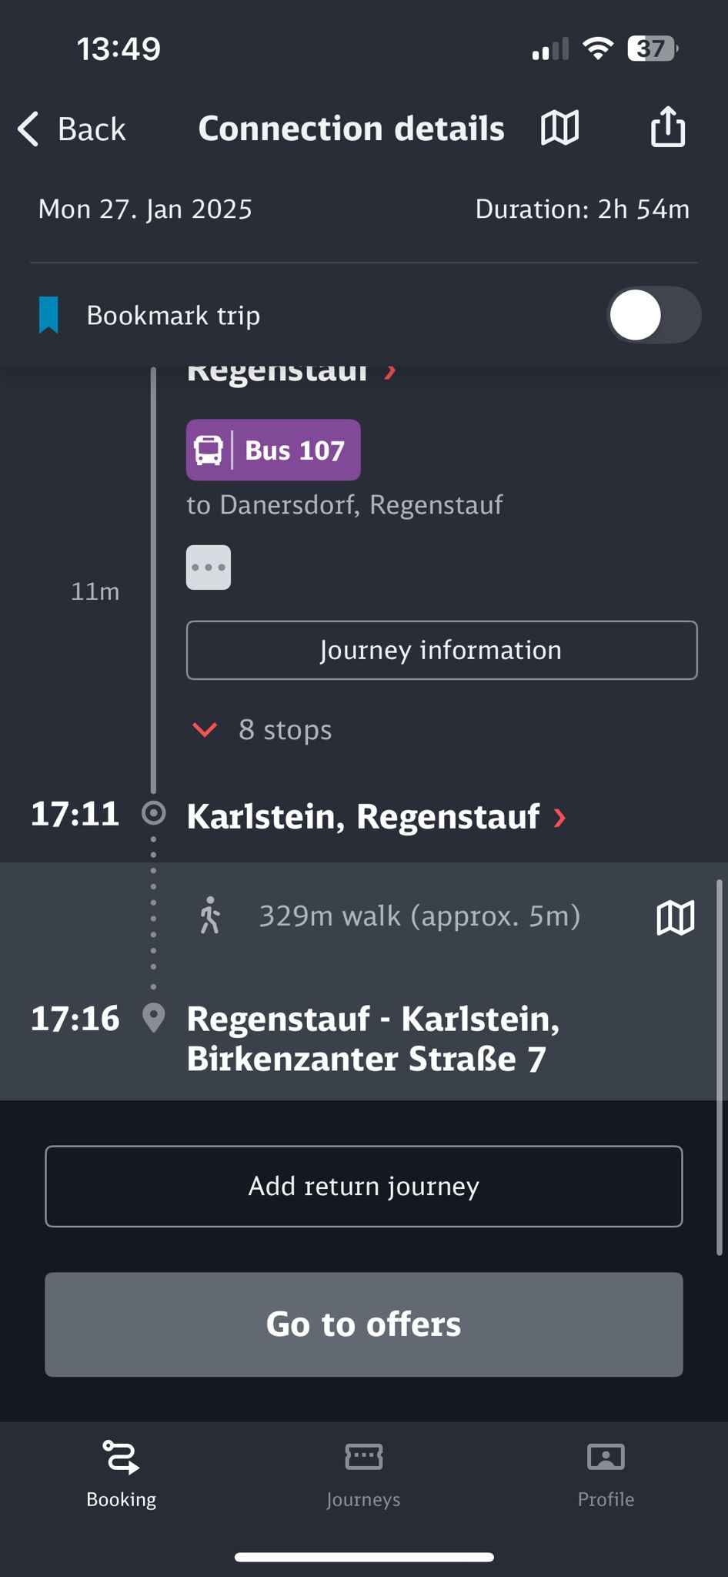

CONTACT
E-mail: Changemakers Debrecen: psiho.community@gmail.com
https://www.facebook.com/changemakerscm

