PIC Number | 888869686
OID | E10284020
Legal Name | ERMİŞLER CUMHURİYET ANADOLU LİSESİ
Business Name | ERMİŞLER CUMHURİYET ANADOLU LİSESİ
Address | 1.Gündoğan Neighrhood Gülhan avenue Güneş street Number:1  ALTIEYLUL /BALIKESIR
CAP
City | Balıkesir
Region | Anatolia
Country | TURKEY
Email address | 755990@MEB.k12.tr
Tel. number | +902665025876 contact person:+905054743948
Website / Social Media | bcal.meb.k12.tr
Type of organisation | Secondary education (high school) students aged 15-18
Public body | yes
Not-for profit | Yes
Legal Representative (Name, Family Name, position, phone number, email address) | AYHAN VARLIK – School Principal - +905058960048
Contact Person (Name, Family Name, position, phone number, email address) | Yasemin KILIÇ English teacher +905054743948  ya-se-min82@hotmail.com eltjasminteacher@gmail.com
Background information and expertise | 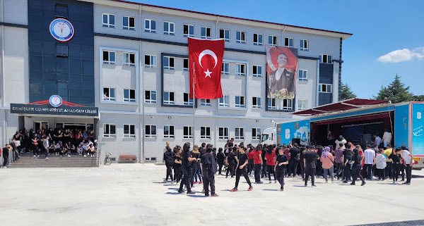  Our school has started teaching since 2005.Our first grad students graduated in 2008-2009 Education Term. We have successful academic standing with the %85 percentage of our students’ success on university exam. Not only do We score remarkable outcomes on social and cultural activities but also sportive areas by the help of experienced educators and talented students every year.  FACILITIES  Our school with the dormitory ,capacity of 96 male students, has conference room (120 people capacity)and dining hall .78 students are hosted in our dormitory There are four students in each room. We have an indoor facility which has 350 seats and a basketball court.  We are comprised of a great executive group with Fifty-seven teachers, A school principal ,four deputy managers, three school maids and 796 students. We have teachers in different branches maths ,music ,religion ,chemistry , physics ,PE,IT ,Drama ,Turkish Language and literature ,English Language and Literature , Deutsch, biology …etc 16 proficiencies.  Our school, which provides education with modern education tools and expert teaching staff continues to service with good education policies.  One of our students came first in robotic Olympics which is an important robot organizations of Turkey. Our female oryantiring team has come first for five times nation wide.Moreover our male futsal team has come first twice nation -wide too. One of our student came second in Muay Thai Martial Sport tournament in Marmara Region.  1.What are your main activities?  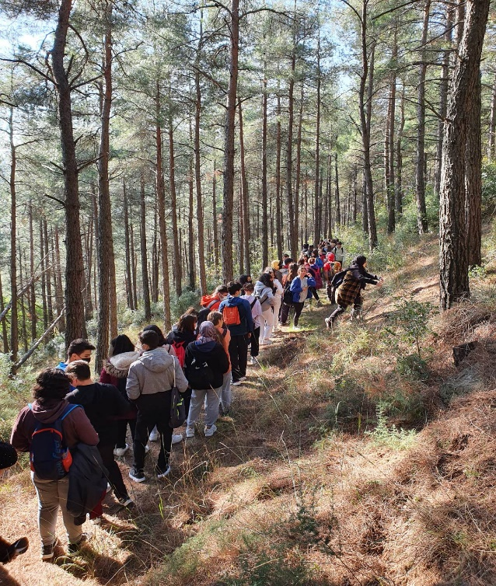  Our school (public school)Cumhuriyet Anatolian High School has the students at the age of 14-18 .The school campus is located in the city center of Balıkesir,having lots of tourist attractions with ıts natural beauty and outstanding beaches.The main target of our school is to pave the way for our students enrolling in best qualified universities not only nationwide but also worlwide.Our school involves three fundamental departments as Maths and Science -Literature and Maths-English Language classes.We are an academic school preparing students for university exam.Besides We mainly focus on both increasing our students’ cultural awareness and improving their social skills.To fulfill these aims ;We have several pupils’ clubs such as futsal ,Drama,Music band,Intelligence games,climbing,orienteering.We are joining world orienteering championships this year 2022/2023 education term  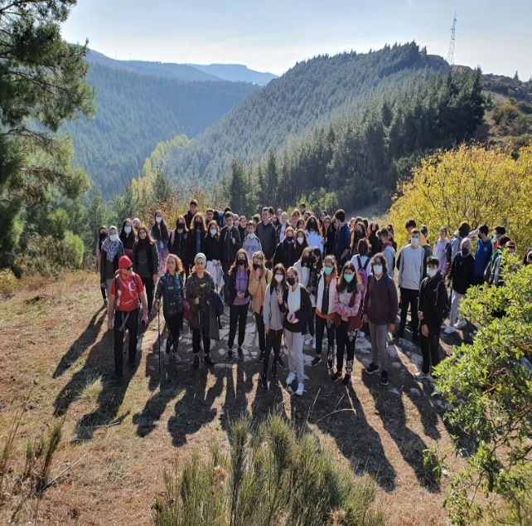  2.What are your school activities in the field of this applications?  In our school Each class has its own smart board with the Internet access furthermore; We have an ICT class seperately.We center on using technological tools for achieving our educational goals.The whole teachers in our school has attended in several courses such as dijital literacy of English teaching ,Innovative thinking on English teaching,Methods and techniques on eavluation of online English speaking skills,preparing digital teaching material with web2.0 tools,usage of interactive smart boards….etc.  As a twenty-first century school we prefer e-book to traditional ones.(Especially interactive software of books)Students can easily get the opportunity of solving many exercises,go over summaries about subjects.Last year Our school was closed and We had to interact our students on internet.so we are getting more and more talented on the net.We taught online with a great effort by using technological tools.We give a chance to pupils to practice all the subjects by means of Kahoot app. Mentimeter, voscreen,youtube,padlet ,wordwall….etc.  3.What profiles and age groups of learners do you have in the school?  We have students generally coming from low income families,inhabit in rural areas,besides our dormitory host 78 students.We have 796 students in total.We have four grade 9th class -10th class -11th class-12th class students. Our students sustain English classes on 9th grade 6 hours as fort he language teaching classes;It reaches 18 hours per week.Also we have few students in need of special education and inclusive education.We have English classes in 11th grade and 12th grade.They are studying English intensively more than 12 hours a week.Our students eager to learn different culture ,liguistic Exchange with the students from all around European countries.Our purpose of taking part in this Project is to undeceive our students’point of view and let them experience abroad by speaking English grammar they learned.We want them to comprehend Why it is important to learn foreign languages, and giving them opportunity of putting what they have learned into practice by speaking English.They are so talented about technology and they can easily prepare kahoot quizzes.

