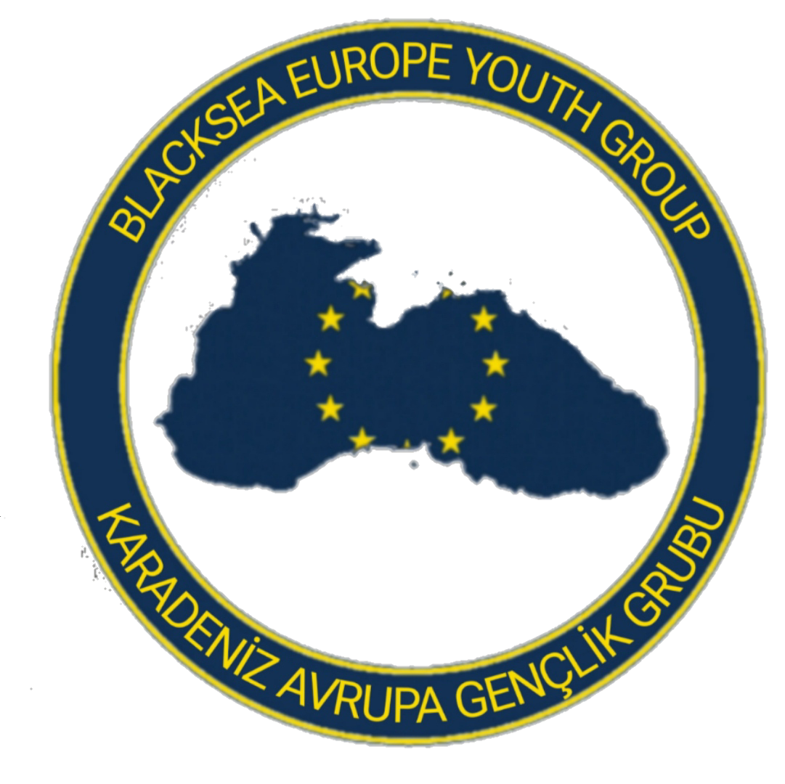
PARTNER IDENTIFICATION FORM
A. PARTNER ORGANISATION
OID Number | E10372004
Full Legal Name  (National Language) | KARADENİZ AVRUPA GENÇLİK GRUBU
Full Legal Name  (Latin Characters) | BLACKSEA EUROPE YOUTH GROUP
Acronym | BLACKSEU
National ID (if applicable)
Department (if applicable)
Address  (Street and number) | Üniversite, KTÜ No:25, 61080 Trabzon Merkez/Trabzon, Türkiye
Country | Türkiye
Region | Ortahisar
P.O Box
Post Code | 61000
City | Trabzon
Website
Email | @blackseuyouth@gmail.com
Telephone 1 | +90 539 921 16 01
B. PROFILE
Type of Organisation | INFORMAL GROUP OF YOUNG PEOPLE
Is the partner organisation apublic body? | No
Is the partner organisation a non- profit? | Yes

C. BACKGROUND AND EXPERIENCE
Please briefly present the partner organisation. | BLACKSEU (Black Sea Europe Youth Group) is a youth group founded by young people who prioritize human rights and freedom. We believe that long-term interactions with different cultures broaden individuals' perspectives and foster a more inclusive worldview. Acting on the belief that cultural diversity enriches individuals and that such experiences should be accessible to everyone, our youth group aims to provide young people with opportunities to develop themselves within the framework of human rights and freedom.  We work to raise awareness of human rights and freedom, strengthen the concepts of equality and justice, combat discrimination by breaking down prejudices, and promote a culture of tolerance through engagement with different cultures. We aim to deepen intercultural understanding based on universal values, develop innovative and diverse perspectives on global issues, and adopt a human rights and freedom-oriented approach in the business world. In this context, we seek to establish global networks focused on human rights and freedom, ensuring that young people actively play a role in creating a more just and equal world. Our goal is to offer young people opportunities for self-development within the framework of human rights and freedom. These areas include:  1. Raising awareness of human rights and freedom  2. Combating discrimination  3. Deepening intercultural understanding based on universal values and breaking down prejudices  4. Strengthening the concepts of equality and justice  5. Adopting a human rights and freedom-oriented approach in the business world

What are the activities and experience of the organisation in the areas relevant for this application? | BLACKSEU aims to help young people better understand their rights and to create a conscious generation that combats class divisions and discrimination among people. Within the framework of protecting human rights, establishing national and international collaborations and focusing on discrimination and marginalized communities are among our primary priorities. By concentrating on universal values such as women's rights and gender equality, we aim to raise awareness in society through widespread youth and educational activities. Empowering and informing people about human rights is of vital importance for building a fair and equal society.  As the BLACKSEU community, we carry out numerous activities both locally and internationally. As a youth community, we work on the issues we focus on together with other young people, organizing meetings and seminars with university communities and youth organizations like ours to foster a common understanding among the youth. We have engaged in and continue to participate in many efforts to further inform local and regional populations in collaboration with local civil society organizations. We conduct various activities to engage young people, making them more informed and aware, and continue our efforts to achieve even more. Our goal as BLACKSEU is to create a generation that knows their own rights, respects the rights of others, and stands against discrimination.

What are the skills and expertise of key staff/persons involved? | Onur Ceyhan, the founder of BLACKSEU, is currently studying International Relations at Karadeniz Technical University. He has participated in many projects, especially Erasmus+ projects, and has visited 18 countries and numerous European cities. In some of the projects he attended, he served as a team leader, assisting his team, while in others, he was a team member. He continuously shares the experiences he gained from these projects with the communities and clubs at his university, making him an important figure in Erasmus+ at his institution. Influenced by the projects he participated in, and with the aim of informing and educating people and youth to create a more advanced generation, he became a youth worker and decided to establish the BLACKSEU youth community to further expand his work on a national and international level. He conducts both inclusive and informative activities related to human rights and discrimination, working with university and high school students, as well as marginalized communities, both in university groups and local NGOs. Additionally, he serves as the Vice President of the KTUMUN (Karadeniz Technical University Model United Nations) club at his university.  Ömer Özalp serves as the Contact Person of the group. He is studying International Relations at Karadeniz Technical University and has been involved in activities related to human rights and discrimination since high school. He has attended numerous seminars and received extensive training on this subject, as well as organizing local initiatives. By actively participating in university groups and local NGOs, Ömer organizes informative meetings for the local community and university students and conducts inclusive events for marginalized groups. Additionally, he holds the position of Vice President at the KTUMUN (Karadeniz Technical University Model United Nations) club.  Orhan Furkan Atlı serves as the Partner Relations Manager of the group and is studying Russian Language and Literature at Karadeniz Technical University. With a social and active personality, Orhan has attended dozens of conferences and seminars, improving himself in various fields. He organizes conferences to reach more people by sharing the experiences gained from the events he has attended. He also organizes and participates in activities with humanitarian organizations, providing mental support to young people and children in need and those facing discrimination. Additionally, he serves as the President of the KTUMUN (Karadeniz Technical University Model United Nations) club.  Yusuf Talha Kaya serves as the Technical Manager of the group. He is studying Computer Engineering at Karadeniz Technical University and plays an active role in university groups. Yusuf has always maintained a strong stance on human rights and against discrimination, and to reach out to young people, he has participated in numerous civil society events and carried out many projects related to these issues within university groups. His talent in software development has made him a key contributor both in the BLACKSEU community and in various university clubs. Additionally, Yusuf Talha Kaya leads the Software Team in the KTUMUN (Karadeniz Technical University Model United Nations) club.  Berk Eren Berber is the Social Media Manager of the group. He is studying Mechanical Engineering at Karadeniz Technical University. Berk is highly skilled in social media and design. He has received training in design applications and has significantly developed his expertise in this field over the years. Besides managing social media, Berk is actively involved in local charity organizations, playing an important role in activities related to combating discrimination and promoting human rights in collaboration with local associations and foundations.

D. LEGAL REPRESENTATİVE
Title | MR
Gender | Male
First Name | Onur
Family Name | Ceyhan
Position | President
Email | @blackseuyouth@gmail.com
Telephone | +90 539 921 16 01
Address | Üniversite, KTÜ No:25, 61080 Trabzon Merkez/Trabzon, Türkiye
Country | Türkiye
Region | Ortahisar
Post Code | 61000
City | Trabzon

E. CONTACT PERSON
Title | MR
Gender | Male
First Name | Ömer
Family Name | Özalp
Department | Project Department
Position | Contact Person
Email | @blackseuyouth@gmail.com
Telephone | +90 537 215 04 61

