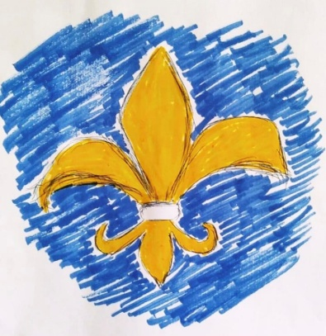

**ERASMUS+ PARTNER IDENTIFICATION FORM**

|  |  |  |  |
| --- | --- | --- | --- |
| **A. Partner Organization** | | | |
| PIC | | - | |
| Full legal name (National Language) | | «All For One & One For All » | |
| Full legal name (Latin characters) | | «All For One & One For All» | |
| Acronym | | «AFO» | |
| National ID (if applicable) | | **E 10348022** | |
| Department (if applicable) | |  | |
| Address (Street and number) | | Aggelou Metaxa 27-29 Glyfada, Athens | |
| Country | | Greece | |
| Region | | Attica | |
| P.O. Box | | - | |
| Post Code | | 16674 | |
| CEDEX | |  | |
| City | | Athens | |
| Website | |  | |
| Email | | grivaskonstantinosgeorgios@gmail.com | |
| Telephone 1 | | + 30 6983149533 | |
| Telephone 2 | |  | |
| Fax | |  | |
| **B. PROFILE** | | | |
| Type of Organisation | | | Informal Group |
| Is the partner organisation a public body? | | | No |
| Is the partner organisation a non-profit? | | | Yes |
| **D. BACKGROUND AND EXPERIENCE** | | | |
| Please briefly present the partner organisation. | All for One & One For All was founded by Konstantinos-Georgios Grivas a MSc Clinical Psychologist after a life-changing Erasmus+ Project in Denmark. Our Informal Group aims to help young people learn in an informal democratic way by learning about social and educational matters in a creative way, and how they can help other people who are in need while enriching their lives by exploring other cultures and new places. Moreover we aim to promote psycho-education espcially about mental health and its importnace and how music, dance art, and sports can help create a more inclusive society with solidarity and respect.  We also focus too on environmental matters and sustainability and we look to the future in order to create a safer more inclusive and sustainable society.  The name of our organisation comes from the French novel The 3 Musketeers by Alexandre Duma, and our logo the 'Fleur De Lys' symbolizes unity and peace, the saying of the 3 Musketeers 'All For One & One For All' means that no one is left behind, that even one can help change the world and all together can help everyone.  Object of the organization:  To help young people learn more about other cultures and meet people from different backgrounds and nationalities while learning in a non formal way about social matters, sustainability, mental health matters and inclusion.  Aims of the organization:   * To develop the creative potential of the youth * To support youth initiatives in various fields especially concerning Mental Health Psycho-education * To create conditions for active involvement of young people both into social, athletic and cultural life of the society * Encouragement impulses to self-actualization of a free individual * Popularization of democratic ideas, institutions of a civil society * To develop respect and solidarity for people with fewer opportunities and Special Needs & Skills * To develop the international youth cooperation, to cooperate with foreign youth organizations | | |
| What are the activities and experience of the organisation in the areas relevant for this application? | -Long Term Esc in Gdansk Poland 2021  -Teams Volunteering in Alatamura, Italy 2023  -Youth Exchange Retteneg, Austria 2023  -Training Course Lecce, Italy 2023  -Training Course Sigerslev, Denmark 2023  -Teams Volunteering Rixensart Belgium 2023 | | |
| What are the skills and expertise of key staff/persons involved in this application? | **Legal Representative – Konstantinos-Georgios Grivas**  Fields of Expertise:  - Clinical Psychology, Sports Psychology, Social Policy & Philosophy, Art Drama & Dance Therapy & Sports  - Youth Affairs, Non-Formal Education  Contact Person – Konstantinos-Georgios Grivas  Duties/Responsibilities:  - planning, development and overall coordination/implementation supervision  of projects, facilitation  - developing project concepts, including goals, objectives, activities and main stages  **The 4 Members of the Informal Group :**   1. **Konstantinos-Georgios Grivas. –Chairman MSc Clinical Psychologist (Licesned Psychologist in Greece & Member of the British Psychological Society).** 2. **Georgios Papanikolaou – Management Support** 3. **Artemis Papanikolaou - Communication Support** 4. **Elda Papanikolaou- Business Administration Financial & Account Manager & Business Coaching Specialist** | | |
| **E. LEGAL REPRESENTATIVE** | | | |
| Title | Mr. | | |
| Gender | Male | | |
| First Name | Konstantinos-Georgios | | |
| Family Name | Grivas | | |
| Department | Board of the Informal Group | | |
| Position | Chairman | | |
| Email | grivaskonstantinosgeorgios@gmail.com | | |
| Telephone 1 | +30 6983149533 | | |
| Address | Aggelou Metaxa 27-29 Glyfada, Athens, Greece | | |
| Country | Greece | | |
| Region | Attica | | |
| P.O. Box |  | | |
| Post Code | 16674 | | |
| CEDEX |  | | |
| City | Athens | | |
| Telephone | +30 6983149533 | | |