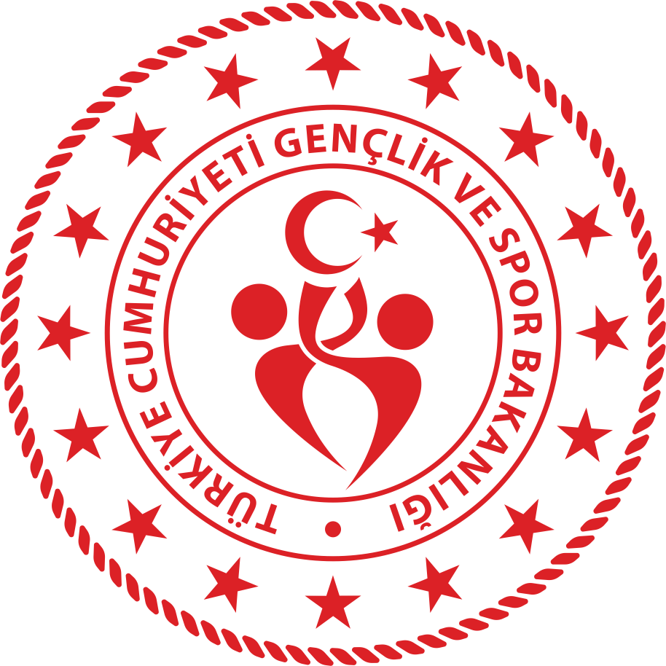

MINISTRY OF YOUTH AND SPORTS
ANTALYA YOUTH AND SPORTS PROVINCIAL DIRECTORATE
TURKEY ANTALYA

PARTNER IDENTIFICATION FORM (PIF)
PARTNER ORGANISATION
PIC | 940086365
ECAS ID NUMBER (for applications) | E10129339
Full legal name (National Language) | Antalya Provincial Directorate of Youth and Sports
Full legal name (Latin characters) | Antalya Provincial Directorate of Youth and Sports
Acronym | AGSİM
National ID (if applicable) | 3930976814
Department (if applicable) | R&D and Erasmus+ Project Unit
Address | Pınarbaşı Mahallesi Akdeniz Üniversitesi Kampüs İçi, Dumlupınar Blv., 07300 Konyaaltı/Antalya
Country | Turkey
Region | Mediterrian
P.O. Box
Post code | 07300
City | Antalya
Website | antalya.gsb.gov.tr
Email | mustafa.koz@hotmail.com
Telephone | +902422803500
Mobile | +905332213644
Profile
Type of organization | Organisation or association representing (parts of) the sport sector
Is the partner organization a public body? (yes/No) | No
Is the partner organization a non-profit? (yes/No) | Yes
Accreditation
Has the organization received any type of accreditation before submitting this application?

NO
IF YES, please fill this table

Accreditation type |  | Accreditation reference
Background and experience
Please briefly present your organisation (e.g. its type, scope of work, areas of activity and if applicable, approximate number of paid/unpaid staff , learners and members of the group).
What are the organisation's main activities?
- Antalya Provincial Directorate of Youth and Sports, affiliated to the Ministry of Youth and Sports, is an institution that provides sports, artistic, educational and cultural trainings for the 04-77 age group.
Since the year it was founded, it has been guiding young people to sports, ensuring their development, and raising successful athletes for their country and nation.
-Antalya Provincial Directorate of Youth and Sports, affiliated to the Ministry of Youth and Sports, is an institution that provides sports, arts, education and cultural education to the 04-77 age group.
Since its establishment, it has been directing young people to sports, ensuring their development, and training successful athletes for their country and nation.
-To carry out and organize social, cultural, artistic and educational activities outside the school time of young people in Youth Centers, to include young people in social life,
- To create volunteer youth leaders by providing volunteer training, Islamophobia, tolerance, doing good, respecting the environment, creating green environmental awareness,
-Helping immigrants in social life, integration processes, language training and psychological support,
-Communication problems faced by immigrants,
- Finding and applying solutions to communication problems arising from religious differences,
-Preventing discrimination against Muslims, showing how to live together in brotherhood,
- Communication problems arising from cultural differences,
- to show the nature and beauty of cultural differences,
- Raising awareness of youth and public on issues such as match-fixing, doping and violence in sports
- Spreading the sport on the floor
-Inclusion of young people with disabilities and disabilities in sports
-Providing sports support to schools and youth in disadvantaged regions
- In Alladdin Keykubat Camp, free camp for young people for 12 months, an average of 5,000 young people camp annually.

What are the organisation's activities in the field of this application?

- Provides service with Sports Halls, Youth Centers and dormitories for university students.- Antalya Provincial Directorate of Youth and Sports, Youth Centers, Sports Halls and Fields, Credit and Hostels Institution dormitories, for everyone from 07 to 77, Football, Archery, School Sports, Orientring, Special Athletes, Chess, Underwater Sports, Water Polo, Taekwondo, Tennis , Triathlion, Volleyball, Bodybuilding and Fitness, Wushu, Sailing, Swimming, Shooting, Athletics, Badminton, Basketball, Handicapped, Billiards, Equestrian, Cycling, Bocce, Bowling, Darts, Boxing, Gymnastics, Mountaineering, Fencing, Traditional Sports , Golf, Visually Impaired, Wrestling, Oil Wrestling, Turkish Folk Dances, Weightlifting, Handball, Deaf, Scouting, Judo, Canoeing, Karate, Skiing, Kick Boxing, Table Tennis, Muay Thai, E-Sports Rafting, Traditional Turkish Archery, Sports trainings of aikido branches
In Youth Centers; Activities such as social cohesion with refugees, cultural fusion and inclusion are carried out outside of school time, where artistic, educational and cultural activities are carried out, keeping them away from evil, protecting national and religious values.Painting, Ebru, Calligraphy, Intelligence Games, Leather Processing, Stone Mosaic, Personal Development, Diction, Foreign Languages, Innovation, Robotic coding, Drone and drone, sea and nature camps in Youth Centers
- After enrolling in the university, young people are placed in dormitories, and their development is supported with accommodation, food and beverage, social, cultural, artistic and educational courses. A total of 20,000 young people live in 20 dormitories, male and female, in the City Center and Districts.

What profiles and age groups of learners are concerned by the organisation’s work?
Antalya Youth and Sports Provincial Directorate provides service to young people with its units.
- 04-77 years old in sports, basic beginner in sports, juniors, stars, youth, seniors and veterans
-Youth Centers; Activities are carried out with young people aged 13-30. It serves middle school, high school, university, graduates, young people who are not studying.
-University students aged 18-25 are served in our dormitories.

How many years of experience does the organisation have working in the field of this application?*

-Antalya Youth and Sports Provincial Directorate has been serving in the fields of sports, youth and dormitories for 52 years.
In Erasmus+ projects, it started with the R&D Project Unit, which was established 6 months ago. We are a new institution in projects. So far we have sent 3 projects to the national agency

What are the skills and expertise of key staff/persons involved in this application?
- Mustafa KOZ; R&D and Erasmus+ Project unit responsible within the body of Antalya Provincial Directorate of Youth and Sports is our employee who has experience in Ka2 Projects. He is experienced in project cycle, writing, implementation, sustainability and preparing final reports. He is a graduate of Atatürk University, Department of Sociology, has been working in Youth Centers for 18 years, and has been an Aikido trainer. Handicraft stone mosaic, leather and woodworking, He received training in personal development, diction, Interview techniques and CV Preparation. She took part in the solution of communication problems of immigrants, cultural differences, adaptation process, and inter-institutional immigrant problems.

-Anıl AŞKAR; He is a law student at Antalya Bilim University.
He worked as a participant in the erasmus programs held at his school. He also plays the guitar and works on software technologies since we live in the internet age.
He recently started aikido training in Antalya Youth and Sports Provincial Directorate.
Together with the youth centers of the Provincial Directorate of Youth and Sports, he worked on environmental cleaning, the protection of stray animals and climate change. In addition to this, it carries out information studies on informatics law.

- Baran CAKICI; He works as a Music Teacher in TOKİ Secondary School affiliated to Antalya Provincial Directorate of National Education. He is a piano and guitar instructor, an Orff Rhythm Instructor with the disabled, participated in the Erasmus+ Ka2 project, and is experienced in project writing, implementation and reporting. He has been giving live music therapy to children with cancer for 4 years.

-Eylül PEHLİVAN; She is a student social science high school. She is making project in her schools. She is playing guitar for four years and sing in school projects. İn her free time she learn and write KA2 projects and attend them. She trying to improve her English skills. She takes care of street animals.
Have you applied for/received a grant from any European Union programme in the last 3 years preceding this application?
YES

IF YES, please fill this table

EU Programme | Year | Project Identification or Contract Number | Applicant/Beneficiary Name
KA153-YOU - Mobility of youth workers | 2023 | 2022-2 TR01- KA1 KA153-YOU-000090520 Sharing My Experience | Turkey Antalya Provincial Directorate of Youth and Sports Bulgaria-Lithuania
KA152-YOU | 2023 | 2022-3 FR02-KA152-YOU 000092724 Listen Active, Communicate Effective | France, Turkey, Ukraine, Hungary, Portugal, Romania
ESC30-SOL - Solidarity projects | 2022 | 2022 SPR ESC30-SOL - Solidarity projects Form ID ESC30-SOL-4A895F4C | Antalya Provincial Directorate of Youth and Sports

LEGAL REPRESENTATIVE
Title
Gender | Male
First name | GÜRHAN
Family name | Yavuz
Department | Antalya Youth and Sports Provincial Director
Position | Provincial director
E-mail | yavuz.gurhan@gsb.gov.tr
Telephone 1 | +902422803500

CONTACT PERSON
Title
Gender | Male
First name | Mustafa
Family name | KOZ
Department | Antalya Youth and Sports Provincial Directorate R&D and Project Unit
Position | Erasmus+ Project Office Manager
E-mail | mustafa.koz@hotmail.com
Telephone 1 | +905332213644
İnstagram | gsb_ozgecanaslangm,  gsb_muratpasagm
Facebook | GSBAntalyaGM

ABOUT CİTY
Antalya is a tourism city in the southwest of the Mediterranean, hosting local and foreign tourists with its 640 km long coast, history, nature, sea, sun and beaches. The city is the most popular tourism city in Turkey. It is famous for its 228 Blue flag beaches and cleanliness. Antalya has golden beaches, historical sites, waterfalls and caves worth seeing. Bergamot jam, tandoori kebab, stuffed zucchini flowers, meatballs and pumpkin dessert are traditional dishes. Everyone should definitely try bergamet jam, tandoori kebab and stuffed zucchini flowers. It is very easy to find accommodation suitable for every budget in Antalya. In our opinion, every young person should definitely see Antalya. We would like to host you in this magnificent city.
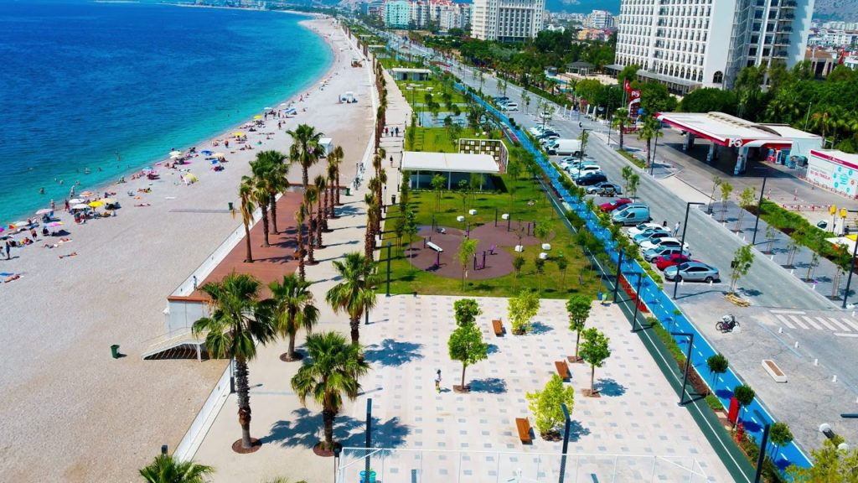
Konyaaltı Beach
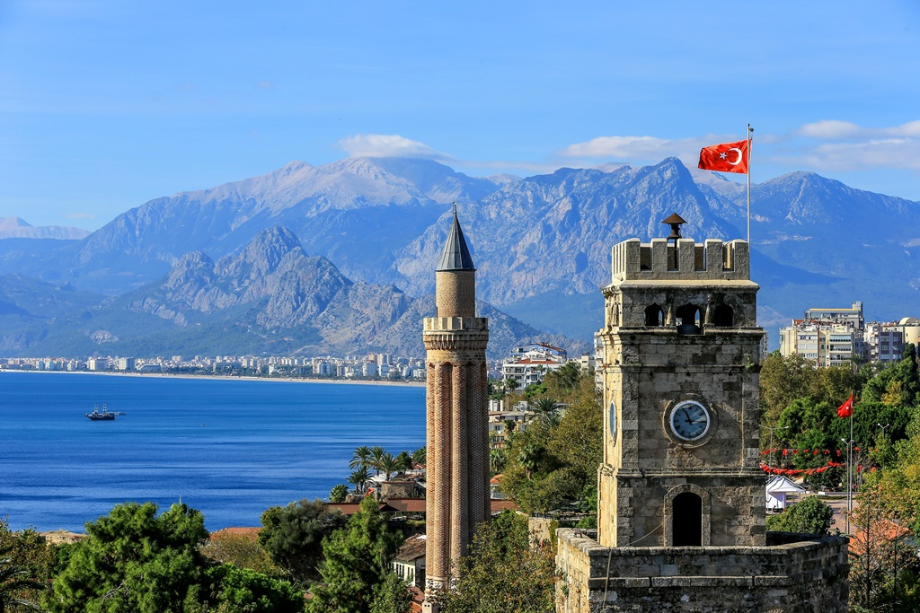
Clock Tower and Yivli Minaret
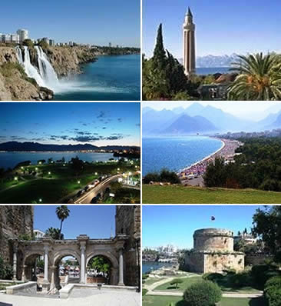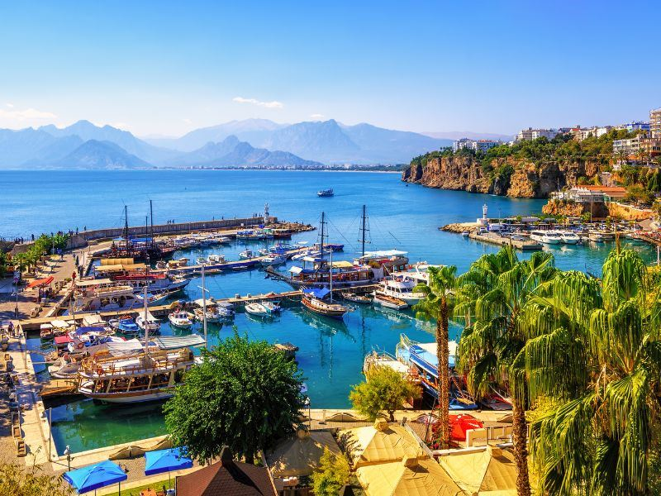

LOCAL FOODS

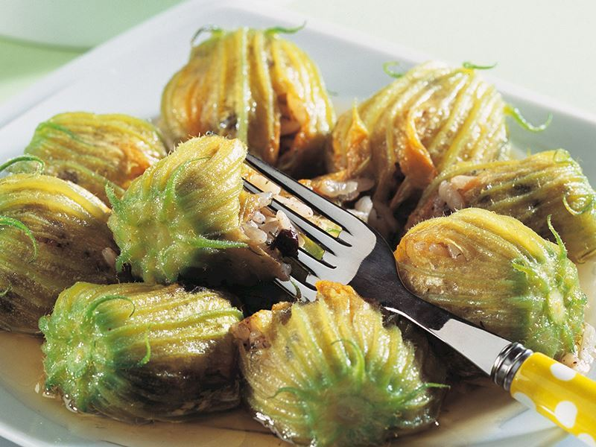
Stuffed Zucchini Flowers
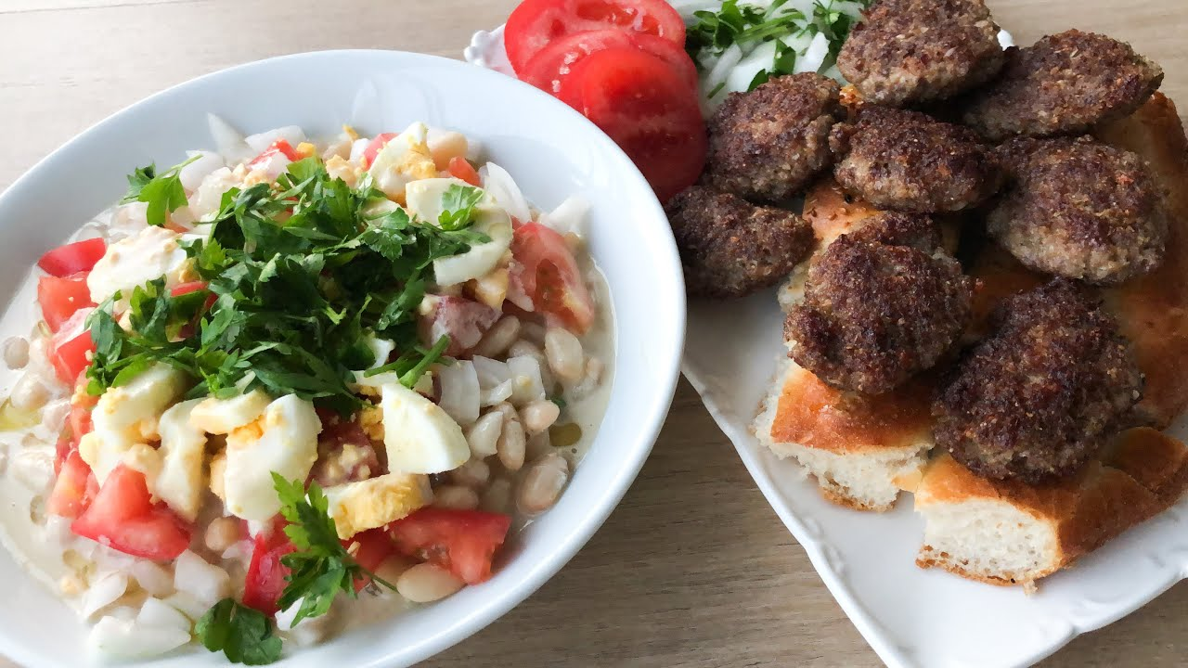
Meatballs and Piyaz
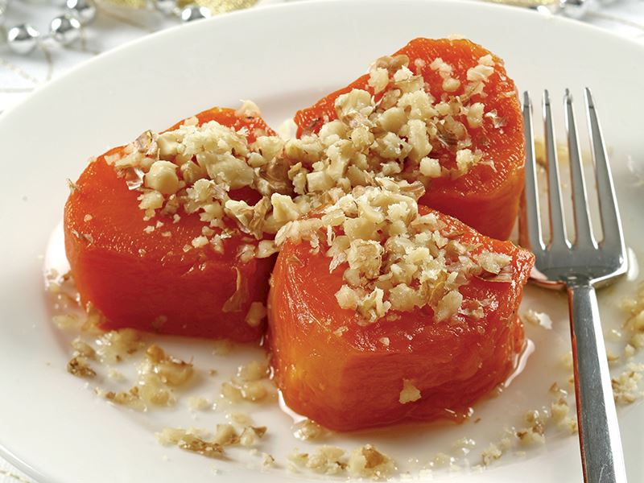
Pumpkin Dessert


Bergamot Jam
Facilities and events affiliated with our institution 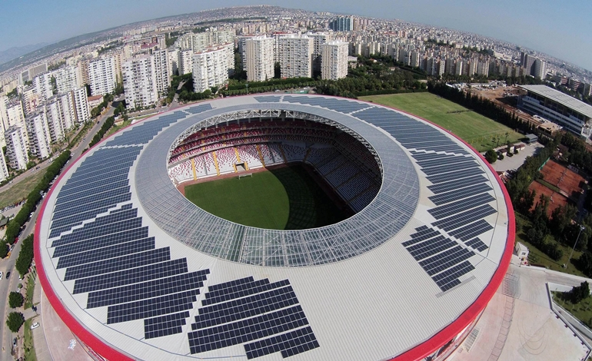
Antalya Stadium (33.000 Audience Capacity)

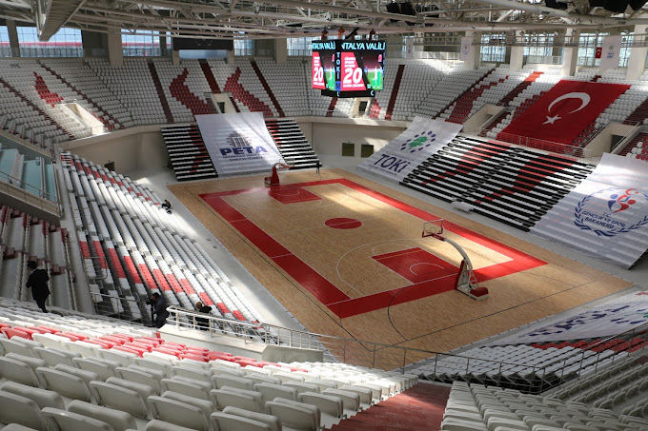
Antalya Sports Hall (10.000 Audience Capacity)

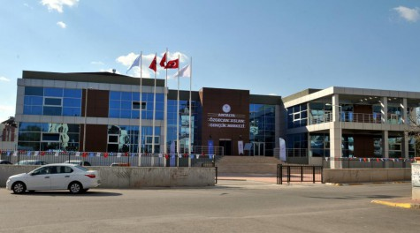
Özgecan ASLAN Youth Center
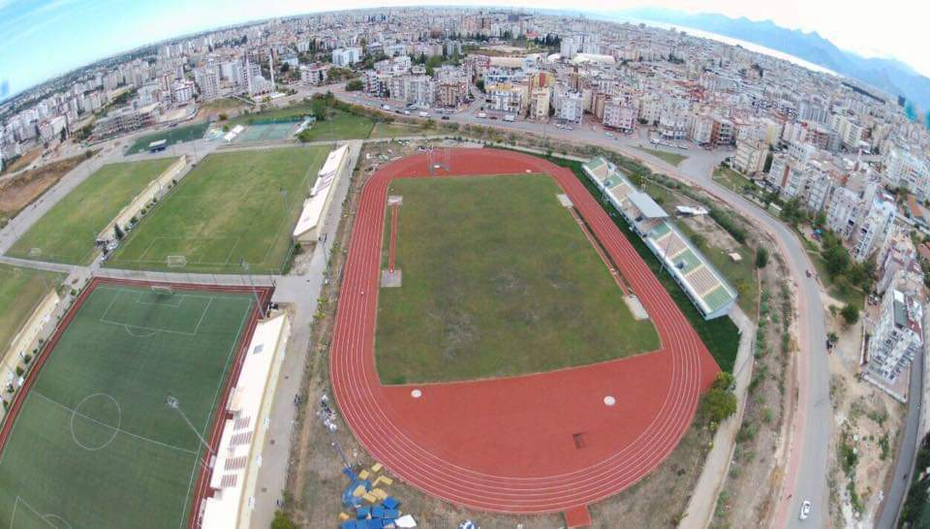
Athletics and Football Fields

