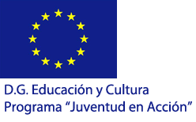
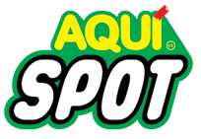

Open roulotte: #Se puede
#It’s posible

Youth in Action programe, Youth Initiatives
Search for partners
for 1st of February 2013 deadline
- Contact person: Feliu Fusté –Project Manager
- Coordinating organization: Aquispot
- Host: http://aquispot.cat
- Location: Vic (Barcelona), Spain
- Start: 10/07/2013
- End: 15/07/2013
The deadline for receiving partnership forms (part 3) via e-mail in scanned/jpg/pdf version is 24 of December, but it is better to send it as soon as possible.
After we confirm you that you will be our partners, Please send us the original as soon as possible on:
Aurora
C/ Martí Genís 20 2n 2a
08500 Vic
Barcelona (Spain)
We strongly encourage you to send us part 3 and we will involve you in the project.

Description of the project:

“Open Roulotte: It’s possible” will encourage participants to take part in different non-formal activities and through them to get to know more about different ecological issues as well as about different attitudes of European countries to the main ecological problems as recycling, or looking for alternative sources of energy and the global environmental challenges. The participants will not just take part in discussion or in workshops. They will have and a chance improve their creative skills and together create new art through creative recycling techniques. Besides the ecological workshops and creative recycling activities the participants will have an opportunity to learn about serigraphy, multimedia, and other capabilities.

The Youth Initiative is designed to make mobile device design of creative recycling. We will transform an old caravan in a traveling workshop that will encourage creativity and recycling. The months duration of the project is to define and implement the idea that Aquispot NGO is visible in public space through an infrastructure that appears in the neighborhoods and squares full of illusion transformative. In the same way that the sharpener walked the streets of our cities with its peculiar melody and his bike-shop, Aquispot Project emerged from the youth initiative, will adapt an old caravan, traveling on a device as a mobile workshop repair and creative transformation.

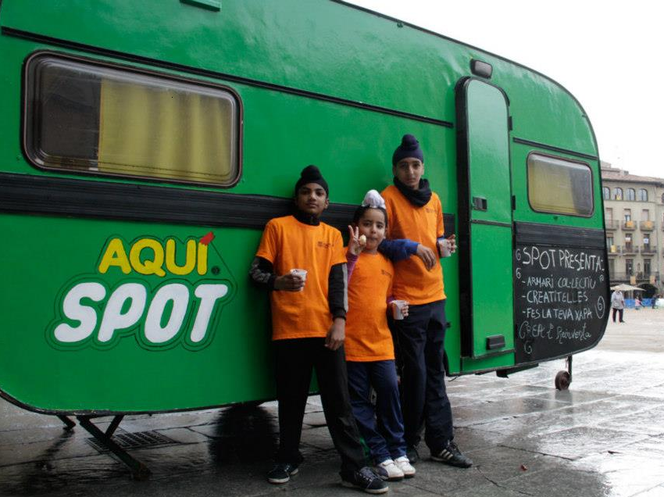
Partners involved: 4

Number of Participants from each partner organization: 2 (1 males/ 1 female)

We are looking for partners from all the member countries of the EU, who’s participants are able to use English as a working language and attend the full duration of the events. This project will promote active citizenship of young people and will raise the topic of youth participation. The participants will have a chance to work in intercultural environment. Therefore, they will be able to develop social skills and better understand the cultural differences and will develop tolerance and solidarity. Working in multicultural town and in so multicultural and multilingual group will surely contribute to mutual understanding among young people from different countries.
Our organization will cover the participant's cost of food and accommodation and 70% of the travel cost.

We ask partners to express their interest until 24 of December 2012 by sending us an email to aquispot@gmail.com with:

- Identification Partner

- Preliminary Agreement

- What is your nearest airport and the cost (per person) to reach it from where you live (round trip);

- Cost estimation for a round trip ticket between your nearest airport and Barcelona or Girona airport

