Inclusion through social entrepreneurship
A training course for youth workers, coordinated by Orenda Foundation, Bulgaria

Dates of mobility: 11-18 May (8 activity days, 2 travel days - 10th of May arrival, 19th of May departure)
Place: Varna, Bulgaria
Participants: 21 youth workers from Bulgaria, Romania, Turkey, Croatia, North Macedonia + 2 more countries ( currently looking for partners)
Requirements: Eligible participants over 18 years, experience in youth work minimum 1 year. Involved in regular youth work activities as part of an NGO or interested to develop a social entrepreneurship idea themselves.

About the project:
This project will familiarise the participants with the concept of social entrepreneurship and how it can be used to solve community problems at the local/regional/national/EU level.
By teaching young people how to create, develop and realise a social entrepreneurship idea we can teach them how to help themselves, overcome their barriers and help their communities.
These are very useful skills, especially for young people with fewer opportunities, who can use the concept to benefit whole disadvantaged groups and communities.
During the project, the involved youth workers will develop the following skills:
- the ability to accurately define a social problem and the reasons for its existence;
- a framework for creating an action plan towards its solution, with a lasting social impact;
- understanding how to implement the social business plan;
- the ability to present the idea to different groups of people for fundraising purposes;
- the skill to successfully involve the young people the organisations work with in solving the social problem, in the life of the organisation and the community they live in.
- the means to measure the social impact after implementing the plan.
The coordinator “Orenda” Foundation has an operating social enterprise and collaborates with 4 more social enterprises from Varna, Bulgaria. The participants will have the chance to visit these enterprises, meet their creators and beneficiaries and gain practical insights.

Project expenses: accommodation, travel and meals are covered for, participants don’t need to pay for any activities part of the official project programme.
Venue: Varna , Bulgaria
Accommodation: Double rooms with private bathroom
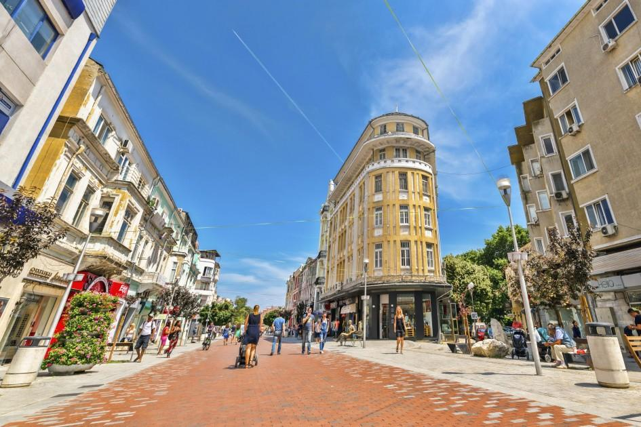
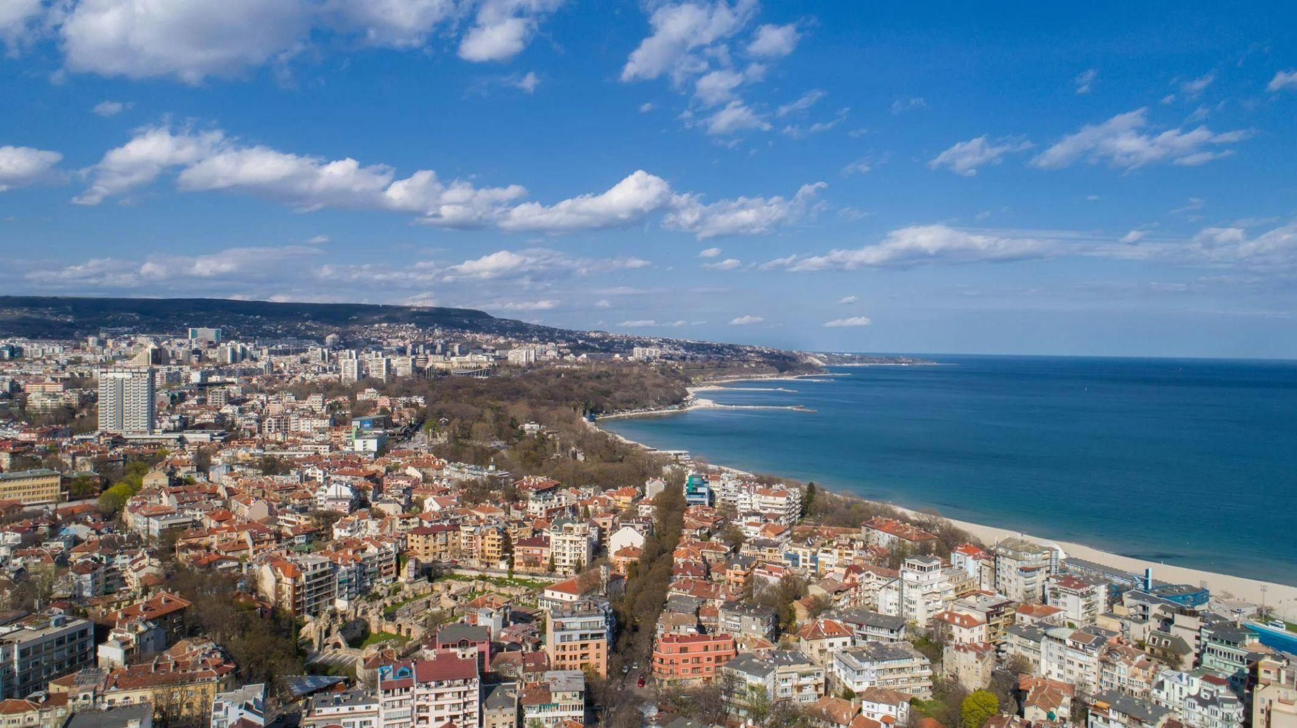

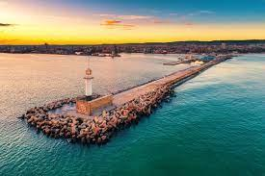

Travel funds:
according to EU distance calculator
100-500 km = 180 EUR
500-2000 km = 275 EUR
Practical information about Bulgaria:
Insurance: Please make sure you have applied for and carry your European Health Insurance card with you as Medical insurance for other EU countries. EHIC entitles you to receive emergency and urgent (medical and dental) care during your stay in the Member States of the European Union and you can obtain it free of charge in your home country.
Currency and exchange: Currency in Bulgaria is Bulgarian lev. You can’t make payments in Euros or other currencies. We advise you to exchange a small amount of money before coming to Bulgaria so you would be able to cover ticket prices/taxi bill to reach the hotel, snacks etc. Once in Bulgaria you can also exchange currency in any bank or big exchange bureau. We strongly advise you not to exchange money on the street or in suspicious small exchange bureaus where there is no information board on rates. Our lev is tied to the euro and the central course is 1 Euro = 1,95583 lev.

Getting around:
Closest airports: Varna airport. You can reach the airport from the city by bus and taxi. Less expensive and convenient flights are available to Bucharest airport and Sofia airport.

Public transport is reliable, especially on working days. The price of 1 ticket is 2 leva. You will receive detailed information about the location of bus stops and bus itinerary once you arrive at the hotel.
Taxi: It is best to order a taxi via phone or online. Here are a few reliable taxi companies. Triumf Taxi: https://www.triumftaxi.com/ Hippo taxi: https://hippotaxi.bg/ We recommend downloading the app and ordering from there. If you want to pay by card in the taxi, it’s good to announce this when ordering (not all taxis have the card processing terminal)
Please avoid taking random taxis on the street, especially the ones standing in front of bus/train stations and at the city center.

Cultural evening:
Preparation for cultural evening: We will have a traditional evening during the project where every team will have space to present their country. You can bring typical costumes, ornaments, leaflets, posters, flyers, food, sweets, drinks… and so on!
Also, you can show videos, photos, sing music and dance traditional dances from your countries! We are counting on you to make this evening as interesting as possible and promise to help you in any way that we can!
There is no project budget for this activity, so decide what you can take, use your creativity, take homemade things etc.

Weather forecast: it is usually quite sunny in Varna in this period but as we are close to the seaside, it can get very windy too. Check the forecast a few days in advance and prepare appropriate clothes and shoes.

Emergency numbers: +112 Emergency Hotline, Bulgarian team: Kunka + 359896807605 , Nikolinka: +359899 881301

Eco-friendly: we are trying to have an eco-friendly project, so would really appreciate it if you can bring:
- a favourite cup/mug from home
- a reusable water bottle that you can refill with mineral water here
- you can choose whether to bring your own towel to be more sustainable (the hotel is providing towels)
- a notebook to take notes (if you like taking notes)

Any other questions?
Contact us at orenda_varna@abv.bg or through WhatsApp at +359 896 807 605

