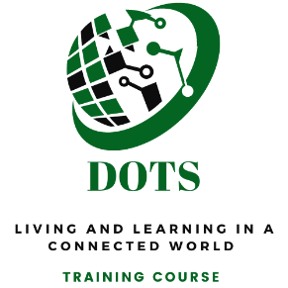
APPLICATION FORM FOR A TRAINING COURSE IN CYPRUS
FOR INTERNATIONAL PARTICIPANTS (FROM THE PARTNERS' COUNTRIES)

Please submit this form to your organisation
Remember to write your name in the file name. In the subject, write DOTS_your name
Country of Residence
Full Name as in passport
Age
Gender
Email
Phone number in international format

We accept only vaccinated participants. Are you vaccinated against COVID-19, and will you be able to present the EU Digital COVID Certificate?
☐Yes ☐No

The participation fee for this course is 30 euros to be paid in cash upon registration. Are you OK with that?
☐Yes ☐No

Level of English. Remember that the training is going to be in English.
☐Low ☐Medium ☐High

Level of Digital Skills. We are going to work with various digital tools during the training.
☐Low ☐Medium ☐High

Are you willing to participate for the full duration of the training?
☐Yes ☐No

Educational background. Please note that your Education is not the most important criterion for selection.

Work experience. Please note that your work experience is not the most important criterion for selection.

Other activities and interests

Experience in Youth Work/ Youth Training/ International Programs (The name of the organisation you represented, the name of the host organisation and your role in each case are obligatory).

Your motivation. Why do you want to participate? What do you expect to get and learn?

Your contribution. How can you contribute to this project? What skills can you share? Note here if you can take professional photos, edit photos in Photoshop, create graphic design, facilitate sessions, help with project management or accounting, keep notes, translate, write content for social media or do something else.

According to Erasmus+ requirements, all partners are obliged to support the visibility of the project in the (social) media. How are you going to help SEAL CYPRUS and your organisation to promote the project?

You will most probably be in the same room with participants of the same gender but from different countries. Are you OK with that?
☐Yes ☐No

Has your friend/relative also applied for this project? If yes, what is his/her name and surname? We will try to send you to the training together.

During the activity, the organisers will take photos and videos to be published on the partners' media such as websites, social media or other promotional material. Your name might also appear.
Do you consent to that?
☐Yes ☐No

It is your own responsibility to arrange for travel insurance for the period of the project activity and health insurance valid in Europe. Do you consent to that?
☐Yes ☐No

YOU ARE INVITED TO FOLLOW OUR SOCIAL MEDIA
Visit our Facebook page www.facebook.com/sealngocy  To mention us on Facebook, type: @sealngocy  https://twitter.com/SealCyprus  @SealCyprus  The hashtag of the project is #dotsEU | Linkedin www.linkedin.com/company/seal-cyprus  Instagram www.instagram.com/SealCyprus  Website https://www.sealcyprus.org  Email: info@sealcyprus.org
Thank you for your interest! The team of SEAL CYPRUS

