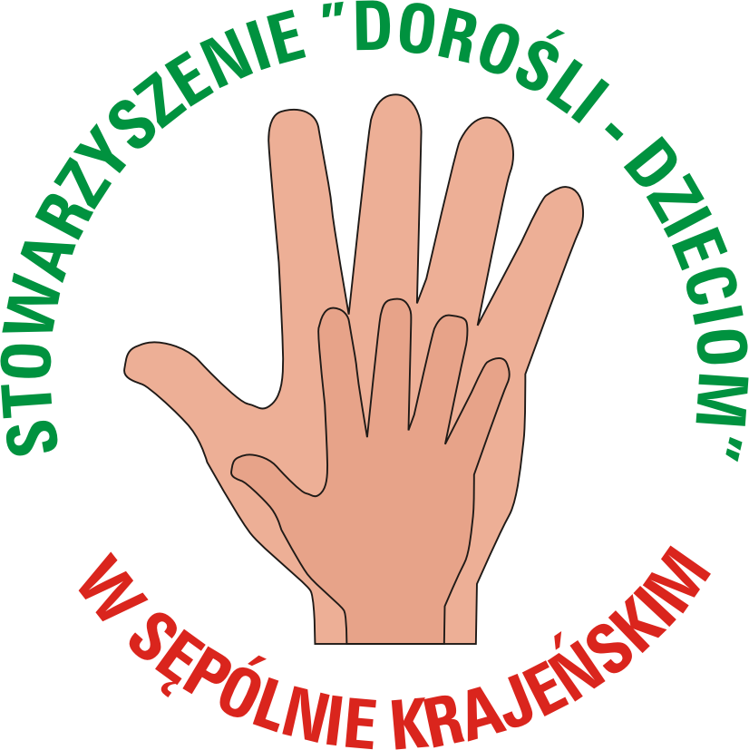

Info pack for Contact-Making Event to develop
YOUTH EXCHANGE project for young people with disabilities

“A L L I n c l u d e d”
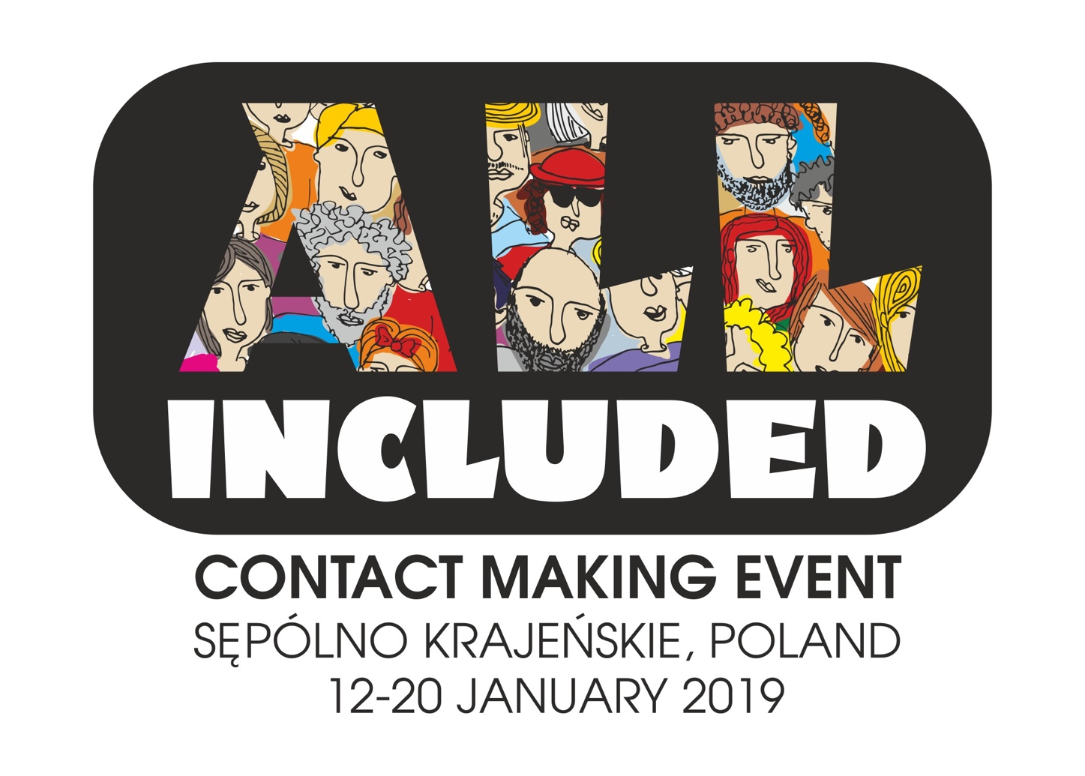

S ę p ó l n o K r a j e ń s k i e, P o l a n d
January 12-20, 2019

GENERAL INFO

The main idea of this contact-making event (CME) is to gather 24 people (teachers, social workers, youth workers) who work with young people with disabilities and wish to meet other colleagues in order to develop some YOUTH EXCHANGE (YE) project within Erasmus+: Youth in Action programme for their youngsters.

Although young people with special needs – thus also disabilities – are one of the priority target groups for youth exchanges, in practice we observe that there are very few organizations that know how and involve youngsters with disabilities in the projects. Taking part in this CME can give you the chance to host an international group in your community OR give youngsters from your community the chance to participate in the exchange in some other country.

IF you want to find out how youth exchanges work and to have the space to sit down with potential partners and work on YOUR youth exchange idea that you could later on apply for and implement, this is a project for you!!!

OBJECTIVES
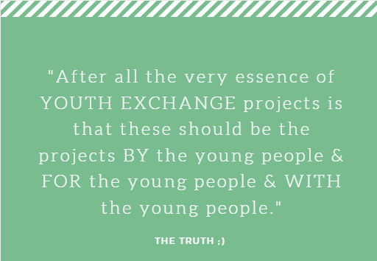
- To build the trust among participants and letting them get to know each other closer so that personal and professional connection serves as a basis for stable partnership in the future youth exchange projects
- To share the challenges, needs and interests of young people in their communities and explore how these could serve as basis for developing youth exchange ideas
- To build participants’ understanding about the crucial quality criteria in E+ youth exchanges, paying special focus on youth participation, inclusion, intercultural dialogue and learning dimension and motivate youth leaders to become promoters of these common values among their young people
- To develop CONCRETE YE IDEAS that could be applied for the nearest deadlines to E+ programme and implemented

Due to unique character of the project, it is very crucial for us that Partner organisations spread the information through suitable channels and select relevant participants (we keep the right to reject participants that do not fit the profile).

PROJECT TIMELINE

PROFILE OF PARTICIPANTS

- Currently involved in working with young people – work with youngsters 13+ with whom they have a good connection
- Interested to get involved in youth work even more by taking responsibility of developing a YE related to promoting common European values and becoming a host or group leader and involving local youth – including also young people that are currently “left out”
- Ready to actively participate in the whole project and have time
- Have serious intentions with the help of sending organization to apply (for February or April deadline) and implement YE in summer/autumn 2019
- Open to challenge themselves and learn
- Fluent in communication in English

PARTICIPATING COUNTRIES AND NUMBER OF PARTICIPANTS

Participating countries | Number of participants
Latvia | 3 + 1 facilitator
Croatia | 3
Italy | 3
Lithuania | 3
Portugal | 3
Romania | 3
Greece | 3
Poland | 3 + 1 facilitator + 1 support person
TOTAL | 27

TRAINING VENUE AND ACCOMODATION:
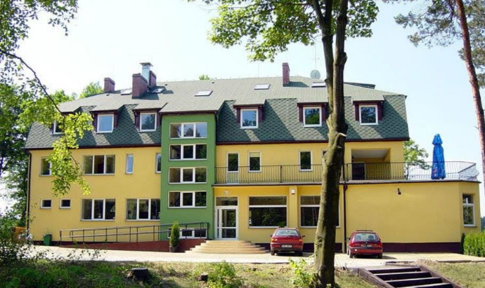
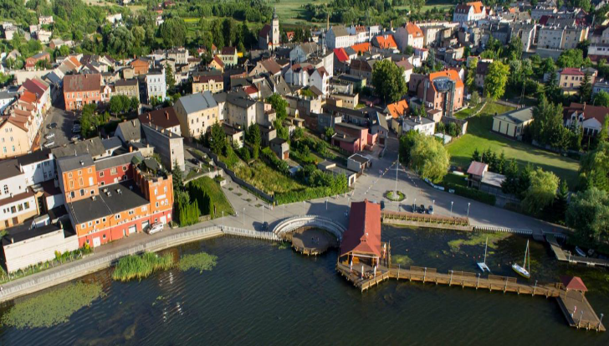
Arrival to the venue: JANUARY 12th, 2019 (preferably in the afternoon/early evening)  Departure from the venue: JANUARY 20th, 2019  (in the morning)  Location: Sępólno Krajeńskie , POLAND  Sępólno Krajeńskie it is a small town located in Kujavian-Pomeranian voivodship, about 350 km from the capital of Poland – Warsaw, with the population of about 10 000 inhabitants. Cozy, quiet, friendly place with the lake in the centre, surrounded by beautiful nature will be perfect place for successful learning process. | 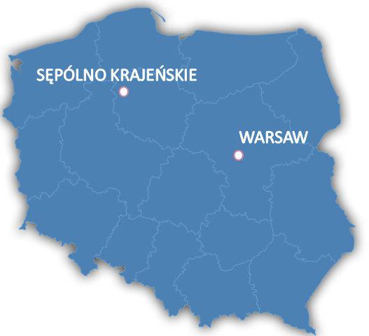
The main activities will take place in HOTEL “JAN” located at the bank of picturesque lake, surrounded by and woods and very near to the town centre. Nice atmosphere, friendly surrounding and beauty of nature – everything in one place…
HOTEL ADDRESS:
1 Leśna street
89-400 Sępólno Krajeńskie
POLAND
https://hoteljan.com.pl/en/home

Meals will be provided in the same place. Bed clothes and towels will be provided too. Free WI-FI interet connection is available in the hotel.
FACILITATORS:

Ieva Grundsteine, trainer (Latvia) has been working in the youth field since 2001 and last 9 years is a trainer of non-formal learning in the field of youth – as a local and European project initiator and manager. She has carried already more than 120 international trainings for different target groups (youth workers, teachers and others): www.salto-youth.net/tools/toy/ieva-grundsteine.1858

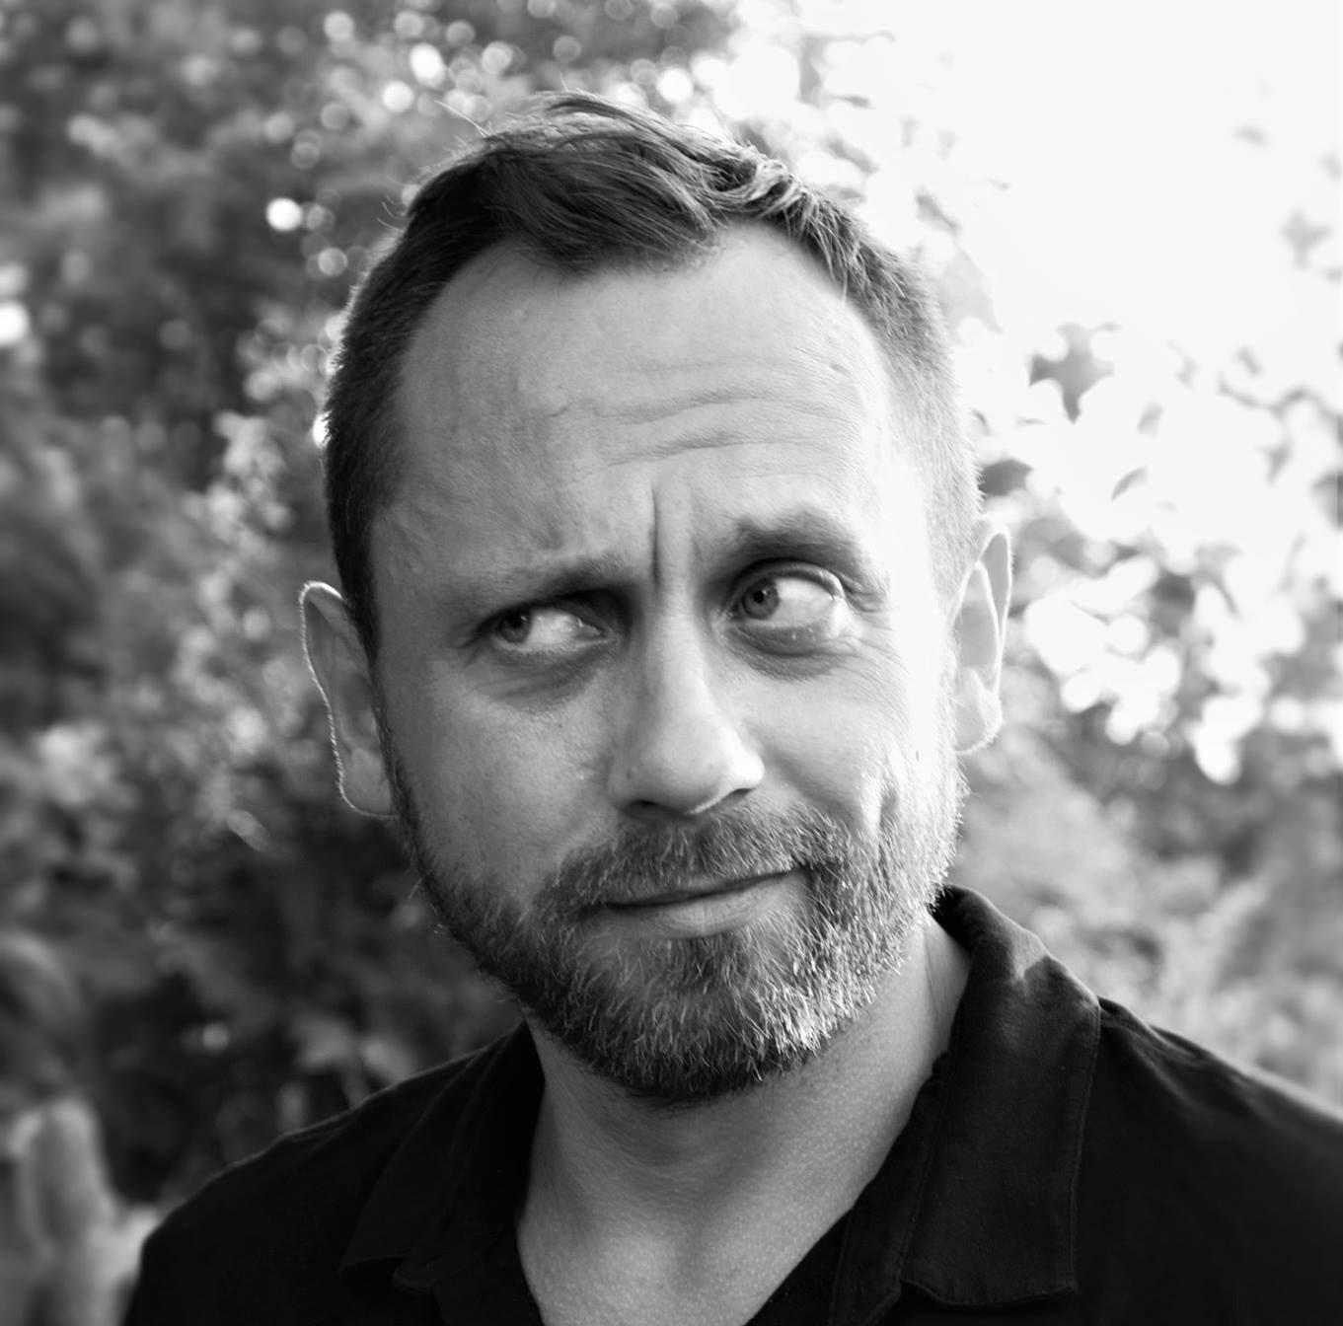 | Daniel Wargin, the a member of the applying organisation: Stowarzysznie “Dorośli – Dzieciom” (“Adults for Children” Association) from Sępólno Krajeńskie, Poland. Actively involved in youth work since 2005. Coordinator of EVS projects, Youth Exchanges and training courses. He is also a teacher working with kids and teenagers (including those with disabilities).

TRAVEL COSTS AND REIMBURSEMENTS:

The training course will be implemented in the framework of EU “ERASMUS+” Programme (mobility of youth workers, KEY ACTION 1. The accommodation and food will be covered fully.
Travel expenses will be reimbursed at flat rates depending on travel distance:

Country of Origin | Maximum Reimbursement (in EURO, per person)
Latvia | 275
Croatia | 275
Italy | 275
Lithuania | 180
Portugal | 360
Romania | 275
Greece | 275
Poland | 0

Most of you will probably arrive to Warsaw Chopin Airport but airports in Gdańsk or Poznań might be also good options (however in most cases the cheapest way is a travel to WARSAW). From Warsaw you will have to go to Bydgoszcz (train/bus tickets will be provided by organisers) and from Bydgoszcz we will pick you up to the training venue… Quite a long way but… worth all your time and efforts…

Once you have chosen a flight connection, please consult it with: Daniel Wargin– daniello13@wp.pl , +48 600062665. Please note that only when he gives you “green light” for the connection and price, you are allowed to buy tickets

ORGANISATION NOTES
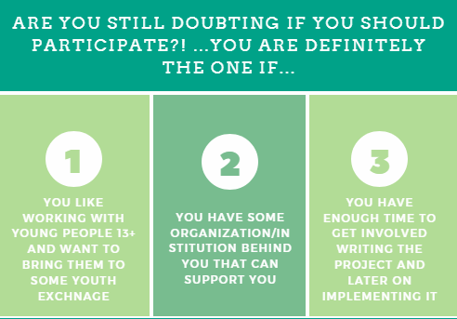
- The project assumes that attendance in all activities for all the participants must be 100%. Failure to attend the activities may result in our inability to reimburse the travel expenses.
- If an emergency happens and for some reason you are not able to attend some session, the team should be informed immediately.

APPLICATION PROCEDURE

Each organization will delegate a team of 3 participants to develop their professional competences. Please –once again – make sure that participants FIT the profile of participants and work with the target group – people with disabilities!!!

Ideally, the participants of this CME will be people that are involved in the partner organizations, but it can be also people that you know and cooperate with.

Once you have someone in mind, please ask them to fill in the online application form:

APPLICATION FORM – ALL INCLUDED

Deadline for submission is 3rd of December 2018

Also, if you are not able to find participants, please let us know as soon as possible.
We will be able to help you find suitable replacements out of our own network.
So please start your selection.

EMERGENCY CONTACT

Please contact us in case of emergency, before/during/after the training: Daniel Wargin: +48600062665 (also Whatsapp).
Preliminary programme

Time / day | Day 1 | Day 2 | Day 3 |  | Day 4 |  | Day 5 |  | Day 6 |  | Day 7 |  | Day 8 | D 9
08:00 – 09:00 | Arrivals | Breakfast
09:00 -11:00 |  | Official Opening &  Introduction  Getting to know each  other | Philosophy of youth exchange projects – “eagle” and “frog” view (European dimension and young people’s dimension) |  |  | Theory input on what is deeper intercultural learning, diversity and underlying competences to be developed in order to promote it | Exploring diversity in town environment (and using city as a learning space) |  | Partnership as basis for the youth exchange project |  | Project development III:  Programe and activities |  | Project development VI:  Plan and calendar of the work. Application, questions, answers, Share the task in the group | Farewell and departure of participants
11:00 – 11:30 |  | Coffee break
11:30 – 13:00 |  | Expectations, contribution, approach, methodology, programme  Intro to Youthpass and Learning Diary | Understanding Inclusion  Crucial elements of YE (quality criteria) and YE life-cycle |  | Tool-fair – sharing the experiences and methods for ICL and Diversity promotion |  |  | Study Visit - discovering local realities regarding inclusion of youth |  | Project development I:  Needs and interests of young people and community |  | Project development IV:  Learning outcomes, impact and results (&risks) | 3rd check in - presentation of results in developing projects,  feedback from the participants and action plan
13:00 – 15.00 |  | Lunch
15:00 – 16:30 |  | Team building activities + Learning contract | Non-formal learning dimension in YE and Youthpasses | Tool-fair – sharing the experiences and methods for ICL and Diversity promotion |  |  | Excursion in surroundings |  | Project development II: ideas about the themes of the project, aim and objectives |  | Project development V:  Different tools to evaluate the projects and do DEOR |  | Summing up the learning outcomes of project and Youthpass
16.30 – 17.00 |  | Coffee break
17:00 – 18:30 | Getting to know each other | Working as a Team,  Difficulties and  Challenges | Real life and kitchen stories: sharing realities on implementing YE | Creative presentations of organizations and young people represented by participants |  |  | Free time |  | 1st check in - presentation of results in developing projects,  feedback from the participants (peer-to peer consultations) |  | 2nd check in - presentation of results in developing projects,  feedback from the participants (peer-to peer consultations) |  | Follow-up and evaluation  Closing
18.30 – 19.00 |  | Reflection & "Family" Time
19:00 – 19:45 | Welcome dinner | Dinner
After 20:00 |  | Initiative Evening | Intercultural Evening?! | Free evening |  |  | Lets see evening... |  | Free evening |  | Local evening |  | Farewell evening

