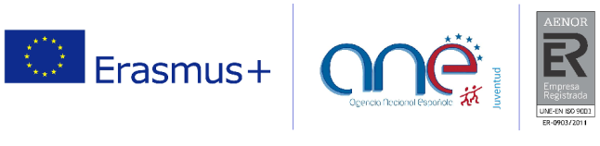
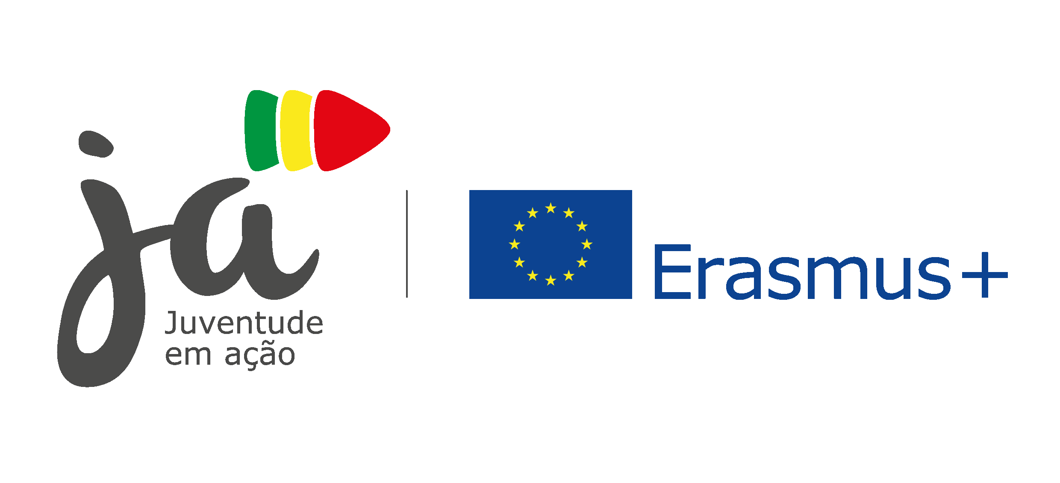


BUILDING BRIDGES FOR INCLUSION: Partnership Building activity II edition
CEULAJ (Mollina-Málaga), SPAIN 11th – 16th DECEMBER 2018
 | TUESDAY  11th | WEDNESDAY  12th | THURSDAY  13th | FRIDAY  14th | SATURDAY  15th | SUNDAY  15th
9:30-11:00 | Arrival  of  participants | Official Opening  Introduction to the PBA - Getting to know each other | Erasmus+ Inclusion and Diversity Strategy | Proposal and opportunities for future inclusion projects | Designing a future inclusion  project I | Departure  of  participants
Break | Arrival  of  participants | Break
11:30 – 13:00 | Arrival  of  participants | Team building activity | Good practices presentation | Working on a future inclusion project | Designing a future Inclusion  project II
13:30 | Arrival  of  participants | Lunch
15:30 – 17:00 | Arrival  of  participants | Presenting  our organizations 1 | Setting up a trustable network | Cultural & Erasmus+  Dissemination  Activity | Presenting our projects
Break | Arrival  of  participants | Break |  | Free Time | Break
17:30-19:00 | Arrival  of  participants | Presenting  our organizations 2 | Inclusion & diversity in the European Solidarity Corp | Free Time | Youthpass & Evaluation
17:30-19:00 | Arrival  of  participants | Daily reflection | Daily reflection | Free Time | Youthpass & Evaluation
20:00 | Dinner
21:30 | Welcome evening | Intercultural evening | Contributions evening | Free evening | Dinner out

