Lava

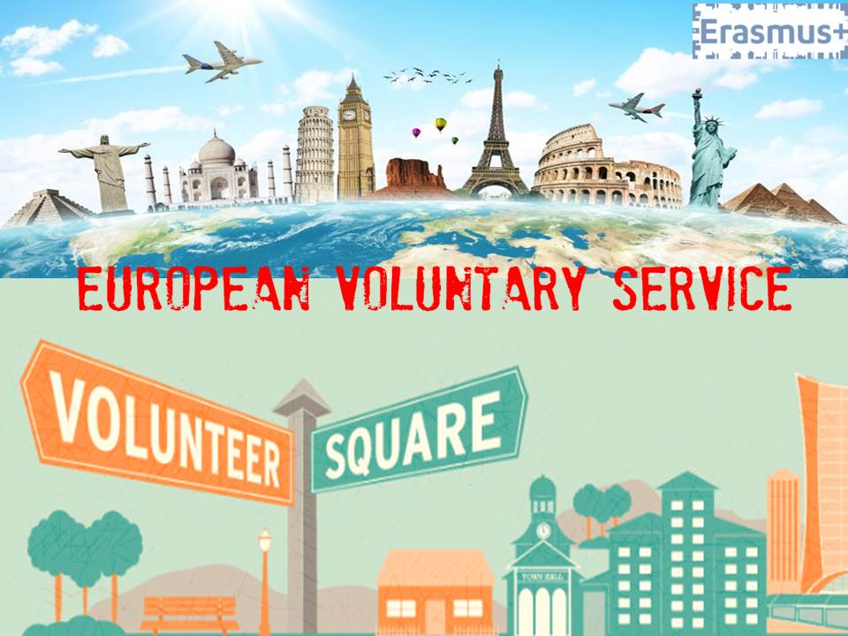

CALL FOR PARTNERS

Title of the project: Lava
Applicant Organization: R.I.V.E (Rete Italiana Volontariato Europeo)
Type of project: Mobility of Youth Workers
Action: Key Action 1 - Erasmus+ Programme - Programme Countries
Date: arrival 21st of November – departure 27th of November
Location: Nicolosi (Catania, Sicily, Italy)
Main Theme: EVS – support offered after the volunteering service
Participant profile - 2 participants per organization:
- 1 Youth Worker dealing with EVS projects (mentor, supervisor, etc)
- 1 Youth Worker former EVS volunteer OR 1 stakeholder representative coming from private or public institutions active in the field of youth
Participant: 30 in total, 6 Italians and 24 coming from 12 Programme Countries Partners.

Short description of the project

Motivation
R.I.V.E. mission is to improve the management of the process of sending EVS volunteers.. The experience tells us that the support provided to the volunteer in his/her community after end of the service is a very delicate phase in which is important to provide support and direction to better capitalize on the experience, assess the skills acquired so be able to take its results and evaluate possible job opportunities or other opportunities for further personal, professional and social development.

Aims
RIVE has decided to take a path that wants to give more concreteness and quality to the project management on the part related to the conclusion of the voluntary service abroad and consequential return to local community, thus placing the following minimum targets:
- Encourage the exchange of good practices and methods in relation to the management measures adopted by each partner of the project regarding EVS service end;
- Provide new tools and resources for youth workers to develop new skills and abilities in managing support to EVS volunteers at the end of the service;
- Identify paths to encourage formal networks and partnerships with universities, entities operating in training and education sector, chambers of commerce, support systems and professional guidance which can give more concrete opportunities after EVS;
- Promote the means and tools that give visibility and greater recognition to the competences and skills acquired by the volunteers during service;
- Promote the program EREASMUS+ and EVS as a remarkable response activities for social and professional development of young Europeans.
Participants Profile:
Each organization will take part in it with 2 participants:
- 1 Youth Worker dealing with EVS projects (mentor, supervisor, etc)
- 1 Youth Worker former EVS volunteer OR 1 stakeholder representative coming from private or public institutions active in the field of youth

Given the pivotal importance of the participants' profile we will ask candidates selected by the partner to fill this form https://goo.gl/forms/WG4yxtBDxeS2Xj6H3. We’ll accept all candidates with role in the organization, experience and motivations in line with this seminar.

Travel budget and participation fee:
For the travel costs (airplane and other means of transports) will be given a contribute up to the amount based on distance calculator. Food and accommodation will be 100% covered. A participation fee of 25€ per participant will be deducted from the travel costs reimbursement in case you the participant don't remain under the budget limit (i.e. having 275€ of travel costs if you spend 250€ of travel costs or less you don't have to pay any participation fee).

Each national group will have to prepare:

- 1 video lasting 2/3 minutes, with the witness of a person who did the EVS and fund a job thank to the competences acquired during the experience;
- a short presentation of its organization and of the support provided to the EVS volunteers at the end of the service
- collect and present one or more good practices on the support of EVS volunteers after the end of EVS, to be shared within the working groups;
- mapping local stakeholders that could help in strategies to support EVS job placement
- need analysis at local/regional/national level in relation with challenges of EVS to find a job at the end of the service.

Table with number of participants and travel budget:

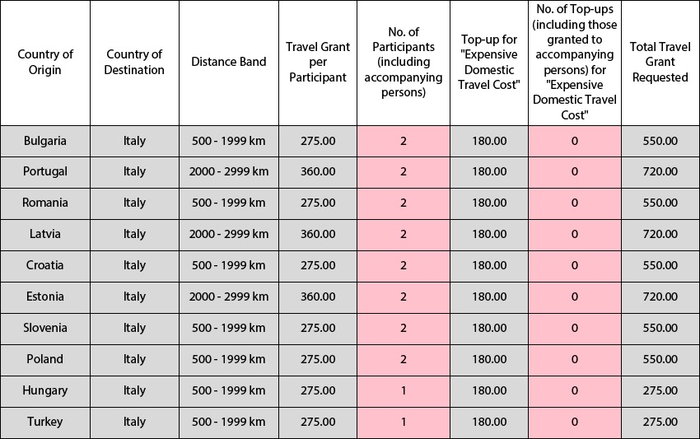
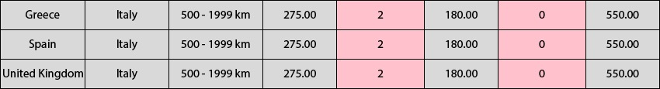

Turkish and Hungarian partners will send only 1 participant. All other participants will send 2 participants.

List of selected partner organisations:

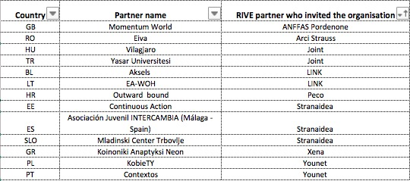

Short description of RIVE
RIVE (Rete Italiana Volontariato Europeo) is a national network of Italian youth organizations promoting international mobility. The network was established in 2013 with the aim of promoting international voluntary work, youth participation, non-formal education and intercultural dialogue.
RIVE promotes European Voluntary Service as one of the most relevant opportunities to develop new skills and gain European citizenship.
The network gathers many youth organizations based in different regions of Italy, all of them very active in sending volunteers abroad through EVS and other international programs. The members of RIVE are: Joint (Milano), Link (Altamura), Cantiere Giovani (Frattamaggiore), YouNet (Bologna), Arci Strauss (Mussumeli), Stranaidea (Torino), Movimentazioni (Pescara), Vicolocorto (Pesaro), Associazione InCo (Trento), Associazione di Prom. Soc. PE.CO (Genova), AMFI International (Celano), Associazione Basilicata Link (Matera), ANFAFF (Pordenone).
RIVE is very focused on quality, which means on defining minimum standards in EVS, in order to ensure good preparation, effective cooperation between sending and hosting organizations and to guarantee a positive learning process for the volunteers.

