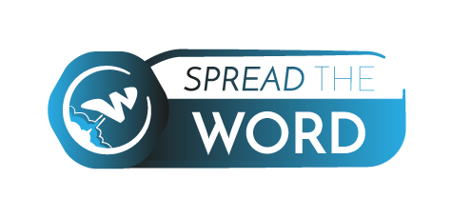

Photo

APPLICANT'S PERSONAL DATA

Please fill out your personal data:

Partner organization:
First Name:
Family name:
Date of Birth:
Gender: | Female |  |  | Male
Telephone Number:
Mobile Number:
E-mail:
Facebook:
Address: | Street name
Address: | Postcode
Address: | Region
Address: | City
Address: | Country
Emergency contact: | Name
Emergency contact: | Mobile
Dietary needs:

Please answer the following questions:

1. Please describe your studies and your current profession.

2. What is your English language level?

3. What is your experience in youth work and working in youth organisations?

4. Can you name and describe some training courses have you organised/facilitated/coordinated?

5. How much familiar are you with the Erasmus+ programme? In how many Erasmus+ programmes have you participated and which ones?

6. Why do you wish to participate in this training course? What are your expectations?

7. How can you contribute to this project? (sharing your experiences, best practices, knowledge and know-how)

8. Please provide some information about best practices of your organisation regarding the visibility of your projects, the dissemination and exploitation of the results of your projects and the networking methods you use.

9. How are you going to disseminate the results of this project in your local community?

10. How are you going to use the learning outcomes in your work after the implementation of this training course?

11. Have you got any health issues or any other personal issues that we need to know?

12. Are you able to stay in a four-bed-room and share the room with participants of the same gender whom you haven’t met before?

13. Are you available to participate in the Spread the Word training course all the days from the 9th of October (arrival day) to the 16th of October (departure day)?

After reading very carefully the info pack and if you agree with the regulations of the Spread the Word project please sign below that you agree to participate in this project under the conditions of the Erasmus+ programme and of this training course:

name, surname – location - date

Thank you for your answers! Please send this registration form together with your CV to myrto.pertsinidi@jkpev.de.



