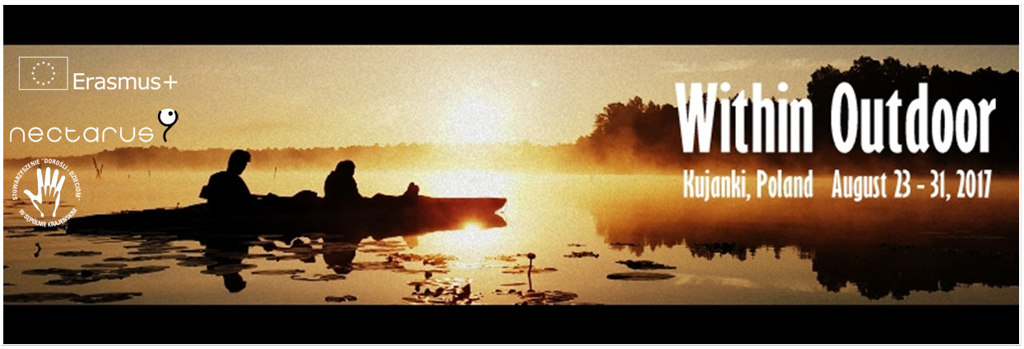

A training course for trainers and youth workers

“Within Outdoor”

Kujanki, Poland

August 23-31, 2017

Short DESCRIPTION of the project:

This training course will bring together 25 experienced youth workers and trainers from Latvia, Slovenia, Lithuania, Poland, Armenia, Georgia, Moldova, Russia, Ukraine and Belarus.

The training course will focus on Outdoor Experiential Learning, which is one of the most powerful tools to work with supporting and using group dynamics processes for educational means and assisting participants in the in-depth personal development process. The training course will have big influence on developing key competencies of participants and their beneficiaries – young people (especially, young people with fewer opportunities) linked to adaptability, dealing with challenges and stress, teamwork and leadership, decision-making, communication and others. Outdoor methodology provides unique opportunities to reflect on personal strong and weak qualities, to get feedback from peers and to try yourself in the situations of ambiguity.

During this unique training we want all participants to experience adventure type of experiential learning activities outdoors as an educational tool (24 hour hike in the Polish wilderness) in order later on to adapt this experience and use it with young people “at home”.

So, after this training, we expect ALL participants to be actively involved in sharing the experiences from this training. Within 2 months after the project (September, October) participants (alone or in cooperation with other persons from the same country) are expected to organize follow-up activities, organizing Adventure Hike with youngsters in your country – including also some young people with fewer opportunities. In addition, you can choose (what is more relevant for you) to write an article, make an outdoor workshop, develop an international cooperation project (for example, youth exchange), etc.

OBJECTIVES that we have set for this training:

1. To develop understanding of in-depth personal development and group dynamics for developing concrete key competences of learners;
2. To experience and explore methodology of outdoor NFL and review it’s practical application for personal and social development of learners;
3. To obtain technical skills and raise the confidence of working with the outdoor methods as low ropes, night hikes and other for ensuring safe learning space;
4. To develop motivation and concrete ideas on how to integrate NFL outdoor approach in the programmes, projects and everyday practices working with young people, especially inclusion youngsters;
5. To promote networking and cooperation between experienced youth workers/trainers from Programme and Partner countries for further improvement of youth work in local and European level.

Profile of participants:
Due to unique character of the project, it is very crucial for us that Partner organisations select EXPERIENCED members (trainers/youth workers) of the organisation who directly work with groups of young people and have reflections about it. NO BEGINNERS or seminar tourists, please! ☺

THE PARTICIPANTS SHOULD:
- Have at least 1 year experience working with youth in non‐formal settings (not just as participant, but in an active role of providing activities for and with the young people – either as a volunteer or a paid worker).
- Represent an organization that works with young people. Ideally this should be official partner organization of this project, but if not possible to get enough strong candidates, please involve your friend organisations.
- Be ready to do follow‐up activities with local young people after coming back from the training (September-November).
- Interested and ready to discover outdoor approach (physically and mentally :)). Be open for outdoor activities, survive limited level of comfort, ready to go for a hike and spend 1 night in the wilderness, carry your (heavy) backpack, cook dinner on bonfire and sleep in a tent.
- Be fluent in English

Participant Countries and number of participants:

Participating countries | Number of participants
Lithuania | 3 + 2 trainers
Latvia | 3
Slovenia | 3
Armenia | 3
Russian Federation | 1
Belarus | 3
Ukraine | 2
Moldova | 1
Georgia | 3
Poland | 3 + 2 staff

TRAVEL COSTS AND REIMBURSEMENTS:
The training course will be implemented in the framework of EU “ERASMUS+” programme (Mobility of Youth Workers, Key Action 1). The accommodation and food will be covered fully. Travel expenses will be reimbursed at flat rates depending on the calculated travel distance. Please consult with us before buying any tickets and we will assist you in finding the best options.

Country of Origin | Maximum Reimbursement (€ per person)
Lithuania | 180
Latvia | 275
Slovenia | 275
Armenia | 360
Russian Federation | 275
Belarus | 275
Ukraine | 275
Moldova | 275
Georgia | 360
Poland | 0

Most of you will probably arrive to Warsaw Chopin Airport but airports in Gdańsk or Poznań might be also good options (however in most cases the cheapest way is a travel to WARSAW). From Warsaw you will have to go to Bydgoszcz (train/bus tickets will be provided by organisers) and from Bydgoszcz we will pick you up to the training venue… Quite a long way but… worth all your time and efforts…

Accomodation:

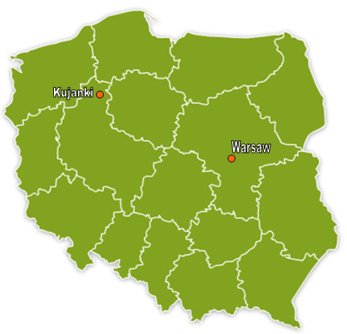 | The training course is going to take place in a very small village Kujanki in Wielkopolskie voivodship. It is about 350 km from the capital of Poland – Warsaw.  Our guesthouse “Poziomka” is located in a very picturesque area, surrounded by forests, in the neighbourhood of several lakes – amazing place for an outdoor project!
Cozy atmosphere, a lot of space to use for training purposes but also for having a rest (nature, lake, small swimming pool and sauna in the hotel) will assure us great conditions to achieve our TC’s learning objectives.  Participants will be accommodated in triple rooms with separate bathroom. | 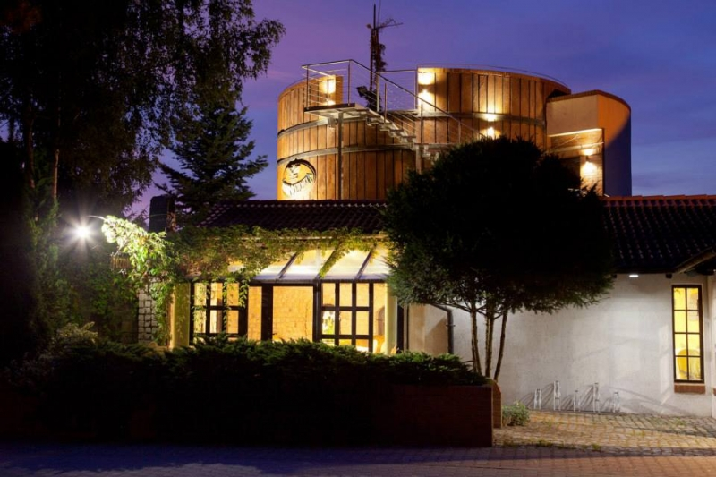
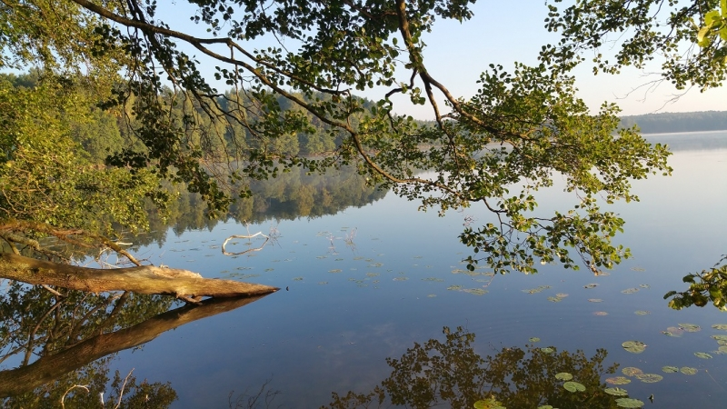 | You can visit guesthouse’s web page – it’s only in Polish but – at least – there are some picture where you can see how does it look like.

Hiking and camping

Our programme includes 24 hours out (hiking and one night of camping) in the wilderness. There is no deadly wildlife in Poland, only some annoying mosquitos and ticks which can transmit Encephalitis and Lyme disease which can be best prevented by tick repellent sprays tightly tucked trouser legs and sleeves and close body inspection by your peers after the hike.

Hiking equipment
Organizers will provide the necessary group equipment:
- tent
- sleeping mats
- cooking pot
- knife
- axe or saw
- safety matches or lighter
- map

However, you should bring your own:
- Flash light
- comfortable shoes for hiking
- anti mosquito and tick fluid
- personal medicaments you might need and anti-alergy drugs
- rain coat
- backpack, not too big
- warmer clothes for hike

What else to bring:
- First of all - bring yourself with all your best talents and ideas to share.
- National snacks to complement our plain standard coffee breaks
- Initiatives how to spend the free time together or even complement the agenda
- We strongly recommend to obtain a standard travel health Insurance (for non-EU residents) or European Health Insurance Card (for EU/EFTA/Swiss residents, free of charge).

Average weather in August
- Day temperature: +20 – 25 ºC
- Night temperature: +10 - 12 ºC
- Rainy days: 2 during our TC (let’s hope )
Please check the weather before you leave but be prepared for everything.

TRAINERS and COORDINATOR:

Donatas Petkauskas, Trainer (Lithuania) – experiential learning trainer and supervisor, specialized on topics of group/ team building, leadership, decision making and conflict solving, training of trainers and training of youth workers. Involved in the training field since 2002. He has conducted numerous trainings using the outdoor approach. | Žilvinas Gailius, Trainer (Lithuania) -  the head of the Lithuanian Association of Professional Relationship Consultants (Supervisors) since 2010.  Since 1996 he has worked intensively on programmes for training and improving youth workers and trainers. His favourite training subjects are non-formal education, experiential learning, and intercultural learning. | Daniel Wargin, project coordinator (Poland) – a member of the applying organisation: Stowarzysznie “Dorośli – Dzieciom” (“Adults for Children” Association) from Sępólno Krajeńskie, Poland.  Actively involved in youth work since 2005. Coordinator of EVS projects, Youth Exchanges and training courses.

How to apply:

All you need is to be INTERESTED, MOTIVATED and meet our participant’s criteria. To apply, please fill in the online application form:

“Within Outdoor” – application form

to be submitted no later than Sunday, August 9th, 2017. The form is quite long and will take time, so, please don’t leave it for the last minute. We will be expecting the applications.

For questions, please contact Daniel Wargin: daniello13@wp.pl or +48 600062665

Looking forward to see you in Poland!!!
Preliminary Programme of the Training Course (changes, of course, are possible)
Time / day | D 1 | Day 2 | Day 3 | Day 4 | Day 5 | Day 6 | Day 7 | Day 8 | D 9
09:00 – 09:15 | Arrivals of participants | Breakfast
10.00 -11.30 |  | Context, aims and objectives of the training course | Our motivation for youth work and discovering outdoor approach and readyness to get involved in outdoor experiential learning for personal and social development | Expected group return time to the training venue - until 10 am | Outdoor experiential learning: using low ropes for working with group dynamics and personal challenges | Developing own educational programmes for young people: NFE, outdoor, personal development, group dynamics | Participants practise stage: action 3rd group | Outdoor experiential learning: reviewing concrete applicability for our context | Planning follow up and future steps. Group disconnection.
11:30 – 12:00 |  | Coffee break
12:00 – 13:30 |  | Learning 2 learn: setting learning objectives and creating learning plan (using unique learning badges) | Experiencing the power of learning through outdoor night hike - group prepares for a night hike: preparations | Resting and refreshing time till lunch | Outdoor experiential learning: using low ropes for working with group dynamics and personal challenges | Developing own educational programmes for young people: NFE, outdoor, personal development, group dynamics | Participants practise stage: action 4th group | Outdoor experiential learning: reviewing concrete applicability for our context | Departure of participants
13:30 – 15.00 |  | Lunch
15:00 – 16:30 |  | Creating learning environment. Group building. | Experiencing the power of learning through outdoor night hike - group prepares for a night hike: preparations | Reflection on the experience: - personal level, - group level, - methodological level | Risk assessment of low ropes exercises as a tool for inclusion. Reflection of the day. | Participants practise stage: action 1st group | Participants practise stage: action 5th group | Starting evaluation process of the whole training course. What are main results and main impact.
16.30 – 17.00 |  | Coffee break
17:00 – 19.00 | Getting to know each other and welcome evening | Creating learning environment. Group building. Reflection the day. | Outdoor night hiking | What is outdoor experiential learning and why it is so powerfull | Free time in the nature | Participants practise stage: action 2nd group | Closing practise stage: evaluation of team work (of small groups) and naming learning outcomes | Agreeing on concrete visability & DEOR activities to spread the learning outcomes and impact of this TC
19:00 – 20.30 |  | Dinner
After 20:30 |  | Evening for socialising | Outdoor night hiking | Open space evening | Free evening in the nature | Evening for socialising | Free evening or some activity proposed and implemented by participants | Farewell party

