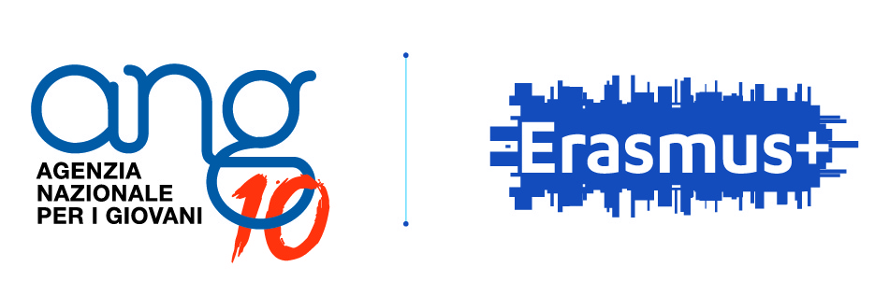

Italian National Agency is glad to introduce to you and
to extend you a warm invitation for

route60+…
stories that shaped a better Europe
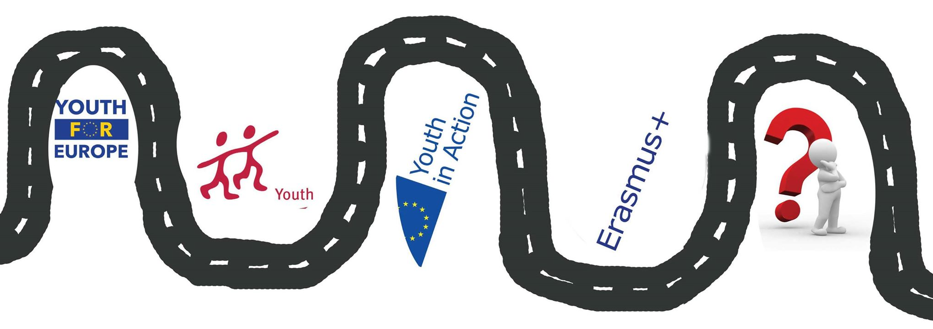

If you have
promoted or been part of learning/educational projects, attended Youth Exchanges,
training courses, EVS (European Voluntary Service), seminars within “Youth for Europe” - “Youth” Program – “Youth in Action” Program – Lifelong Learning Program- Erasmus+ Program

If you are (or have been in the past)
a youth worker, trainer, mentor, project coordinator, NGO manager,
participant in European educational projects and through it you are
actively involved in your community

If you and your organization have
benefitted from the European programs/projects
and are willing and eager to share your experience/story
with the European Programs but also, sometimes you were struggling in
explaining, sharing about those amazing experiences

If you believe
that “Europe” has had a virtuous path and that despite some more recent problems or challenges, that path is worth to be continued and improved;
that this virtuous path of Europe, the impact and benefits of 30 years of European Programs need a narrative, a story that collects many personal stories

then route60+ is the project you want to be in (and in which we want you!!)

Context, background of this project:

In 2017, we are celebrating the 60th anniversary of the “Roman Treaties”, one of the remarkable milestones in the “European making process”, one of the many steps towards the Europe, as we know it now. Exactly half of these 60 years were filled with the European Programs, some also for Youth. Years with “Youth for Europe”, “Youth”, “Youth in Action” and now “Erasmus Plus Youth”.
Thanks to these programs, new generations of young-adults have grown and have in fact contributed to building and shaping a better, stronger, safer Europe, based on people, on stronger values, overcoming stereotypes, fighting xenophobia, racism and ignorance. Thanks to these Programs, Education and Learning have a new meaning, a deeper quality, largely because of the Non-Formal Education/Learning approach. The concept of “empowerment” got a new and fresh meaning.
All these Programs mean thousands of projects, thousands of organizations from all over Europe and neighbouring countries were cooperating and networking, thousands of people have been meeting, interacting, sharing and simply building a wide “European Community”.

However, not all aspects about the “virtuous path of Europe” built and promoted through these programs are really well known by a wider audience, especially people who are not involved in European Programs. Are we just a beautiful bubble?
Despite a lot of communication about results, impact, long-term benefits, outside graphics and statistics, numbers and percentages shown, we may not have the power to really “tell and share the story” of these Programs to a wider audience of Europeans. What is missing perhaps is the same amount of work based on people’s real STORIES that are behind statistics and numbers. Names, faces, people, A-HA moments, discoveries…in one word: stories…

Topics

The route60+ project is a long-term initiative meant to collect “stories of/for Europe”, stories that over the past 30 years have literally built, shaped and re-shaped a better Europe, through the participation, involvement, empowerment and change of hundreds of thousands of people, all over Europe and beyond, in meaningful educational programs.
The participants involved throughout the long-term project process will not only collect stories, but also share their own story linked with being Europeans and create together a format to record these stories in such a way as to develop a valuable tool to be shared with all other stakeholders.

More about participants’ profile

Are you from one of the Erasmus+ Program countries? Or Partner countries?

Have you had at least 2 experiences in the implementation/participation in one of the European Youth Programs ever since those Programs started?

Have you something to say or share about the meaning and effects of European Educational Programs, on yourself or others?

Are you motivated and ready to work in a long-term project in ALL the 4 phases (described below), learning, providing your ideas, creating materials and contributing to producing end products related to the project topic?

Do you want to contribute to the writing of a “new Narrative of Europe”?

Our “expectations” from selected participants, simply:

- to be genuinely interested in the project topic and motivated to contribute to the content
- to be eager to discover together the meaning of a new narrative of Europe
- to be passionate about stories, education, non-formal learning, Europe, youth and how all these connect
- to have an adequate level of English, needed in the extensive communication processes we will develop inside and outside the project events

The main project objectives are to

- Focus on and enhance the virtuous path of Europe through the European Commission educational programs for Youth.
- Look-back and revive the impact of EU Programs, how they positively affected youth, people, organizations and in the long term…Europe and the European constructions and values
- Collect and share stories/experiences from actors (youth-workers, trainers, mentors, project managers, participants in European projects, organizations) who have benefited from these Programs
- Reveal a new and positive narrative of Europe through the real stories of people who used and benefited from the “mobility” learning opportunities
- Look forward (after looking-back) and use the positive impact of 30 years of EU programs to better deal with the new challenges Europe is facing
- Reinforce the importance and recognition of education and more specifically non-formal education
- Emphasise how a better quality of learning and a deeper awareness of learning processes, can make a change

What will happen in this long-term project?

Dates and time investment
route60+ will last 6 months divided in 3 phases:
- October Online preparation with the selected participants
- November 2017 Training course
- December 2017 – April 2018 Creative Remote Work, Collecting Stories from all over Europe
- April 2018 Final event: closing seminar + open-conference

So as time investment consider 12-14 days (travel days included) for the training course and the final event, plus the self-organized work, time during the 5 months of remote work
(further info about the phases below)

Route60+ working philosophy

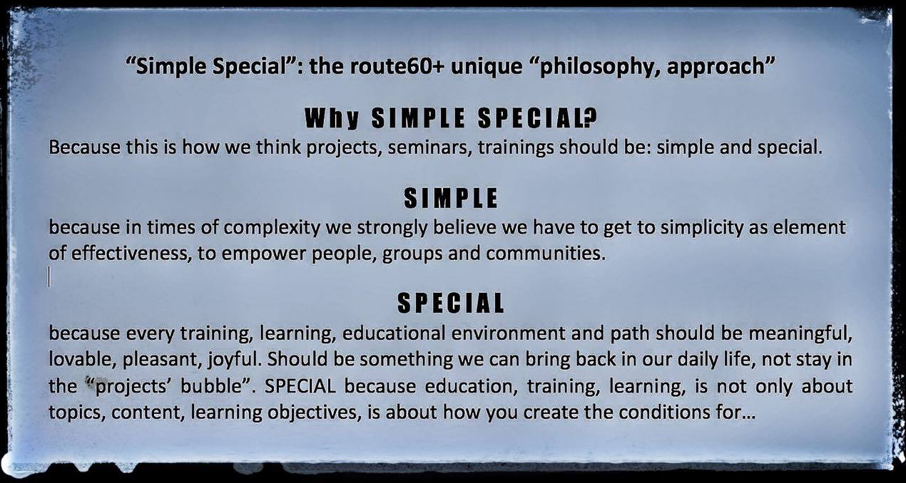

Project phases

PHASE 1

Online Preparation

The selected participants will have a period to get more familiar with the project, to start interacting with each other and have a smooth approach toward the first training course. The team of trainers will guide this online preparation.

17-23 November 2017 – Training Course
“The meaning of Stories and meaningful communication”, training course on communication, Storytelling, media (5 working days + 2 travel days).
How do we tell a story? When and why we do it. How do we share them? Can they make a difference in OUR lives? In the lives of others? “Route60+” is about stories as a communication and learning tool…

Objectives of the TC:
• To introduce the purpose and potential of looking at people’s experience and their learning/educational Programs (Youth, YiA, E+), as a “story”, that can be shared as a valuable tool
• To offer space and time for participants to reflect, assess, evaluate and share their experiences, in a “story-format”, at different levels: personal, organizational, community
• To improve the knowledge of participants about meaningful communication, storytelling, media-tools
• To explore what was (and is) the design, philosophy, meaning of the different EU Programs for youth
• To create a format for collecting, editing and sharing stories
• To find innovative ways to communicate through online platforms and tools
• To prepare a strategy for collecting stories from other people and organizations from all over Europe (Program and neighbouring countries) during the remainder of the project

PHASE 2

Practicing and collecting stories (December 2017 – March 2018)
Participants of the training course will work remotely (also in teams which will be formed during the training course) to collect stories from people and organizations from all over Europe, using the format and tools commonly created during the TC.

PHASE 3
route60+ hands on…

Finalizing project products (March-April 2018)
This phase is allocated to assess the contents of the collected “stories”, for finalizing the final products (stories and their formats, online tools), and preparing the final event (contents, products, dissemination, visibility). Participants and the project team work based on the tasks and responsibilities agreed in the previous phases.

Final event – April 2018

The final event consists of a seminar and the “route60+ open conference”

The seminar will serve for setting-up the non-conference, for the evaluation of the learning experience of the project;
The seminar objectives are:
- to evaluate the process of collecting stories from all over Europe
- to focus on the dissemination and visibility of the project and products
- to promote the results and products of the project through an open conference
- to set-up the route60+ conference environment
- to carry out the final evaluation of the project with the involved participants

Team of trainers
3 friends, 3 colleagues, 3 parts of a dynamic trio, born during 2007 SALTO Youth in Action Training of Trainers

Corina Pintea – Romania – corapintea@gmail.com
https://www.salto-youth.net/tools/toy/corina-pintea.3143/

Panayiotis Theodorou – Cyprus - panayiotisth@gmail.com
http://www.salto-youth.net/tools/toy/panayiotis-theodorou.1273

Salvi Greco – Italy – salvigreco@gmail.com
https://www.salto-youth.net/tools/toy/salvi-greco.1675/

