„Inclusive Education for Roma Youth „TRAINING COURSE

14-22 May 2017 Location: Craiova, Romania

Host NGO: „Centrul Educational de Resurse si Training – CERT”

This info pack will provide you with the necessary information that you need before arriving to Inclusive Education for Roma Youth Tranining course in CRAIOVA , Romania;we provide you with useful details on travelling arrangements, accommodation, and some general information on the area you will stay.http://en.wikipedia.org/wiki/Craiova;

Participant countries: Greece, Bulgaria, Croatia, Romania, Turkey, Italy, Poland, Slovakia
Number of participants – 28 3/country Italy and Bulgaria 4/country

Training tax for participation : 20 euro / person (STUDY VISIT )

Accomodation will be in rooms of 2 individual beds, in a national network youth hostes with 3 meals included- https://www.booking.com/hotel/ro/hostel-griffon.ro.html

Currency:You can’t use Euro in Romania! exchange rate is 1 Eur=4,5 lei

The host association: Our association aims to :
• periodically create informative materials for young people and the local community;
• organize training courses, seminars, conferences, public debates, social events and public opinion awareness campaigns;
• support social assistance activities in the rural area
• inform and promote the human rights;
• raise awareness upon the democratic principles such as: equality, degnity, freedom.
Our main activities are:
• ecological and environmental protection activities;
• voluntaring in social work;
• protection of human rights and the rights of children, especially in the rural area;
• empowering young people from the rural area;

Travel details:
How to reach Craiova:, THE HOST CITY

Have a look on: http://www.romaniatourism.com/maps/romania/romania_detail_map.html is 250 km far from Bucharest,
You should book your flights for Bucharest or Craiova; From Airport – GARA de NORD (The train station in Bucharest) go for Bus: 780 / 783 and from Gara de Nord take the train to Craiova (every 1 hour).
The necessary documents for reimbursement of travel (Reimbursements will be done after CERT receives all coming-return original tickets by postal address, money t=will be sent to your sending NGO;s account)
- Tickets (bus, metro, train, boarding passes, flight tickets);
- Invoice – where the price is, your name(if the case), time;
- Provement of payment (bank excerpt, credit card online payment-emails, paper bill)
(Without any of these, we cannot reimburse your money for travel; NO TAXI –except for night hours is the case)
Down here you can find the travel budget / country / person. Pls fit in and let us know if we can support you in choosing best way of traveling. 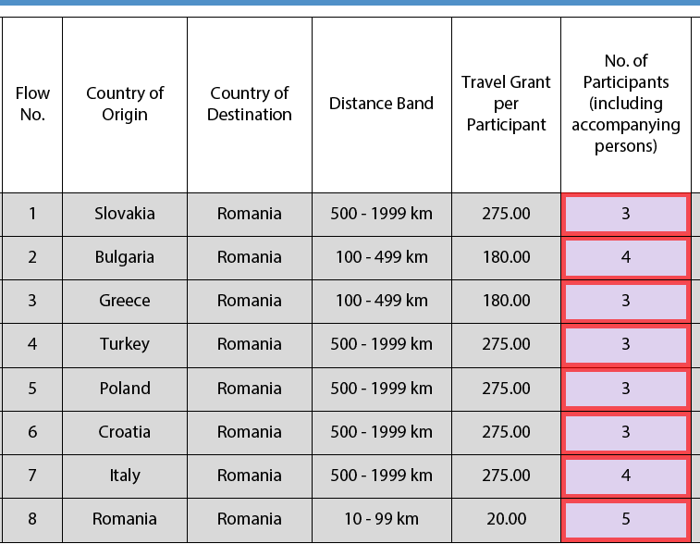

Travel insurance: pls follow the link to make your own travel insurance http://ec.europa.eu/social/main.jsp?catId=563&langId=en#nationalinfo

For more details :
Coordonator proiect: ALEXANDRA BADEA
https://certdolj.wordpress.com
Tel :0040784787870 ; alexandra_alina98@yahoo.com

