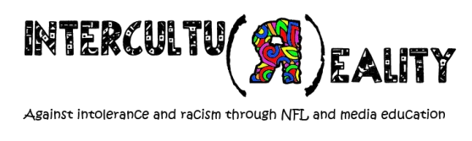
Training Course: Intercultu(R)eality
Palermo, Sicily 8. 05. – 16. 05. 2016

DRAFT of PROGRAM
 | 09. 05. 2016 | 10. 05. 2016 | 11. 05. 2016 | 12. 05. 2016 | 13. 05. 2016 | 14. 05. 2016 | 15. 05. 2016
9:30-11:00 | Introduction of project, objectives, program  Knowing Each Other | Intercultural reality-  reality check | From stereotypes and prejudice  to Discrimination and rasizm | Education to Human Rights | Media as promoters of tolerance and hostility | How to design activity of intercultural learning | Tools market
11:30–13:00 |  | Intercultural learning  What it is and how does it works? |  |  |  |  | Erasmus+
13:00-15:00 | LUNCH | LUNCH | LUNCH | LUNCH | LUNCH | LUNCH | LUNCH
15:00-16:30 | What is Non Formal Education? | Different but Equal | Media Education  Introduction | free | Promotion of Intercultural tolerance | Intercultural learning and media education in practice | Networking
17:00-18:30 | Youth Pass and Key competencies | Different but Equal | Media Education  Introduction | free | Promotion of Intercultural tolerance | Intercultural learning and media education in practice | Final Evaluation
18:30-19:00 | Reflection time | Reflection time | Reflection time | Reflection time | Reflection time | Reflection time
19:00-20:00 | DINNER | DINNER | DINNER | DINNER | DINNER | DINNER | DINNER
 | Welcome evening | Intercultural  evening | NGO market | free | free | free | free

