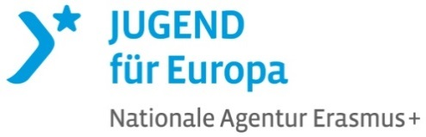
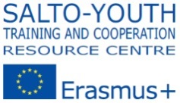
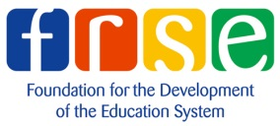

U-Turn
Learning journey for trainers in the youth field
12-18th of March 2016, Estonia

Are you curious about your professional identity as a trainer?
Are you willing to deepen your unique path as a youth field trainer?
Are you curious about the European Youth Work field and your role in it?

The field of training in European youth work is very diverse. Trainers active in the field have various backgrounds and different paths: they initiate own training projects to learn and develop, training practise and/or first steps into training are made in local/regional/national youth work settings, they learn and are supported by international organization or National Agencies, learning also takes place by participation in European-level training for trainers.
If you have made your first steps into training others (volunteers, youth worker, young people) you would like to reflect on your paths as trainer, deepen it and consider European youth work developments as a plus, please come to U-Turn!!!
“U-Turn: A learning journey for trainers in the youth field” is an initiative from a number of Erasmus+: Youth in Action National Agencies (E+: YiA NAs) sensing to offer opportunities to develop competences of trainers and facilitators of learning processes contributing to the quality development of youth work on local, national and European level. This project is part of the strategy of the “Trainer Competence Development Group” https://www.salto-youth.net/trainercompetencedevelopment/ on European level aiming at a more holistic approach to training of and for trainers. This specific course is a possibility for people acting as trainer in the youth field to deepen their professional practice, connect their work in a more meaningful way to a European dimension and shape the future of training field.

This training opportunity aims to
contribute to the quality development of youth work on local, national and European level by developing competences of trainers active in the field who will be able
- to develop their professional identity as trainer and facilitator in the youth field and based on this become more pro-active and connected,
- to commit themselves to an on-going competence development process according to the Competence Model for trainers to work internationally, developed in the frame of the European Training Strategy in the field of Youth,
- to link their training practice with relevant learning theories in general and their educational approach specifically,
- to collaborate with partners in the bigger picture (NAs, international organisations, other trainers etc.) for bringing a stronger European dimension into the youth training field, and
- to relate their training work to the bigger picture of European Youth Work.

What will be in the U-Turn?
The training content will be largely influenced by the learning needs of participants. It is an invitation to build the course on each other’s talents, ideas and wisdom, experiment and take hands-heart-head approach to learning. The course will tackle in addition to the aims furthermore the following important aspects:
- the relationship between trainer, participant and group and group dynamic in general,
- different roles and responsibilities of a trainer,
- the creation of inspiring learning environments, and
- the essentials of training programme design.
The methodology will be based on principles and approaches coming from experiential learning, self-directed learning and Theory U as a practice supporting processes of transformative learning.
Is it for you?
We are looking forward to learn with you, if you:
- have experience as a trainer in the youth field (not necessarily in Youth in Action).
- have experience with international cooperation (youth projects, network, organisation) in a leading role (project manager, youth leader, trainer).
- interested in deepening your professional development.
- have the intention to contribute to the bigger picture in the role of a trainer/facilitator of learning.
- have open mind, curiosity, readiness to question/challenge own beliefs related to learning.
- capable to work as a trainer in English.

Are you ready for U-Turn?
- If yes, please apply here until 15th December 2015!
- The selection will be made by the respective National Agencies based on your application form and you will be informed about the selection results by the Estonian NA after 10th January.
- Please be aware that U-turn participation consists of preparation activities (individual, possibly national group related) and follow up activities.

The journey will be hosted by the Erasmus + National Agency of Estonia and the trainers will be Piret Jeedas and Peter Hofmann.
“I am curious about life, myself, the learner and creating meaningful learning spaces to adults. My academic background is in adult education and I am part time lecturer at Tallinn University, where I enjoy learning and co-creating with future trainers. I started my professional career as a trainer in the youth field, f.e. working with youth unemployment, intercultural learning, volunteer service etc. Currently I am interested in innovation in education and therefore initiated a strategic cooperation project within Erasmus+ “MoveMakers: Co-Creating New Ways of Learning”. Enthusiastic about nature, good friends and tasty organic food.”
Piret Jeedas
I am passionate about learning design and facilitation of learning. I have been involved in non-formal education – with young people as well as adults – for more than 10 years already. I was active as trainer and mentor in many European–level courses organized within the framework of European Youth Work – Training of Trainers for European Youth Projects, TALE, further training for NA staff members or trainer pools and others. I am also passionate about dealing with change and transition, systems thinking in education, self-directed learning, coaching and mentoring, my family, being in nature, especially on mountains. More info: www.limina.at/Peter.
Peter Hofmann

The training activity will be organised in cooperation with the Erasmus + Youth in Action National Agencies Estonia, Germany, Slovenia and the SALTO Training & Cooperation Resource Centre.

If you have any questions regarding the course, please contact Marko Vene (marko.vene@archimedes.ee).

