CALL FOR PARTICIPANTS
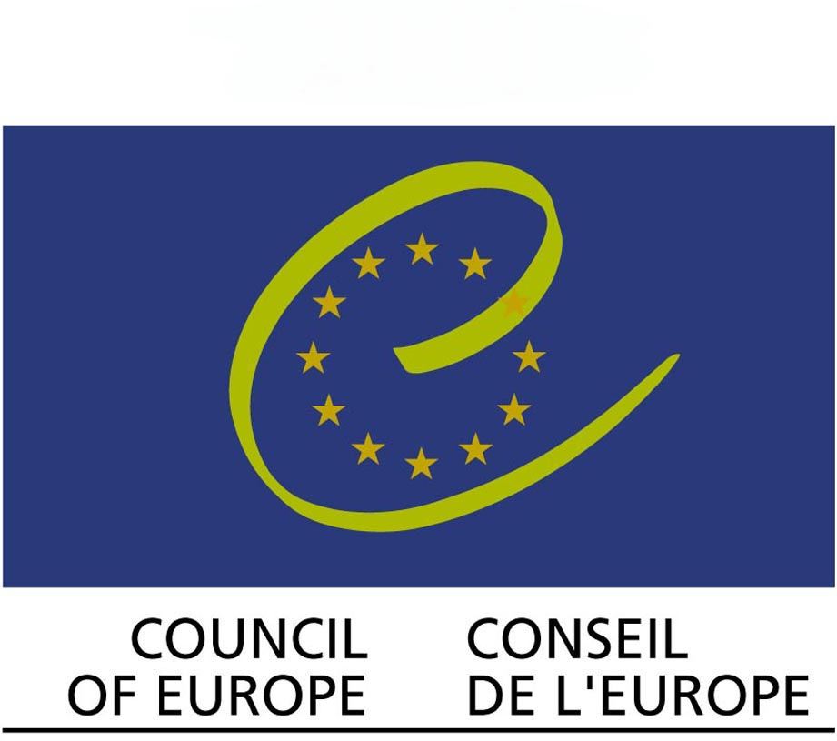  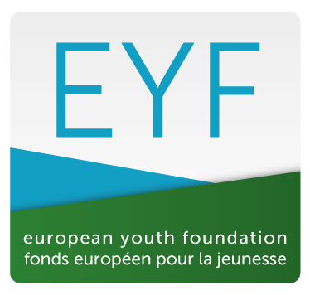  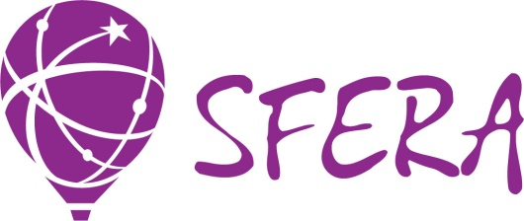 | Seminar - training “Social diplomacy –  the field where YOUth has a real power”. STEP 1  The seminar- training “Social diplomacy – the field where YOUth has real power” is aimed on raising awareness about social diplomacy approach towards the international youth work and peace building projects.  In the current situation of raising youth mobility, the important role of Internet and social networks in the international communication among young people it`s very important to act as an “social diplomat” to build friendly relationship between young people from different countries in spite of political situations and decisions on the governmental level. Young people through international projects with volunteering and humanitarian purposes bring peace and build peace in the international reality.  Some researchers of social diplomacy phenomenon call it “soft power” in the international relationships and underline the importance of young people in this field. During this training we want to realize the role and place of youth organizations in the “soft power” phenomenon.  Social diplomacy has strong connection with peace building process, it is the way how to develop and reach peace and we will take into account both social diplomacy and peace building in a relation during the training.  The main elements of the social diplomacy are understanding own culture, tolerance to another culture, mutual understanding and common actions. These elements are absolutely suitable for international youth work and can be used as elements for pre-departure preparation of volunteers who are going to participate in the international youth projects.  The project contributes to the empowering youth organizations to implement peace building projects with social diplomacy approach in the COE members states, to promote among young people values of tolerant communication and mutual understanding as a tool for democracy development on the “bottom” level and active citizenship of young people. It collects practices of peace building projects and campaigns, implemented in different parts of Europe and, using synergy, produces concrete suggestions how to develop social diplomacy approach in the youth field on the national level taking into consideration all-European experience. The outcomes of the meeting will be translated on the territory of the Council of Europe and outside thanks global networking cooperation of involved organizations with Alliance of European voluntary organizations and Service Civil International what turns the project into the platform for translation of European values and approaches to other countries.  The 6-days training will gather 30 participants from 15 countries, representatives of youth organizations working with peace building projects to share their experiences and best practices in peace building and social diplomacy projects, to develop skills on non-violence communication, conflict transformation, work and leadership in multicultural groups, effective communication skills in the international reality, dealing with stereotypes and prejudices.
Dates | 17/08/2015 – 23/08/2015
Place | Nizhniy Novgorod, Russia
Profile of participants | We expect to receive from our partner organizations the participants with following profile:  1. Youth workers from 18 years old who are involved in daily activity of partner organizations and are interested in the topic of social diplomacy and peace.  2. Participants who wish to develop a multiplier effect after the training.  3. Participants who are ready and wish to develop cooperation in the field of peace building projects.  4. Participants who are able to attend training in English.  5. Participants who have skills in project management and implementing international youth projects.  6. Participant who have experience in working with international groups.
Project aim and objectives | The main aim of the project is to encourage young people involved in the international youth work and volunteering to develop projects in the field of social diplomacy and peace building through raising their awareness about social diplomacy approach towards the international youth work.  In order to achieve this aim we are going to implement following objectives:  1. To raise awareness about social diplomacy itself: definition, actors, publics, means and goals.  2. To reflect about the role of international voluntary youth organizations in social diplomacy and peace building process.  3. To provide participants with the set of necessary competences and skills related to the topic of social diplomacy and peace building: non-violent communication, conflict transformation, work and leadership in multicultural groups, effective communication skills in the international reality, stereotypes and prejudices.  4. To share the best practices of youth organizations in social diplomacy and peace building.  5. To build up the network of young people and youth organizations who are interested to develop cooperation in the field of social diplomacy and peace building projects.  6. To develop the idea of the International campaign “YOUth is the power” among young people - participants of the international youth projects to promote mutual understanding, tolerance and peace building.  7. To create the tool-kit for youth workers “Social diplomacy approach in youth work” with the set of practical materials and methods based on social diplomacy approach (understanding own culture, tolerance to another culture, mutual understanding and common actions) and to be used by involved organizations and their partners for further cultural preparation of young people going abroad to participate in youth social/volunteering projects: international voluntary workcamps, youth exchanges, European Voluntary Service.
Financial aspects  of the project | The Programme covers:  - 100% of accommodation, food and trainings materials,  - 65% of travel costs (the limit for buying tickets is 350 euro)  Participants cover:  - 35 % of the travel costs,  - Extra fee -60 euro,  - visa and insurance expenses.
Invitation letter | In order to obtain Russian visa we will provide you with the invitation letter with the dates 14/08 – 26/08  To make the invitation letter for you we need the scan copy of your passport.
Contact person | Alla Krinitsyna, projects.sfera@gmail.com

