Project Summary:

This project is a follow-up activity of PBA activity ''Difabville, the place to meet people with different abilities!”( NL-31-E5-2013-R1) in which the Community Center of Erzurum Metropolitan Municipality was represented by 2 participants. 'Engelleri aşalım Erzurum'da buluşalım - Europe meets in Erzurum for people with fewer opportunities’ is a training course under Erasmus + programme, Training of youth workers. The projects brings together 30 people who work for the disabled people in their local societies. At least ¼ of the participants consists of disabled people themselves.

The activities takes place in Erzurum, Turkiye within the dates: 15-20 April 2015

The main theme of the project is disabilities and cities. The training course aims to create an awareness among participants about the lives of disabled people and challenges they face in their daily life. To overcome these challenges, the project offers to create a report defining how a disabled-friendly city should be like.

The training will use non formal education tools such as presentations, team building, flash mob activity, field visits, theatre, music and drawing, group work, panel, brainstorming, dabates, sports and role play. These tools will allow the participants not only understand the difficulties of disabled people but also to experience to be a person with wheelchair, a deaf or blind person.

The report will be disseminated to 500 municipalities and NGOs in Turkey and partner organisations’ countries.

The partner organisations are public bodies and NGOs from Bulgaria, Crotia, Spain( municipality), Latvia, Romania, Greece, Turkey ( Erzurum Metropolitan Municipality) is the hosting country.

Selection of participants

Target group: There is no age limit for participants but we prefer youth workers between 18 and 35 years (we prefer some gender balance when possible).
Language: English
Criteria: Disabled participants are given priority to selection.

Accommodation
We have made sure we rented rooms of maximum three people. We have planned a day to visit Erzurum, so you will get the best of both worlds: the tranquility of the forest and the vibration of our city!

Accomodation place:
http://www.dedeman.com/otel-erzurum/dedeman-palandoken-skilodge.aspx

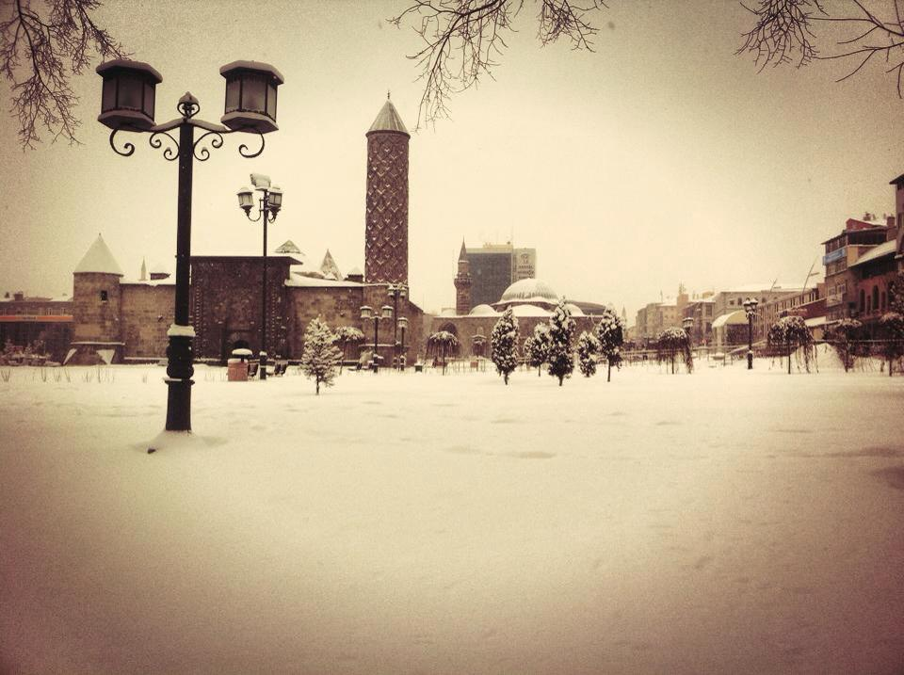

Traveling
Please remember that according the Erasmus+ Program guidelines you need to use the cheapest way of transportations which means no Business Class and First Class tickets and no Taxis.
We would love to receive your travel details as soon as possible, please confirm with us first and then book your tickets. This is just to be sure that you've found your participants and the easiest-cheapest way to reach us!

*You are expected to arrive in Erzurum on 15th April 2015 and leave on 20th April 2015. You may choose stay in Turkey up to 4 extra days however all costs on these extra days will be on your responsibility.

Travel Reimbursements
When you choose your way of transport please note that we can only refund up to the maximum limit of the distance band. We need the proof of train tickets or other means of transport from your city to Erzurum

*Please keep all your boarding passes and tickets. We will also need the invoice or bank receipt of your flights.
Reimbursements will proceed by bank transfer after the training course upon receiving all travel documents and international bank details. If you wish you to be reimbursed on the spot, you will need to present all your tickets and boarding passes to the organizers during the training course. We will be given a cheque to receive your reimbursement from a local bank.
*Taxis are not eligible for reimbursements.
Reimbursement will be done in EUR, regardless of the currency indicated on the ticket and receipt/invoice. Any tickets purchased in a local currency other than EUR, will be converted and calculated according to the exchange rate of the month when the tickets were purchased, as stated in the official European Commission website at http://ec.europa.eu/budget/inforeuro/
*Maximum Reimbursement Amounts for each participant
Crotia: 360 Euros- 3 participants
Spain: 530 Euros – 4 participants
Poland: 360 Euros- 3 participants
Romania: 275 Euros- 4 participants
Greece: 275 Euros- 4 Participants
Bulgaria: 275 euros- 4 Participants

Visa
The participants that will need a visa for this project are responsible for themselves to apply for the VISA on time. You can send us a copy of your passport and we will send you an invitation letter to assist your visa procedure.

*Please keep all the original invoices and tickets for the visa request.
Genaral
The weather in Erzurum in April is cold however It can also be raining, so please make sure to pack good shoes and warm clothes. A raincoat or umbrella should be in your luggage. Scarf, shawls and gloves are optional. If it snows, we may go to skiing

The program will be well balanced and with a good mix of leisure and sessions. The methods we will use are all informal and some will be unexpected or maybe even brand new. We ask all our participants to be willing and open-minded. You will also be able to make contributions when it comes to energizers and mood busters.

Health system / insurance every participant is responsible by themselves to take the necessary insurances for health, repatriation, theft, damages and etc.
Emergency numbers
112- Ambulance
155- Police
110- Fire Station

Erzurum Metropolitan Municipality
http://www.erzurum.bel.tr/
0442 233 00 04
erasmuserzurum@gmail.com

Cihat YILMAZ
Project Coordinator
+90 505 593 11 55
erasmuserzurum@gmail.com


We are looking forwards to meeting you in April 2015!

