Inspectors for Accessibility

Project granted by the European Commission, Erasmus + - Key Action 1 – Key Action 1: Learning Mobility of Individuals
Project’s dates: October 15 – August 10
Activity dates: February 1 – 8, 2015
Craiova, Romania

CSCD – Center for Sustainable Community Development is a nongovernmental, apolitical association established in January 2010 and mainly operating in the rural areas of SW part of Romania. Since its establishment, CSCD had been developing youth participation opportunities for vulnerable youth, with a special focus on rural youth. The main projects of activities of the association had been integrating human rights education, social animation, education for citizenship and intercultural education as learning approaches. Since 2012, CSCD had been constantly involved with TGBDER’s international projects and activities on learning methodologies for mixed abilities group and with the support of our Turkish partner and of the current partnership structure, had been successfully applying and getting the support of the European Commission – Erasmus +, Key Action 1 to implement its first training course for mixed abilities’ groups.
Inspectors for Accessibility is a training course involving a group with 28 participants with mixed abilities from 8 countries: Romania, Turkey, Italy, Spain, Bulgaria, Croatia, Latvia and Lithuania, Activity that will take place in Craiova, Romania, in February 2015. The training course aims at equipping youth workers with a set of skills, methods and activities on working with mixed abilities groups. Accessibility is the fundamental component of equality in societies. It is about giving equal access to everyone. Without being able to access the facilities and services found in the community, persons with disabilities will never be and feel fully included. Still in many societies, there are innumerable obstacles and barriers that hinder persons with disabilities such as stairs, lack of information in accessible formats such as Braille and sign language, and community services provided in a form which persons with disabilities are not able to understand. Even if the international legal framework - The Convention on the Rights of Persons with Disabilities (UNCRPD) and the European documents would guarantee the rights of persons with disabilities, even if offered with opportunities, the approach is not inclusive. Having inclusive international youth activities means that youngsters with different abilities would come together and are being offered with the same opportunities to participate. But working with mixed abilities groups is always a challenge for youth workers who have neither the expertise nor the chance to get their skills and competencies improved when it comes to mixed abilities groups in international events. When organizing an international youth event for mixed abilities group, is a wide range of measures that the associations and youth workers should be taking – from working on inclusive attitudes, to boosting up the intercultural communication, from respecting the rights to tailoring up the programme so that it would fit to all the learning needs as well as ensuring a physical space that would be accessible for everyone. Inspectors for Accessibility offers the opportunity to explore all these aspects as well as to pilot an innovative set of methodologies when working with a mixed abilities group. At the end of the training, the youth workers will have improved skills and competencies as well as the opportunity to adapt and replicate the methodologies both in their communities as well as in other international youth events
 | Partners | Country
1 | Asociatia Centrul pentru Dezvoltare Comunitara Durabila | Romania
2 | TURKIYE GENCLIK BIRLIGI DERNEGI | Turkey
3 | SAY! | Latvia
4 | Politikos tyrimu ir analizes institutas | Lithuania
5 | Association of the deaf and hard of hearing of the city of Zagreb | Croatia
6 | Centar za mejdunarodna mladejka deinost - Bulgaria | Bulgaria
7 | Esplora | Italy
8 | EPSJ Jovial La Guardia | Spain
.

Project’s description:
80 million in the European Union (16% of the population) and one in four Europeans have a family member with a disability (European Disability Forum), but this percentage is not reached amongst young people benefiting from the European programmes and opportunities. Europe 2020 targets related to inclusion and growth will be impossible to be achieved without the contribution of European citizens with disabilities. The participation of the citizens with disabilities should be guaranteed by the article 3.3 of the Treaty on the European Union. According to the statistics, when it comes to youth with disabilities, they are two to three times more likely to be unemployed than non-disabled youth; the more severe the degree of disability, the lower the participation in the labour force. Less than 20% of young people with severe disabilities, compared to 68% of those without disabilities is part of the labour market. When it comes to education, youth with disabilities is less likely to reach third level education as non disabled persons by more than 50%. 38% of people with disabilities aged 16 - 34 across Europe had an earned income, compared to 64% of non-disabled people. Most of the European organizations are running local and international ‘disability projects’ where the young people with a disability are secluded again. Through our training course, we are stimulating the ‘togetherness’ dimension of the international youth activities offering the youth workers involved concrete tips and guidelines to make mixed-ability projects approachable for youth with fewer opportunities and appealing for youth without special needs. Inspectors for Accessibility fully integrates the European Disability’s Forum motto: Nothing for us without us and aims at boosting up the international youth projects for mixed abilities groups as an excellent learning opportunity for all the categories involved, youth with special needs finally being offered with the opportunity to feel more accepted and integrated and those without learn to deal with disability as well as to benefit of the mobility rights offered through Erasmus +. The international youth activities are also offering the opportunity for youngsters to have a clear understanding of the European citizenship and In order to understand this dimension, youth with special needs should be as well offered the opportunity to participate and to be part of initiatives where they would feel free to interact. Considering the fact that youth work is about taking young people out of their comfort zone and structuring learning opportunities, while supervising them, Inspectors for Accessibility equips youth workers with the set of methods of structuring international learning opportunities for mixed abilities groups. The mobility is structured as a learning opportunity for youth workers equipping them with the tools, methods and techniques required to ensure the accessibility of their youth projects and youth initiatives and offers the essential information and methodology for the participants to run international youth projects. Consequently, Inspectors for Accessibility fully integrates the specific objectives of Erasmus + in the field of youth: improving the level of key competences and skills of youth workers who are directly working with youth with fewer opportunities and specific needs, in running international youth activities aiming at promoting the participation of youth with disabilities in the democratic life of Europe, developing competencies related to intercultural dialogue, intercultural communication and offering them an international learning mobility; fostering quality improvements in youth work through coming up with an innovative set of tools and methodologies that the youth workers and the organizations could use in order to run international youth projects with a highly improved accessibility dimension, promoting as well the cooperation between different stakeholders and actors. As for the priorities of Erasmus + (Youth), Inspectors for Accessibility invests into developing the transversal skills both of the youth workers involved as well as of the youngsters with whom the participants are working in their organizations and communities, mainly of the entrepreneurial and innovation skills, multilingualism and extensively on promoting highly innovative methodologies of working on the accessibility dimension of the international youth projects.
Inspectors for Accessibility has the following objectives:
- Equipping the youth workers working with youth with and without disabilities with the required competencies and expertise on running international mixed abilities initiatives
- Developing an innovative set of working tools and techniques on running international mixed abilities group
- Offering the opportunity for networking and boosting up the cooperation between organizations in Europe that are aiming at developing international mixed abilities project.
Participants’ profile:
The participants involved with the training course are youth workers working with youth with and without special needs and disabilities, aiming at equipping themselves with specific tools and methodologies of working with mixed abilities groups, both with experience in leading international events as well as aiming at acquiring experience on leading international activities for mixed abilities groups. The participants are to be recruited by the partner organizations their motivation to get new tools and methods and to run then international mixed abilities events, ensuring the gender balance of the group and having no age limit criteria set.
Number of participants per country:
Country | Number of participants
Romania | 5
Turkey | 4
Italy | 4
Spain | 3
Lithuania | 3
Latvia | 3
Bulgaria | 3
Croatia | 3
 | 28

Practical details
The participants are to be hosted in Craiova, a city that’s running as candidate for the European Capital of Culture in 2021. Craiova is the 6th largest city and capital of Dolj County, is situated near the east bank of the river Jiu in central Oltenia. It is a longstanding political center, and is located at approximately equal distances from the Southern Carpathians (north) and the River Danube (south), being situated at 220 km from the capital city – Bucharest.
Find out more about Craiova here: http://www.craiovaculturala.ro/en/
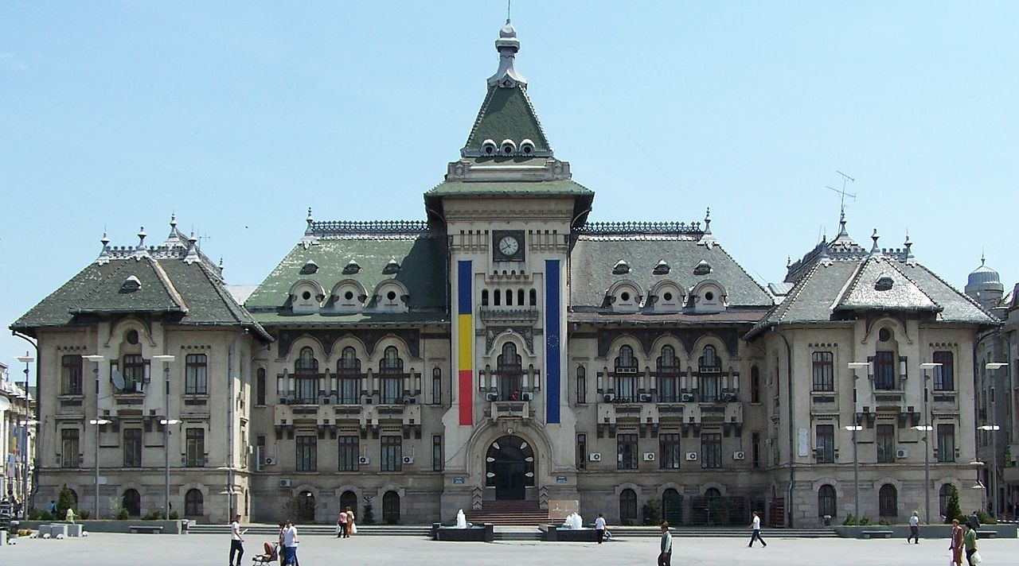

- The hosting association had been completing the arrangements for the accommodation, meals and activities ensuring the conditions for hosting participants with special needs.

The training course will be hosted by Hotel Flormang:
http://www.flormang.ro/
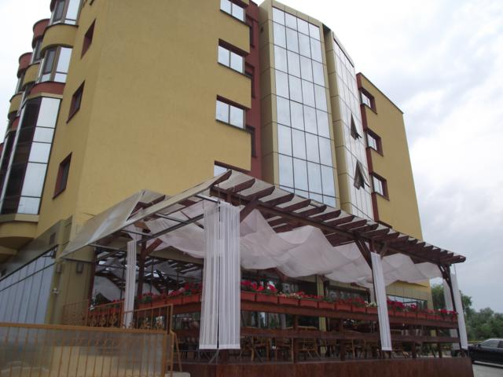

Travel arrangements:
Travel grants:
Country | Number of participants | Travel grant per participant | Total grant per national group
Romania | 5 | 0 | 0
Turkey | 4 | 275 | 1100
Italy | 4 | 275 | 1100
Spain | 3 | 360 | 1080
Lithuania | 3 | 275 | 825
Latvia | 3 | 275 | 825
Bulgaria | 3 | 180 | 540
Croatia | 3 | 275 | 825
Total: | 28 |  | 6295

How to get to Craiova?
- Check out the flights to Craiova - http://en.aeroportcraiova.ro/
- Flying to Bucharest International Airport - http://www.bucharestairports.ro/
From the Airport in Bucharest, using the Express 780 Bus (the cost of the trip is 3.5 lei and you will find the ticket office at the Arrival’s Hall of the Airport - -1 Floor) you will go to Gara de Nord - http://www.cfrcalatori.ro/imagini/Imagini-feroviare/Gara-de-Nord,-Bucuresti-881/s-1/p-28 and travel by train to Craiova (3 hours ride), the cost of the ticket is aprox. 62 lei = 15 eur.
Trains for February 1 2015:
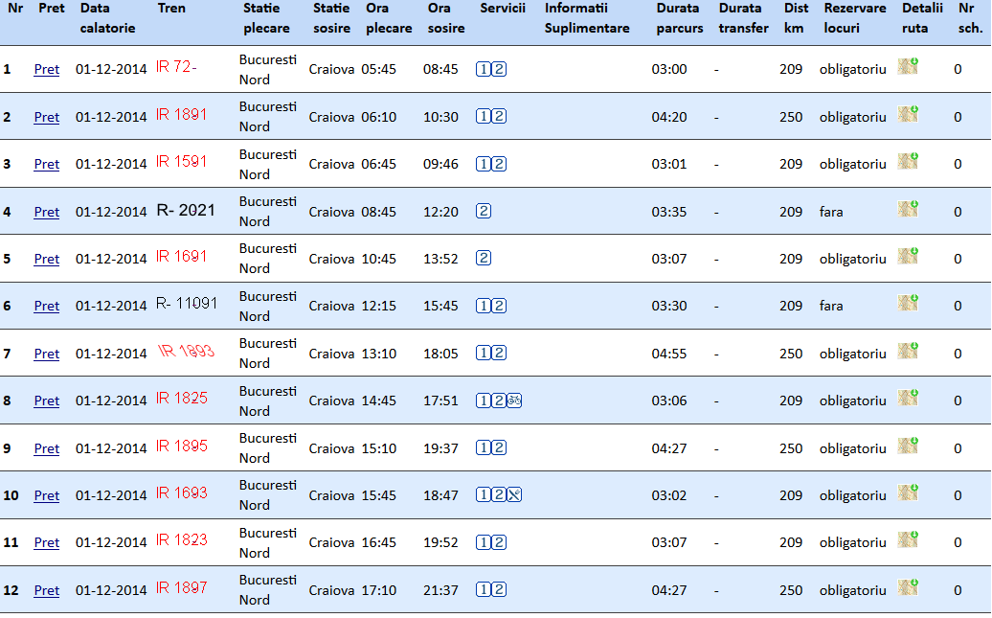
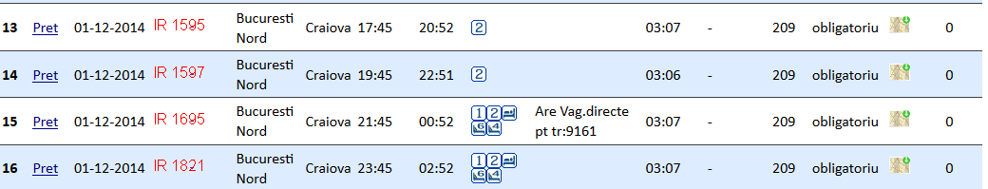
*Once you will get into the train and head to Craiova, text +40741075409 (Adina) and the organizing team will be in the train station in Craiova, waiting for you.

Important information:
- VISA costs will be covered 100%.
- travel cost will be reimbursed up to the limit set by the European Commission through the distance bands – sums available above!
- -The flight is based on the cheapest fare available in the issuing country.
- -Reimbursement of travel expenses will be made via participants’ associations bank account only after receiving all the return travel documents.
- -A participation fee of 20 EUR will be paid by the participants at the end of the training course (the 7th day)
- - The participants are responsible for their own travel and health insurances
- -Please do not buy your flight tickets before we confirm your participation!
Considering the profile of the participants and their special needs, the hosting team will be supporting individually every national group within the preparation phase and planning the travel details!
For any details regarding the practical details and the selection, please, contact Adina: adina@cdcd.ro as for details regarding the methodology and training content, you can either contract Adina or Elif: elifce10@gmail.com
We are looking forward to see you in Craiova in February!
The team! ☺

