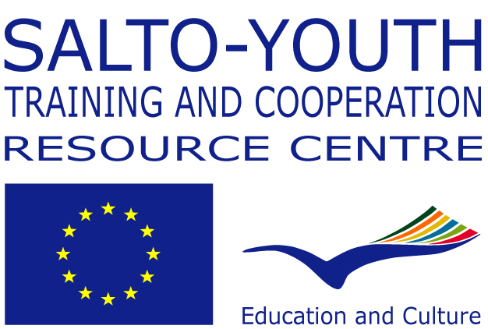

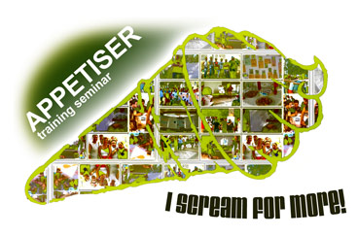

‘APPETISER’
An introduction to international youth work
Training seminar

For the participants

Dear participant of ‘Appetiser’,

First of all we would like to congratulate you for being selected to take part in this unique seminar

‘Appetiser’
An introduction to international youth work

We hope that you are motivated and looking forward to meet with the others that will join this seminar.
We would like to provide you with some information that will guide you in your preparation for the seminar. In this document you will find:

- some background information about ‘Appetiser’

- daily programme of Appetiser”

- the latest information on the new "Erasmus+ | Youth in Action" Programme

- list of things to bring with you

All this information should help you understand what Appetiser” is all about! Still, in case you have any questions, please contact the organisers of this seminar.

For now we say:

“See you soon!”
Yours,
The ‘Appetiser’ trainers’ team

BACKGROUND INFORMATION ABOUT ‘APPETISER’

Why ‘Appetiser’?

At first you might have a thought that it is a culinary seminar we are inviting you to!
No, it is not! But you might feel hungry after our ‘Appetiser’! Hungry for new activities, new possibilities; hungry for more!
The name of this seminar represents the entire idea – to motivate (“appetite”) people to expand their activities internationally! The idea for ‘Appetiser’ was born in 2004, where the need for new beneficiaries in the EU “Youth” programme (now ‘Youth in Action’, soon ‘Erasmus+ | Youth in Action’) was expressed. We thought that there are many youth leaders and youth workers around Europe, who organise great activities for young people in their town or in their country, but they do not spread their ideas at European level. Thus “Appetiser” is nothing more than a space for these people to meet, share their experiences, gain knowledge and confidence to organise international projects.
Be hungry and eat your trainers with questions! They are there for you!
Inga, Lithuania

Specific aims and objectives were set for ‘Appetiser’:

- To give a strong positive first experience of international youth work and motivate you to use the upcoming programme for youth (within Erasmus+).
- To taste non-formal and intercultural learning
- To enjoy the first intercultural youth project experience
- To exchange local youth activities in the international context
- To explore possibilities of support available for international youth activities offered ‘Erasmus+ | Youth in Action’ Programme.
- To analyse examples of successful international youth projects
- To see how to benefit from international context in participants' local work practice.

First ‘Appetiser’ was held in Malta, in 2004. Since then appetisers too place in more than half of the current EU member states and Turkey and Norway. In feedback on the previous ‘Appetisers’ from National Agencies of the current Youth in Action programme, it truly showed that participants were appetised, as these agencies saw that most participants indeed got active with the programme, by applying grants of that programme.

The current ‘Youth’ in Action programme runs to an end this year, but most features and actions will be returning in the new ‘Erasmus+ | Youth in Action’ Programme, which will run for seven years more!

What is Appetiser?

As you might have understood already, ‘Appetiser’ is a training seminar, where we will provide you with an opportunity to learn what to consider when organizing an international youth project.
Each ‘Appetiser’ within the last 9 years has been developed further based on the feedback received by the participants, but the main idea remains the same. Below you can see an ice cream-type scheme, which, actually, is the model we will be following during the seminar. Probably you will not find a restaurant where ice cream is included into the menu of appetisers, but we think that this dish is very motivating!
Take the maximum out of it! It’s a lifetime experience you’ll never forget it!
Nada, Romania

Shortly, topics written in the ‘ice cream’ are the ones we are going to work on during our seminar. As you can see, we will very much focus on non - formal education/learning and intercultural learning. They are two big pillars of international youth work. You might be questioning yourself, what exactly do they mean, but this is exactly the reason you are coming to ‘Appetiser’! There are more interesting things to say about this “ice cream”, but we will reveal the whole secret in our meeting!
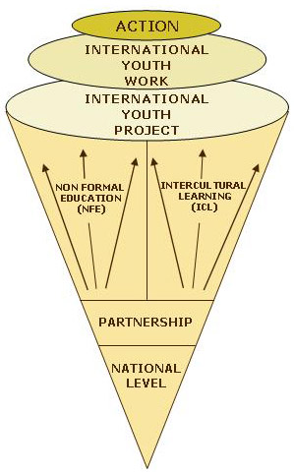

PROGRAMME OF ‘APPETISER’

 | Day 01 | Day 02 | Day 03 | Day 04 | Day 05
09.15 – 11.00 | Arrivals of the participants | Official welcome &  Group Building | Intercultural  Learning  ‘Theory & Practice’ | ‘Erasmus+ | Youth in Action’ Programme, further explained | Departure of the participants
11.30 – 13.00 |  | Introduction of the seminar  Small tasting ‘Erasmus+ | Youth in Action’ Programme |  | Good practices
13.00 |  | Lunch
15.00 – 16.30 |  | Organizations’ bazaar | Non-formal education/learning | The value of international youth work
17.00 – 18.30 |  | Sharing of experiences |  | Youth Pass
 |  |  |  | Dessert time
18.30 – 19.00 |  | Dessert time | Dessert time until 17.30 | Evaluation of the seminar
19.30 | Dinner
21.30 | Getting to know each other | Intercultural Evening | Dinner out | Farewell party

Above is the day-to-day program of our training seminar. As you can see, it will be quite intensive: 3 full working days with not so much free time. But we will do our best to make it interesting and motivating for you. During the programme we will not just provide you with information; we will invite you to get substantially involved through interactive exercises, simulation games, visual presentations etc.
Make sure that you are able to actively participate during all 3 days.
As the programme will be intensive, we will not provide you with possibility to visit famous places. If you want to see more, please arrange your travel so you can have extra days to see the country. Board and lodging will not be provided for your extra “tourist” days, you will have to take care of it yourself.
All ‘Appetiser’ participants are entitled to receive a Youthpass certificate (for more, visit: http://www.salto-youth.net/youthpass/ or www.youthpass.eu) for which they will be supported by the trainers in going through a process of self-assessment on their learning outcomes according to the framework of 8 Key Competences (see ‘Useful links’ at the end of this document or find more information also in the web sites mentioned above) during the “Appetiser” seminar itself. Each day, you will have some time, space, tools and support to reflect on your learning, assess it and make it relevant to your personal, social and professional context.
We would like to draw your attention to the intercultural evening, which might be your first experience. Please see the ‘List of things to bring’ further in this info - pack.

INFORMATION ABOUT ‘Youth in Action’ and the new ‘Erasmus+ | Youth in Action’ Programme.
You have probably noticed that until now we have used the name of ‘Youth in Action’ programme quite often and maybe you have heard about it from your colleagues or friends. You might be wondering, what it is?
Future ‘Appetisers’: this seminar will “open your appetite” and you will scream for more(!!) “ice cream”!! ;-)
Matina, Greece

It is a European Union Programme for the promotion of non-formal education/learning and it is a great chance for young people, youth organisations and youth workers to participate in and organise international youth activities. As said before, the current programme is coming to an end, end of this year, but the new programme will have most of the same features and so called actions.

‘Youth in Action’ consists of 5 Actions as follows:
- Action 1 - Youth for Europe: supporting exchanges and youth initiatives and encouraging young people's participation in democratic life;
- Action 2 - European Voluntary Service: encouraging young people to take part in a voluntary activity abroad that benefits the general public;
- Action 3 - Youth in the World: encouraging cooperation with Partner Countries by building networks, promoting the exchange of information and assisting with cross-border activities;
- Action 4 - Youth Support Systems: promoting the development of exchange, training and information schemes;
- Action 5 - European Cooperation in the youth field contributing to the development of policy cooperation in the youth field.

This programme is administrated by so-called National Agencies in each programme country (see “Useful links” at the end of this document for the List of National Agencies). You have been accepted and sent to this ‘Appetiser’ by the National Agency that is coordinating the ‘Youth in Action’ programme in your country.
Not the whole story of ‘Youth in Action’ programme and its successor (‘Erasmus+ | Youth in Action’ Programme) will be told in detail in our seminar. You will have the chance to contact your National Agency and they will provide you with information in your own language. In “Appetiser” you will have the possibility to come across examples of successful ‘Youth in Action’ programme projects.
If you can’t wait and are already hungry for information, please visit the official site of ‘Youth in Action’ programme, http://ec.europa.eu/youth/index_en.htm, where you will be able to read more. Or you can visit the web site of your National Agency, where all the relevant information will be presented in your language.
.

LIST OF THINGS TO BRING!

Here is a list of things that you will need during our seminar:

<1> Clear information (in English, if possible) about the main activities of your organisation, so that you can present it to other participants.

<2> Map, posters, postcards about your country/region/town to be introduced during intercultural evening.

<3> Some typical gastronomic specialities (snacks and/or drinks. Please contact other participants from your country to decide on what to bing. Make sure you just bring something to “appetite” the others, not to make them explode; think that others will do the same and it is always a pity to have food thrown away

<4> Comfortable clothes (you can even bring your slippers!), because we will do many active exercises.

Please make sure that organisers are aware of your special needs (dietary, mobility, accessibility of information etc.) if you have them.
For more information please consult your National Agency or the organisers of ‘Appetiser’.

See you soon!

‘Appetiser’ trainers.

Yvor Broer
ybroer@in-dialogue.org / http://www.salto-youth.net/find-a-trainer/12.html

Eylem Certel
eylemcertel@gmail.com / http://www.salto-youth.net/find-a-trainer/365.html

Monika Kezaite
monikele@centras.lt / http://www.salto-youth.net/find-a-trainer/404.html

Athanasios (Sakis) Krezios
sakis@kidsinaction.gr / http://www.salto-youth.net/find-a-trainer/681.html

USEFUL LINKS
Youth in Action Programme, European Commission
http://ec.europa.eu/youth/index_en.htm

Youth in Action Programme, The Education, Audiovisual and Culture Agency Executive Agency (EACEA)
http://eacea.ec.europa.eu/youth/index_en.php

Youthpass
www.youthpass.eu or http://www.salto-youth.net/youthpass/

Key Competences, User-friendly brochure
http://ec.europa.eu/dgs/education_culture/publ/pdf/ll-learning/keycomp_en.pdf

List of National Agencies
http://ec.europa.eu/youth/youth/contacts_en.htm

