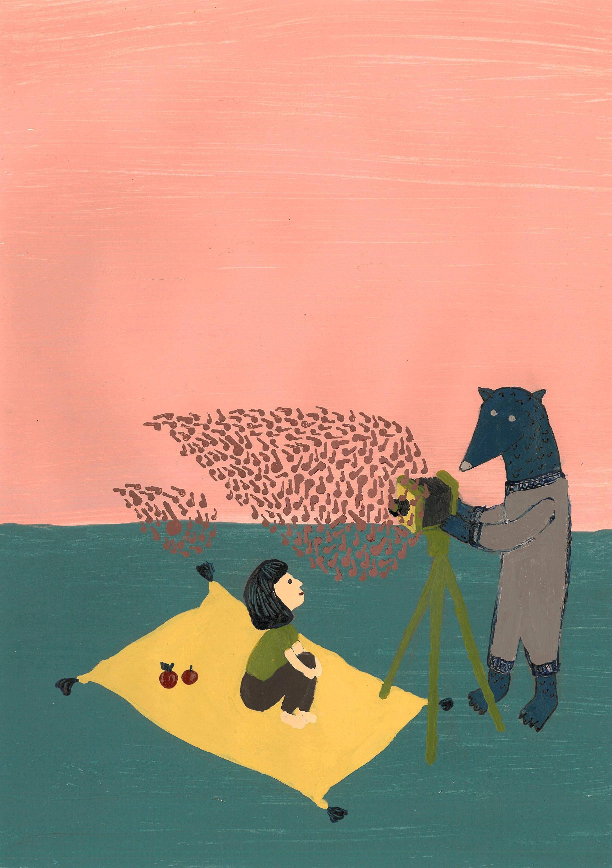
ANIMATION FOR EDUCATION
1-6 December 2014 / Porto, Portugal

Application deadline: 20th of September, 2014!

PERSONAL DATA

Name: | Surname:
Birth date: | Gender:
Tel. | E-mail:
Address:

ORGANIZATION
- Please give a short description of the organization(s) where you work/volunteer/collaborate and its main activities.
- What is your role in the organization (worker, volunteer, youth leader, etc.)? Please describe briefly your responsibilities.

EXPERIENCE
- What is your personal/professional experience in relation to youth work and non-formal education?

- If you have any experience in education through arts, please describe it briefly
- Describe the target group that you work with (age range, numbers, how often you meet, what challenges the young people face, main activities you do with the young people)

- Have you ever participated in Erasmus+ Youth in Action projects? (tick the appropriate answer)
No and I don´t really know much about the programme
No, but I have a basic knowledge about the programme
Participated (please specify the types of the projects)
Organized (please specify the type of the projects)

- Level of English (tick the appropriate answer)
Beginer (no english knowledge)
Elementary
Intermediate
Advanced

MOTIVATION and EXPECTATIONS

- What is your main motivation to take part in this training course?
- What experience of youth work you would like to share with other participants and how. What other contributions you could make during the course (leading or helping in some ice-breakers, team-building activities, energisers, evaluation sessions, free-time activities at night etc. )?
- What are your main expectations from this training course in terms of learning?
- How do you plan to use the competences gained during this training course back home?

Application and further information
Application form should be sent till 20th of September, 2014 to the organization in your country

Italy: unlasportellogiovani@gmail.com (applications and inquiries about the selection process)
Spain: diaz.durillo@gmail.com (applications and inquiries about the selection process)
Romania: eliza.vas@younginitiative.org (applications and inquiries about the selection process)
Portugal: - anilupa@sapo.pt (application and inquiries about the selection process). Applications from Portugal accepted till 30th of September.

If you have any doubts or need any additional information about the training (but not related with the selection process) please contact the coordinating organization in Portugal:
Associação de Ludotecas do Porto
Jurga Miksyte – e-mail: jurgamk@gmail.com

The results of the selection of 5 participants from each country will be announced by 3rd of October.

