


BABEL EDUCATION and ERASMUS+ PROGRAMME

Present

The international training course:
Storytelling: senses and competences
11th-18th October 2014 in Timisoara, Romania
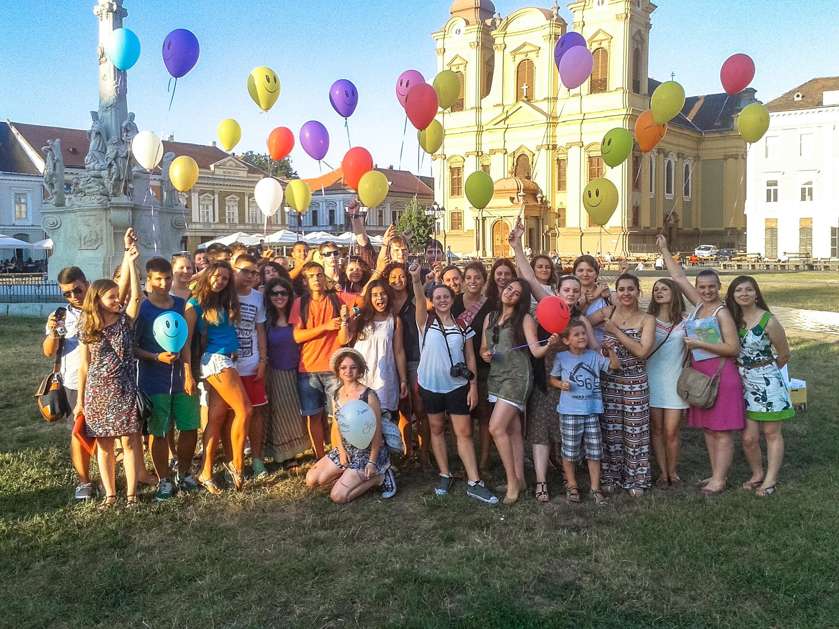

Who we are?

Babel Education is a Non-Governmental Organization created in 2010 in Romania by a young and optimistic group of teachers who wanted to contribute to a change in education. Our main purpose is to increase the opportunities and contribute to the development of non-formal methods of education in our community. We want to offer and contribute to the personal growth of individuals of different ages and backgrounds.
We are active in the following areas:
- Empowering young people to have a proactive attitude
- Promoting non-formal methods of education
- Storytelling and Creative Writing
- Resource Center for teachers EduCafè
- Building empathy
- TEMEsoara- the town of easy homework

What is Storytelling: senses and competences?

Storytelling: senses and competences is a training course which will take place between 11th and 18th October in Romania, in Timișoara. The project themes are:

- Non-formal method of education Storytelling through all sesnses;
- Youth Empowerment;
- Self-Empowerment;
- Employability
- Healthy Behaviors.

In this project are 7 organizations:
Babel Education (Romania) –the coordinating organization-
Klub studentu, rodicu a pratel Cyrilometodejskeho gymnazia v Prostejove (Czech Republic) Cooperativa Sociale Immaginaria A R.L.Onlus (Italy)
Klubs Maja - jaunatne vienotai Eiropai (Latvia)
Piedzivojumu parks (Latvia)
Animashow Associação Cultural e Recreativa (Portugal)
Stowarzyszenie Sprezyna - Centrum Edukacji Nieformalnej (Poland)

The aim of the project is to make youth workers aware of the potential of the innovative method of Storytelling in developing competences needed for employability.

To achieve our aim we have the following objectives:

1.enabling 20 youth workers to get to know and experience the non-formal method of Storytelling;
2.offering the 20 participants the opportunity to discover and understand the employability competences that are developed through Storytelling;
3.creating an intercultural network of youth workers and organizations that use the method of Storytelling in developing employability skills;
4.creating printed and online tools to promote the method of Storytelling in working with young people (the Storytelling Resource Pack and the Storytelling Resource Blog)

When?

Participants' Arrival day: 11th October 2014
Full working days: 12th-17th (6 days) October
Departure day: 18th October 2014

If you plan to arrive earlier or leave later, and you need to find an accommodation, let us know, so that we can support you. Your expenses out of the days of the training will not be reimbursed by the organizers. (Flights that are earlier or later with more than 2 days from the start/end of the training will NOT be reimbursed)
Please inform the organizers before you buy the tickets to check if the routes and the prices are ok with our budget.

The Training Course

The course is prepared and will be run on the basis of a methodology that emphasizes active participation and commitment of all who’s involved. Therefore, the program is subject to regular changes and adaptations before and during the course. The activities foreseen are ice-breakers, role-plays, teambuilding and outdoor activities, debates, open space and several workshops to develop life skills and competences useful for any youth worker. The working methods are the: “Experiential learning”, “Educator to Peer” and "Peer to Peer".
The participants will also organize some local events for the local youth.

Who?

Participants & Partner Organizations

The project “Storytelling: senses and competences” is a training course which aims at bringing together 20 youth workers, from 7 countries: Romania (4), Czech Republic (3), Italy (3), Latvia (4. There are 2 organizations from Latvia so that each will bring 2 youth workers), Portugal (3), Poland (3).
The right person to participate to this training course are:
- persons who want to develop professionally and personally;
- persons who need an innovative method of education in their daily work with young people;
- persons who are willing to contribute to creating the Storytelling Resource Pack;
- persons whose need is to find the right path towards the youth employment;
- persons who need to belong to a network of youth workers;
- persons who are over 18, speak English and are willing to be an active participant for the entire duration of the course.
- nevertheless we are looking for motivated, open-minded, willing to cooperate and share from experience people;

Financial conditions?

Participation fee

Each participant should pay a participation fee of 30 EUROS, which will be taken from the travel costs that will be reimbursed after the training.

Travel reimbursement & Insurances.

According to the Erasmus+ financial rules we will be able to reimburse a specific amount of money for each country, which is described in the table below. For some participants, depending on the destination and means of transportation, we can reimburse the full amount of travel costs. For other participants we can reimburse only in the limit of the specific amount of money. Please pay attention to the figures and conditions.

PARTNER ASSOCIATION | COUNTRY | N° OF PAX | MAX. PER PERSON
Animashow Associação | Portugal | 3 | 360 EURO
Klubs Maja - jaunatne vienotai Eiropai | Latvia | 2 | 275 EURO
Cooperativa Sociale Immaginaria | Italy | 3 | 275 EURO
Piedzivojumu parks | Latvia | 2 | 275 EURO
Klub studentu, rodicu a pratel Cyrilometodejskeho gymnazia v Prostejove | Czech Republic | 3 | 275 EURO
Stowarzyszenie Sprezyna | Poland | 3 | 180 EURO

We are strongly recommending you to have insurance while you are in Romania. Each participant will be in charge of purchasing one, because no private insurance will be reimbursed.

Very important: your tickets have to be given to the organizers during the project. Therefore, if you cannot provide your original tickets, receipts and invoices clearly stating the travel agency, your name and the exact costs of the tickets, we will not be able to reimburse you.

Where?
The training course will take place in Timisoara (West part of Romania) https://www.youtube.com/watch?v=V3Wdd7bn23M . We will give you more details on how to get there in the coming weeks.
HOW TO ARRIVE TO THE TRAINING LOCATION: The main destination will be TIMISOARA, which is the largest city of West part of Romania. Timisoara has an international airport, where several companies are operating, and good train and bus connections with other countries. There are also options to fly to Budapest (288 km away from Timisoara) and then to come by train or bus to Timisoara. Because some of the countries are not so far, you can take into consideration coming by car, train or bus.
Concerning special needs (diets, medicine) please, tell us beforehand if you need any assistance from us in this matter.

How to apply?

If you are interested to join our project you should fill in the application at this link:
https://docs.google.com/a/babelcenter.ro/forms/d/1w60vFkOfbPpjSXP4lKCv9aGUjt0IPxkciVLGCZUB9qA/viewform?c=0&w=1&usp=mail_form_link
Deadline for application: 5th September
The selection results will be published on 6th September

About Romania

With a surface area of 238,391 square kilometres (92,043 sq mi), Romania is the largest country in southeastern Europe and the twelfth-largest in Europe. Romania's terrain is distributed roughly equally between mountainous, hilly and lowland territories. The Carpathian Mountains dominate the centre of Romania, with 14 mountain ranges reaching above 2,000 m/6,600 ft, and the highest point at Moldoveanu Peak (2,544 m/8,346 ft). These are surrounded by the Moldavian and Transylvanian plateaus and Pannonian and Wallachian plains. Romania's geographical diversity has led to an accompanying diversity of flora and fauna.

Our currency is the Romanian Leu (RON): 1 Euro = 4.40 RON
Remember this:

Romania is member of the EU since 1st of January 2007;

Prices in Romania
Prices in Romania are not so high and this is true for nearly every kind of goods, except for cigarettes, fuel, coffee and alcohol.
Examples for prices in Romania:
Bread 500 g +/- 1,00 EUR
Beer 0,25 ltr +/- 2 EUR
Softdrink 0,25 ltr +/- 1,5 EUR
Sandwich +/- 1,80 EUR
Dish of the Day +/- 10 EUR

Contact information

If you have questions, something is not clear or you want to know more about the training, you can use the contacts below:

Sandra Horea – Project coordinator
Sandra.horea@babeleducation.ro
0040-726-50-44-87

More details about Babel Education:
www.babeleducation.ro
www.facebook.com/pages/Babel-Education
Training Course Program. Storytelling: senses and competences
11.10.2014 Saturday | 12.10. 2014 Sunday | 13.10 2014 Monday | 14.10. 2014 Tuesday | 15.10. 2014 Wednesday | 16.10. 2014 Thursday | 17. 10. 2014 Friday | 18.10. 2014 Saturday
Arrival of participants | Work-out in the garden | Work-out in the garden | Work-out in the garden | Work-out in the garden | Work-out in the garden | Work-out in the garden | Departure of participants
 | Get to know each other activities | Experimenting Storytelling through sound and movement | Experimenting Storytelling through sight and touching | Experimenting Storyteling through smell and touch | Storytelling your experience | Storytelling with Andrew Wright session I
 | Erasmus + Presentation | Input on using Storytelling through sound and movement | Input on using Storytelling through sight and touching | Input on using Storytelling through smell and touch | Compiling the Storytelling Resource Pack | Storytelling with Andrew Wright session II
 | Presentation of the project and the agenda of the TC | workshop on dealing with emotions on stage | preparing the local event and drafting the Storytelling Resource Pack | Storytelling through cooking and sharing rural traditions | Free time | Action planning and Risk management
 | Storytelling the city | preparing the local event and drafting the Resource Pack | local event: "Stories around Europe | preparing the local event and drafting the Resource Pack | World Café on reaching employability competences | Evaluation and feedback
 | Reflection | local event: "Stories around Europe" | Reflection | local event: "Stories around Europe" | Reflection | Farewell Party
 | "My place in Europe" evening | Reflection |  | Reflection

