21.7. | 22.7. | 23.7. | 24.7. | 25.7. | 26.7. | 27.7. | 28.7. | 29.7. | 30.7.
Arrival day | Expectations, fears, rules, schedule of TC, Team work, thrust. | Personal fears, sources, scruples | Tolerance, respect, emotions, nonverbal communication, borders of conflict | Anger management, strategy of conflict solving | Trip day and Czech culture | Crisis intervention, mediation in problem or conflict | Day of work on our energy sources and our motivation and burning out prevention | Evaluation day, YiA, Youthpass | Departure day
morning | Introduction, Expectations, schedule, personal plan | Fears, Scruples and positive crossing | Topic of tolerance, respect and emotions | Anger and conflicts – self experienced part | Trip to Prague | Introduction into Crisis intervention, practice | Music, dance, meditation, relaxation and other living sources which energizing us. | Big evaluation  YiA and Youthpass
afternoon | Team tuning | Working with fears and scruples | Our professional borders | Strategy from M.H.Erickson |  | Introduction into Mediation of conflict and practice
evening | Reflection | Working with fears II. And NLP working | Reflection | NLP calibration and nonverbal technics of communication |  | Reflection
night | Atmosphere game | Night optional activity | Intercultural evening |  | Sharing |  | Music night with local community
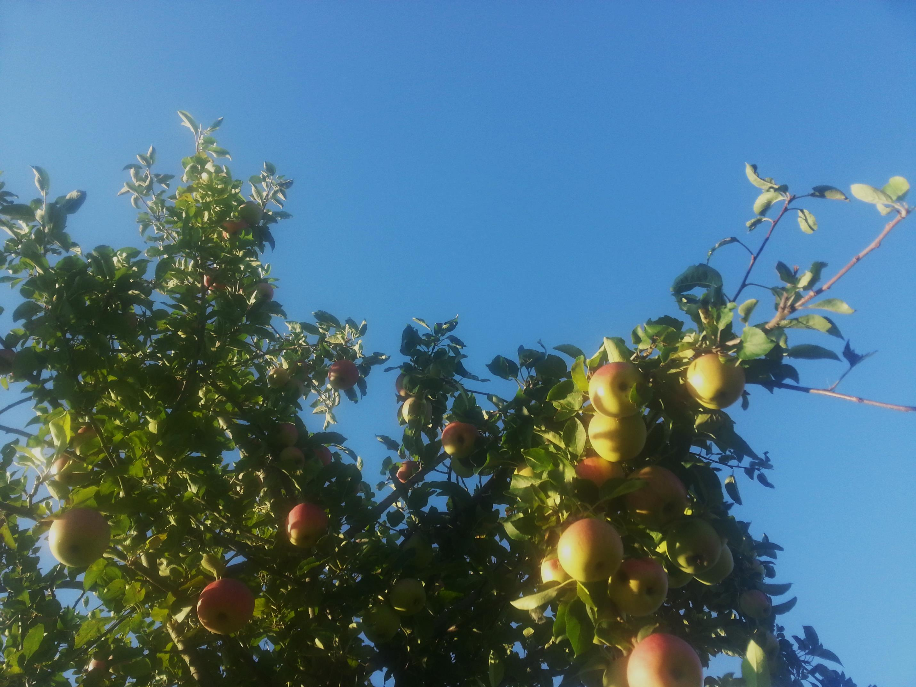
AdamsAppleTrainingCourse

In Czech Republic from 21.7.- 30.7.2014

