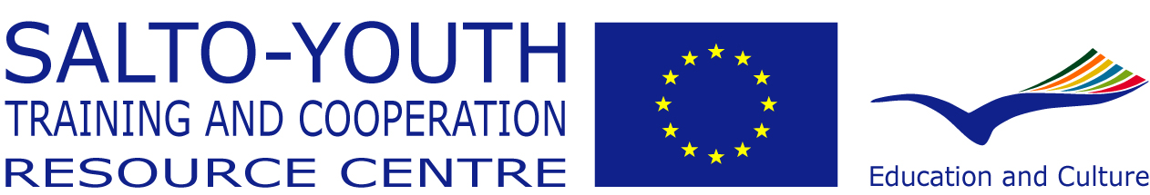

Training of Trainers
for European Youth in Action Projects 2014/15
Supported through the ERASMUS+ YOUTH IN ACTION Programme

YOU HAVE
...already gained experience as a trainer within the field of Non-Formal Education (ideally within the EU-YOUTH/Youth in Action programme).
YOU WANT
...to explore further your potential as a trainer and facilitator.
...to develop further your competences as a trainer.
...to expand your training work to the European level.
YOU CONSIDER
…making training your profession.

THEN THIS IS THE RIGHT COURSE FOR YOU:
This Training of Trainers lasts a year and consists of
- Three residential seminars (Seminar 1: 28 September – 6 October 2014 in Austria; Seminar 2: 16-25 January 2015 in Poland; Seminar 3: 21-28 June 2015 in Italy)
- An international training project you design and run with some other participants
- Online work between the residential seminars
- Ongoing mentoring with one of the course trainers as your mentor

Time Investment
This course requires a considerable time investment from the participants: in total you should plan at least 54 days:
- 27 seminar days (including travel)
- 12 days overall for the training project (preparatory work, prep meeting and the course itself)
- 15 days (on average 1-2 days per month) for following the personal learning commitments, the online work, peer learning, mentor talks etc.

Recognition and certification
The participants will receive at the end of the course a Youthpass certificate. Youthpass is the instrument of the Youth in Action Programme to recognise the non-formal learning taking place during projects. During the course, the participants will assess their own learning along a trainer competence profile, which is connected to the eight key competences of the life long learning strategy of the European Union.

Co-ordination & team of trainers
This training course is co-ordinated by the SALTO Training and Cooperation Resource Centre in the name of the network of National Agencies for the ERASMUS+ Youth in Action Programme of the European Union.
The team of trainers is Peter Hofmann, Paul Kloosterman and Hazel Low.

Background of this training course

The Training of Trainers took place for the first time in 1999/2000 – then still under the Youth for Europe programme. It was an initiative of the Austrian association Interkulturelles Zentrum, then National Agency, in particular Helmut Fennes, its director at the time. The prime reason for creating this course was to raise the quality of training courses within the programme. Several studies, conferences and debates, at that time, showed the need to invest in quality of the programme, specifically for the users of the programme: youth workers and young people themselves.

One of the responses to that need was the establishment of a Training of Trainers course.

Since 1999, the course has been organised 13 times and has offered up to today around 320 participants the possibility to further develop their potential as trainers and facilitators and, hence, to become part of a growing group of professionals supporting the quality development of European Youth projects. Over the years the course has become more and more an important entry point into the European Non Formal Education Trainers’ circuit. It has also become one of the Network Training courses offered and co-ordinated by the SALTO Training and Cooperation RC for all the National Agencies.

But, most of all, the course has developed over the years into an acknowledged high quality offer for trainers, educators and facilitators aiming for “more” – be it more competence, more reassurance, more confidence, more contacts, more professionalism or more clarity for the next steps in their professional careers.

Due to the high level of continuity of the trainers delivering this course there has been continuous improvement and development from one course to the next. However, the structure and methodology of the course have remained basically unchanged even though a developing Youth in Action programme brings in new priorities and actions – as well as a lot of opportunities for competent and motivated trainers to contribute to a high quality implementation of projects.

Interested in more details about former participants, the history of the course, how the methodology has developed – here you can download an interesting brochure about this course.

Overall aim of the course
 | The major aim of this training course is to train trainers who have the competences and the motivation to contribute to the improvement of the quality of projects within the ERASMUS+ Youth in Action Programme of the European Union.
Further reading  (Respective documents can be found on www.salto-youth.net/tot/background_docs) | Participants should be familiar with the aims and priorities of the ERASMUS+ Youth in Action programme before coming to the course as described in the Programme Guide.

The competence framework in ToT
 | Within this Training of Trainers course (ToT-course) participants have the chance to further develop their competences as a trainer. In line with the European Training Strategy in the frame of Erasmus+ Youth in Action programme the ToT-course considers the following 6 competences to be essential when working as a non-formal education trainer within the Youth in Action programme:  - The competence to understand and facilitate individual and group learning processes.  - The competence to design educational programmes.  - The competence to direct one´s own learning (Learning to Learn)  - The competence to co-operate successfully in teams.  - The competence to communicate meaningfully with others.  - Intercultural competence.
Further reading  (Respective documents can be found on www.salto-youth.net/tot/background_docs) | The competence development process in ToT is based on self-assessment. Self-assessment is guided and supported by a variety of different tools and methods one of them being the so-called Self-Perception Inventory.

Educational approach implemented in the ToT-course
 | Participants enter the ToT-course with various levels of prior experience as trainer as well as competences developed - consequently, the learning needs of participants are different. The educational approach implemented in the ToT-course intends to allow for these different learning needs to be identified and pursued. At the core of this process is the competence of the participant to direct his/her own learning. The group as a source for peer learning and the trainers as facilitators of these learning processes are essential pillars of this approach.
Further reading  (Respective documents can be found on www.salto-youth.net/tot/background_docs) | The guiding principles of the team of trainers for this course give an extra insight into the educational approach practiced in the ToT-course.  A special feature of the course is the mentoring. Each member of the trainer’s team is responsible for mentoring 8 individual participants. The primary role of the mentor is to support each of the “mentees” in his or her “learning journey” through ToT. The document on mentoring in the background documents explains more how it is implemented in ToT.
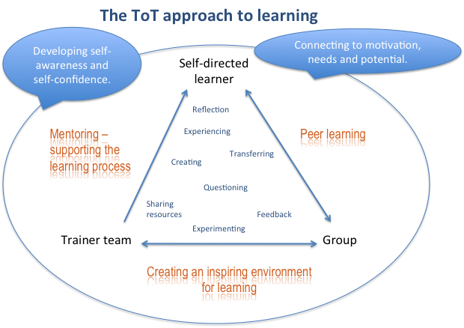

The blended learning journey – the phases of the course
 | The methodology of the ToT-course is following a blended-learning approach where the 3 residential seminars are interlinked with the online phases between. The ToT-course is offering a 10-months accompanied learning process where participants can make important progress in their professional development as a trainer – based on the needs they identify for themselves.
Phase 1: Preparing the journey and taking off | This phase starts with preparing by reading the background documents, getting acquainted with the structural context of the course (the Erasmus+ Youth in Action programme and its training dimension), and meeting with the responsible staff person in the National Agency to share expectations, talk about needs and develop some aims together.  It includes also becoming familiar with the online environment of the ToT-course.  Phase 1 ends with the first residential seminar (7 working days).  The initial seminar focuses mainly on laying the foundation for the whole course and includes: group building, Erasmus+ Youth in Action Programme and the political context of the course, developing an optimal learning environment, how do I learn and how do I assess my learning (Learning to Learn), essentials of training, group dynamics, roles of a trainer, preparing for the next phase, setting learning objectives for the course, establishing mentor-mentee relationships and, last but not least, starting the preparation of the training project phase and forming the training project teams.
Phase 2: The learning journey is on its way | Back home after seminar 1 it is about using the dynamic from the first encounter of the group for working on the learning plans and commitments. The ToT-online environment supports this journey with providing resources (ToT-library), space for discussions and sharing’s (ToT-forum), working together on resources (ToT-Wiki) and virtual “live” meetings (ToT online week 1 and ToT-aperitivs) in the online ToT-lounge.  The two mentor talks provide the opportunity to see of the journey is still on track, if new “fuel” is needed or destinations have to be changed.  First preparations for the practical training project have to be taken care of. There will be one or two virtual team meetings facilitated by the support person from the trainers team to establish a clear framework for the project (defining aims and objectives, target group).  Phase 2 ends with the second residential seminar (8 working days). Largely based on the training needs of the group, this seminar provides opportunities to further develop specific training competences; a special focus will be placed on teamwork, training design, intercultural learning and methodology. The design of this seminar is greatly shaped by inputs from participants – it provides several options for practising skills and sharing resources within the seminar. Project teams have the chance to actively experience themselves working as a group within several parts of the programme. Reviewing the personal learning path and preparing for the next phase
Phase 3: Exploration and arriving | After the second residential seminar the journey is heading towards the implementation of the practical training project. A preparatory meeting allows for putting all the learning from seminar 2 into the training project.  Parallel there is a lot of activity happening in the ToT-online environment: Continuing discussions and reflections from seminar 2; exchanging about learning commitments and results; and 2 more exciting virtual meetings (ToT online week 2 and ToT-aperitivs) in the ToT-lounge.  The two mentor talks are excellent opportunities to take a step back from all these activity and see what achievements can be celebrated and what shortcomings are to be tackled.  Phase 3 and with it the ToT learning journey ends with the third residential seminar which is dedicated to evaluating, taking stock, looking forward and closing. Participants get the chance to reflect on specific aspects of their training projects together with the others in the group. Furthermore, the seminar provides the opportunity to reflect on the individual learning paths throughout the year and to re-visit some training topics. Last but not least it facilitates the exit from the course and the entry into the next steps of the development as a trainer.
Further reading  (Respective documents can be found on www.salto-youth.net/tot/background_docs) | If you want to know more about the online part the ToT-course offers read the related document which is among the background documents to this course.

Training Practice Projects
Each participant designs, prepares, runs and evaluates an international training project together with other participants from the course. The training projects are organised between Seminars 2 and 3 (between 1 April and 20 June 2015).
Participants either design and implement a training project proposed by National Agencies or identify projects themselves based on the priorities of the Erasmus+ Youth in Action programme in general and supported by specific NAs. They form international teams with other participants of the course in the first seminar. The preparation and evaluation of the projects happens, in the main, outside the programme of the residential seminars. However, seminar 2, especially, is designed in a way to support the preparation process of the training project.
Each team has one member of the trainers team as a support person. The role of this support person is:
- Supporting finding an agreement with the involved National Agencies with regards to the funding and hosting of the course.
- Facilitating one or two virtual team meetings between seminar 1 and 2 to reach a consensus on aims and objectives and profile of target group.
- Resource person for the team with regards to design and content of the course.
Further reading  (Respective documents can be found on www.salto-youth.net/tot/background_docs) | On the SALTO website you can find a document which explains this crucial feature in ToT more in detail.

Profile of Participants
Participants have to be recruited by one of the National Agencies for the ERASMUS+ Youth in Action programme covering the expenses related to the participation in the course (travel, board and lodging, fee).

Participants are expected
- To have been already involved at least three times in a team of trainers designing, implementing and evaluating a training course in the framework of Non-Formal Education.
- To have had international experience in the youth work field with a function of responsibility (not only as a participant) – organising international youth projects, leading a youth exchange, mentoring EVS volunteers, etc.
- To have the potential and need to develop training competences and act after the course as a trainer for European Youth in Action projects and/or for training courses organised by the National Agencies of the Erasmus+ Youth in Action programme.
- To show initiative and willingness to self-direct their own learning process.
- To be prepared to reflect on and question their own beliefs and approaches as trainers.
- To be able to run training courses in English.

Co-operation with National Agencies
 | Participants are recruited for the course solely through the National Agencies of the ERASMUS+ Youth in Action programme. Ideally there is co-operation between participant and their National Agencies to support their active participation in the course. This should include a preparatory talk before the first seminar to update the participant on the latest developments in the Erasmus+ Youth in Action programme as well as on the training priorities of the Agency. Furthermore this talk could be used to exchange ideas about possible project ideas for the training practice phase as well as possible ideas for follow-up after the course has finished.
Further reading  (Respective documents can be found on www.salto-youth.net/tot/background_docs) | On the SALTO website you can find the contact details of all NAs  https://www.salto-youth.net/tools/european-training-calendar/help/national-agencies/

Application
 | Applications must be submitted by the latest 1 June 2014 using the online form available here: http://trainings.salto-youth.net/4154.  Before filling it in, though, check with your National Agency about the exact procedure for the application. Participating NAs in ToT 14-15 are: Austria, Flemish speaking community of Belgium, Bulgaria, Croatia, Czech Republic, France, Germany, Greece, Hungary, Italy, Latvia, Netherlands, Poland, Portugal, Spain, Turkey and United Kingdom.  The selection of participants lies in the responsibility of the respective National Agency. The final list of participants will be fixed the latest by the end of June 2014. Participants will receive further information about the course thereafter.

„A Learning approach that includes the use of appropriate combinations of information technologies--videoconferencing, audioconferencing, Internet, CD-ROM, and other media, combined with appropriate learning technologies, on-site facilitated activities, and strong learner support systems.” (from web.worldbank.org)
See definition of the ERASMUS+ Youth in Action Programme Guide for training courses: An educational learning programme on specific topics, aiming to improve participants’ competences, knowledge, skills and attitudes. Training courses lead to higher quality practice in youth work in general and/or, specifically, Youth in Action projects. In average a course lasts between 3 and 10 days and has between 20 and 30 participants.

