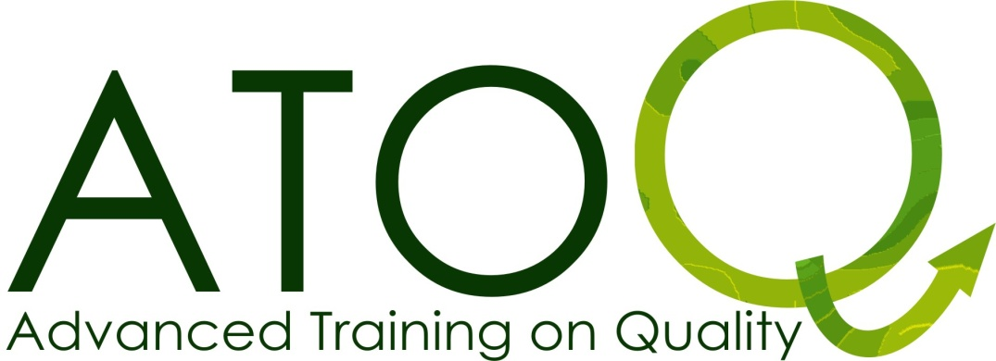
Participant Pack

ATOQ France 2014

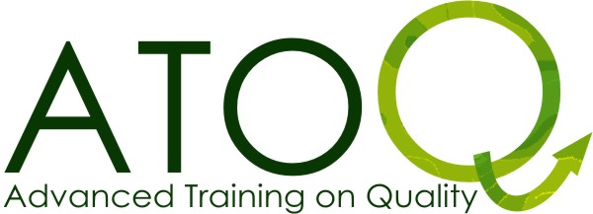
PARTICIPANT

PACK

Improving QUALITY for youth exchanges

DEAR PARTICIPANTS,

We are looking forward to welcome you on this ATOQ Training Course and to work together with you on different aspects and quality elements in organising and running international Youth projects.
We hope that you are as excited as we are with this training, which is specially, designed for experienced users (who run at least one youth exchange) of the ERASMUS + YOUTH Programme (and/or previous YOUTH IN ACTION Programme).
ATOQ is not only based on a ‘one way information-flow’ but requires a pro-active participation from you. Therefore the importance of this information before the start of a hopefully adventurous, challenging and inspiring ATOQ!

During this training course you might find new partners, but this is NOT the main objective of this ATOQ.

Please read carefully next chapters.

BRIEF DESCRIPTION OF THE ATOQ…

1. TARGET GROUP

The training course is open for voluntary and professional youth workers, working directly with young people, which organised and/or participated as a team member in at least one international youth exchange (which is completed) and plan to organise another within the frame of the Youth in Action programme.
Participants should be at least 18 years old.
Be aware that this training course will be in English, without any possibility of permanent translation.
Therefore, we ask you to have a good level of English (to be able to understand and to communicate).

Group size: approximately 30 participants

2. AIMS AND OBJECTIVES

The aim: To support experienced youth workers/leaders in increasing the quality of the European youth exchanges they set up within the ERASMUS + YOUTH Programme.

The objectives for the ATOQ are:

The ATOQ training course will provide the participants with opportunities to:

1. Critically reflect upon their previous international youth exchange experience(s) and the impact on young people;

2. Increase the understanding of different quality aspects of youth exchanges such as: active participation of young people, involvement of promoters and stakeholders, diversity and intercultural learning, program building;

3. Experience a non-formal learning process and understand its importance in youth exchanges;

4. Improve their project management competences (knowledge, skills and attitudes) in order to better organise the different phases of a youth exchange.

ATOQ can also provide: An opportunity to meet possible partner groups and to make contacts in other countries.

3. THE PROGRAMME

The ATOQ is built on the past experiences of participants and is interspersed with workshops, info-sessions, activities to improve group dynamics and ends with an evaluation. At the end of this information, you’ll find a global overview of the programme.

4. THE TRAINERS’ TEAM

The program will be run by 3 experienced trainers of the ATOQ trainers’ pool, alternating between the current 6 trainers. Profiles can be visited on below links to the Salto website.

Elizabeth Kasa | http://trainers.salto-youth.net/elizabethkasa
Anita Da Silva | http://trainers.salto-youth.net/anasilva
Wim Vogelaere

FOR YOU TO BRING…

ABOUT YOUR YOUTH EXCHANGE

During this training course we will look back to your last organised youth exchange. You will also have the possibility to share your experience with the rest of the group. If you find it important for your own support you may bring the program, the aims and objectives and the evaluation report of your last exchange, but there won’t be a special time to present these, you will only be invited to share your past experiences, good practices and challenges or difficulties you found on the way.

ABOUT YOUR ORGANISATION

During the ATOQ, each one will get the opportunity to present its own organisation in a visual way (during the session Youth Exchange & Organisation Market). Please be aware that there will be no time within the organised frame of the TC to present your organisation in front of the whole group. We however encourage you to bring as much –relevant- materials as possible. In case you wish to bring Power Point Presentations or CD Rom with pictures, there will be an opportunity to show these during this evening, the informal moments and the coffee breaks, generally the method used to present the organisation is a free market where people can go around and freely discover each other’s organisations, so don´t worry about big presentations to the whole group, it will be more like one-to-one talks.
To bring with you:
- English information about your organisation
- All relevant information you have on the previous international project(s) you’ve organised / been part off (reports, gadgets, press releases...).
- Pictures, posters, etc.

ABOUT YOUR COUNTRY / REGION / TOWN

Most of you have probably experienced before an ‘International Evening’. During this ATOQ we also plan to organise one. We invite you to bring gastronomic specialities from your region or country: food (attention: we are not sure if it is possible to heat food or to cook light dishes in the training centre) and drinks to share with others; You can also bring a map, posters, postcards, leaflets etc.
Please note that if you bring with you videos you will only be able to watch and show them during your free time, which is sparse.

Bring CD’s of traditional/typical and party music or other special things typical from your country that you wish to share with us during this evening and other evenings.

ABOUT THE ERASMUS + YOUTH PROGRAMME

We ask you to bring along with you the Programme Guide of the ERASMUS + YOUTH Programme; in the language you prefer (your favourite language or the English version). It’s not a compulsory request, but it might help you to understand better some of the content that will be presented.
Please be sure that you bring along the version valid as from 1st of January of this current year.

You can find more information about the ERASMUS + YOUTH Programme at http://ec.europa.eu/programmes/erasmus-plus/index_en.htm

If you don’t have the Programme Guide, you can download the document threw this link:
http://ec.europa.eu/programmes/erasmus-plus/index_en.htm
It’s a big document and a full printed version is not needed. Bring at least the chapters which focus on Youth Exchanges!

You can also contact your National Agency for further information.

ABOUT THE FEW MOMENTS OF FREE TIME

There are indeed very few free moments during this training course. Some people use these opportunities to rest, while others look forward to another kind of sharing time with each other. We invite you to bring material which you would like to share with the others such as different methods you used during your exchanges, games or board games, interesting video’s or a music instrument, etc.

Looking forward to meet you on the ATOQ!

The ATOQ team.

ATOQ TRAINING PROGRAMME

Time | Day 1 | Day 2 | Day 3 | Day 4 | Day 5 | Day 6
8.00 |  | Breakfast | Breakfast | Breakfast | Breakfast | Breakfast
9.00 |  | Intro of the training, team and participants  Non-formal learning:  Try to sell it! | Intro to the day  Project life cycle: a practical approach  Active participation of young people, partners… and (the) rest | Intro to the day  Quality in Youth Exchanges: workshops run in parallel, according to the learning interests & led by trainers  Consultation possibilities with present NA officer(s) | Intro to the day  Thematic exercise on Quality:  We invest in you(th)  Feedback on improving quality in exchanges  Youthpass:  just another certificate? | Departure of participants & team:  unless you loose your plane ;-)
13.00 | Lunch | Lunch | Lunch | Lunch (till14h30) | Lunch
15.00 | Arrival of participants  17.00 Getting started | Exchange of “good” and “bad” practice in your Youth exchanges: the box exercise  Reflection time on own learning | Diversity and Intercultural learning  Programme Design  Reflection time on own learning | Share expertise about youth exchanges  16.00 Departure to town | Reflection time on own learning  Evaluation of the training course  Closure
19.00 | Dinner | Dinner | Dinner | Dinner in town | Dinner
21.00 | Welcome evening | Youth Exchange & Organisation Market | International evening | Evening in town | Goodbye evening
Note : This program can undergo slight changes on the spot according to the general level of experience of the participants.

