

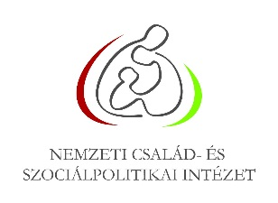
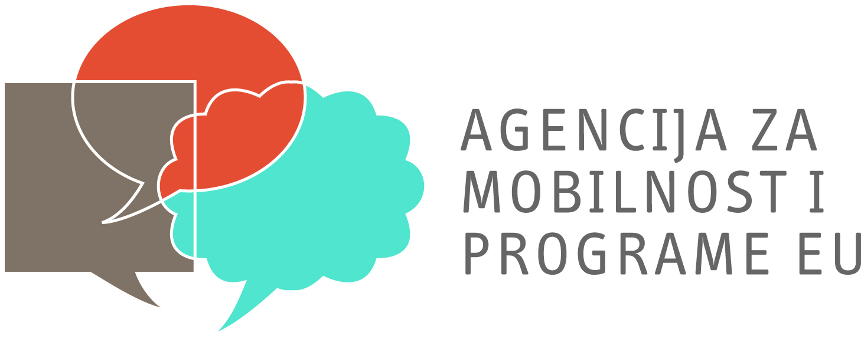


CALL FOR PARTICIPANTS

COMMUNICATION MATTERS TC
5-11 MAY - BUDAPEST, HUNGARY

Do you wonder how to make the results of your projects visible for as many people as possible? Do you like to learn more about different communication and PR techniques that will help you promote better your work? Are you interested in gaining new knowledge, experience and tools in the mass and social media as well as to discover which the other communication channels are? If the answers of all these questions are YES, then this training is for you.

COMMUNICATION MATTERS offers you the opportunity to share good practices from your projects together with other participants and to approach the communication and PR field from a practical point of view. It will bring together experienced beneficiaries, newcomers and professionals to learn from practical exercises, to understand the overall communication process within the project cycle and to develop competences, as well as to learn new communication tools in a creative and open setting. The training includes the creation of an online platform as an example and a direct result of the practical work of the group.

If you want to learn more about this training opportunity and its programme, please have a look at the attached document.

Training Background:
Dissemination and exploitation of results (DEOR) is one of the crucial areas of the Erasmus+ project lifecycle. In order to successfully disseminate and exploit project results, organisations involved in Erasmus+ projects are asked to plan effective communication activities when designing and implementing their project. The international training offers participants the opportunity to share good practices from their projects and to approach this field from a practical point of view. It will bring together experienced beneficiaries, newcomers and professionals to learn from practical exercises, to understand the overall communication process and develop competences, as well as to learn new communication tools in a creative and open setting.

Aims & Objectives:
The objectives of this activity are:
- to explore various tools, ways, creative techniques useful for DEoR;
- to help participants design communication and dissemination activities relevant to their projects, target groups, scope of activities;
- to develop competences, skills necessary to implement PR and communication and multiplication strategies efficiently;
- to share good practices;
- to provide opportunities, space and frames for participants to experiment on possible relevant tools and methods during the training;
- to share new and innovative approaches, concepts and activities;
- to give emphasis to the development of practical aspects.

Learning Outcomes:
- Understanding the role and the way strategic planning has in the communication process,
- Being aware of good practices and methodologies in communication of project results,
- Getting familiar with guidelines and tips on DEOR strategies,
- Exploring concrete ideas and plans of DEOR activities for the future or ongoing projects,
- Discovering available social media tools.

Profile of Participants:
- Representatives of youth organisations and informal groups experienced in Youth in Action
- Representatives of formal education & administrative bodies working with youth
- Youth workers, trainers and coaches
- Newcomers in the Erasmus +

Logistics:
- Deadline to apply: 3rd of April 2014
- Feedback on application status: 11th of April 2014
- Date: between 5-11th May 2014 (including travel days)
- Venue: European Youth Centre Budapest, Hungary

Organisers:
- NIFSP – Erasmus+ Youth National Agency (National Agency of YiA, Hungary);
- Agency for mobility and EU programmes (National Agency of YiA, Croatia);
- Danish Agency for Higher Education (National Agency of YiA, Denmark);
- JUGEND für Europa (National Agency of YiA, Germany).

Working Language:
The training course will be conducted in English

